

**GRIFFITH COLLEGE LIMERICK**

***Mobile Application associated with IoT Device for potential Animal Adopters to find their Pet to love***

**A Thesis submitted to Faculty of Computing, IT & Engineering,**

**Griffith College Limerick,**

**in partial fulfilment of the requirements for the award of**

**Bachelor of Science Degree (Ordinary) in Computing Science**

**by**

**Paula Carine Oehme 2957903**

**Sarah Narayamy Tavares Silva 2960992**

**June 2020**

***Supervisor:* Sonia Zheleva**

***Second Reader:* Bridget Murphy**

***External Examiner*: Dr John Noonan**

**Disclaimer**

We hereby certify that this material, which we now submitted for assessment on the programme of study leading to the Bachelor Degree of Science (Ordinary) in Computing Science at Griffith College Limerick, is entirely our own work and has not been submitted for assessment for an academic purpose at this or any other academic institution other than in partial fulfilment of the requirements of that stated above.

**Signed:  Date: ___________________**

**Signed: Date: ___________________**

**Acknowledgements**

# ABSTRACT

The current Project will research into the topic of use of Internet of Things today and animal adoption from Shelters in Ireland in order to develop an Android Mobile Application that will assist potential animal adopters by providing a search for a desirable pet through Animal Shelter’s database, using an IoT home device. The information on the database will be provided and managed by shelters across Ireland and it will be updated as an animal enters the shelter or is adopted and taken by the new owner. The application will interact with an IoT device’s interface, such as Google Home, and through voice command the smart home device will do the search through the database, with results presented on the application’s interface. The application will also have features to assist communication between shelters and potential adopters and filling forms of intention of adopting.

# CHAPTER 1: INTRODUCTION

## 1.1 Problem Statement and Background Information on the Topic

Over the years, the relationship between animals and their owners has gained significant importance, from being considered only a tool to protect households, or help with the day-to-day labour in the fields in the early years, to becoming loved and cherished pets and friends, and family members in more recent years, which is the case for most pet owners in Ireland, with 91% of them recognising pets as members of their families (Independent, 2016). However, even with all this affection towards animals, every year millions of them are abandoned worldwide, which has major impacts over animal welfare and public and private organizations finances (Houpt, et al., 2007).

In Ireland, the Department of Rural and Community Development (DRCD) is the governmental organization, responsible for dog control and regulations, as well as dog-related statistics. According to their publications, from 2010 to 2018 over 132 thousand dogs entered pounds all over Ireland, of which more than 29 thousand were euthanized due to inability of finding new home for them, which means an average of 21% per year. These numbers have been dropping along the years, but still show the need for tools and campaigns that can help increase the adoption rate, following the animal welfare standard (Department of Rural and Community Development, 2018).

The animal welfare standard is a challenge in terms of uniting stray animals with owners and finding suitable homes for stray and unwanted animals. Entities, like the Irish Society for the Prevention of Cruelty to Animals (ISPCA), work in partnership with affiliated members and other animal welfare groups in order to reach these goals, however, this is not a simple task. According to the ISPCA annual report from 2018, they were granted only a total of €439,716 by the Government, which corresponds to only 14% of their yearly income, while the majority of that income comes from other trading activities, such as dog warden services (The Irish Society for the Prevention of Cruelty to Animals, 2019). In the same year, the DRCD had a deficit of €2.463.273,17 only with expenditures for local authorities across Ireland under the Control of Dogs Acts (Department of Rural and Community Development, 2018). There are no statistics disclosed, regarding expenditures with other animals, e.g. cats, horses, rabbits, but they should also be taken in consideration when thinking of the importance of minimizing the abandonment rate, or at least, increasing the adoption rate.

The current Project is intended specifically to help increase the adoption rate by making use of *Internet of Things* and *Mobile* technology in building an application to help potential adopters find their desired pet more easily, while helping shelters and local authorities providing animal information and allowing the potential adopters to initiate the adoption process.

Internet of Things (IoT), also called Internet of Everything, or the Industrial Internet (Lee & Lee, 2015), stands for an idea in which a supposedly ordinary objects stops being just ordinary by adding connectedness into them. Thus, the IoT idea is about all the physical devices or “things” that *connect* to the Internet and are able to *collect* and *share* data (Ranger, 2020).

It is also important to understand what fuels the use of such devices: Wireless technology like Bluetooth, Radio Frequency Identification (RFID), Wi-Fi, telephonic data services and embedded sensor and actuator nodes allow the wide range of connectedness. Hardware, Middleware and Presentation are the three components to enable IoT. Hardware is made up of sensors, such as Wireless Sensor Networks (WSN), controllers, embedded communication hardware, RFID’s, which allow the automatic identification and data capture by using radio waves or a tag and a reader; middleware involves on-demand storage and computing tools for data analytics; and Presentation represents the visualization and interpretation tools which can be accessed and designed on different platforms for different platforms (Gubbi, et al., 2013). Cloud computing is another important component of IoT due to the fact that allows the enormous amount of data to be generated from each device connected to the Internet (Lee & Lee, 2015).

These devices are being widely used in retail in order to manage inventory, improve customer experience, optimize supply chain and reduce operational costs. Manufacturing companies are using IoT to gain competitive advantage by using sensors that can measure when production output is compromised, check equipment for accuracy thus, it can reduce operating costs, improve uptime and asset performance management. The automotive industry is implementing sensors that can detect and alert the driver if there is any malfunction or equipment failure in vehicles. It can also be used in Transportation and logistics, public sectors, healthcare and general safety across industries (Oracle, 2020).

The best example of an IoT device is the *Smart Home* device, in which one can voice control or remotely control the things connected to it, such as a bulb, or the thermostat of the house and smoke detectors. One can even see from work what is being delivered to their house through a sensor at the doorstep or if someone is nearby. There is no limit on what can be done, using these objects. It is possible to pay a bill, using a smartwatch.

The abilities of the Internet of Things are explored by the use of *Raspberry Pi,* which is a very important tool composed by a set of General Purpose Input Output (GPIO) pins, which allow the control of electronic components for physical computing (Open Source, 2019). The idea of *Raspberry Pi* started with Eben Upton, a British engineer, who wanted to provide more accessible computing science knowledge at a low cost for students, since there was a high price of computers in the UK in 2012, at the time when Raspberry Pi was launched (Fromaget, 2020).

Raspberry Pi is nothing but a single boarded computer, but that does not mean it is not challenging. Its GPIO pins can vary from a 3V3, which is a constant supply of 3.3 volts, or a 5V, which is a constant supply  of 5 volts, or a GND, which is a ground pin (0 volts), or a Serial Peripheral Interface (SPI), or a Inter-integrated circuit (I2C), or even a Universal Asynchronous Receiver/Transmitter (UART) (Nuttal, 2017). These pins can be controlled by using Linux Operating System and Python as a programming language. Although other languages can be used, Python seems to be the simplest and the most popular. Also, simple components can be connected to the board by the use of jumper wires, or add-on boards, that can be added to provide embedded components on a Printed Circuit Board (PCB) (Nuttal, 2017).

## 1.2 Project Goal

The Goal of the current Project is to research in the field of animal adoption in Ireland and the use of IoT devices, to create a mobile application with specific functionality, which can be integrated with a *Google Home Assistant* to facilitate the access to animal shelters’ information about animals, available for adoption in sanctuaries within specified area. Through voice commands, the user will be able to easily filter information and find desired pet of their interest of specified type and breed, in specified location, by accessing current and relevant information, provided by the animal shelters.

## 1.3 Project Objectives

The objectives of this Project are as follows:

* Prepare Project Proposal, based on performed initial Secondary research on the topic about:
  + the importance of IoT today, as well as its components and accessibility
  + the use of Raspberry Pi and Arduino
  + pet adoption policies in Ireland
  + pet adoption issues within government authorities, as well as statistics and public policies to minimize the number of abandoned animals in sanctuaries
  + similar existing applications
* Perform Primary research on the topic, following *Mixed* Research methodology:
* Apply a *Quantitative* research method to design and distribute a Survey questionnaire to gather information from potential adopters about the accessibility of accurate and up to date information on animals, available for adoption from shelters
* Apply a *Qualitative* research by preparing a Structured Interview questions to gather opinions of Sanctuary workers on the proposed application and process of passing on the information, related to the animals available for adoption within the shelter
* Perform analysis of the results gathered from the Survey and Structured Interviews to critically evaluate the need of and feasibility for the proposed project
* Prepare a Conceptual Model, based on the results of the Primary and Secondary research performed
* Design, Code and Test the application
* Integrate the application with *Google Home Assistant*, test and making it available for *smart home* users
* User-evaluate the developed application, critically analyse the results of the user feedback, both from potential adopters and shelter workers, in order to assess and reflect on the project achievements, provide conclusions and make suitable recommendations for scope of improvements, alterations or additions to the project
* Complete the Thesis and present the Project.

## 1.4 Project Description

The proposed for development application would be an easy and helpful finder of pets to adopt by animal lovers. Through a database, integrated with a *smart home* device, such as *Alexa* or *Google Home*, the user will be able to search and filter for a desired animal, using keywords, such as animal “Type”, “Breed”, “Size”, “Gender”, “Colour” and “Age” as criteria.

The application will act as a platform to connect animal shelter workers from one side, who will input and frequently update information in the database about animals available for adoption, and potential adopters from the other side, who will actually perform the search within specified location and own criteria to find animal to adopt. It is imperative that the shelters provide frequent update (daily basis) on the database to keep it current.

It is also important to take into consideration that there will be only one profile on the app for each shelter involved, as in the shelter itself; thus, even if there are 20 people working within the shelter, it means that either only one person in the shelter will have access to the database or all 20 people will be using the same login credentials.

***Key Features:***

* Good Interface Design
* Easy navigation
* Robust application
* Security of sensitive personal information

***Functionalities:***

Animal Shelter Workers Interface:

* Create a Shelter profile with the application (Registration performed offline for security measures to prevent impersonation)
* Login
* Add information & images for new animal, available for adoption
* Archive information about animal that has been already adopted
* Receive Adoption Intent forms from Potential Adopters
* Reply to Potential Adopters with scheduled date & time to visit the sanctuary

Potential Adopters Interface:

* Register online & create User profile with the application
* Login
* Initialize the search, according to own specified criteria, using voice commands to *Google Home Assistant*
* Browse animals of specified type, breed, etc. own criteria for shelter(s) in specified location
* Select animal for adoption
* Fill in the *Adoption Intent Form*
* Reply to the Shelter’s notification of scheduled date & time for visiting the shelter

## 1.5 Project Milestones, Deliverables and Timeframe

**Project Milestones:**

The Project milestones include the following:

* Research on potential topics & brainstorming ideas for suitable project
* Perform preliminary Literature Review for the Project Proposal Draft
* Amend Proposal according to Supervisor’s feedback
* Identify suitable samples of participants for Survey and Structured interviews
* Design and distribute Survey questionnaire & Structured Interviews to participants
* Gather and analyse data from Survey & Interview and complete Thesis Ch.1
* Perform comprehensive Literature review to complete Thesis Ch.2
* Perform System Analysis and structure the system requirements in Conceptual model; complete Thesis Ch.3;
* Submit Thesis First draft (Ch.1, 2 & 3)
* Undertake Design and Coding of the application; Interface the application with *Google Home*; complete Thesis Ch.4
* Choose appropriate Testing method and perform application Testing; complete Thesis Ch.5;
* Perform User Evaluation, analyse results, reflect on project achievements, conclude and provide scope for future work on the project in Thesis Ch.6
* Submit Thesis Second draft (Ch.4, 5 & 6)
* Prepare PowerPoint presentation slides
* Submit 3 printed & bound Thesis copies and present the Project.

**Project Deliverables:**

* Project Proposal draft
* Completed Project Proposal
* Thesis First Draft
* Thesis Second Draft
* 3 printed and bound Thesis copies
* Application Source Code
* Project Presentation slides

**Project Timeframe:**

|  |  |  |  |
| --- | --- | --- | --- |
| **#** | **Milestone** | **Deliverables** | **Duration** |
| 1 | Research on potential topics | 2 viable ideas for project | 1 week |
| 2 | Brainstorming ideas for project topic | Appropriate project topic & Research method identified | 1 week |
| 3 | Perform preliminary literature review: Define project goal, objectives and scope; Milestones, deliverables, risks and Gantt Chart | Project Proposal draft | 1.5 weeks |
| 4 | Amend proposal according to Supervisor’s feedback | Completed Project Proposal | 3 days |
| 5 | Identify participants for Survey and Structured Interview;  Design draft of Survey & Interview questions; | Suitable samples of participants for the study;  Draft of Survey and Interview questions | 1 week |
| 6 | Amend Survey draft according to Supervisor’s feedback | Completed Survey questions | 1 day |
| 7 | Distribute Survey questionnaire, gather and analyse data; complete draft of Structured Interview questions | Result of Survey data analysis; Draft of interview questions | 3 days |
| 8 | Amend Structured Interview questions according to Supervisor’s feedback | Completed Structured Interview questions | 1 day |
| 9 | Distribute Interview questions, gather and analyse data; write Thesis Ch.1 | Results of Structured Interview data analysis; Thesis Ch.1 completed | 1 week |
| 10 | Perform comprehensive Literature review; write Thesis Ch.2 | Thesis Ch.2 completed | 1 week |
| 11 | Perform System Analysis and create system’s Conceptual model; choose appropriate Design Methodology; write Thesis Ch.3 | Thesis Ch.3 completed | 2 weeks |
| 12 | Submit Thesis first draft | Thesis Ch.1, 2 and 3 completed and submitted | 1 day |
| 13 | Undertake Design and Coding of the application; Interface the application with *Google Home*; Write Thesis Ch.4 | Design & Coding completed, Application interfaced with *Google Home* and Thesis Ch.4 completed | 3 weeks |
| 14 | Choose appropriate Testing method and perform application testing; Write Thesis Ch.5 | Fully tested application and Thesis Ch.5 completed | 1 week |
| 15 | Perform User Evaluation, analyse results, reflect on Project achievements, conclude and provide scope for future work on the project; Write Thesis Ch.6 | Thesis Ch.6 completed | 1 week |
| 16 | Submit Thesis second draft | Thesis Ch.4, 5 and 6 completed and submitted | 1 day |
| 17 | Prepare PowerPoint presentation slides; complete and print Thesis | Project presentation completed; 3 printed and bound Thesis copies | 2 days |
| 18 | Submit Thesis and present the project | Thesis submitted and project presented | 1 day |

**Project Risks, Measurement, Monitor & Mitigation (RMMM) Matrix:**

|  |  |  |  |
| --- | --- | --- | --- |
| **No** | **Risk Description** | **Impact** | **Action** |
| 1 | Need to learn new programming languages | Critical | Manage time to learn the to be used programming languages |
| 2 | Time organization | Critical | Good time management in order to complete the deliverables on time |
| 3 | Loss of data | Critical | Frequent data backups, storage on the Cloud |
| 4 | Authorization to interface with *Google Home* | Critical | Contact *Google* beforehand to find the appropriate steps to follow |

The Gantt Chart of the Project is presented in *Appendix A1*.

## 1.6 Project Research Methodology

The Project uses a *Mixed* Research method, which relies on both, *Quantitative* and *Qualitative* studies to gain further insight into the target audiences’ opinion of feasibility and viability of the application to be developed, based on the results of the completed research in the current project.

*Quantitative* research is a method, in which variables are measured, using a numerical system. By doing so, it is possible to understand, describe, and predict the nature of a problem. It is usually done by using the *Survey* technique.

On the other hand, a *Qualitative* research is performed, that involves the use of a Structured Interview. This type of research involves small sample of participants (does not represent the general population), who provide their own experiences and opinions, that are assessed by researchers. The questions that are used in such research are questions that allow answers about experience, meaning, and perspective of the interviewed. These opinions cannot be counted or measured (Hammarberg, et al., 2016).

Constraints must be taken into consideration when dealing with projects like the current one, thus the Rapid Application Development (RAD) in Object Oriented environment is deemed as suitable method, in order to meet the Project’s objectives. According to LucidChart Content Team (2020), in a study made by PWC in 2017, Agile projects are 28% more successful than traditional projects. By using the RAD methodology, projects have a fast turnaround by minimizing the planning phase and maximizing the Prototyping phase. It usually has four phases: Requirements planning, User design, Rapid Construction and Cutover.

During the Analysis phase, Use Case, Sequence and Object Class diagrams are created in order to structure the functional requirements of the application into a Conceptual Model.

During the Rapid Construction phase the Prototype is created, according to the results of the Quantitative and Qualitative research made, and the requirements specified in the Conceptual model.

## 1.7 Evaluation Criteria

The mobile application is made available in *Google Play* Store and with it an online Evaluation Survey is conducted in order to get feedback from target users. The feedback will help the developers to produce a more robust, fully functional application, based on the user needs and requirements as analysed. The Evaluation Survey addresses the following key factors, based on user feedback and comments:

* *Accessibility* - evaluates the application availability to users, cross Android devices compatibility. Current and future ability to access the application.
* *Navigation* - evaluates how easy and intuitive the app is to navigate through, with clear indication of navigation menu defined where user can easily anchor to different topics.
* *Design* - evaluates the general aesthetic value of the application’s graphical interface, the use of appropriate colours, fonts & size, and logical use of buttons.
* *Content* – evaluates presented information that has been promised as purpose of the application. Intention of the project is clearly provided under different topics. Appropriate formatting and styling for ease of readability.
* *Security* - evaluates how personal information is protected in the application against any threats and hacks, with strict provision of measures against security flaws.

## 1.8 Potential Adopters Survey Questionnaire

A *Survey Questionnaire* was created and distributed to potential adopters, people who already had a pet, as well as people who in general care for animal’s welfare. The *Survey* consisted of 28 questions and its purpose was to collect information about the difficulty of finding a pet for adoption, especially when looking for specific characteristics, as well as how these people make use of the Internet, apps and *smart home* devices, such as *Alexa* and *Google Home*. The Survey was also used to gather information in order to measure the effectiveness of using such devices through voice command to run a search through the database within the app to speed up the search.

## 1.8.1 Analysis of Potential Adopters Survey Questionnaire Results

There were **75** respondents to the Survey in total (please, see *Appendix A2*). The ages of the respondents varied and ranged from 18 to over 66, of which the majority (37.3%) were aged between 26-35 years bracket, 26.7% were in 36-45 years bracket, 16% were 46-55 years of age, 10.7% were 18-25 years of age, followed by small percentages combined (9.7%) for the rest of respondents of 56-65 and 66+ age brackets.

To Q2, *How many people live in your house, incl. children*, received were 75 responses, most of which (44%) were of people living alone or with a partner, 24% - respondents leaving in house of 2-3 people, 16% were respondents leaving in houses with 3-4 occupants, and the rest 16% were respondents in houses of 4-5 and 5+ occupants.

To Q3, *Do they have interest in adopting a pet*, 75 responses were obtained, from which 80% answered positively (and constitute our target audience for the Project) and 20% answered negatively.

To Q4, *Are they a pet owner, or had been one*, 75 responses were obtained, from which only 2.7% have never been a pet owner, while the rest 97.3% answered positively.

To Q5 (which was a subsequent question to those, who answered *positively* to Q4) *What way was the pet acquired*, 72 responses were received, of which 61.1% had their pet adopted, 11.1% had received them from someone and 27.8% had their pet bought.

To Q6, (which was a subsequent question to those, who answered “Adopted” to Q5) *How hard it was to find their pet to adopt*, 46 responses were received, that are englobed in our target audience. The majority of them (94.9%) did not have much difficulties to find their pets (for 32.6% the process was *Very easy*, and for 58.7% the process was *Easy*), while 8.7% stated that the process was *Not easy at all*.

To Q7, while trying to filter our target audience to those that either have interest in adopting a pet and those who use technology to do so, we asked the surveyed whether they *search for pets available for adoption online,* and 70 responses were received, the majority of which (80%) said “Yes”, and 20% answered negatively.

Getting deeper into our analysis, from Q8 to Q12 we tried to specify different characteristics that may be important to determine the filters that would be most crucial for potential adopters when trying to find a pet with specific attributes:

Q8 determined the importance of filtering the pets available for adoption *regarding preference for specific species*. From 73 responses received for the question, 47.9% *have preference* for specific animal species, while 30.1% said that *sometimes* it does matter, 13.7% *have No preference* and 8.2% said that it *does not matter at all*.

Q9 determined if the *breed is important* when searching for a pet, and for that 34.2% of all 73 respondents to the question said that it is *not important*, while most of the participants (41.1%) said that it *is important* and 24.7% said that it *may be important*.

Q10 determined if the *size of the pet is important* when searching for a pet and for that the majority (68.5%) of all 73 responses said that it *is important*, while 13.7% said that it *may be important* and only 17.8% said that the size *is not important*.

Q11 determined if the *gender is important* and for that only 28.8% of all 73 responses said that it *is important*, while the majority (53.4%) said that it *is not important* and for 17.8% it *may be important*.

To Q12, determining if the *age of the animal is important*, we got a balanced response from all 73 replies, with 38.4% for both “*Yes*” and “*No*” answers, and 23.3% for “*Maybe*” answers.

After considering all these important characteristics while looking for a pet, from all respondents that have answered that **any** of these characteristics in Q9 to Q12 are **important** for them, 64 people answered Q13, *How hard it is to find the animal they are looking for*, with the majority (46.9%) of them stating that it is *Not easy at all* to find a specific pet, 45.3% said that it is *Easy* to find a specific pet, and 7.8% stated it was *Very easy* process (however, it might be related to those who have answered “No” or “Maybe” on any of the previous questions - once less amount of characteristics they are looking for in a pet, the easier it is to find one). From all the surveyed that have answered the Questions 9 to 12, a total of 9 people have answered “No” and/or “Maybe” to all questions, but it does not interfere in the analysis of Q13 itself.

To Q14, 75 responses were obtained, and all surveyed (100%) *have* Internet access.

Even though smart home devices have become more popular over the recent years, it is still not expected that a large amount of people have them, especially among a specific group, such as the one for the current Survey. For this reason, the Survey participants’ answers to Q15, *Do they have a smart Home device*, have surprised us, showing that 45.3% of all 75 respondents of the questionnaire *do have* a smart home device, with a slight difference of the percentage of answers (54.7%) of those who *do not have* a smart home device.

Q16 was a subsequent question to Q15 for only those, who answered *negatively* to Q15. However, the results for Q16 showed 74 responses, which means there were also answers from respondents who have answered *positively* to the previous question, thus, the results cannot be counted as accurate representation. The question asked if those who answered negatively to Q15 *be interested in having smart home device in the future*. Nevertheless, from the 74 responses obtained, only a small amount (18.9%) stated that they would *not be interested* in acquiring such device in the future and were asked to proceed to the Survey’s End, while a total of 81.1% said that they *are* or *may be interested* in acquiring one in the future.

To Q17, *Do respondents have a smartphone*, 66 responses were obtained, of which 98.5% answered *positively*.

To Q18, *Do respondents use Social media,* 97.1% of all 69 respondents answered *positively*.

Q19 asked participants who answered *positively* to Q18, to state what type of Social media do they use, and the results (of 61 responses) can be summarised as follows: the most used social medias are Facebook and Instagram (where 96.7% use Facebook, and 65.57% use Instagram). Other Social media also cited, were WhatsApp, Twitter, Snapchat, LinkedIn, HouseParty, Discord, DigitalHorse, Li.com.

Q 20, answered by 67 respondents, *whether they would use any of these medias to search a pet for adoption*, 89.6% said “*Yes*” and only 10.4% said “*No*”.

When asked in Q21, *do they use applications on their mobile phones*, from 69 responses obtained - 95.7% answered *positively*, and only 4.3% *do not use* apps on their mobile phone and were asked to leave the Survey.

When those that answered *positively* to Q21, were asked in Q22 *How often they use apps on their phones*, 67 responses were obtained, from which 74.6% said that they use them *Very often*, 23.9% said that they use them *Often* and only one person said that they use them only *Sometimes*.

To Q23, *do they know of/ have used any app that integrates information from all shelters within the country to help find a desired pet*, 66 responses were obtained, of which 89.4% said that they *do not know* of any such app, while 10.6% said that they *do know*.

When Q24 inquired about the *name or URL of such applications* from those 10.6%, who answered *positively* to Q23, 3 responses were obtained, with two respondents provided as app names *Dogs trust* and *Cork Dog Action Welfare Group* - DAWG), with one of them providing “*animal welfare*” as app name, but it was not possible to check if it is related to DAWG or if it is a different one.

The features/functionalities that surveyed stated that they liked most in such applications in Q25 were: *easy to navigate*, *pictures* allowing potential adopters to see dogs for adoption, and details of the pets such as *gender*, *past traumas*, *size*, *breed* and *temper*.

To Q26, *would a mobile app that integrates information from all shelters within the country and interfaces IoT Home device, through which a command can be given to make search for a pet to adopt, be useful and efficient tool*, a total of 66 responses were obtained, from which 81.8% answered “*Yes*”, and 16.7% answered “Maybe”, which sums up a total of 98.5% *in favour* of it, against was only one person, who thinks it would not be a useful tool.

To Q27a, (which was a subsequent question for those who answered positively to Q26), *what features would they like to see in such an application*, 65 responses were obtained, of which:

* 92.31% would like the app to have *easy navigation*;
* 67.7% would like the app to be *secured* regarding sensitive personal information;
* 64.6% would like the app to have a *good interface design*;
* 23.1% would like the app to be *robust*;
* 7.69% suggested that the app should present *filters*, such as location, pet age, breed, size, gender, background;
* One of the surveyed suggested a fuzzy search within the app, as well as alternative recommendations.

We believe all suggestions are valid and important, however it is important to prioritise what can realistically be done within our limited project timeframe from the determined requirements. Filters are already established to be implemented in the current project, however, we believe that the background of the animal should not be determined as a filter but be described in the pet’s profile. We also believe that the fuzzy search and alternative recommendations suggestions are not applicable/viable in this project, considering the timeframe we have for developing such application.

To Q27b, (which was also a subsequent question for those who answered positively to Q26), *what functionalities would they like to see in such an application*, 64 responses were obtained, of which:

* 90.6% would like to be able to *browse content* included by shelters in Ireland for available animals for adoption *by category* and for adoption process;
* 87.5% would like to *get a notification* for available date and time to visit the shelter and see chosen for adoption pet;
* 81.3% would like to be able to *fill Adoption Intent Form* and send to specified shelter;
* 64.1% would like to be able to *login / register* *for first time users / reset password*;
* 15.6% would like to be able to *use IoT device* (like Google home, Amazon echo, etc) *to make voice command for browse/initiation of adoption process*;
* 1.6% would like the app to provide an option *to make donations*;
* 1.6% would like the app to *speed the updates once pets are booked*;
* 1.6% would like that there would *have a mandatory home check*;
* 1.6% would like to be able to *list the criteria of pet they would like*, similar to dogs in distress;
* 1.6% would like to have the ability to *list what they can offer to a pet*, such as if there would be any other pets in the same house, if the pet would be sleeping inside or outside, etc;

Once again, we believe all suggestions are valid and important, however it is important to prioritise what is feasible or not to achieve, according to the main goal of the project, and what realistically can be done within the limited timeframe of the project from already determined requirements to be implemented. In relation to the suggestion to speed up the updates, the current proposal already intend to apply such idea, however in a different manner, where the pet would be hidden within the database as soon as the adoption process is completed in fully. The mandatory home check suggestion is important, however the intention of the project is not to eliminate any further steps within the adoption process other than maximize the search, therefore it is responsibility of the shelters/local authorities to carry out any home checking. We believe that the suggestion to list what potential adopters have to offer, such as physical space and what they can provide to the pet, is intended in order to be seen as a more suitable adopter, however this is also the shelter’s/local authority’s responsibility to find a safe/suitable environment for each pet.

Regarding the suggestion of listing the criteria of pet they would like, we believe that it was meant as preferences within the adopters’ profile, or a filter to search for a pet, though it does not apply for this project, as if it is used as a filter it could segregate even more the pets once just a few people would intentionally look for a pet with traumas or troubled personality, for example, and if it is intended as a preference within the adopters’ profile it is still incumbent upon shelters/local authorities to filter the most suitable adopter for each pet. The last suggestion, even though it is a great and generous idea, due to our tight timeframe won’t be feasible to apply to this project, yet it can be dealt with in the future.

To the final Q28, *would respondents use such an application when developed/ recommend it to friends/colleagues*, 65 responses were obtained, 89.2% of which answered *positively* that they would use the proposed application and/or recommend it to friends and colleagues, and 10.8% answered with “Maybe”. There was no *negative* answer (0%).

## 1.9 Shelter Workers Structured Interview

A separate Structured Interview was created through Google Forms and distributed to several different shelters (please, see *Appendix A3*). This was a bit different from the potential adopters’ questionnaire, as the aim of such Interview was to gain information on the shelters’ animals’ turnover, as well as accessible facilities that different businesses have, and how these facilities affect their customer base. The interview consisted of 14 questions. The first couple of questions were to find out about specific business information, including the interviewee’s name, position held in the company and the company’s name. The interview also gathered information about how the business currently advertise their accessible facilities.

However, due to the COVID-19 pandemic and work restrictions in the country, during the time of the Project research and development phases, unfortunately no answers were received from the animal shelters’ Management, to whom the Interview questions were e-mailed, and for the past 3 months several gentle reminders were e-mailed as well. These included the Management of Limerick Animal Welfare (LAW) shelter and the Irish Society for the Prevention of Cruelty to Animals (ISPCA) shelter.

# 

# 1.10 Chapter Summary

Considering the results from the preliminary Literature research, performed on the problem identified, and the Survey results, the project proved feasible and worth developing. This integration between the mobile application proposed and an IoT device would be highly advantageous for the purpose of increasing the adoption rate in Ireland, once it would provide an easier and faster connection between potential adopters of pets available for adoption, and the animal shelters in the country, as more effective way to search for the pet to be loved. From one side potential adopters will benefit from the use of an efficient searching tool, and from the other - shelters will gain an easy to maintain and useful database of pets available for adoption to upload and update information in.

The next chapter provides comprehensive Literature review on the topic, including laws regarding animal welfare, data privacy, history of IoT, mobile applications, Raspberry Pi and similar Case Studies on pet adoption mobile applications and IoT apps.

# Chapter 2: Review of the Literature on the Topic

## 2.1 Shelters

Animal shelters are organisations that receive homeless and unwanted animals, as well as some animals that have been victims of cruelty. Each shelter has its own guidelines, adoption rules, area of focus and services provided, but the general rule for any animal shelter is that they will treat each animal the better they can, calm them down, give them love and support, and help them to find their forever home (peta.org).

Shelters can be public or private-owned, where the former may, or may not receive governmental allowance, and the latter, usually referred to as a rescue centre, is owned by a private organisation and/or supported by private investors (Cyrenne, 2019). Ireland currently has many animal shelters around the country, and a table with information provided by the website *Rescue Animals Ireland* categorises 129 organisations within their county (please, see *Appendix A4*). Many of the organisations listed in this website do not disclose their foundation date, it is possible to infer that the oldest ones date from the mid-end of the 19th century, such as the *Dublin Society for Prevention of Cruelty to Animals* (DSPCA), being founded in 1840, followed by the *Cork Society for Prevention of Cruelty to Animals* (CSPCA) in 1870, *Kilkenny Society for Prevention of Cruelty to Animals* (KSPCA) in 1882, *Wexford Society for Prevention of Cruelty to Animals* (WSPCA) in 1888 and *Wicklow Society for Prevention of Cruelty to Animals* (Wicklow SPCA) in 1910. Over the last 20 years, 45 organisations among those provided by the *Rescue Animals Ireland* website have been founded, of which 18 only during the last 10 years (Rescue Animals Ireland, 2020a).

In addition to the shelters and rescue centres, animals can also be retained in pounds, which are Council facilities that shelter an animal that was found wandering, or even captured by wardens, or abandoned by the public (Pet Rescue, 2019). Besides the reasons already mentioned, there are many more for dogs, ending up in pounds. In Ireland, by law, a dog can only be retained in a pound up to five days and if a dog is not reclaimed, rehomed or adopted within this period, it may be destroyed (Dundalk Dog Rescue, 2020). In pounds, if an unwanted dog is given by its owner, the pound may sell it, give it away or destroy it in a humane manner (Control of Dogs Act, 1986).

## 2.2 History of Animal Adoption and Data Privacy Laws in Ireland

Laws, regarding animal protection in Ireland, have been improved and amended over the years, since they were first created between the second half of the 19th century and the beginning of the 20th century with the *Control of Dogs Act* and *Protection of Animals Act*, when Ireland was still under the British government. In 1935, the *Pounds Provision and Maintenance Act* was created, which describes the duty of the local authorities to provide pounds, the control and cease of use of pounds, about their repair and regulations (Pounds Provision and Maintenance Act, 1935). In 1965 an amendment of the *Protection of Animals Act* was released, in which they talk about animal abandonment, animal rights when being kept in pounds, penalties for anyone that commits animal cruelty, and more (Protection of Animals Amendment Act, 1965).

The Animals Act of 1985 came to amend the Law, relating to liability for damage done by animals and the Law, relating to the impounding of animals. In 1986, the Irish Government released their own specific Law, regarding dogs, also called *Control of Dogs Act*, where the prohibition on keeping a dog without a license and exemptions, as well as the duration and fees, were explained. This Act also deals with the owner responsibilities when in charge of a dog, the seizure of stray dogs, the receival of unwanted dogs by a Local authority, the register of seized dogs, the duties of the Local authorities, the impose of control of a dog, or its destruction, offences and penalties, and more (Control of Dogs Act, 1986). Furthermore, the Minister of State at the Department of Rural and Community Development stated that the Control of Dogs Acts, 1986 to 2010, aim to provide arrangements focused on the protection of the society, while complying with the dog owners’ rights, in a fair and feasible manner. This law set additional requirements, regarding owners of 10 specific breeds (Canney, 2019).

Based on several previously established laws, among of which we can cite the Control of Dogs Act, the Control of Horses Act, Diseases of Animals Act and Protection of Animals Act, the Animal Health and Welfare Act was created in 2013, even though it only came into play in 2014. This Act was established in order to revise the law relating to the health and welfare of animals, their protection and identification, as well as to provide regulations, to prevent cruelty, but not restricted to those (Animal Health and Welfare Act, 2013). Amendments to all the laws previously mentioned, have been made over the years, however they will not be all presented in this research document.

Despite all regulations, regarding animals in Ireland, there is no specific law, involving the steps to follow when initiating any pet adoption process. Nonetheless, there are some common steps that potential adopters must follow in most shelters during the adoption process, such as visiting the shelter to see all pets available for adoption, talking to one of the consultants/shelter workers about a pet they are interested in, and filling an application form. Not only that, a dog meeting may be required in order to check the compatibility of any existing dog, the person may have, with the one that is under the adoption process, and a home check is usually carried out to guarantee that the house is suitable for the pet. The steps may also vary, depending on the species of pets the person is interested in: for a cat, for example, the adoption process can be much simpler, by just visiting the shelter, talking to a consultant/shelter worker and filling up the adoption form (The Dublin Society for Prevention of Cruelty in Animals – DSPCA, 2020). Even though shelters and rescuers are usually non-profitable, they may charge the adopter a fee as a donation, in order to help with their expenses, regarding all the services provided, like kennelling, food, vet bills, spay/neuter, microchipping, vaccination and deworming (Rescue Animals Ireland, 2020b). Yet, in case of dog adoptions, there are still a number of legal requirements that pet owners must obey after having adopted them, such as acquiring a dog license when the dog is over 4 months of age, microchipping and registering their dog on an authorised database up to the age of 12 weeks (if they are not already microchipped and registered), dogs must wear a collar containing their name and owners’ address, specific breeds must be muzzled and kept on a leash at all times, and some more requirements (Citizens Information, 2020).

All these rules raise questions and debates from the public about their data privacy

and how their personal information is being and can be used. In order to protect people’s privacy, data protection laws have been sanctioned and amended over the years. The first specific law in Ireland, regarding data protection was created in 1988, the so called *Data Protection Act*, (1988) to give effect to the Convention for the Protection of Individuals with regard to Automatic Processing of Personal Data, in 1981, where the European Union member States signed a treaty that aimed to provide guarantees in relation to the collection and processing of data (including sensitive data) in the absence of proper legal safeguards (Council of Europe, 1981). The Data Protection Act, written in 1988, among other things, guarantees that the personal data kept within a data controller must be accurate and kept up to date, as well as it should only be kept for specified lawful purposes and not to be used or disclosed in any manner that is incompatible with the purpose(s) it was acquired, also it must not be kept longer than is necessary. All data must be secure in a way that “appropriate security measures shall be taken in case of unauthorised access to, or alteration, disclosure or destruction of, the data and against their accidental loss or destruction” (Data Protection Act, 1988).

Amendments to the Data Protection Act were made in 2003 and 2018, where the latter came into play in order to abide to the new European Union-wide framework, the General Data Protection Regulation (GDPR). This regulation improves the standardisation of interpretation and application of data protection norms across the European Union. In September 2nd 2019, a Revised Act was released, in which all Acts up to and including the Judicial Council Act 2019, in an administrative consolidation of the Data Protection Act 1988 (Citizens Information, 2019).

## 2.3 Mobile Application History

A mobile application, or as commonly referred to in the current days, “mobile app”, is defined as a software program, developed for mobile devices to perform specific tasks (Viswanathan, 2019). The history of mobile apps dates back to 2002, when the first Blackberry Smartphone was launched, however, Apple’s App store went online only in July 2008, releasing about 552 apps, of which just 135 were free to download, followed by the Android market later that year (JetRuby, 2017).

According to JetRuby (2017), 85% of the users in 2017 preferred mobile devices than desktops and an app could be chosen from a list of 5,000,000 applications available on the market, however, with no doubt this number has increased in the past 3 years. Before March 6, 2012, Android users had to download the desired apps in each specific content store, though after that date, all these small stores were consolidated into a single platform, called *Google Play Store* with a total of 450,000 Android apps and games to download, once more, these numbers have obviously increased to over 1.5 million in *Google Play* and over 1.2 million for iOS users in the *Apple App Store* nowadays (Callaham, 2017).

## 2.4 IoT History

Looking into the past of Internet of Things (IoT), it started in 1982 with the creation of the Internet with the TCP/IP protocol. Subsequently, the first connected device was created in 1990, which was a toaster, created by Simon Hackett and powered through the Internet; the term “Internet of Things” came up 17 years later, in 1999, by Kevin Ashton who established a global research network, focused on Radio Frequency Identification (RFID) and the IoT; at the same year, the MQ Telemetry Transport (MQTT) protocol was introduced by Andy Stanford-Clark of *IBM* and Arlen Nipper of *Eurotech* (former *Arcom*). This protocol presented the first machine-to-machine protocol for connected devices. A year later, the first connected refrigerator plan was launched by *LG* - the idea suggested that the device would sense items stored inside by scanning barcodes and RFID’s (Romkey, et al., 2014).

According to Romkey, et al. (2014), in 2005, the IoT became globally known for being mentioned by the United Nations in an International Telecommunications Union report, and three years later the first international IoT conference happened in Zurich. Still in 2005, a WiFi enabled rabbit was able to alert and speak about stock market reports, news headlines, alarm clocks, RSS-Feeds, etc. (Hardwood, 2019). *Arduino* and *Raspberry Pi*, which are great tools to be used in IoT, had their first prototypes created in 2005 and 2006, respectively. (The history of *Raspberry Pi* will be discussed in Section 2.5 of this document).

After that, year 2008 was marked with the promotion of IP connections between networks of “smart objects” by *IPSO Alliance*. By 2009 there were more things or objects connected to the Internet than people, which means that by 2010 the number of devices connected to the Internet was brought to 12.5 billion (Hardwood, 2019). Still in 2010, there was a significant progress was made by *Google*, which introduced a *self-driving vehicle* project, and in the same year Bluetooth Low Energy (BLE) was introduced, enabling more applications in different industries, such as fitness, health care, security and more home entertainment.

Figure 2.1 shows the progression of number of devices connected over Internet according to the population of the world in the period 2003 – 2010, which denotes drastic change from 0.08 devices/person in 2003 to 1.84 devices per person; it also shows a prediction for the following 5-years period (2015 – 2020). Although these numbers are taking into consideration the entire world population, according to Evans (2011), if we look only into people who actually had access to the Internet by 2010, which was approximately 2 billion people, the progression of the number of connected devices per person would be showing an increase to 6.25 devices connected per person by year 2020.

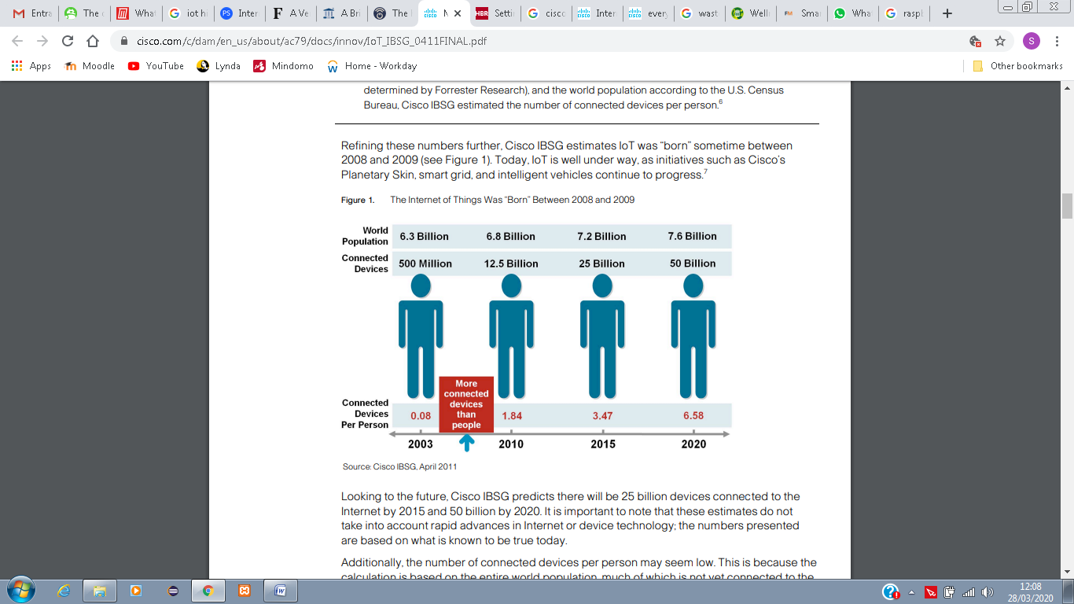

Figure 2.1: IoT progression numbers (Evans, 2011).

The following year, *Google* started *Nest*, by use of sensors, WiFi, programmable thermostats and smoke detectors. Also, due to the large amount of users and devices connected to the Internet, the number of IPs (unique identifier of a device) were reaching an end, thus the creation of a new type of IP was made necessary, creating the IPv6 type, which allowed the identification of over 340 undecillion new IP addresses to be assigned to devices. In 2013, *voice recognition* software came in handy in order to control the new IoT device, *Google Glass*, which was released to developers with a built-in touchpad. The year 2014 brought up geo-location services, advanced by the firm *iBeacon*, and *Apple* announced two health and home automation developments.

Subsequently, in 2014/2015, the IoT became real and reached its mass market with data from *General Electric*, who announced the generation of $1 billion revenue of IoT-related projects, and *Google* also announced to buy *Nest* for $3.2 billion.

Back to the prediction, made by Evans in 2011 for the years to come, we can see that these numbers have been outdated. Evans himself has lowered his expectations by saying “*I think people do tend to latch onto numbers that seem really hard to fathom. Fifty billion is pretty staggering*”. The following predictions seem to be more accurate, even though has been hard to prove, since there are a lot of different concepts regarding IoT and what does it involve.

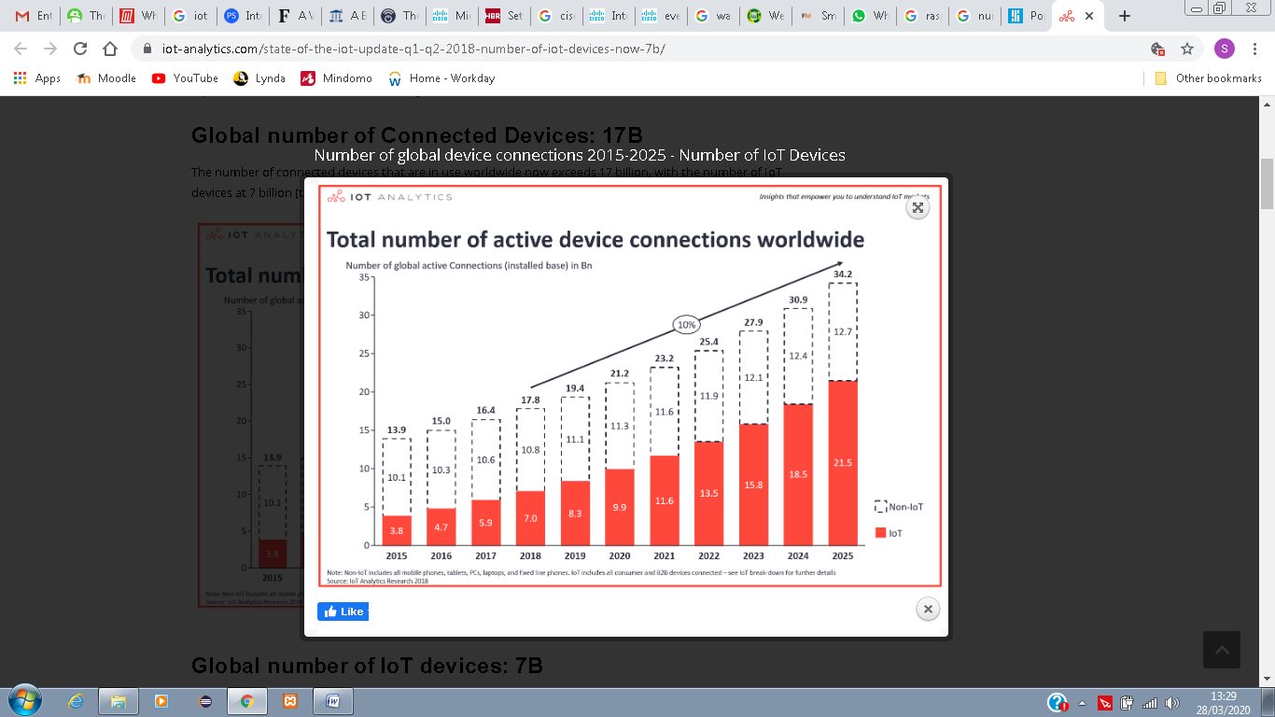

Figure 2.2: Total number of active device connections worldwide (Lueth, 2018).

As presented on Figure 2.2, Lueth (2018) showed a number, closer to the reality, and the different numbers between IoT devices and regular devices, such as Smartphones, laptops, PC’s, etc. Thus, by 2015, there were a total number of 13.9 billion devices connected, of which only 3.8 billion were considered to be IoT devices, and a projection of 21.2 billion of devices connected to Internet by 2020, of which 9.9 billion would be IoT devices. This year’s numbers are still to be confirmed in the coming years, but since there were 16.4 billion of devices in 2017, it seems we are in the right path to achieve the prediction goals.

The years that followed 2014 brought up a lot of improvements in terms of the use of IoT technology in real life devices, in order to create efficiency for users. A few examples will be mentioned in Section 2.6 of this document.

## 2.5 Raspberry Pi

One important description to be made, that has not yet been clarified in the current document, is how *IoT* and *Raspberry Pi* connect with each other. In order to answer this question, we must first describe the concept of IoT, which involves the collection of data, using sensor(s), the processing of the collected data, and the ability to act on the collected data, according to a criteria (for example, if a doorbell senses that there is someone nearby the house, it would alert the house owner and an action can be made upon the information).

*Raspberry Pi,* as well as *Arduino*, is used in IoT with the goal to provide the hardware that will do these actions (collect, process, act), since they are a small, inexpensive electronic board credit card-sized computer, that allows the connection of external accessories, such as sensors. Raspbian Operating System (based on Debian Operating System (OS)), is the most popular OS used for *Raspberry Pi,* and *Python* is the language, used for coding it (Lee & Chang, 2018).

The history of *Raspberry Pi* dates back at 2006, with Eben Upton, at time we were at the beginning of the Internet. The name *Raspberry* came from a convention, since most computer manufacturers’ names came from fruits (Apple, Acorns and Apricots) and the *Pi* came as a reference to the *Python* language, used to program these devices. The models and versions of *Raspberry Pi* were released as follows:

* 2012 – Raspberry Pi Version 1 B
* 2013 – Raspberry Pi Version 1 A
* 2014 – Raspberry Pi Version 1 A+
* 2015 – Raspberry Pi Version 2 B
* 2015 – Raspberry Pi Zero
* 2016 – Raspberry Pi Version 2 B ver. 1.2
* 2016 – Raspberry Pi Version 3 B
* 2017 – Raspberry Pi Zero W
* 2018 – Raspberry Pi Version 3 A+
* 2018 – Raspberry Pi Version 3 B+
* 2018 – Raspberry Pi Zero WH

The reason why there is a *Version A* and a *Version B* is because Upton wanted to create a Cheaper model (*A*) and a Faster model (*B*), with the *Zero* model came in handy, since it was also smaller (Fromaget, 2020). Figure 2.3 shows the *Raspberry Pi Zero W* model and its features.

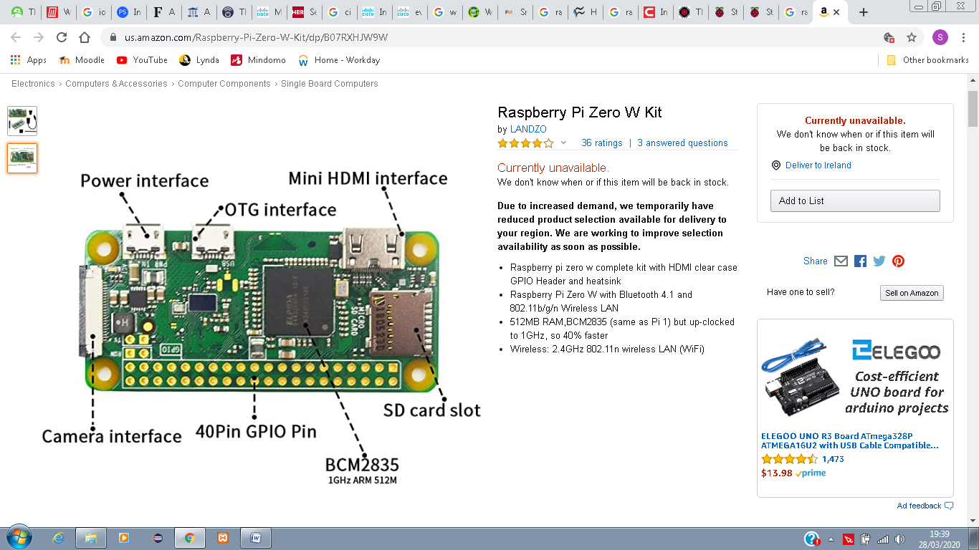

Figure 2.3: Raspberry Pi’s Features (Amazon, 2020).

GPIO or General Purpose Input/Output are very important feature when using Raspberry Pi because they can be designated as an input or output within the software and used for several different purposes. Current Raspberry Pi versions are provided with a 40-pin GPIO header (as show in Figure 2.4) while earlier versions (prior to the Pi 1 Model B+ from 2014) were provided with only a 26-pin header (Raspberry Pi Foundation, 2020).

Other components on the Raspberry Pi board are as follows:

* Arm CPU/GPU
* RCA
* Audio out
* LEDs
* USB
* HDMI
* Power
* SD cardslot
* Ethernet

(Johnson, 2020)

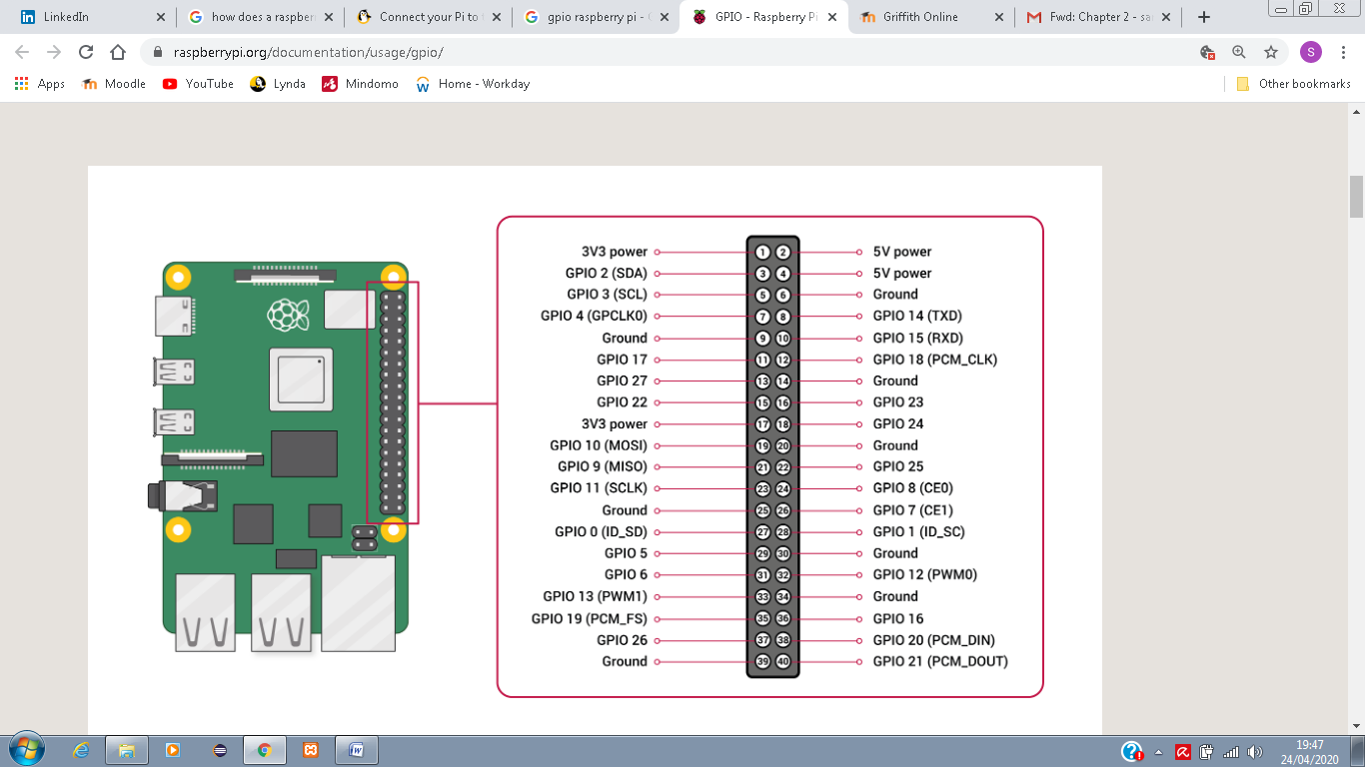

Figure 2.4: Raspberry Pi 40 GPIO pins (Raspberry Pi Foundation, 2020).

After said that, it is no mystery how these devices are connected to the internet. In a wired connection, an Ethernet cable can be used to connect to routers and an IP address is configured to Raspberry Pi via DHCP. However, in modern versions of Raspberry Pi as from version 3, Wi-Fi is built in the device (Dataplicity, 2019).

## 2.6 Uses of IoT in Real Life

After all that has been mentioned, we now have an idea of the magnitude and importance of IoT and it is even more important to show how it was implemented over the years with some real projects.

Most of the projects, using IoT to improve and facilitate the user’s life, are simple devices which are not meant to be “smart”, but now are able to connect to the Internet, pay bills, etc. Some such devices are watches, bulbs, sensors, cameras, etc. These devices have access to technology, such as *Bluetooth*, *NFC*, among others, that allow them to connect to the Internet, collect data, transmit data, analyse data and most importantly - take measures in case needed (Bravo, 2019). With that in mind, the need for creating smart cities and introducing the IoT into the public sector has increased in the past decade. Amsterdam, for example, since 2019 has more than forty streetlights that can be controlled via mobile phones of users, in order to create a more smart, safer, cleaner (energy related) city. The city’s streetlights are equipped with LED technology and the use of solar panels and wind turbines. While citizens can control the lights via mobile phone app while walking, running or cycling, the visibility can be improved creating a safer environment. Once the users have passed the streetlights, the light intensity would automatically drop. This is all possible thanks to the use of movement sensors and traffic density. Accidents and emergencies can be better dealt by Police departments and traffic offices with the use of such devices (Bravo, 2019). The picture presented on Figure 2.4 shows the difference between and the advantages of using smart lightning options over traditional lightning options.

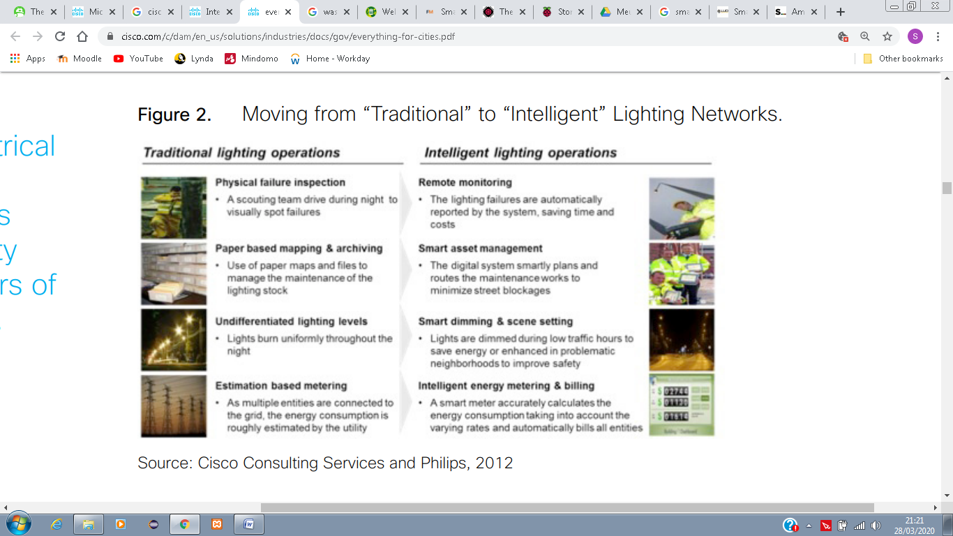

Figure 2.5: Traditional and Intelligent lighting comparison (Mitchel, et al., 2013).

Granada (Spain) has implemented a pioneering project for smart waste collection. The project consists of use of volumetric measurement sensors, installed in reinforced bins, which would inform the collection centre that the bin needs to be emptied soon. By doing so, truck routes became more efficient, it can save millions to the city, and reduction of carbon emitted by the trucks, while stopping at each and every bin, including the empty ones (Horwitz, 2017).

An initiative to save Rhinos, Elephants and other endangered animals, targeted for their body parts in Kenya, have been put in place by the Zoological Society of London in partnership with a grant from *Google*. The project uses camera that looks for wild animals, but most importantly for poachers (Upton, 2013).

A very important IoT device nowadays is the *Smart Home* device, examples of which include *Google Home*, *Amazon Echo* and *Apple HomePod*, each one using its digital assistants, such as Google Assistant for *Google Home*, Alexa for *Amazon Echo* and Apple’s Siri for *Apple HomePod* (Gebhart, 2019). They all have the same abilities, however, use different operating systems. In order to keep it simple, since the current Project intends to use *Google Home* to integrate with the proposed mobile application, we will describe the *Google Home’s* features in this document.

Still, according to Gebhart (2019), *Google Home* is a central hub for connected devices (smart speaker), launched in 2016 and designed to compete with *Amazon’s Echo*, which was launched in 2014 and became very popular by the time. The device always listens to the environment and responds to the user’s commands when the *key words* are spoken, in this case, “*OK, Google*” or “*Hey, Google*”. However, the most interesting thing about *Google Home* is its capability to connect with several different devices, and the ability to control each and every one of them. For example, you can connect *smart bulbs*, *smart fridge*, *smart heaters*, etc., and with that, the user is capable of turning on/off the lights, increase/decrease the temperature in the house’s fridge, turn on/off the heater in the house, etc. Some of the supported devices by *Google Home* are as follows: Nest Thermostats, Philips Hue, Samsung SmartThings, Honeywell, Belkin Wermo, TP-Link, LIFX, Best Buy Insignia, IFTTT, iHome, Emberlight, Leviton, among others (Westernberg, 2019). These are just a few examples of what can be done with the device, but the possibilities are infinite.

## 2.7 Case Studies on IoT Applications

Internet of Things (IoT) devices are becoming more popular over the years, which leads to an increase in number of mobile applications, able to connect and interface with them, the *IoT apps*. These apps are developed with everyday situations in mind, that customers usually face, in a way that it can hugely affect people’s lives (Cherednichenko, 2018). Some examples of such applications are discussed as follows:

* **Nest**

According to Cherednichenko (2018), *Nest* is one of the best examples of an IoT app. Compatible with *smart thermostats*, *home alarm systems*, *doorbells*, *smart cameras* and *smoke alarms*, this app allows the user to control many different types of devices, while away from home. It also has a feature that manages the home automatically when the user set it to the *away* mode, such as tuning everything off or switching the cameras on (please, see Figure 2.5). This app has a rating of 4.3 from all its 110,140 evaluations on *Google Play Store* (Google Play, 2020a).

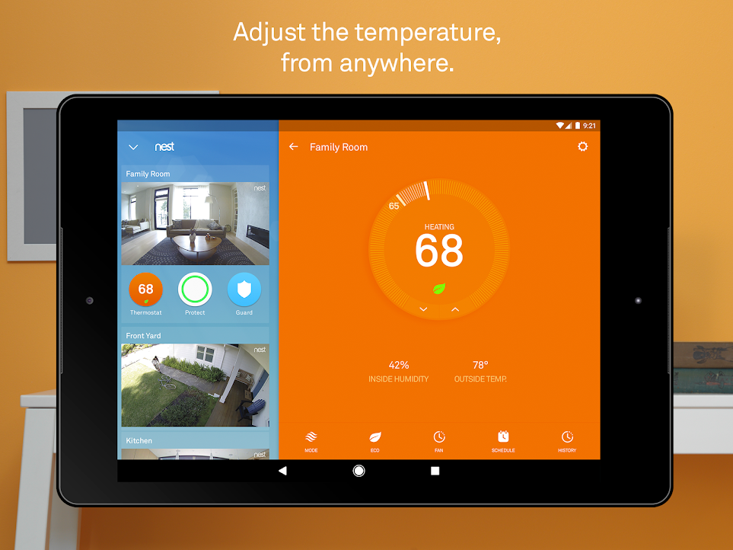

Figure 2.6: Control Screen of the Nest app (Google Play, 2020a).

* **Whistle – Pet Tracker**

Still, according to Cherednichenko (2018), *Whistle – Pet Tracker* is another useful IoT app to give it a go. This app is integrated with *Whistle GPS* tracker device, that can be attached to the pet’s collar. This allows the pet owner to find their dog by showing their exact location, as well as their activity (please, see Figure 2.6). This app has a rating of 3.3 from all its 706 evaluations on Google Play Store (Google Play, 2020b).

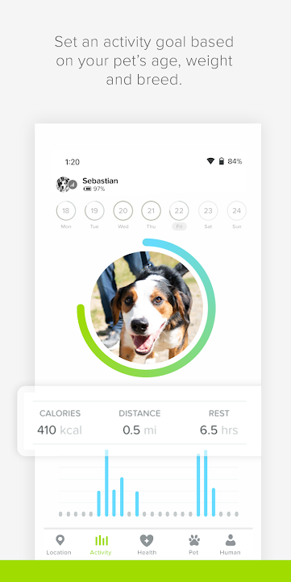

*Figure 2.7: Whistle - Pet Tracker, Activity Screen (Google Play, 2020b).*

* **Smart Life**

*Smart Life* is an IoT app that allows the user to remotely control home devices from anywhere. It can be connected with multiple smart devices and it can automatically start/stop working, according to the users predefined settings, if any, such as according to weather changes, or following a specific schedule (please, see Figure 2.7). This app can be *voice* controlled via *Amazon Echo* and *Google Assistant*. The app has a rating of 3.6 of all its 24,038 evaluations on Google Play Store (Google Play, 2020c).

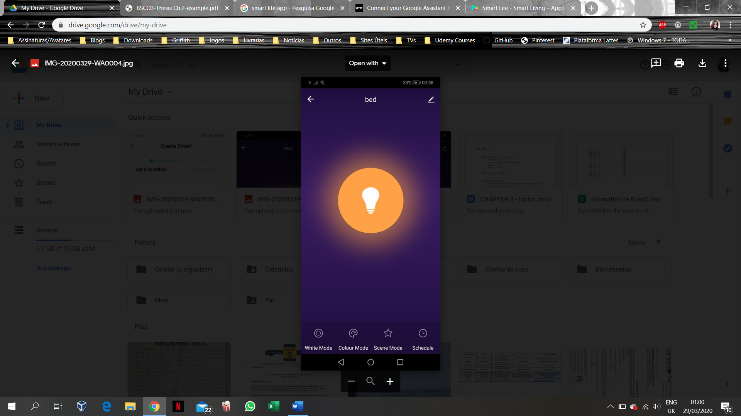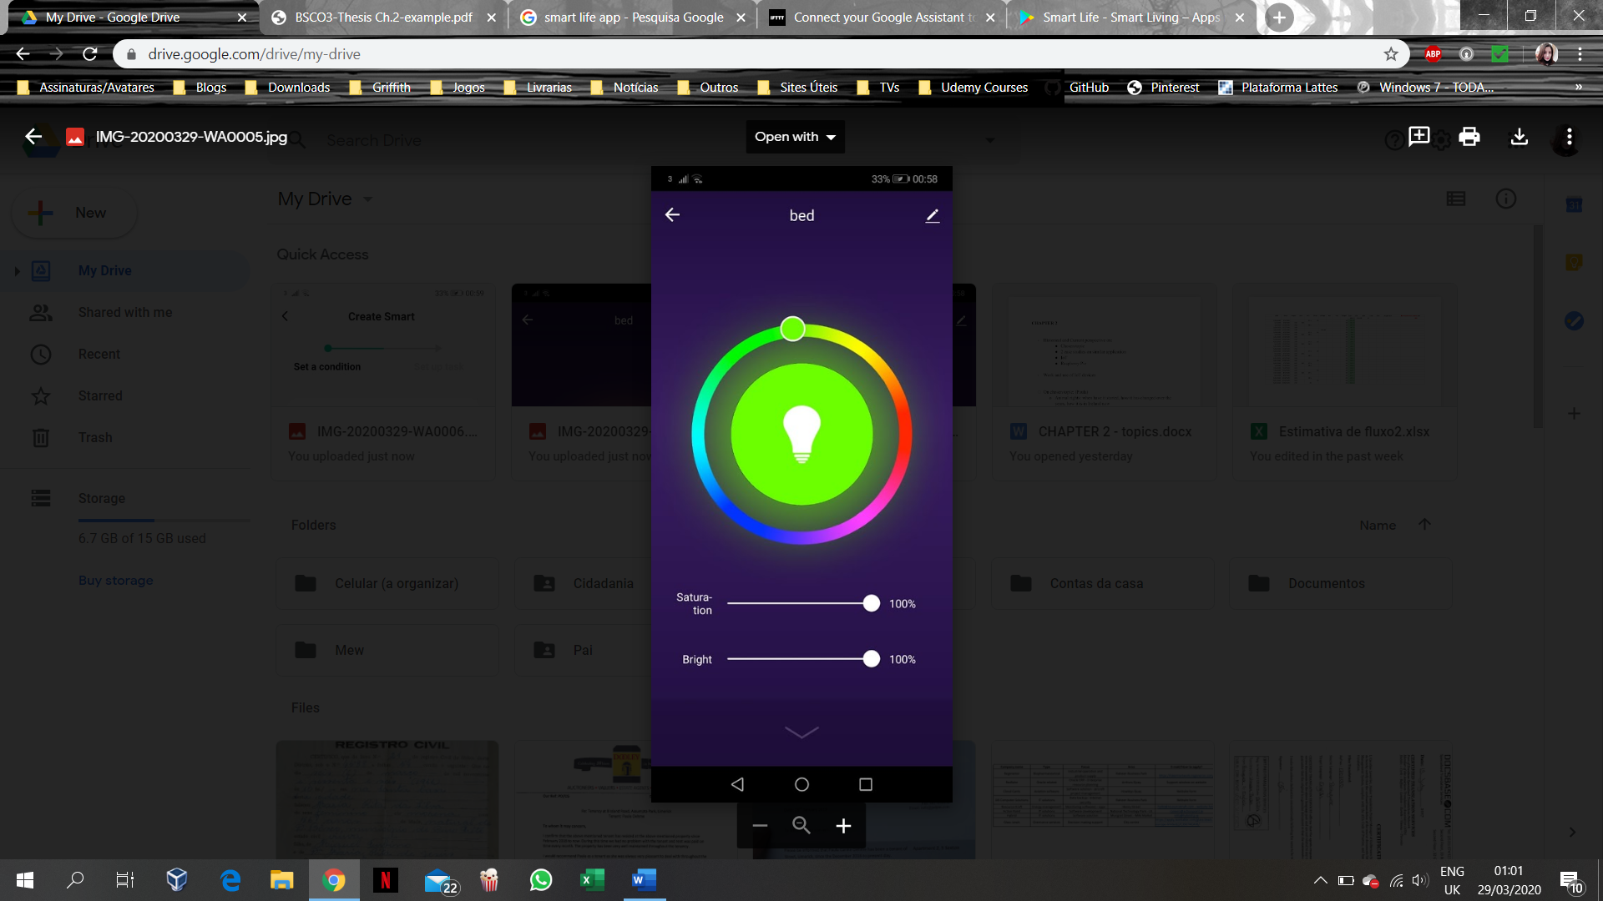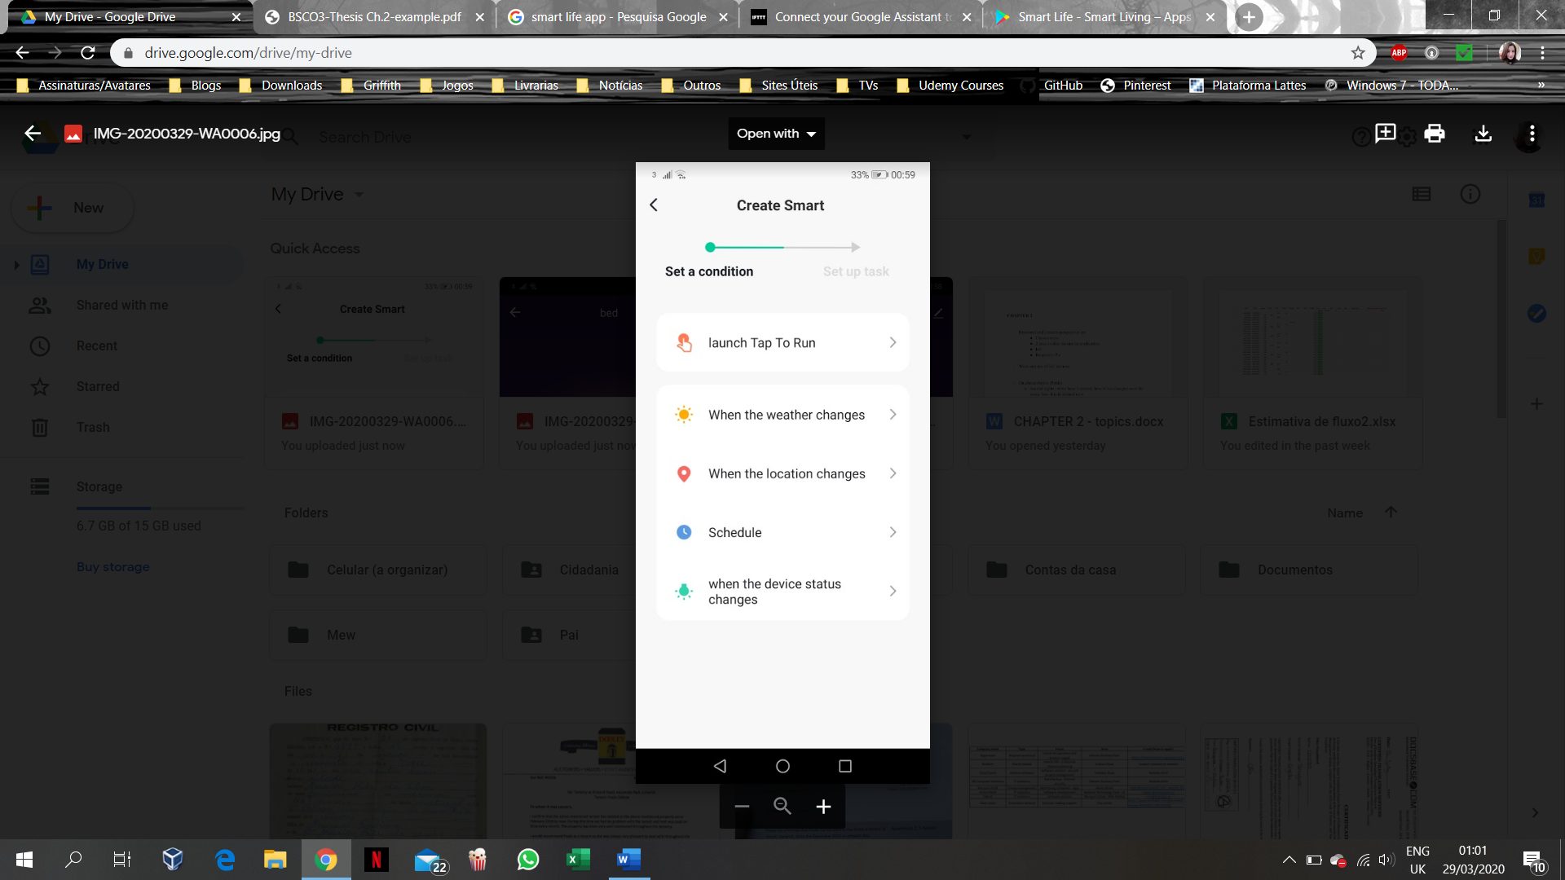

Figure 2.8: Smart Life bulb control and automated control screens (Google Play, 2020c).

## 2.8 Case studies on similar mobile applications

* **Appets**

*Appets* is an app, programmed by the Colombian Jonny Acevedo. In the app, you can browse through a list of pets available for adoption, and each animal can be posted by different entities, whether they are a foundation without a profit, a pet shelter, or a civilian that has puppies to give for adoption (please, see Figure 2.8). The app provides a world-wide range of places to search for a pet, with exceptions. At first, the user is asked to login - the app provides you with options to either *adopt a pet*, *find lost pet*, or *find services* and *help*. The *find a lost pet* option is designated to people who have lost their pets and want to find them by posting information, as well as helping people find their lost pets that have been already found. While browsing an *adopt a pet* option, or *find lost pets,* you can either filter or scroll down through pictures of the pets available. Once the pet is selected, you are directed to a screen in which you find the information of the current owner of the pet, as well as the option to send them a message through the app, however, this message option is not available for all the pets, which means that there is an option for opting messaging out from the owners of the pets. The app has a rating of 3.5 from 37 evaluations on Google Play Store (Google Play, 2020d). However, when using the app to find a pet in Limerick, Ireland, it did not return any results. Thus, the application to be developed in the current Project aims to provide a more local search, which can be applied to any country in the world, amending to its adoption’s parameters, however, intended specifically for Ireland at present. Also, the information provided for each pet would be from registered organizations within the local authorities, which means the information would be more reliable.

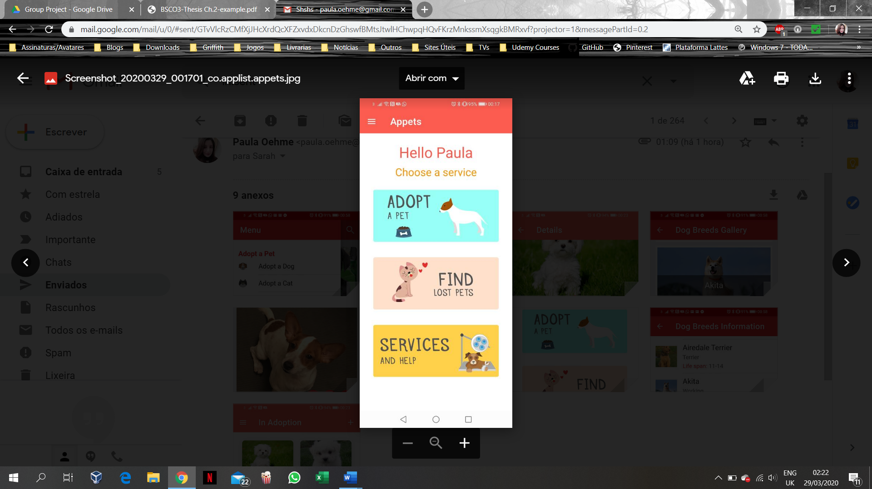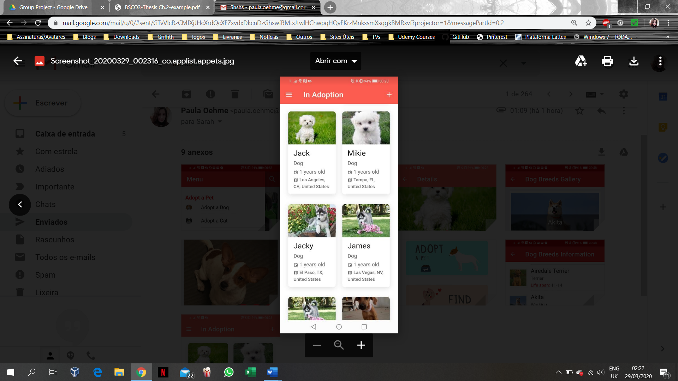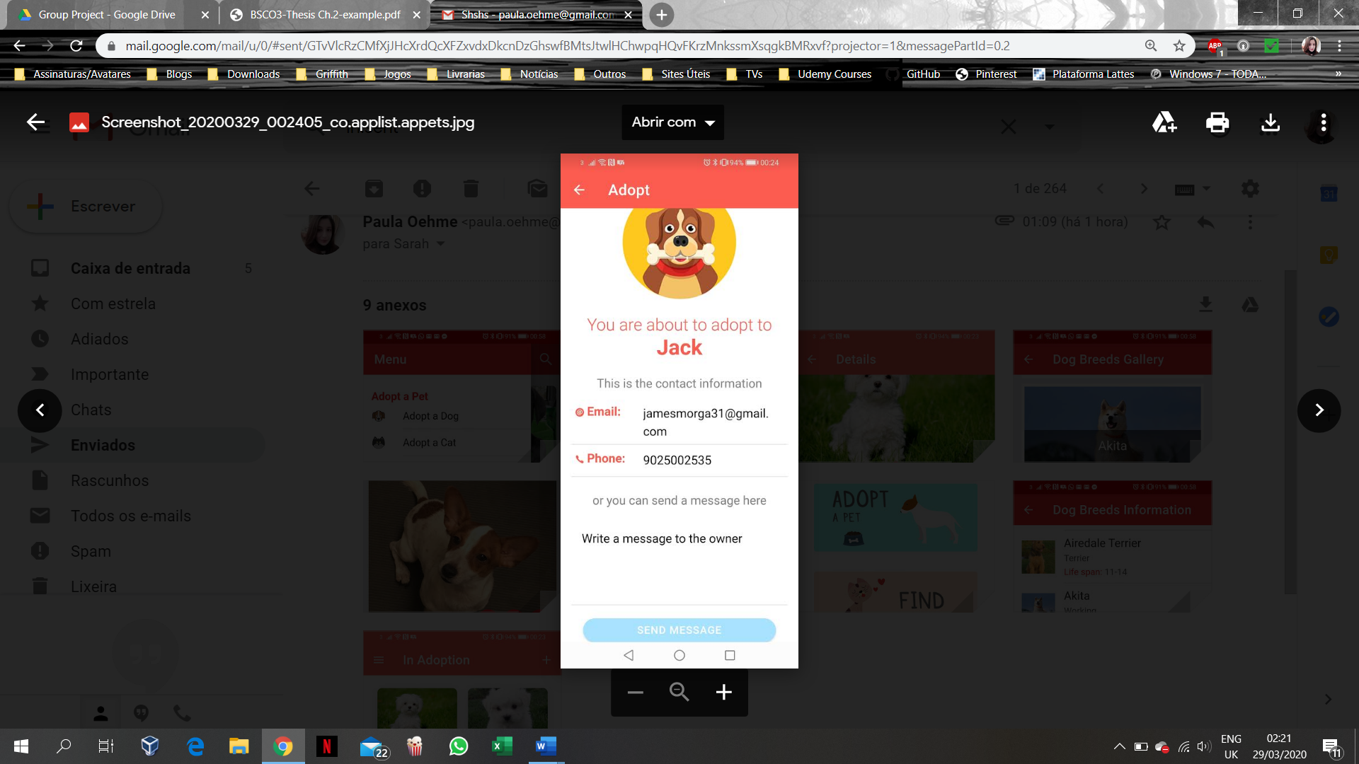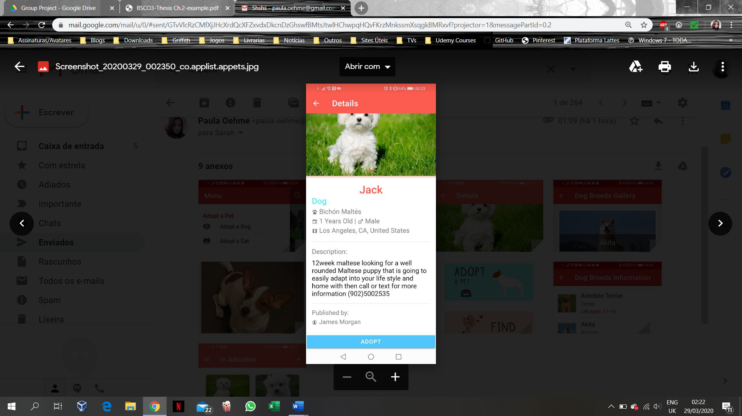

Figure 2.9: Appets app’s Features (Google Play, 2020d).

* **Pets Adoption**

The *Pets Adoption* app provides a search through a database of pets with different categories, such as Dogs, Cats, Rabbits, Horses and Birds. The interesting thing about this app is that it has a database with information and gallery of several dog breeds, such as Akita, Australian Shepherd, among others (please, see Figure 2.9). The application allows you to search for pets, based on their location, breed, age, size, and gender. It provides details about each pet, as well as information about the current owner of the pet. Also, the app allows you to contact the organization/owner of the pet, in order to start the adoption process. The app has a rating of 3.4 from 57 evaluations on Google Play Store (Google Play, 2020e). However, when using the app to find pets in Limerick, Ireland, it did not return any result.

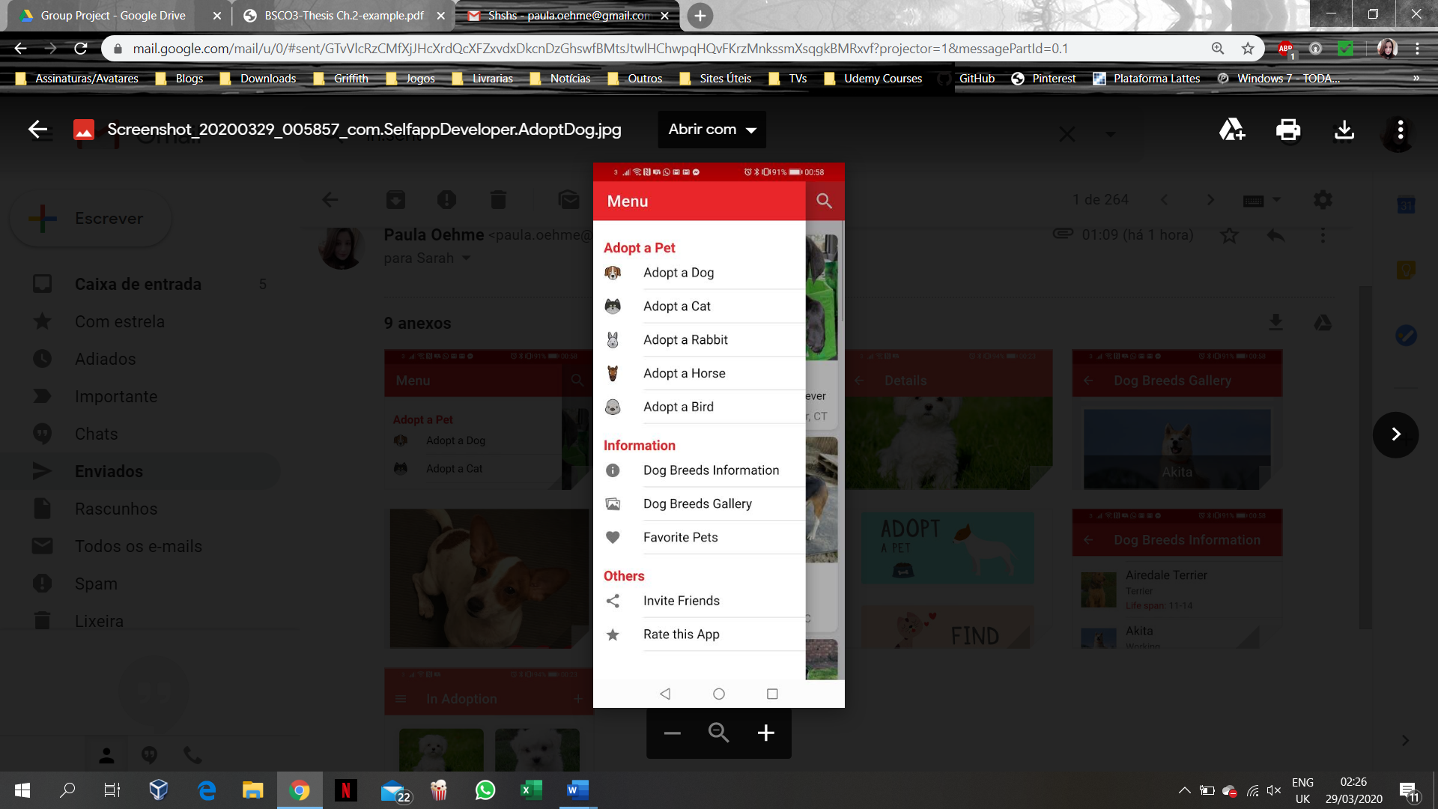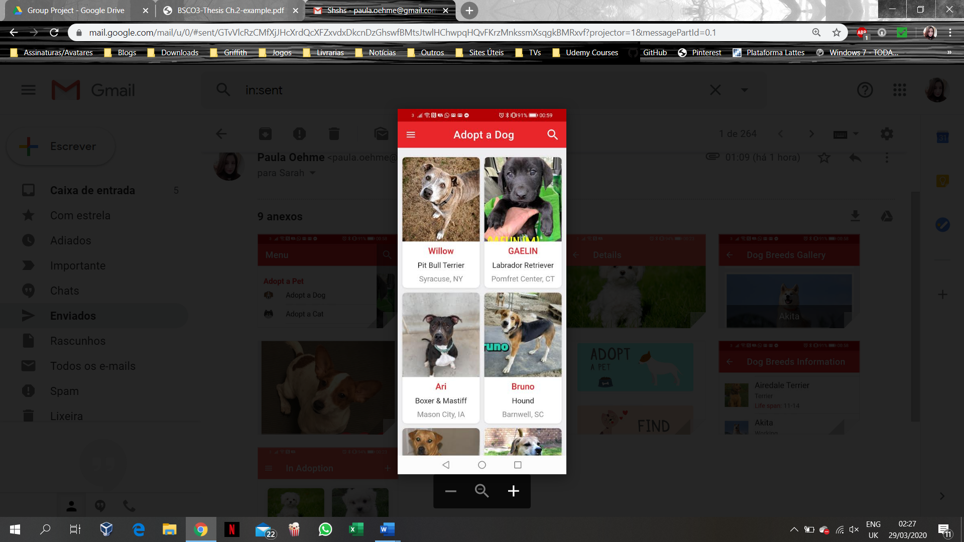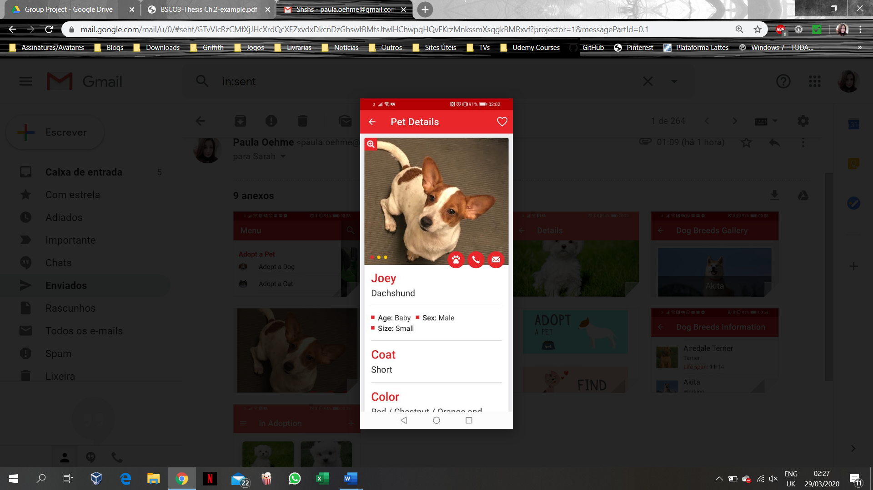

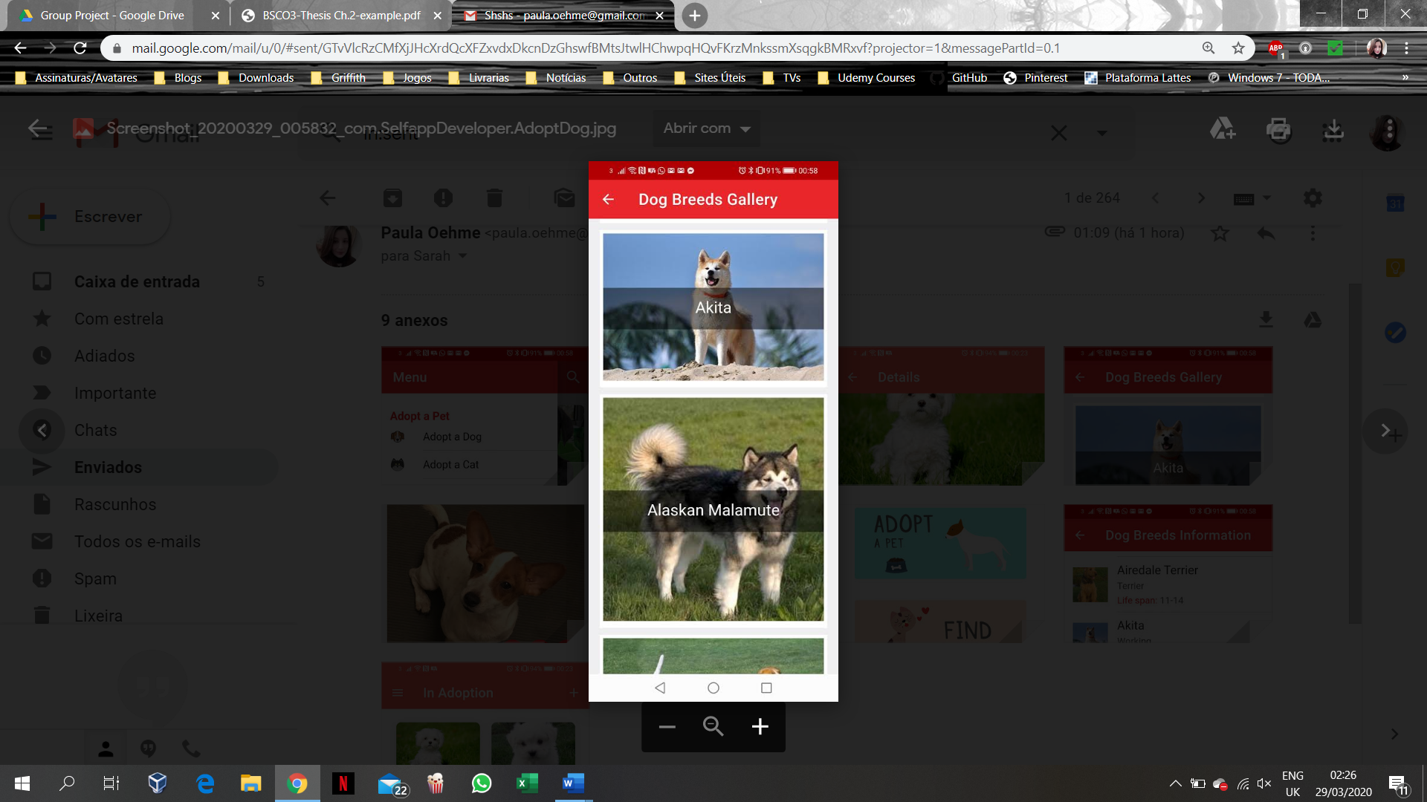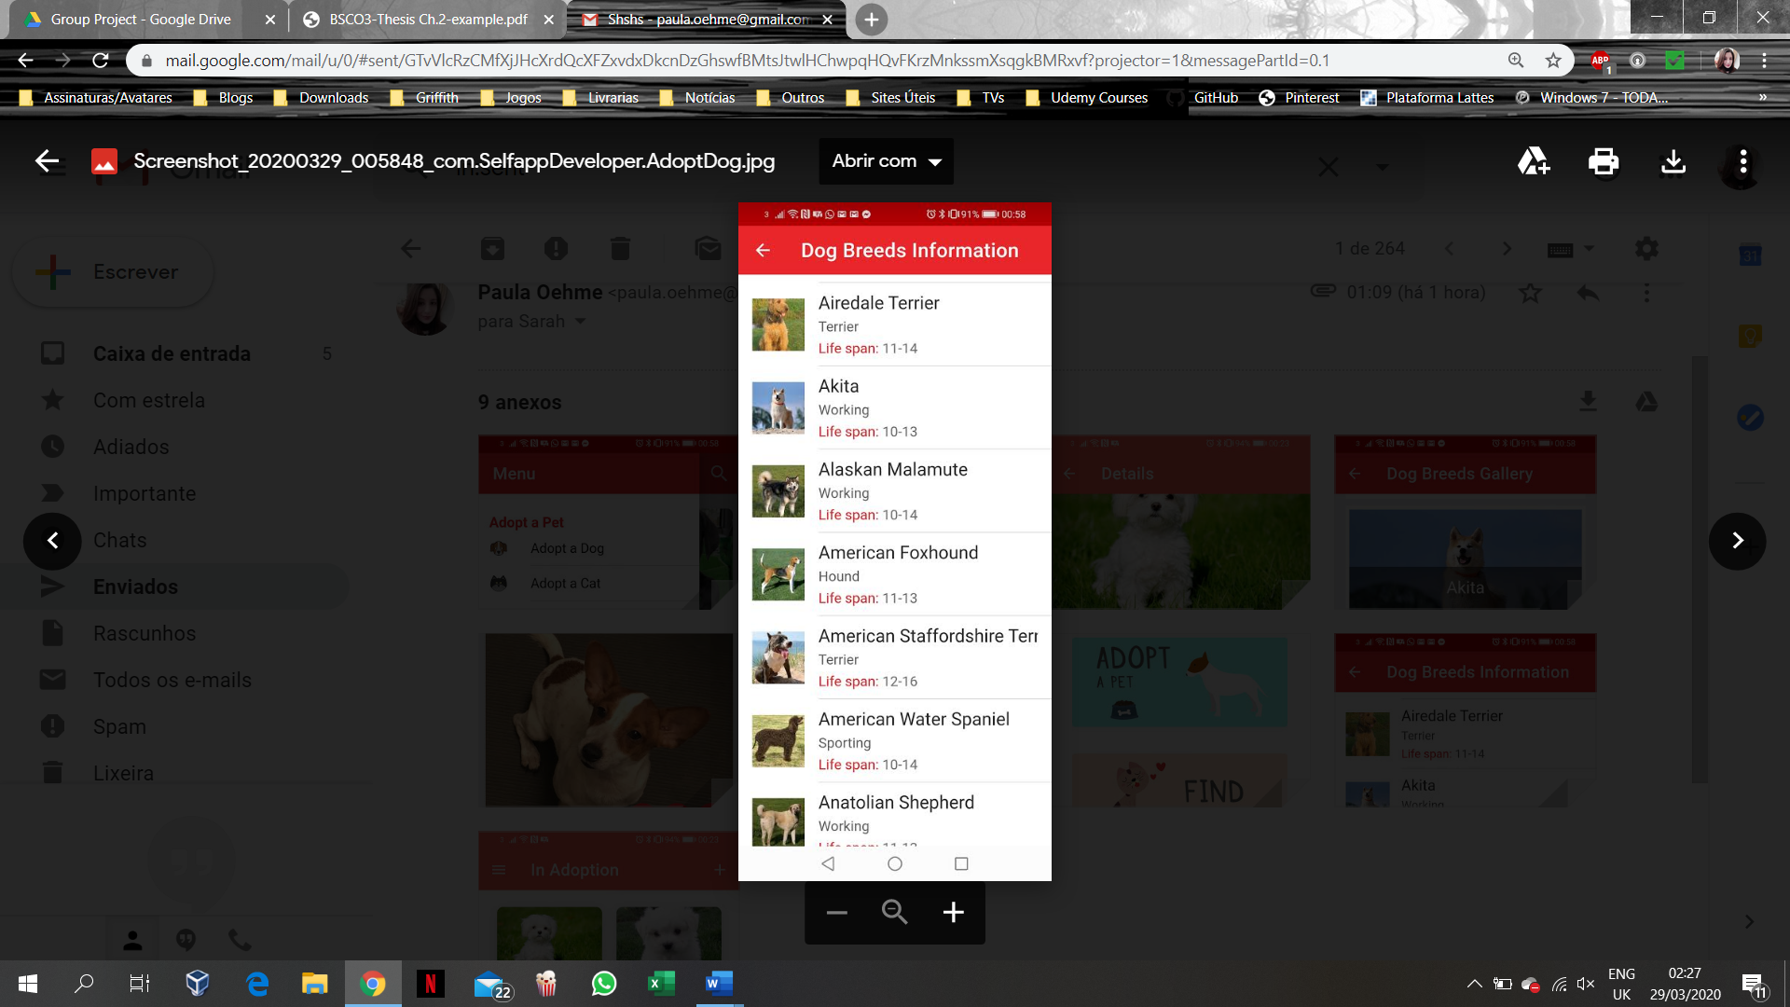

Figure 2.10: Pets Adoption app’s Features (Google Play, 2020e).

## 2.9 Chapter Summary

All the apps discussed in the chapter showed lack of available mobile application for helping potential adopters to find desired pet for adoption locally in Ireland. Unfortunately, we could not find such app for the country, which increases the need of creating such an app, that could as well interface IoT device, like *Google Home*, since nowadays everything is connected to the Internet and everyone is using mobile phones. However, a few apps were found worldwide, providing similar ideas to the current application project.

Even though there are some similarities to those, cited in the discussed Case Studies, the current project aims to provide a stricter range of search for example a country and specially a more reliable source of information regarding the pets, since this information will be provided by registered organizations within the local authorities. Also, the current project aims to provide the means to initiate an adoption process within the shelter without excluding a physical visiting and approval from the organization in question.

The next chapter will describe the project application Analysis phase, the chosen Development methodology and approach to be implemented for the project.

**Chapter 3: Project Application Analysis Phase**

The Secondary and Primary research carried out on the topic and discussed in the previous two chapters, have proved the feasibility of and the need for development of a suitable mobile application to help potential adopters in Limerick, Ireland, find a desirable pet to love. In order to do so, an appropriate Development methodology must be implemented. This chapter describes some of the Development methodologies used in the industry today and compares their advantages and disadvantages in the process of selection of most appropriate for the current Project methodology to be followed during the Project’s development stage.

**3.1 Mobile Operating Systems Overview**

There are several different types of mobile operating systems (OS), however, the most used OS in Ireland are Google’s Android and Apple’s iOS, as shown by StatCounter (2020a) on Figure 3.1.

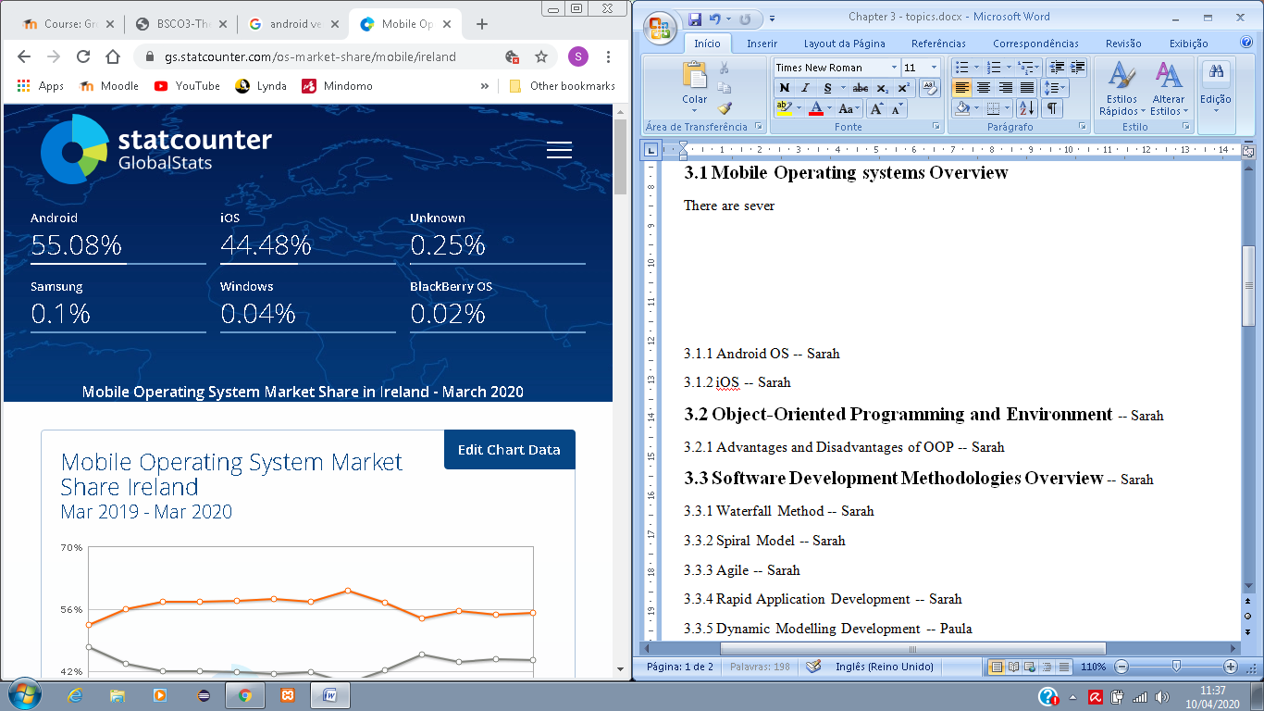

*Figure 3.1: Mobile Operating System Market Share in Ireland - March 2020*

*(StatCounter, 2020a).*

If we consider the worldwide view, instead of just one country, the research still shows a greater frequency of Android and iOS OS and a dominance of Android over iOS (please, see Figure 3.2).

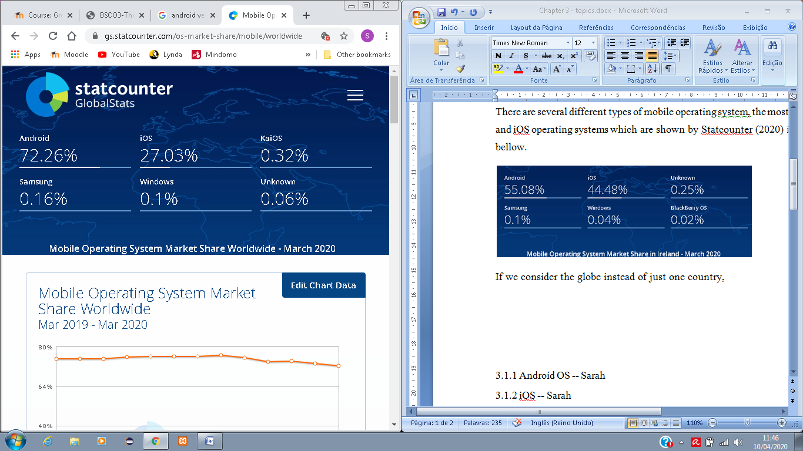

*Figure 3.2: Mobile Operating System Market Share Worldwide - March 2020*

*(StatCounter, 2020b).*

Having said that, it is more than reasonable that Android and iOS were the options to be considered for the current Project application, since the other alternatives do not show considerable market share, thus it would not be worth the application development time for them.

Ideally, such application as for the current project, should be developed for both OSs that are most widely used, in order to reach a wider target audience, however, due to time restrictions only one will be implemented in this current project, with the Android OS being the chosen one, since is the most worldwide used (with 72.26% of users globally), and also for reasons like better programming language alternatives, IDE tools, Emulators and the verification procedures that are more accessible by *Google Play* Store than the *Apple App* Store. These characteristics of Android Operating System will be discussed in the next section.

**3.1.1 Android OS**

Rich Miner, Nick Sears, Chris White and Andy Rubin founded the company Android Inc in 2003 in Palo Alto, California. By that time Rubin said that they would develop smarter devices that would be more aware of its owner’s location and preferences; this was the first idea for the *Android* OS. After that, the company and the software itself have undergone a lot of changes, including the acquisition of *Android Inc* by *Google* in 2005. *Android* is an open source Operating System with a great user base and a simplified mobile app development process (Sharma, 2019). All the *Android* versions, since 2008 when its first public debut was made, are listed as follows (Callaham, 2019):

* 2008 – Android version 1.0 to 1.1
* 2009 – Android version 1.5: Cupcake (birth of Android version names tradition)
* 2009 – Android version 1.6: Donut
* 2009 – Android version 2.0 to 2.1: Eclair
* 2010 – Android version 2.2: Froyo
* 2010 – Android version 2.3: Gingerbread
* 2011 – Android version 3.0 to 3.2: Honeycomb
* 2011 – Android version 4.0: Ice Cream Sandwich
* 2012 and 2013 – Android version 4.1 to 4.3: JellyBean
* 2013 – Android version 4.4: Kitkat
* 2014 – Android version 5.0 to 5.1: Lollipop
* 2015 – Android version 6.0: Marshmallow
* 2016 – Android version 7.0 to 7.1: Nougat
* 2017 – Android version 8.0 to 8.1: Oreo
* 2018 – Android version 9: Pie
* 2019 – Android version 10

Version 10 is the most recent version of *Android* and is the version that quit the dessert themed tradition, by being known simply by a number (Raphael, 2020).

There is a range of Integrated Development Environment (IDE) and programming languages that can be used when developing for *Android* OS. Starting with the programming languages, *Java* is the most popular one. However, *Kotlin* is an alternative to *Java* since it is easier to read and code for developers, especially for beginners, which means that coding can be done in a more efficient way. C# is another alternative, which is supported by tools like *Unity* and *Xamarin* for gaming and multi-platform applications (The Tool, 2018). According to The Tool (2018), there are different tools that act as Front-end Application Development Environments (IDEs) for Android, including *Eclipse*, *Android Studio* and *IntelliJ* IDE’s.

*Kotlin* and *Java* are both open sources and Object-Oriented programming languages. The first one, although easier, “better language” than *Java*, that is sponsored by *Google* and been announced one of the official languages for Android Development in 2017 (GeeksforGeeks, 2020), is not going to be used in the current project, due to limited time for project development and lack of experience of the development team with it. Since *Java* is the language we are more familiar with, it has been the chosen programming language to use in the current project.

**3.2 Smart Home Devices Overview**

In a world where everything at home is smart, or is capable of being smart, it is important to mention the devices that allow the interaction with other devices in order to maintain the quality of smartness. *Smart Home* devices are IoT devices that connect with other devices, such as bulbs, cameras, sensors, etc, and allow full control of those devices by the users, according to their needs. Even though *Apple* is in the market and has made improvements over the past few years with Apple *HomeKit*, *Amazon* and *Google* hold the supremacy of the market with *Alexa* and *Google Home* (Reisinger, 2020).

Both devices, *Amazon Alexa* and *Google Home*, present the same abilities, such as allowing set up of alarms, control of other smart devices, listening to entertainment, etc. However, certain attributes are more specific to each one of them. *Alexa*, for example, has a wider range of Third-party support for connected devices, but there are some restrictions on skills if the user is not an Amazon Prime member. *Google Home* on the other hand, comes with its own built-in virtual personal assistant, *Google Assistant*.

For reasons, mentioned in the previous sections for choosing Android Operating System, the developers of the current project’s mobile application have chosen to interface it with the *Google Home*, once it has been developed.

**3.3 Object-Oriented Programming Environment Characteristics**

Object-Oriented Programming (OOP), unlike the procedural programming, uses the principle of dividing the “problem” into small components, which are the objects. Usually, an Object-Oriented program is comprised of many different objects, which can store information, perform certain behaviours, and interact with other elements of the environment (Anderson, et al., 2015). According to Anderson, et al. (2015), these objects are related to real world entities. For example, a person is considered an object, which has attributes such as hair colour, eyes colour, name, etc.; these would be the properties of the object; and also, the person can undertake actions, such as eat, travel, sleep, which would be the methods within the object.

* ***Encapsulation***: is one of the most important concepts in OOP. This concept involves *hiding information*, whereby the object only provides essential information for users to manipulate. The internal details are hidden for the outside world, in order to avoid the data manipulation, and especially to avoid possibility of the user performing something they should not do within the program. This can be done by defining the attributes and the actual piece of code of the methods as private, allowing only the methods name and signature being known by the outside world (Nakov, et al., 2013).
* ***Inheritance:*** with this principle, a class is able to inherit the behaviour and the characteristics of a class that is more general, for example a class for cats has attributes and behaviours, such as having four paws, being predators and hunt their prey. All these characteristics and methods can be coded and be reused in a different class for “Felidae” which is a biological family within the cats that encloses Lions, for example (Nakov, et al., 2013).
* ***Abstraction:*** this is a principle that uses the idea of not knowing how things work internally but knowing how to use them. For example, a remote control for the TV, we do not really know how the control operates internally, but we know how to use it by just pressing the buttons (Nakov, et al., 2013).
* ***Polymorphism:*** with this principle, a method or an ability of object class can be performed in different ways. For example, if we have a class of Big Cats and a method for hunting their preys, which is done in different ways by each cat, the Lion class, derived from the Big Cats class, can override its method by setting that Lion sneaks on its prey, whereas the Cheetah, which is another class derived from the Big Cats class, overrides its method by setting it to outrun its prey (Nakov, et al., 2013).
* ***Association:*** this principle establishes the relationship between two classes that are unrelated to each other. That means that they are *associated* through their objects and each one can exist without the other (Monus, 2020).
* ***Aggregation:*** it involves the HAS-A relationship between the two associated classes. For example, a person HAS-A job or HAS-A car but a car or a job does not necessarily HAS-A person. The relationship is one-directional, which means that only one class is dependent on the other (Monus, 2020).
* ***Composition:*** in composition, two different classes are mutually dependent on each other and each of them cannot exist without the other. This principle involves the PART-OF relationship, for example, an engine is PART-OF a car and vice versa. Thus, if engine stops existing, so does the car (Monus, 2020).

**3.3.1 Advantages and Disadvantages of OOP**

**Advantages:**

* Better developer productivity;
* Lower programming costs;
* Organization;
* Decision building;
* Code reusability;
* Security through data hiding;
* Object co-existence;
* Software with higher quality;
* Easy upgrading from small to large systems.

**Disadvantages:**

* Slower software;
* Adaptability to Object-Oriented, abstract thinking for programmers;
* Mastery in software engineering and programming methodology is required;
* Difficulty tracing and debugging message passing between objects.

**3.4 Software Development Methodologies Overview**

Managing projects well is what leads to their success. The choice of a suitable Software Development methodology to work best for a project, allows the project to be managed more efficiently. There are different methodologies, with different strengths and weaknesses each, but all of them lead towards the success of a project. The following sections describe some of the used in industry Software Development methodologies with their characteristics.

**3.4.1 Waterfall Method**

*Waterfall* model is commonly considered the most traditional Software Development method. This methodology was first created by Winston W. Royce in 1970, and is a strict linear approach, in which the requirements from stakeholders and customer are gathered at the beginning of the project. A sequential project plan is then created, in order to accommodate these requirements (Project Manager, 2020). There are usually five to seven stages in this model, and a new stage of the project can only start when the previous stage has been fully completed and documented; however, there is no possibility of going back to a previous stage (IntellectSoft, 2019). The stages of this model are presented on Figure 3.3.

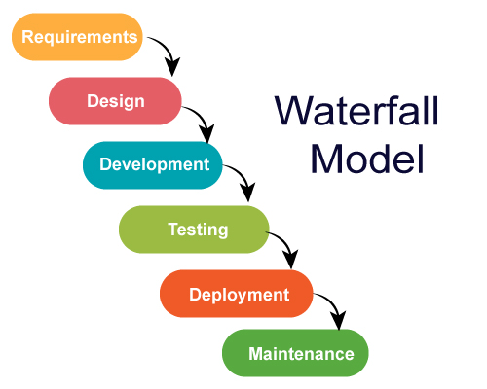

*Figure 3.3: Visual Representation of the Waterfall Model (JavaTPoint, 2018).*

**Advantages:**

* Simple and clear planning and scheduling;
* More accurate estimates of cost, resources and time schedule for the project;
* Clearly defined stages;
* Well understood milestones;
* Great documentation of process and results;
* There is no delaying of production, since there is no adding of new requirements from customers until product is developed.

**Disadvantages:**

* Customers may find difficulty articulating their requirements at the beginning of the project;
* Can be very expensive to go back to designing the code again if the customer is dissatisfied with the developed product;
* Working software is only produced in late stages within the Life Cycle;
* High risk and uncertainty;
* Not recommended for complex projects in Object-Oriented environment;
* Not suitable for projects with frequent changes in requirements and ongoing maintenance;
* Lacks flexibility in case of unexpected events (IntellectSoft, 2019).

**3.4.2 Spiral Model**

The *Spiral* methodology is a combination of *Sequential* and *Prototyping* methods and is presented like a spiral with several loops. These loops can vary in number, depending on each project, and each of these loops represents one Prototype version of the Project. The Project Manager decides how many Prototype versions are needed to develop the Project, depending on the Project risks. The cost of the project is represented by the radius of the spirals and the progress made so far in the current Prototype version is represented by the angular dimension (Pal, 2019). The phases of this methodology can be seen on Figure 3.4.

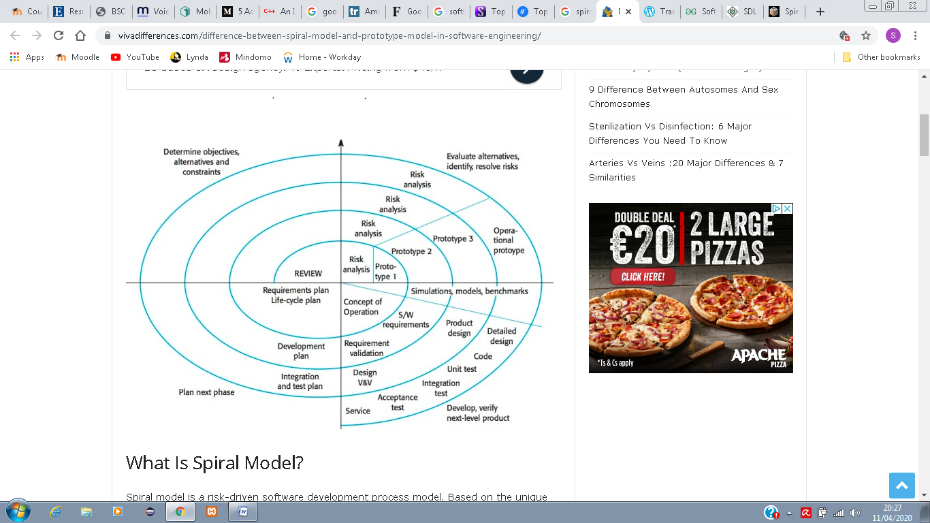

*Figure 3.4: Visual Representation of the Spiral Model (Viva Differences, 2019).*

**Advantages:**

* Fast development;
* Strategic ways are created for handling larger projects;
* Proper Risk Evaluation;
* Total control in each phase of the Life Cycle;
* Features can be added in a systematic way at each Prototype version;
* Early production of the software;
* Faster implementation of changes with the customer’s feedback.

**Disadvantages:**

* Expert people are required for Risk Analysis;
* Not recommended for small projects and small organisations, since it may be expensive;
* The Spiral can go infinitely;
* Large amount of documentation (Pal, 2019).

**3.4.3 Rapid Application Development**

Rapid Application Development (RAD) is a pre-Agile project management strategy with a fast project turnaround. RAD is focused on minimizing the planning phase and maximizing the development of the prototype phase. The process can be broken down in a few ways which include four main phases:

* Requirements planning;
* User design;
* Rapid construction;
* Cutover (LucidChart Content Team, 2019).

RAD is a methodology that should be used when the project needs to be developed in a short time frame (2 to 3 months) and can be modularized (Tryqa, 2017). Highly experienced development team is required, since RAD provides a very fast paced environment. The phases of RAD methodology are presented on Figure 3.5.

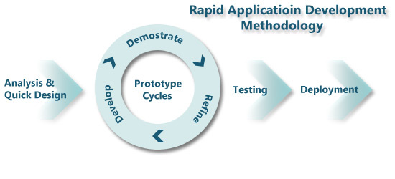

*Figure 3.5: Visual Representation of the Rapid Application Development Methodology (Islam, 2017).*

**Advantages:**

* Risk reduction;
* Increased quality;
* Faster time to market;
* Frequently changing requirements can be accommodated;
* Time for development is reduced;
* Components are highly reusable;
* Initial reviews occur in a quick manner;
* Customer feedback is encouraged.

**Disadvantages:**

* Dependence on strong team and individual developers’ skilful performance;
* Only appropriated to systems that can be modularized;
* Not too appropriated for cheaper projects since the cost for modelling and code generation is high (Tryqa, 2017).

**3.4.4 Agile**

*Agile* methodology was created with the purpose to improve the inadequacies and inflexibility of the traditional methods, like the *Waterfall*. Starting with the fact that software is continuously upgrading, which means that developers also need to improve constantly their skills and be innovative (Muslihat, 2018), the *Agile* software development involves software development practices that are based on iterative development. In this case, requirements and solutions are always evolving throughout the project, with collaboration between self-organizing cross-functional teams. It promotes disciplined process that encourages regular inspections and adaptations, teamwork, self-organization and accountability, and rapid delivery (Sacolick, 2020). It is a framework, divided into number of sub-frameworks, such as Scrum, Kanban, Extreme Programming, Lean Software Development (LSD), Rational Unified Process, Dynamic Systems Development Method (DSDM), among others (Appelo, 2008). The Agile Development process is presented on Figure 3.6.

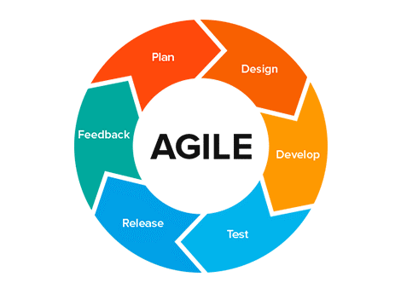

*Figure 3.6: Visual Representation of the Agile Development Process (Abellán, 2020).*

**Advantages:**

* Flexibility and adaptability;
* Creativity and Innovation;
* Faster time-to-market;
* Lower cost;
* Improved quality;
* Faster bug detection and fixing;
* Customer satisfaction;
* Employee satisfaction;
* Organizational synergy.

**Disadvantages:**

* Required training and high skills;
* Organizational transformation;
* Scalability;
* Integration with project/program management (Appelo, 2008).

**3.4.5 Dynamic Software Development Method**

The *Dynamic Software Development Method* (DSDM), is an *Agile* approach for software development, in which users are required to be actively involved and the decision-making process is made by the team (please, see Figure 3.7). This methodology uses techniques such as *Time Boxing*, MoSCoW rules, and Prototyping (Guru99, 2020). The two main focuses of DSDM model is the strict time frame and assigned budget. It involves continuous feedback in order to deliver maximum functionality, according to the agreed requirements (IntellectSoft, 2019).

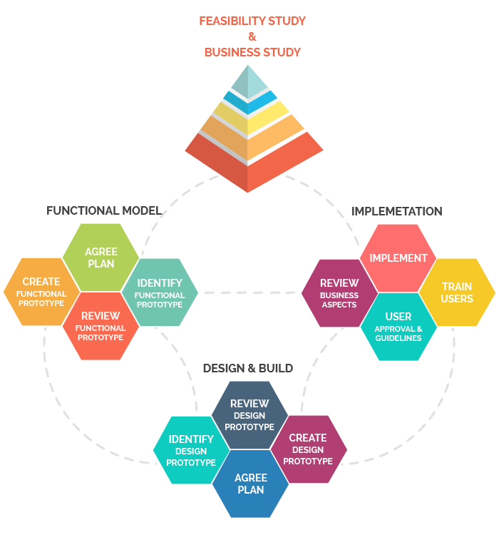

*Figure 3.7: Visual Representation of the Dynamic Software Development Method*

*(TatvaSoft, 2015).*

**Advantages:**

* Excellent communication between all involved in the project (developers and users);
* Fast to reach the functionality needed;
* Developers’ easy access to end-users;
* Projects are delivered on time and within specified budget.

**Disadvantages:**

* High cost to implement;
* Developers and users must be trained;
* Not suitable for small organizations (IntellectSoft, 2019).

After considering the discussed above methodologies for software development, DSDM was chosen to be used in this project due to reasons such as time constraints and the skills level of the programmers. DSDM approach uses techniques that are essential for the timely completion of this project, such as Time Boxing, MoSCoW rules and Prototyping. Time boxing is very important in this case because the time management must be very precise in order to deliver the software on time within a very tight timeframe. MoSCoW rules determine what Must Have, Should Have, Could Have and Would like to have, but not necessarily this time, and the Prototyping technique allows the developers to test the software as it happens.

**3.5 Unified Modelling Language**

The Unified Modelling Language (UML) is a standardised language used to specify, visualise, construct, and document the objects of software systems. It was developed in order to help system and software developers by allowing project teams to communicate regarding potential designs of the software (Visual Paradigm, 2020). There are many types of UML diagrams available, but for this project the three that are used are: Use Case Diagram, Sequence Diagram and Object Class Diagram. Use Case Diagrams, as well as Sequence Diagrams, are used to capture the dynamic aspects of a system (Tutorials Point, 2020).

**3.5.1 Use Case Diagram**

Use Case Diagrams are applied for high-level requirement systems to present all its functional requirements, as well as both internal and external influences, in order to detect all functionalities and identify the actors of the system. They are used to get an outside view of the system and show the interactions between actors and the system and their involvement in the system’s functionalities (Tutorials Point, 2020).

*Actors* in a Use Case diagram can be either human users, or other system(s), external to the system modelled, which are involved directly in one or more functionalities within the studied system. To be an actor within the system the user must produce or consume data (Lucid Chart, 2020a).

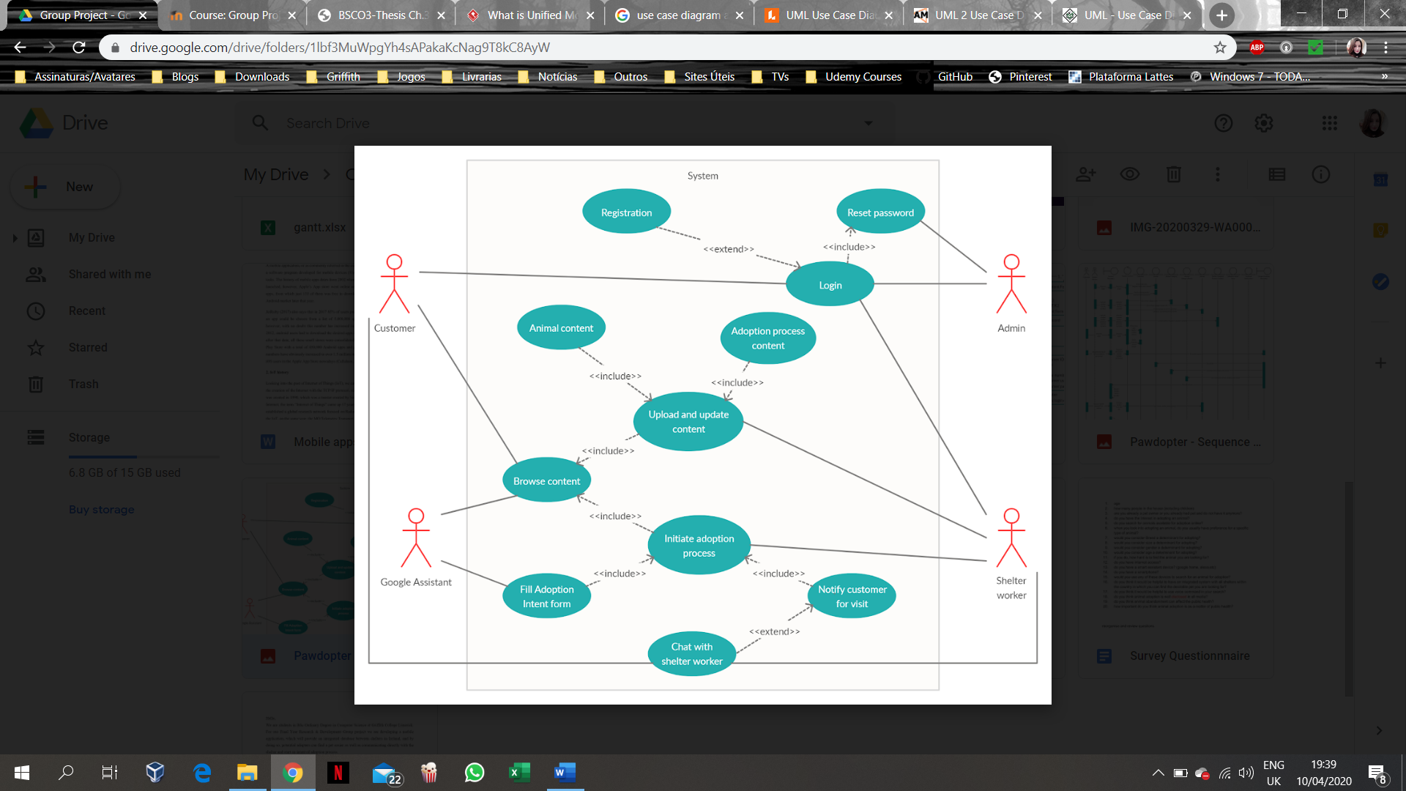

*Figure 3.8: Visual Representation of an Actor on a Use Case Diagram.*

*Use Cases* in a Use Case Diagram represent the functional requirements of the system. The name of a Use Case should be selected in a way that it identifies the functionality to be performed (Tutorials Point, 2020). On Use Case Diagrams, a Use Case is represented by a horizontal ellipse that is going to be connected to an actor and/or another Use Case through a relationship (Agile Modeling, 2020).

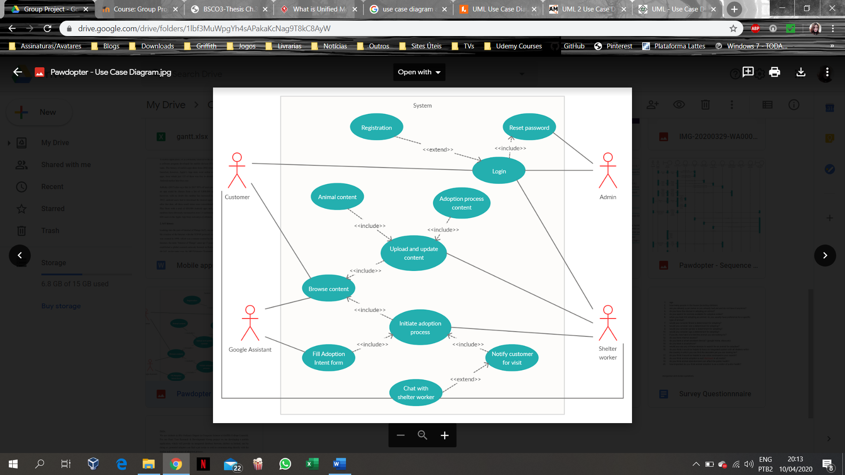

*Figure 3.9: Visual Representation of a Use Case in an UCD.*

In a Use Case diagram, a relationship can be presented as existing either between a Use Case and an Actor, or between Use Cases. The relationship between actors and Use Cases is called *association*. It is presented by a straight solid line, connecting an Actor to a Use Case; each actor can be associated with many Use Cases (but it must be associated with at least one), and each Use Case can be associated with many different actors.

The relationship between two Use Cases can be either an <<extend>> or an <<include>> relationship. The <<extend>> relationship takes place when a functionality of the system is extended, adding to the existent one. It is an optional relationship, and the functionality of the *extended* Use Case will be occasionally triggered, depending on a condition. The <<include>> relationship takes place when a common functionality must be reused, usually between multiple Use Cases. It is a relationship that shows that the behaviour of the *included* Use Case (the one, towards the arrow’s head points to) is considered as part of the *including* one (the one, from where the arrow originates). The *included* Use Case presents a mandatory behaviour and can exist on its own, whereas the functionality of the *including* Use Case is incomplete without the functionality of the *included* one (Silva, 2019).



*Figure 3.10: Visual Representation of Relationships between Use Cases and between Use Case and an Actor.*

The Use Case Diagram for the current Project is presented in *Appendix A5* as the High-End alternative solution, designed for the project. It presents 4 different actors outside of the system, which are the Customer, the Shelter Worker, the Admin, and the Google Assistant. There are few use cases that are common to more than one actor, which are *Login*, *Browse* and *Chat with Shelter worker*. *Registration* and *Chat with Shelter worker* are Use Cases that extend functionality of another Use Case (the *Registration* extends the *Login* and it will only be triggered when a new user registers to join the system, while the *Chat with Shelter worker* extends the *Notify Customer for Visit)*. The analysis of the possible alternatives will be discussed further in this chapter.

The *Login* functionality will allow both, the Customer and the Shelter Worker, to enter the system, and be involved in different functionalities, depending on the type of user they are:

If it is a Customer, they may create/update personal *Profile*, and *Browse Content* to start searching for their desired pet, using criteria as filters, which can be done by themselves or by asking the Google Assistant to do so, since *Browse Content* is an Use Case in which both actors are involved. From the results obtained, the user can check the pets’ information and if they are interested in a specific pet, they can *Initiate Adoption process*, by *Filling Adoption Intent form* just asking Google Assistant to activate that Use Case, where they will be able to fill up an Intent Form to be sent to the Shelter.

In case of a Shelter Worker, after successful *Login* functionality, they will be able to *Upload/update Animal content*, *Upload/update Adoption process content*, as well as *Browse Received Intent forms for Adoption* from Customers. In case of the latter functionality, they will also be able to *Notify the Customer for Visit of chosen pet*.

Both, the Shelter Worker and the Customer, can in some cases, start a *Chat* since both are involved in the *Chat* Use Case. If they have forgotten their password, or need to update the password, a *Request to* *Reset password* can be sent, in which functionality the Admin is involved.

**3.5.2 Sequence Diagram**

Sequence Diagrams illustrate the interactions between objects within the system, through the messages sent over period of time between them (Smart Draw, 2020). They describe how and in what order the objects’ interaction takes place. The basic components of a Sequence diagram are the actors, the objects with their lifelines, and the messages (Jain, 2019).

The actors in a Sequence diagram are represented with a stick figure notation, same as in the Use Case diagram. In the Sequence diagram, the actor represents the person, another system or system component that plays a role in the studied system, and that will interact with the system’s objects. A Sequence diagram can have one or more actors (Jain, 2019).

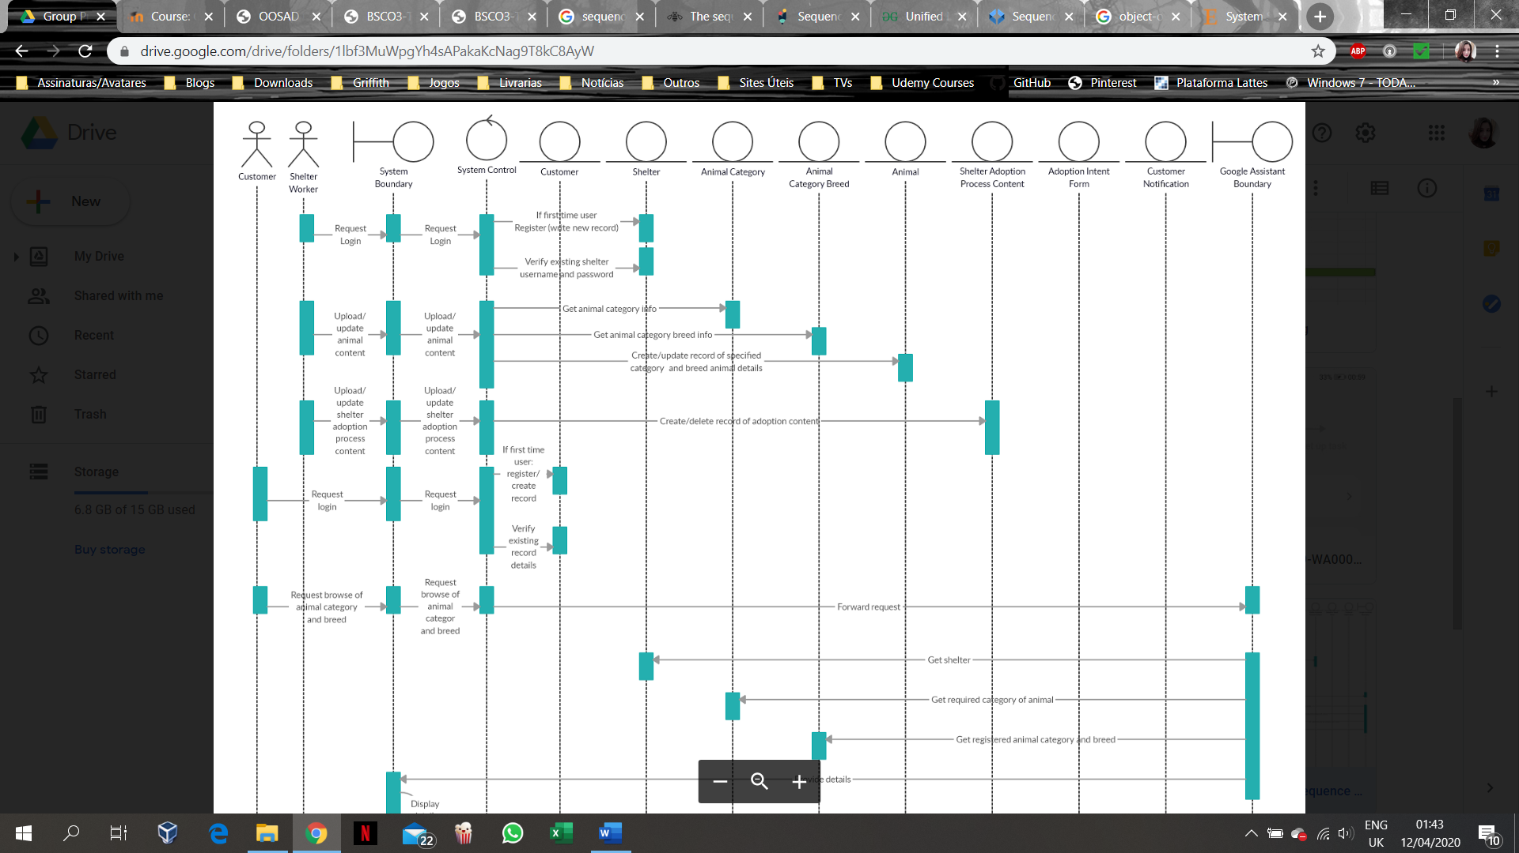

*Figure 3.11: Visual Representation of an Actor in a Sequence Diagram.*

The system objects are presented on the diagram with their vertical lifelines. Thin boxes on the lifelines, called Focus on control, represent the time the interactions take place on the objects’ lifelines in a sequence that they happen. The lifeline of an actor demonstrates when an action with the system is initiated by the actor (Athuraliya, 2017). All object classes in the system (the Boundary class, the Control class, and Persistent Entity classes) are presented with their lifelines.



*Figure 3.12: Visual Representation of the Objects Lifelines in a Sequence Diagram.*

The Boundary class is responsible for receiving the Actor’s messages and displaying any results of the internal processing to the respective Actor. If the message is not the Boundary’s responsibility, the Boundary class is forwarding the message to the System Control.



*Figure 3.13: Visual Representation of the System Boundary in a Sequence Diagram.*

The System Control class is responsible for managing the system. It determines which Persistent Entity class is the recipient of a message, and forward the message to the class responsible for processing it. It is also responsible for returning any responses that it got from the entity classes to the boundary class, so the response can be displayed to the actor.



*Figure 3.14: Visual Representation of the System Control in a Sequence Diagram.*

The Entity classes represent the Persistent objects within the system, which at Design and Development stage will become Database Tables of the system and will exist throughout the system’s life. They are the entities that encapsulate specific attributes and methods. The Persistent Entity classes are going to receive Actor’s requests that were forwarded from the System Control class, process those messages and return a result to be displayed on the System Boundary class.



*Figure 3.15: Visual Representation of an Entity Class in a Sequence Diagram.*

The messages in a Sequence diagram are the requests that are going to travel through the system and be processed at some stage. They are placed onto the lifelines and rewritten every time they are forwarded to a different class. When a message is not redirected to another class, but it is forwarded to the same one instead, it is called a self-message. The direction in which a message travels is represented by an arrow pointing to the class’ lifeline that is going to receive the message.



*Figure 3.16: Visual Representation of Messages being sent and forwarded in a Sequence Diagram.*

The Sequence diagram for the current Project is described as follows:

***Actors:***

* Customer
  + Messages:
    - Request Login;
    - Request Browse Animal category and breed;
    - Choose Shelter Animal from the list;
    - Choose to Fill Adoption Intent Form.
* Shelter Worker:
  + Messages:
    - Request Login;
    - Upload/update Animal content;
    - Upload/update Shelter Adoption Process content;
    - Create Notification for Customer to Visit chosen pet.

***Persistent Entities:***

* Customer – holds Customer’s information;
* Shelter – holds Shelter’s information;
* Animal category – holds Animal categories information;
* Animal Breed – holds Animal Breed information;
* Animal – holds specific Animal’s information, e.g. name, age, size, personality;
* Shelter Adoption Process content – used to store information, regarding both Shelter and Customer, as well as to store the link that will lead the user to the actual documentation;
* Adoption Intent Form – used to store information regarding both customer and animal, as well as to store the adoption intent form text;
* Customer notification – Used to store information regarding both shelter and customer, as well as the actual notification information.

The current project presents two different boundaries. One is the System Boundary that is going to receive and redirect the Actor’s requests to the System Control, and the other is the Google Assistant’s Boundary. The Google Assistant boundary is going to receive some of the forwarded requests from the System Control, retrieve the necessary information from the entity classes and then forward the results to the System boundary, so it can be displayed to the actors.

The full representation of the Sequence diagram for the current project is presented in *Appendix A6*.

**3.5.3 Object Class Diagram**

An Object Class Diagram presents the objects within the system and the nature of their relationships. They allow the developer to visualise the structure of the system at a given time and to understand the functional requirements of the system (Jain, 2020).

The visual representation of an object in an Object Class diagram is a rectangle with three different sections. The top one is reserved for the name of the object class, the middle one is used to display all the object class’ attributes, while the bottom one is used to store the methods that operate on the attribute values of this object class. The attributes in the middle section are preceded with a minus sign (-), which indicates a private information that can only be accessed by the class itself, while the methods at the bottom section are preceded by a plus sign (+) (Lucid Chart, 2020b).

The lines connecting object classes on the diagram represent the relationships between them. The number placed close to a class indicates the cardinality of the relationship with the class on the other end of the relationship. The most common cardinalities of relationships are: zero to one, one to one, zero to many, one to many and many to many (Jain, 2020).

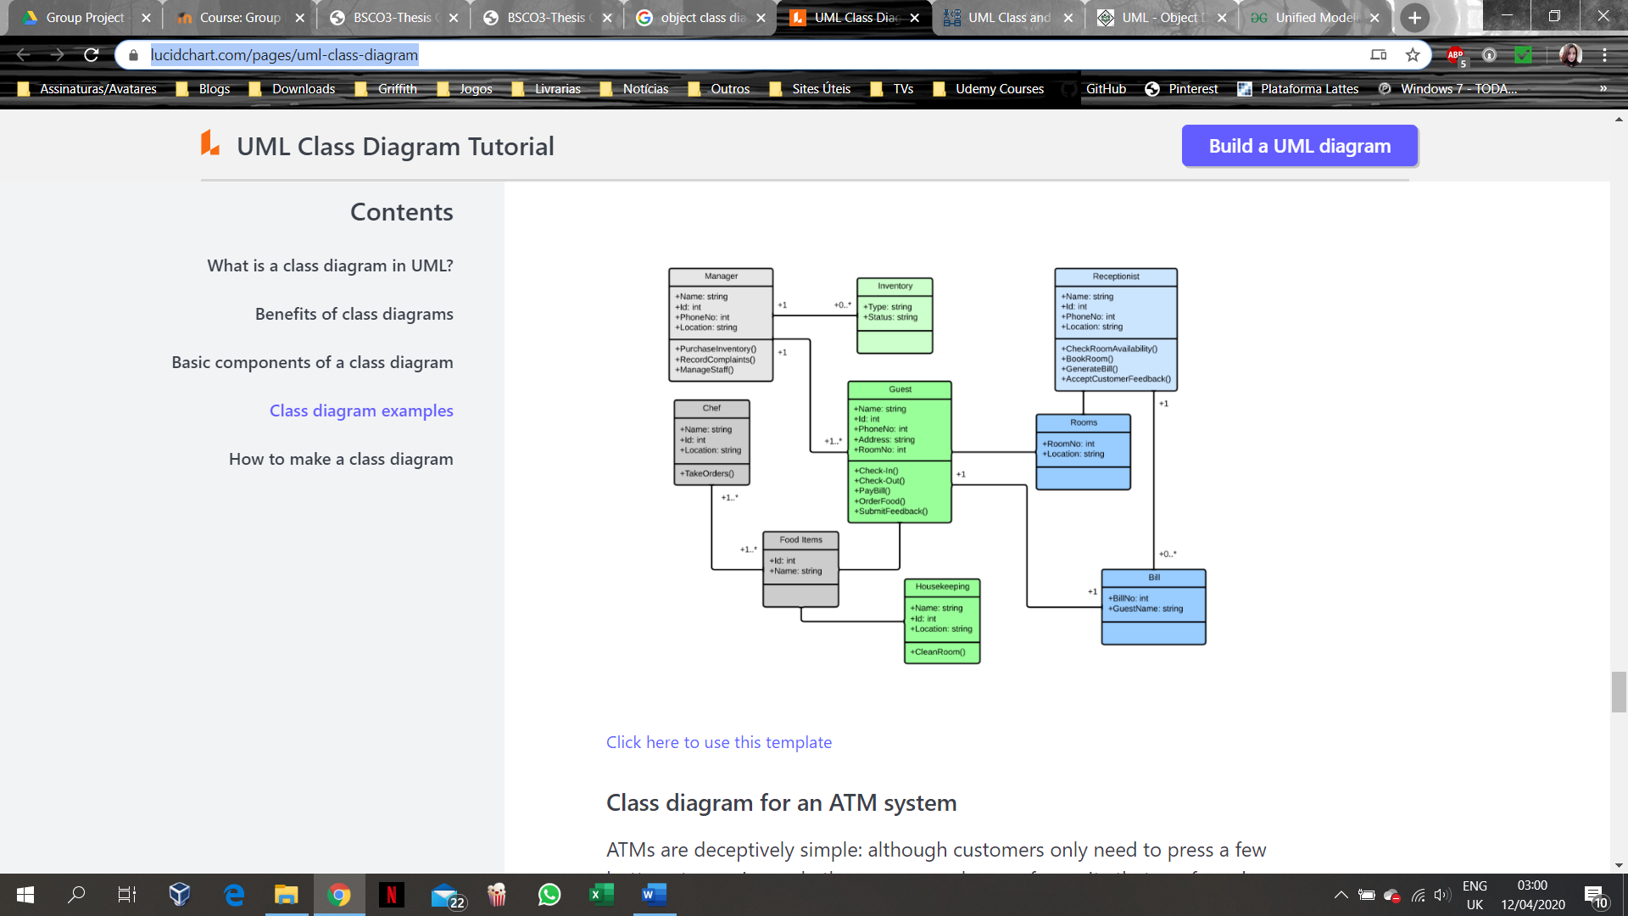

*Figure 3.17: Example of Visual Representation of an Object Class Diagram (Lucid Chart, 2020b).*

The Object Class diagram for the current Project is described as follows:

***Animal***

* Attributes:
* Animal ID (P.K.);
* Category ID (F.K.);
* Breed ID (F.K.);
* Shelter ID (F.K.);
* Name;
* Gender;
* Size;
* Age;
* Chip number;
* Picture;
* Personality.
* Methods:

+ Create record;

+ Update record;

+ Get chosen animal details.

***Animal category***

* Attributes:
* Category ID (P.K.);
* Category name.
* Methods:

+ Get animal category information.

***Animal category breed***

* Attributes:
* Breed ID (P.K.);
* Category ID (F.K.);
* Breed name.
* Methods:

+ Get animal category breed information.

***Shelter***

* Attributes:
* Shelter ID (P.K.)
* Shelter name;
* Shelter address;
* Shelter phone number;
* Shelter username (e-mail);
* Shelter password.
* Methods:

+ Create New Record;

+ Verify login details;

+ Get shelter information.

***Shelter adoption process content***

* Attributes:
* Adoption document ID (P.K.);
* Shelter ID (F.K.);
* Document link.
* Methods:

+ Create new document record;

+ Delete existing record.

***Customer***

* Attributes:
* Customer ID (P.K.);
* Name;
* Age;
* Phone number;

- Customer username (e-mail);

- Customer password.

* Methods:

+ Create New Record;

+ Verify login details.

***Adoption Intent Form***

* Attributes:
* Form ID (P.K.);
* Animal ID (F.K.);
* Customer ID (F.K.);
* Adoption Intent Form text.
* Methods:

+ Create new record.

***Notification***

* Attributes:
* Notification ID (P.K.);
* Shelter ID (F.K.);
* Customer ID (F.K.);
* Notification information.
* Methods:

+ Create new record.

The full representation of the Object Class diagram for the current Project is presented in the *Appendix A7*.

**3.6 Alternative Design Solutions**

Three different Design solutions were analysed for the development of the current project, taking into consideration its time constrained nature, where each of the alternatives presents different level of functionalities that could be implemented in each one of them.

**3.6.1 Low-End Alternative**

The Low-End alternative presents the basic functionalities of the system, without which the application cannot exists. This alternative involves as actors the customer, the shelter worker and the admin, only. The basic functionalities are as follows:

* Login / Registration;
* Reset password;
* Upload/update content (animal content, adoption process content);
* Browse content.

**3.6.2 Mid-Range Alternative**

The Mid-Range alternative represents compromise between both, the Low-End and the High-End alternatives, and all actors are involved in this solution. Therefore, the Mid-Range alternative includes **all** functionalities of the Low-End solution, **plus**:

* Initiate Adoption process;
* Fill Adoption Intent Form (within Initiate Adoption process);
* Notify Customer for Visit.

**3.6.3 High-End Alternative**

The High-End alternative not only includes all functional requirements for the system, but also provides extra features that the users may wish for. This alternative also involves all actors in the system. Therefore, the High-End alternative includes **all** the functionalities of the Low-End and Mid-Range solutions, **plus**:

* Chat with Shelter Worker

**3.7 Alternative to be implemented**

As discussed at the beginning of this chapter, the Android Operating System surpasses the iOS market share in Ireland, and even though it is just a slight difference of 11%, it is the most widely used mobile operating system in the world. Based on that and the fact that the members of this project have a previous experience with Java language and that the Android Operating System can be developed using Java, the current project will be based on an application using Android Operating System. Another reason for choosing Android Operating System for development of the application is because of the integration of the application with the smart home device since the *Google Nest Hub* is compatible with *Android* applications.

As already mentioned, due to time constraints for the project’s development and the skills level of the developers, the Dynamic Software Development Methodology was the one chosen to be implemented in this project. The Alternative Design Solution to be used in the Development stage will be the Mid-Range solution, due to limited timeframe of the project.

**3.8 Chapter Summary**

This chapter has focused on research of different mobile operating systems, smart home devices, Object-Oriented programming characteristics, Software Development Methodologies, types of Unified Modelling Language diagrams and Alternative Design solutions.

From the research, discussed in this chapter, it was possible to establish that the Android Operating System and the iOS are the mobile operating systems that are most used worldwide, where the *Android* leads the market in Ireland, closely followed by the iOS. Also, it was possible to determine that in order to create a robust application, it is necessary to include the Object-Oriented Programming concepts and specify the most appropriate methodology to be used, while developing it. The used Unified Modelling Language diagrams for the Project’s Conceptual model gave the developers a better view of the requirements for the project, as well as made it possible to design different scenarios that can be accomplished according to the project’s constraints, varying from the simplest form of application that is going to satisfy the project’s minimum requirements to an alternative that presents a high-level of functionalities.

# The next chapter will describe the developing process of the current project, from the design to the actual coding of the project’s application. It will show in details step-by-step the application’s building process.

**Chapter 4 – Design and Development Phase**

The Design stage of a project is a phase in which the design of the Graphical User Interface (GUI) for a smooth User Experience (UX) of the application is conceived, as well as the design of an appropriate Data Storage for the application. During this phase, using a storyboarding process, Screen wireframes are created as Blueprints to allow developers to build the application.

The wireframes are an UX-based view of how the application is going to work and show the logic and flow of the application operations. It is also taken into consideration the attractiveness of the app, meaning it is important to mix the design in terms as aesthetics to the functionality of the application. In a real word situation, this phase is made according with the client, so all aspects are in accordance before they move on to the next phase which is the development.

After all the wireframes have been provided, the app can actually be built, this is called the Development phase of a project. With the Rapid Application Development methodology, as being used in this project, the coding process is done with prototype versions being created, which breaks the development up into iteration versions of the prototype, and each iteration is focused on a different bit of functionality. Once all these versions are complete, the project goes to the UAT (User Acceptance Testing) version, which the client can test and sign off. By the end of this phase, the client should have the product developed with all the specification integrated and the whole source code for the application.

The current project is also based on Voice User Interface (VUI), which involves the communication with a *Smart Home* device (IoT device), in this case - *Google Home*. The user is able to perform a search for desired pet through a voice control of Google *Assistant* from the *Google Home* device, and by doing so, the result of the search will appear on the app without the need of clicking through its buttons. The platform used to develop the VUI is the *Dialog Flow*, which will be described at the end of this chapter.

The proposed mobile app starts with a *Splash* screen, emphasizing the *logo* of the project. The *splash* screen, or *start* screen, or *start up* screen, is defined by Techopedia (2016) as a specific screen to be displayed while the application is still loading. Once it is loaded, the user will be directed to the main application screen (*Home* Screen).

**4.1 Screen 1: *Home* Screen**

When the user opens-up the application, the first screen they see is the *Home* Screen, which has two clickable links: the first one is intended for a user that has already been registered within the *Pawdopter* application (the potential adopter has already created a user profile and recorded in the app’s database). The second button, is for users who are not yet registered within the application, meaning that they need to Register first, before been properly Logged in (Signed in) the application to use its functionalities. The Wireframe of this screen is presented on Figure 4.1a.

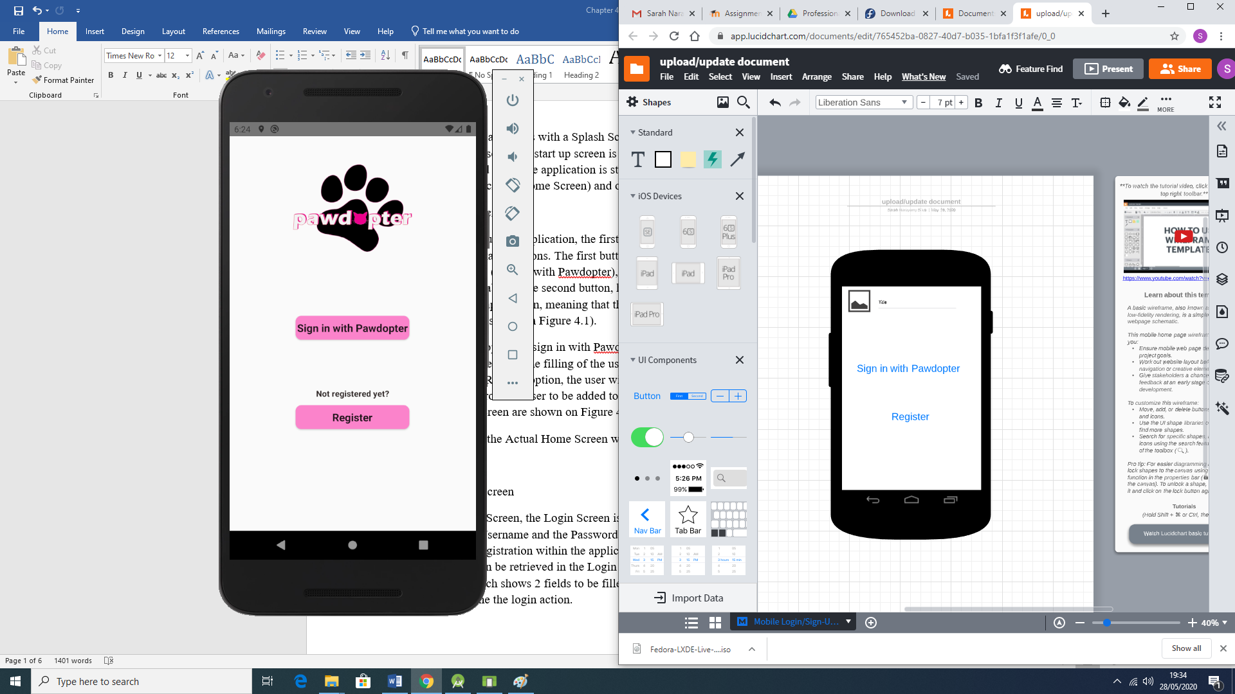

Figure 4.1a: Wireframe for Application Screen 1: Home

Clicking on the option to *Sign in with Pawdopter*, the potential adopter is redirected to a *Login* Screen, which requires typing of username and password, as provided at registration point. Clicking on the *Register* option, the user will be redirected to a *Registration* Screen, which will collect necessary data from the user to create a *user record* in the database. Figure 4.1b shows snippets of code (Java code to the left, and XML code to the right) for the *Home* Screen, while the actual application *Home* Screen is displayed on Figure 4.1c.

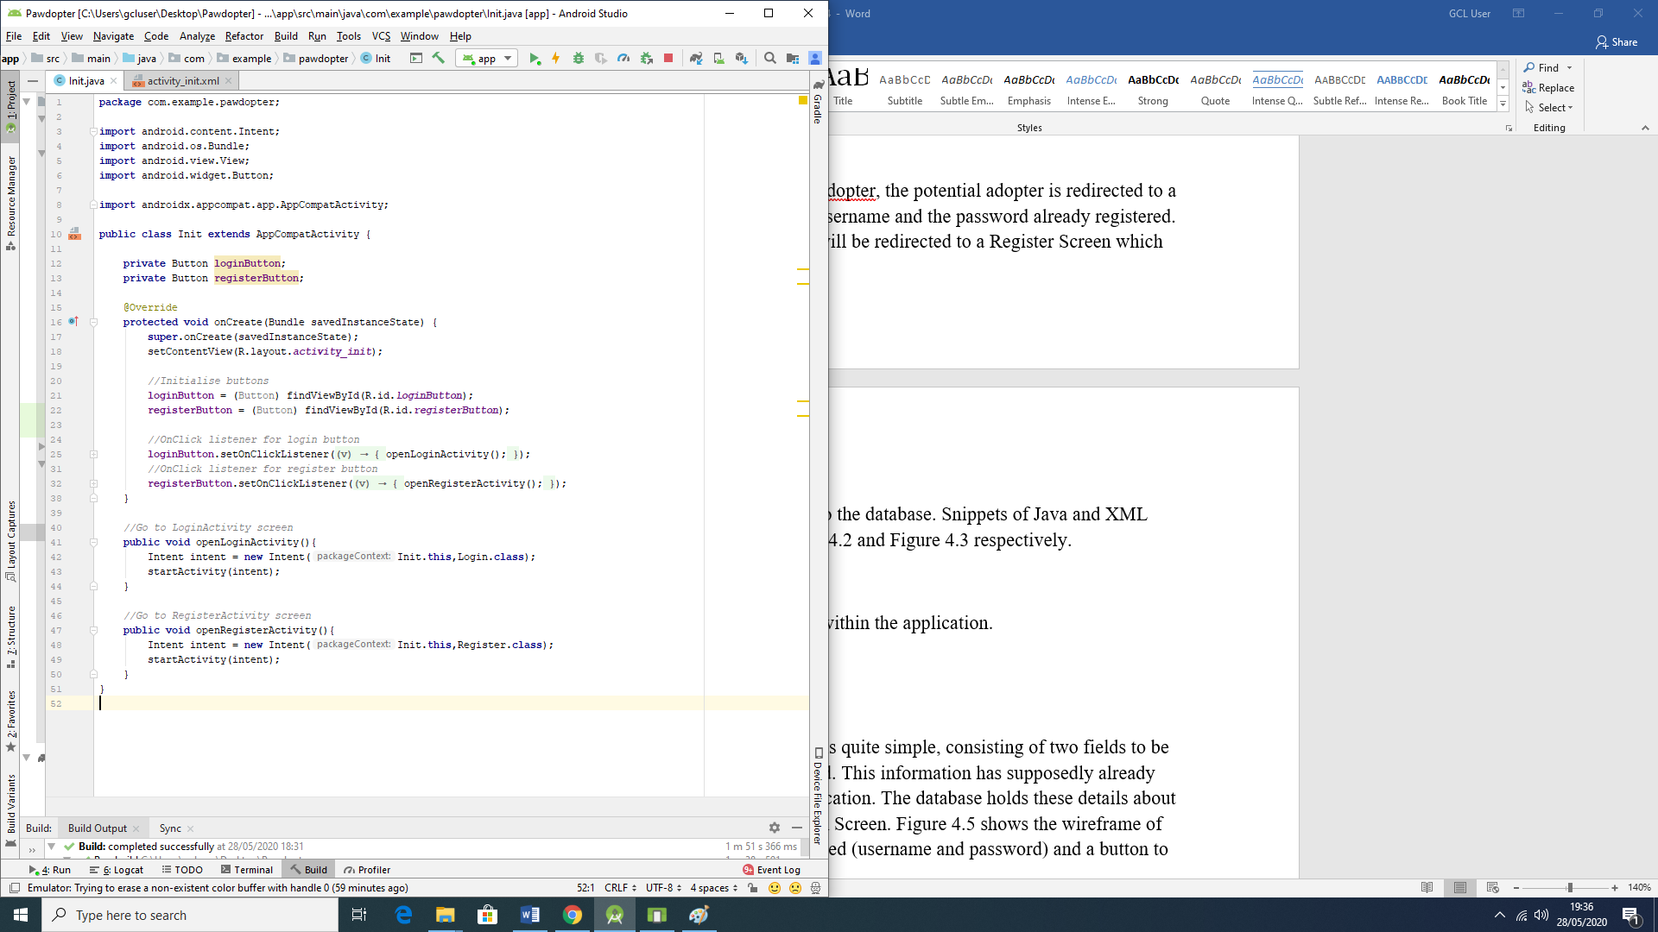 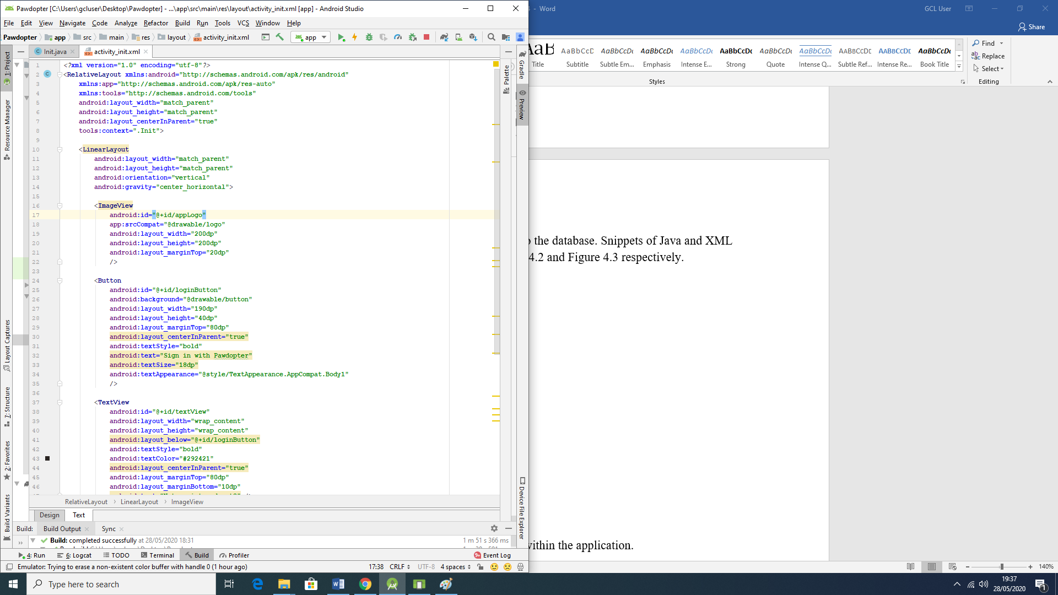

Figure 4.1b: Snippets of Code for Application Screen 1: Home Screen

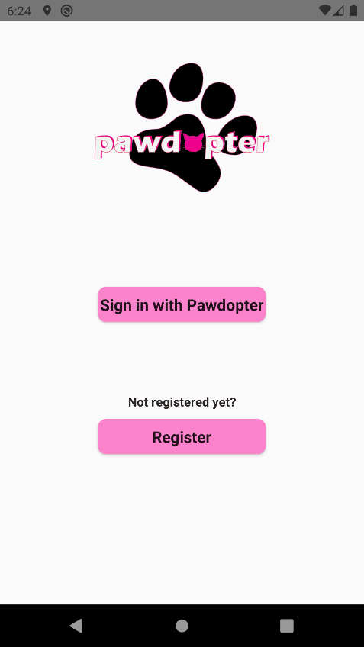

Figure 4.1c: Snapshot of the Actual Application Screen 1: Home Screen

The wireframe and the actual screen differ on where the *title* and *logo* of the app appears. In the wireframe the *logo* is set to be at the top left corner of the screen and the *title* right beside it, as a pattern for all screens. However, for aesthetics reasons, it was decided to place the *logo*, which already contains the name/title of the app, aligned on top centre of the screen.

**4.2 Screen 2: *Login* Screen**

As with the *Home* Screen, the *Login* Screen is quite simple, consisting of two fields to be filled: *Username* and *Password*. This information is to be provided at *Registration* point and placed as user record in the application database. The database holds these details about each user, and they can be retrieved and compared with the captured entries for *Username* and *Password* at *Login* point. Figure 4.2a shows the wireframe of the *Login* Screen with the 2 fields to be entered (*username* and *password*) and a button *Login* to be clicked to begin the *Login* process.

Figure 4.2b shows snippets of code (Java code to the left, and XML code to the right) for the *Login* screen, while Figure 4.2c presents the actual application Screen 2: *Login* Screen.

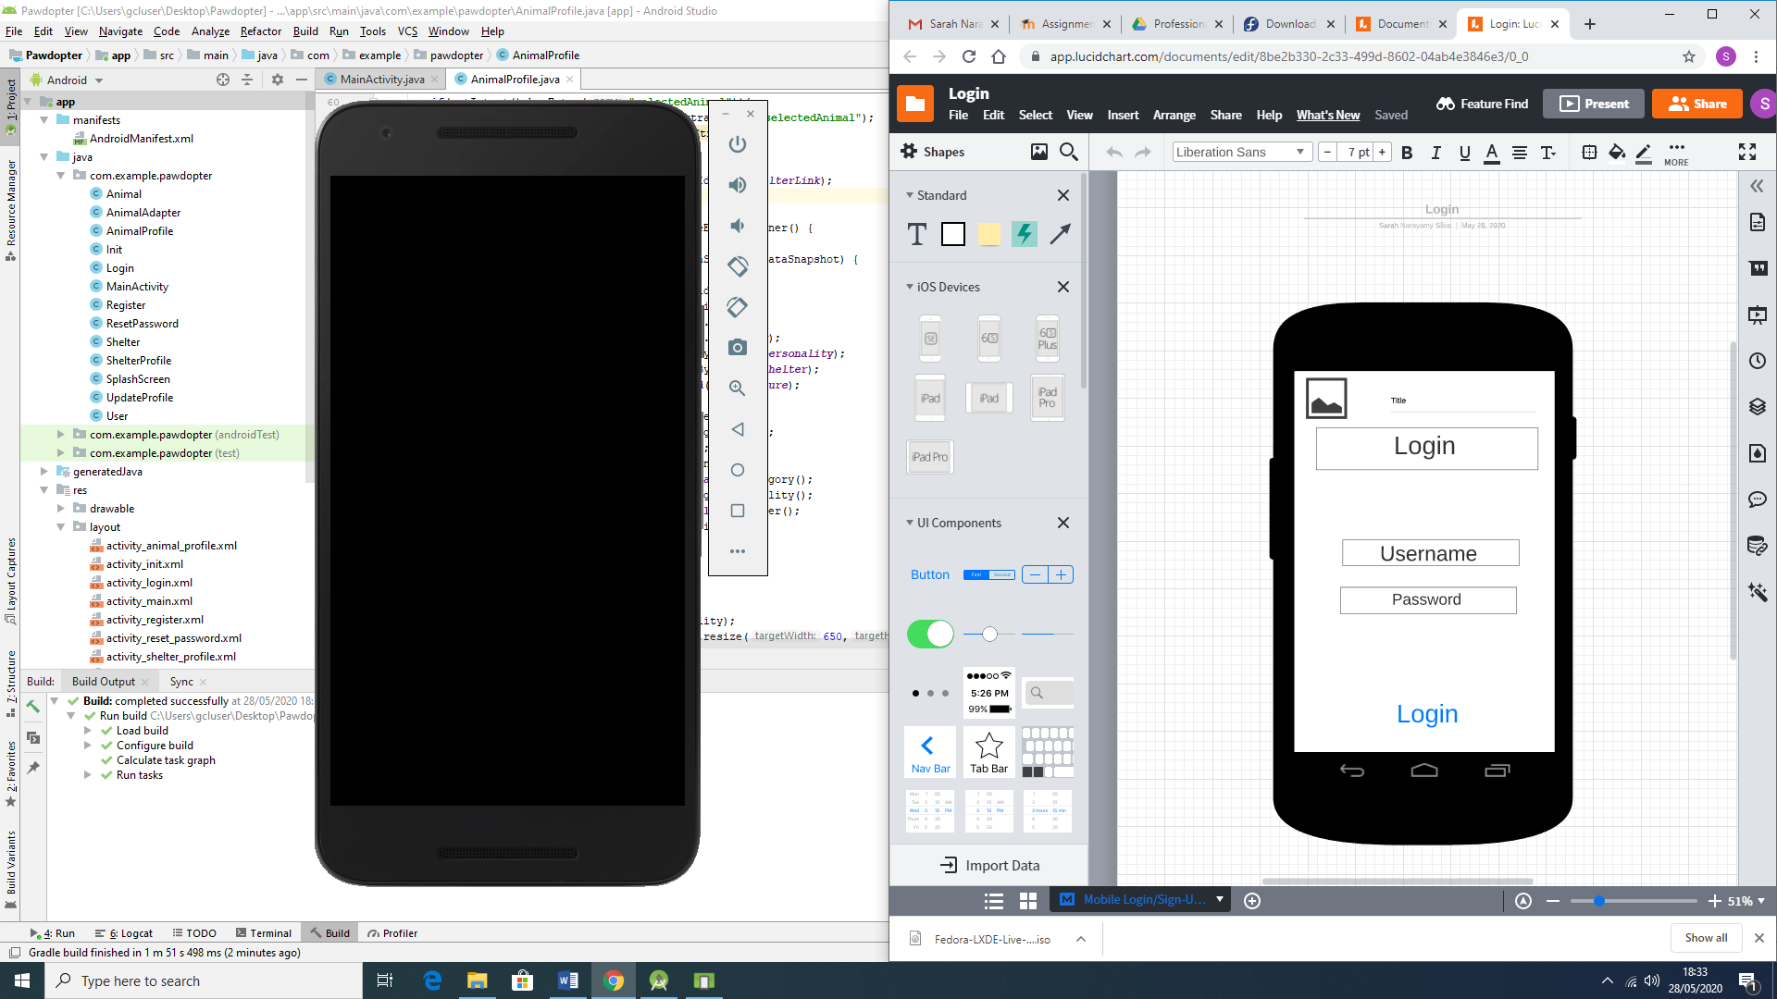

Figure 4.2a: Wireframe for Application Screen 2: Login Screen

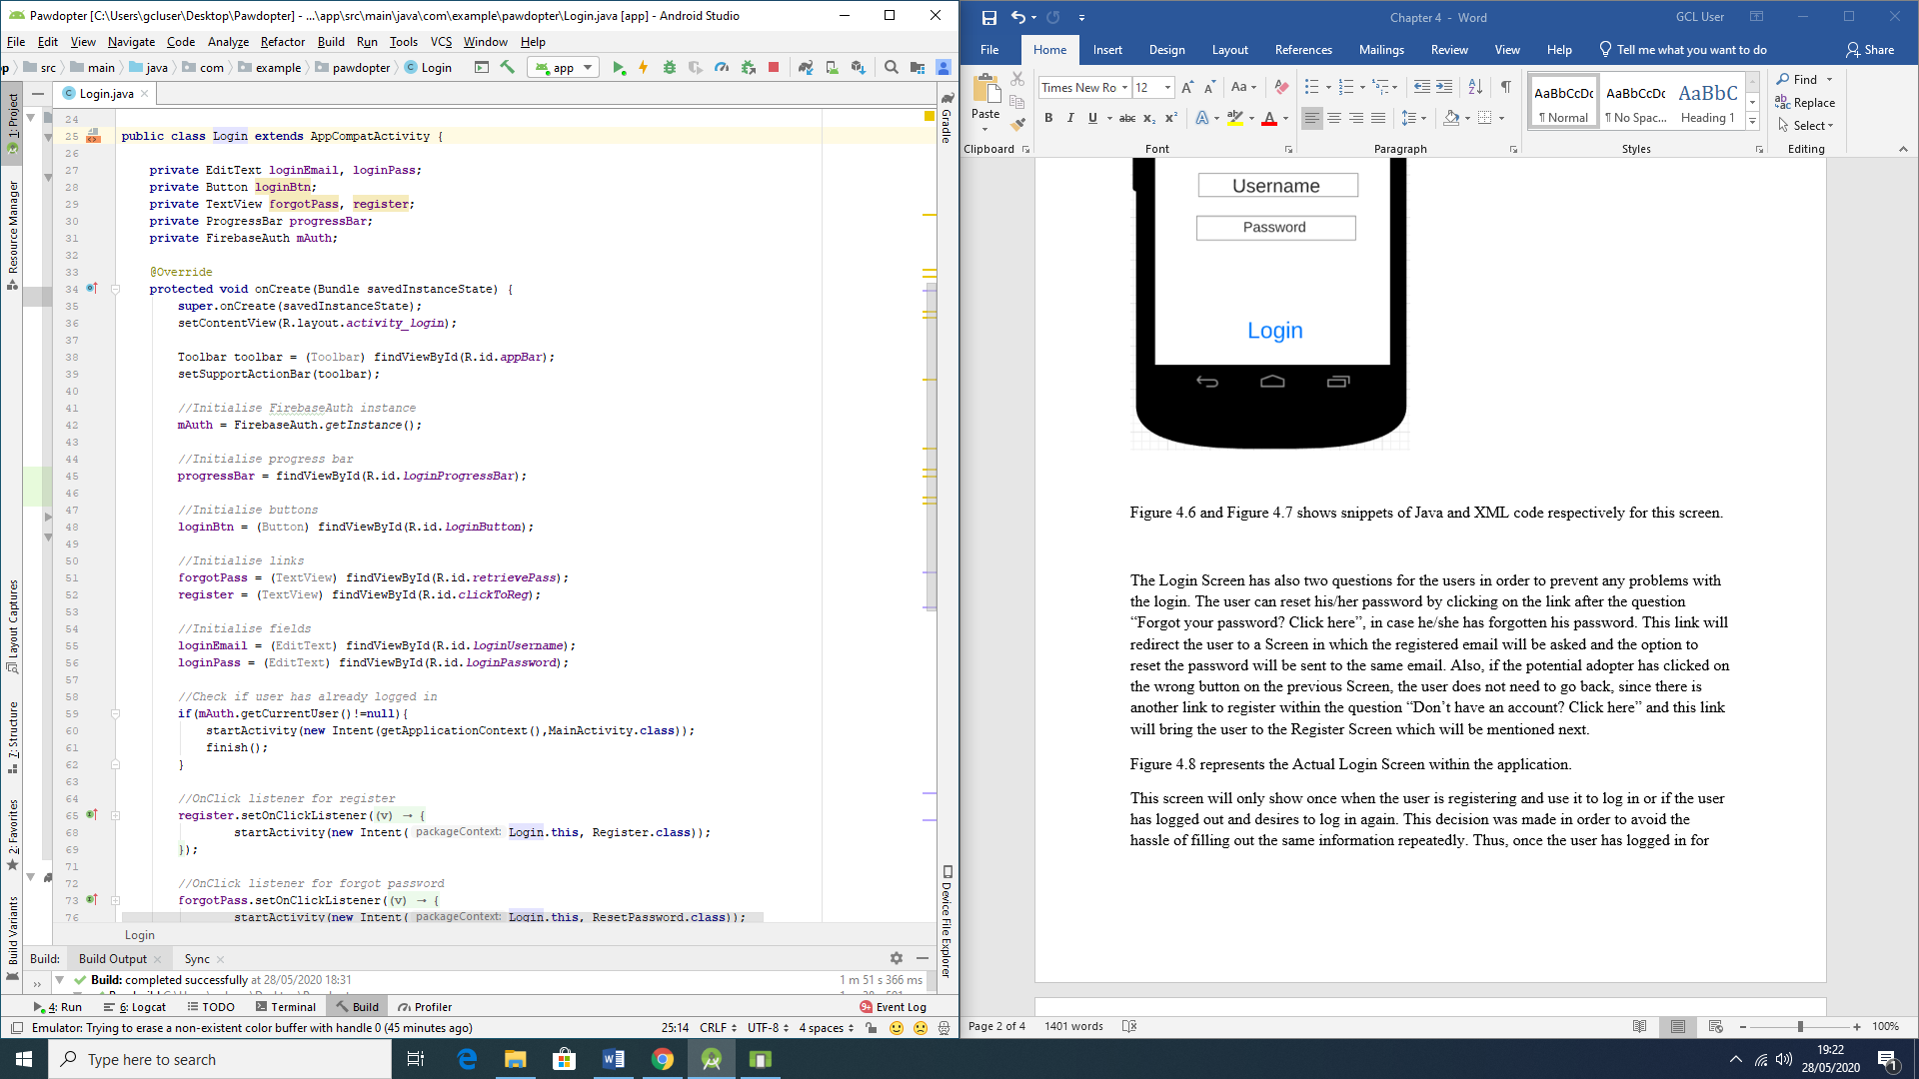 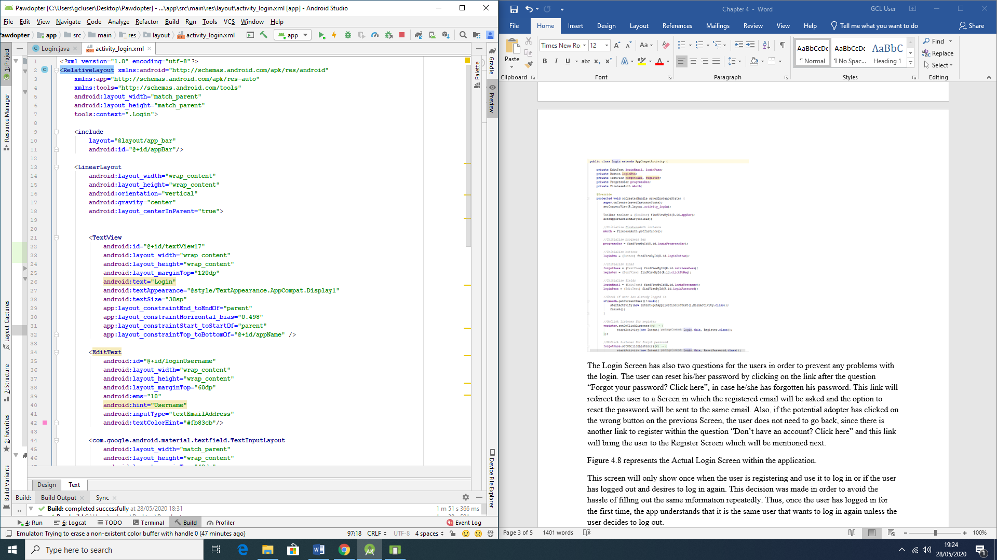

Figure 4.2b: Snippets of Code for Application Screen 2: Login Screen

There are also two links on the *Login* Screen: “*Forgot your password? Click here*” link (in case the user has forgotten their password, they can *reset* it by clicking on that link, which will redirect the user to a screen where they need to type their registered email address and a *reset password* link will be sent to that same email), and “*Don’t have an account? Click here*” link (if the potential adopter has clicked on a wrong link at the previous screen, this link will bring the user to the *Registration* Screen to properly register with the application).

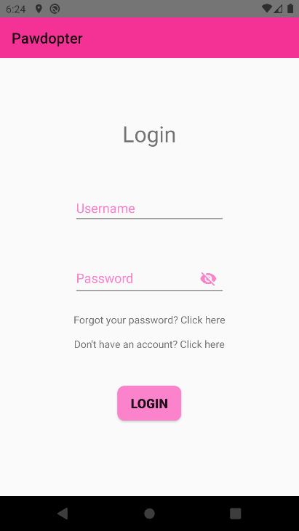

Figure 4.2c: Snapshot of the Actual Application Screen 2: Login Screen

As with the *Home* Screen, the wireframe of the *Login* Screen and the actual application screen differ where the *title* and *logo* of the app should be, and as explained for the previous screen, due to aesthetics reasons, it was decided to display only the title of app on the top left corner. There are also the added links in case of *forgotten password* and for *registration* (*creating an account*), without having to go back to the previous screen to do so.

**4.3 Screen 3: *Registration* Screen**

The *Registration* Screen is very important, since it will collect the data needed from the potential adopter, which data will be recorded in the application database. The information to be captured on this screen consists of *Name* of the user (which is needed in order to deal with the user in a direct and respectful way, by using their name, for example, “Welcome Sarah”; *Phone Number*, which is important in order to contact the user, when necessary; *E-mail address*, which could also be used to contact the user but most importantly - to determine the *Username*, since the email address is unique for each person; *Password* chosen by the user (which should contain mixture of lower- and upper-case characters, number(s), and special character(s) and be not less than 8 characters long); *re-entered (confirmed) password*, to allow verification of entered and confirmed password.

The screen has a *Submit* button, which must be clicked, after all the fields are entered by the user. It is important to state that all the fields are *mandatory*, which means that the user will not be able *to register* if one or more fields are blank. There are also different criteria for the fields, in order to validate the information, such as mobile number (which should start with “08” in order to be validated as an Irish number, and should be 10 digit long). The e-mail address should contain the username, the @ symbol, and the domain.

Figure 4.3a illustrates the wireframe of the *Registration* Screen, consisting of the fields to be entered by the user and the *Submit* button. Figure 4.3b shows snippets of code for the screen (Java code to the left and XML code to the right), while Figure 4.3c presents snapshot of the actual application Screen 3: Registration Screen.

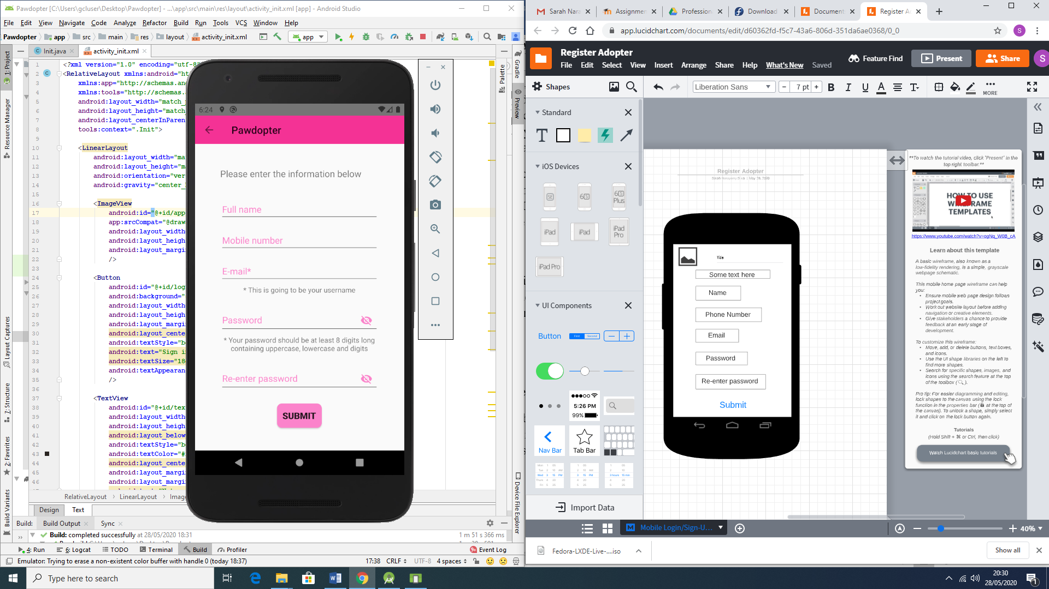

Figure 4.3a: Wireframe for Screen 3: Registration Screen

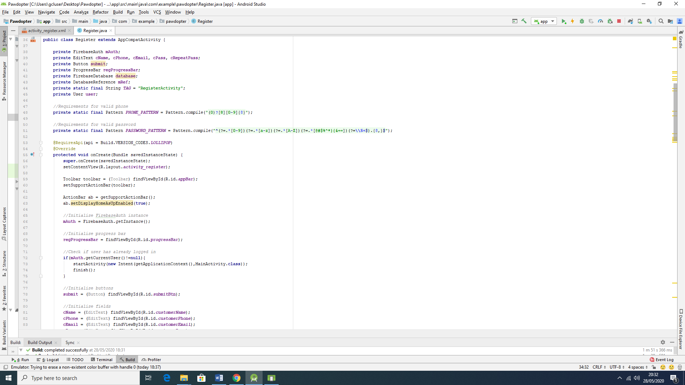 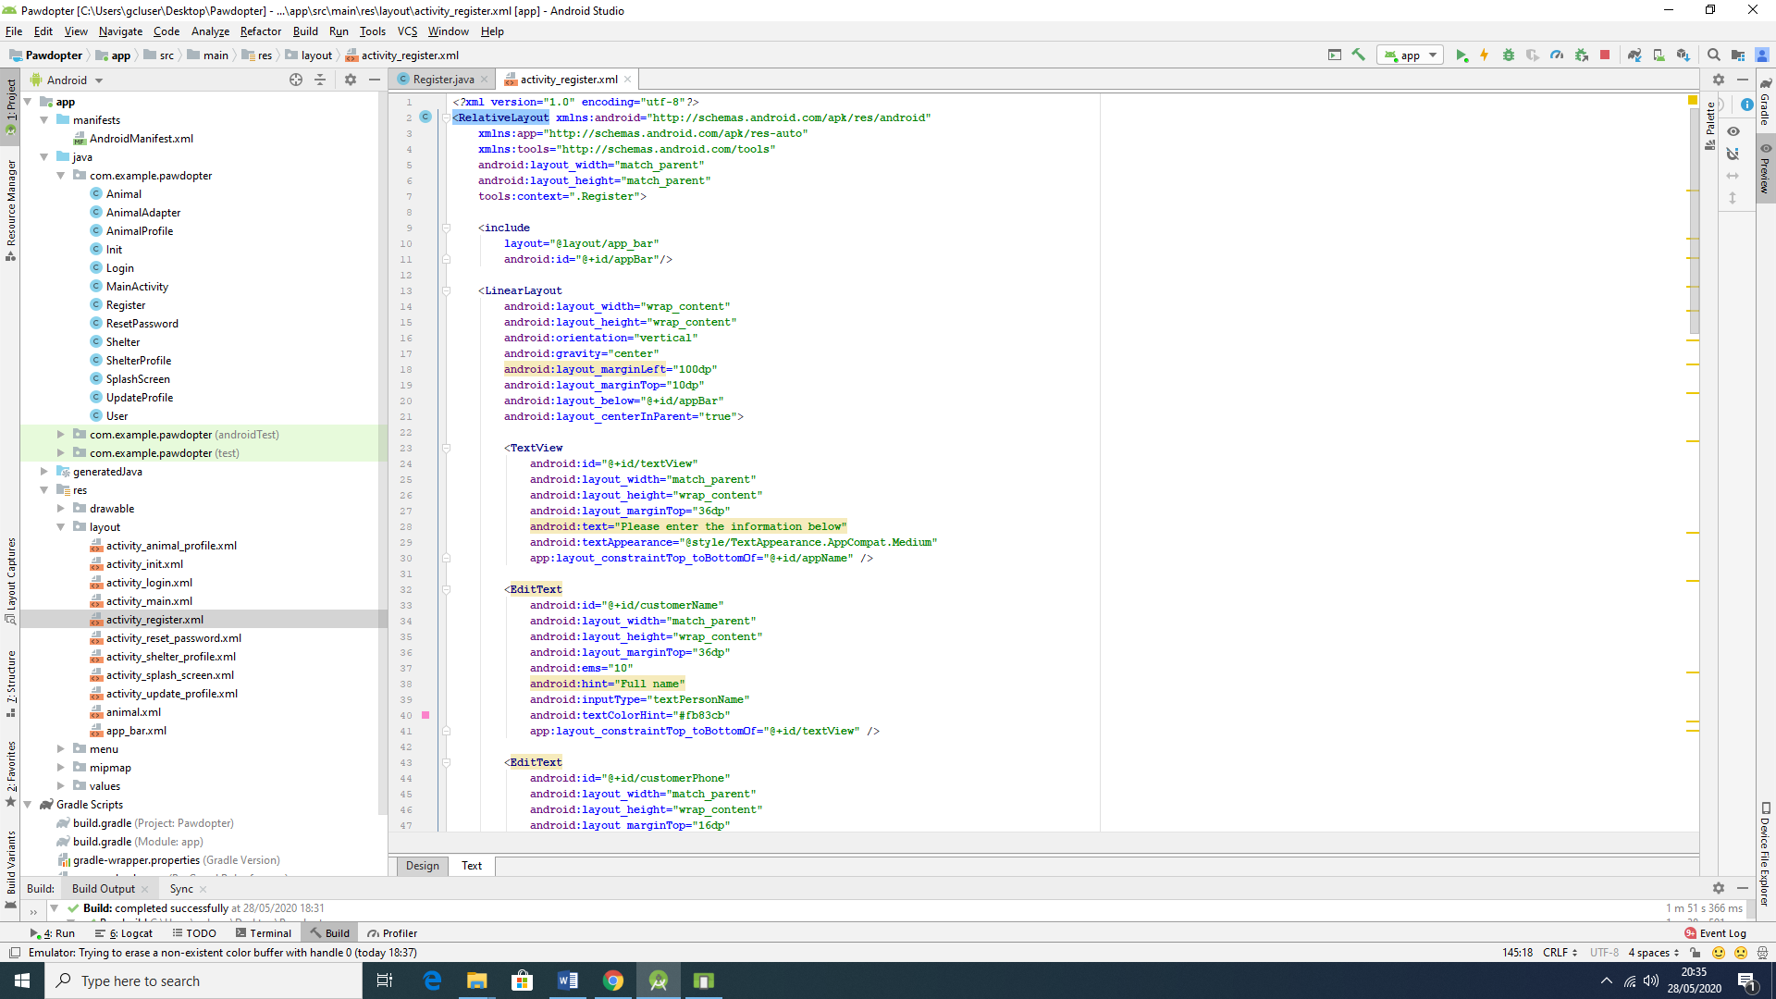

Figure 4.3b: Snippets of Code for Screen 3: Registration Screen

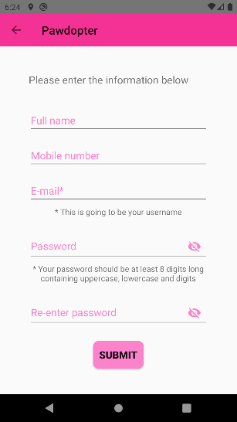

Figure 4.3c: Snapshot of the Actual Application Screen 3: Registration Screen

As with Screen 1 and 2 wireframes before, the wireframe and the actual application *Registration* screen differ for the same aspects mentioned before, related to the *logo* and *title* of the application. On this screen, the *logo* is replaced with an *arrow* pointing to the left (which implies that the user can go back to the previous screen), followed by the *title* of the app.

**4.4 Screen 4: Pets Browsing and Filtering Screen**

On this screen, the user can browse all available for adoption pets, as well as making use of the filters to search for a pet with specific characteristics. The available in the chosen sanctuary animals are each presented with their photograph, name, age, and short description of personality. Each animal entry is clickable, to reveal more detailed information about the chosen pet on another screen, designed specifically to show only that specific pet’s detailed information.

The animals can be filtered by *category* (choosing what type of animal is desired (dog, cat, etc.)), followed by *size* (small, medium or large animal), and lastly - by *breed,* (as per stored breeds of available animals in the app’s database). It is important to emphasize that these filters are nested and dependent on each other. Once the filtering is done by the user, the *Browse* screen will only show pets that correspond to the filter(s) characteristics, specified by the user.

Another important aspect of this screen is that it provides a menu for the user to *Update* their profile, or to *Logout*. This menu, once clicked, redirects the user to the respected different screens, accordingly.

Figure 4.4a illustrates the wireframe for the *Pet Browsing and Filtering* screen. Figure 4.4b presents snippets of code for the screen (Java code to the left, XML code to the right of the figure), while Figure 4.4c displays the actual application Screen 4: *Pet Browsing and Filtering* Screen.

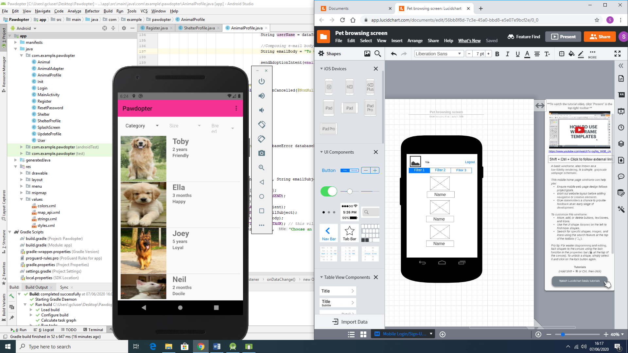

Figure 4.4a: Wireframe for Screen 4: Pet Browsing and Filtering Screen

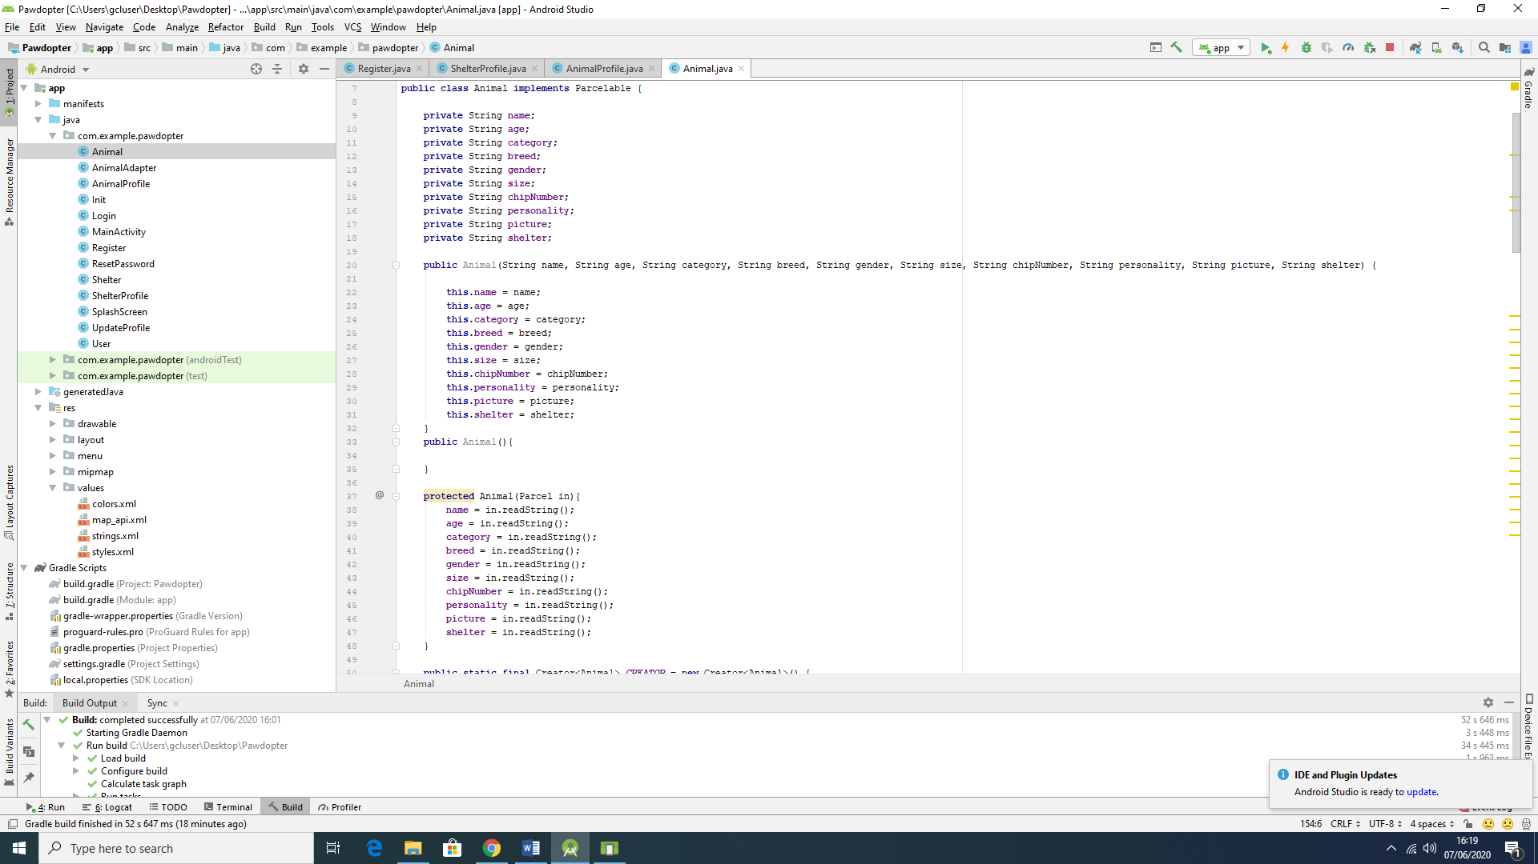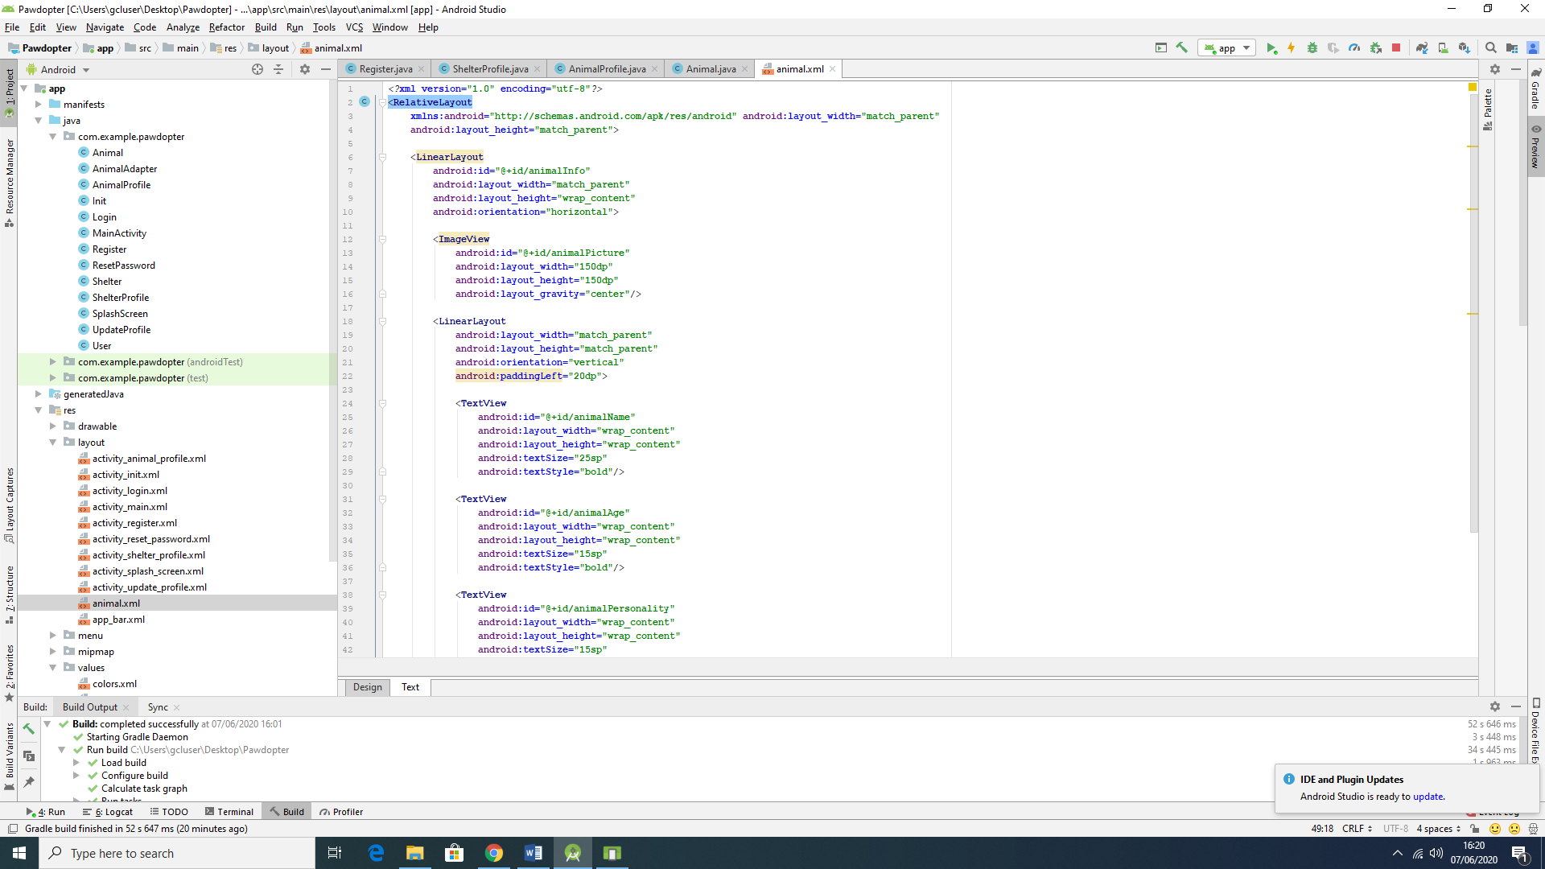

Figure 4.4b: Snippets of Code for Screen 4: Pet Browsing and Filtering Screen

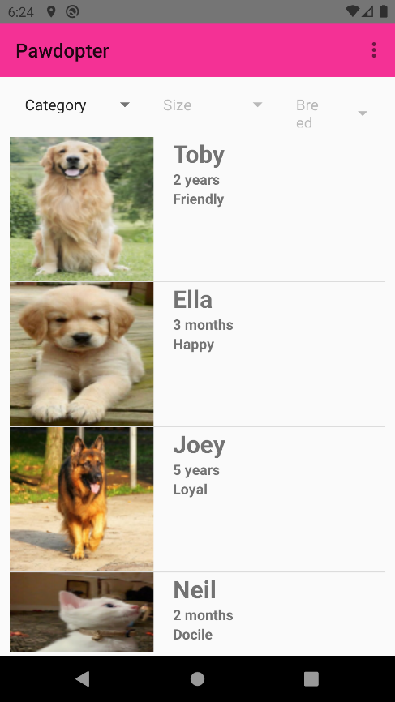

Figure 4.4c: Snapshot of the Actual Application Screen 4: Pet Browsing and Filtering Screen

The filtering process is presented with snippet of code on Figure 4.9d.

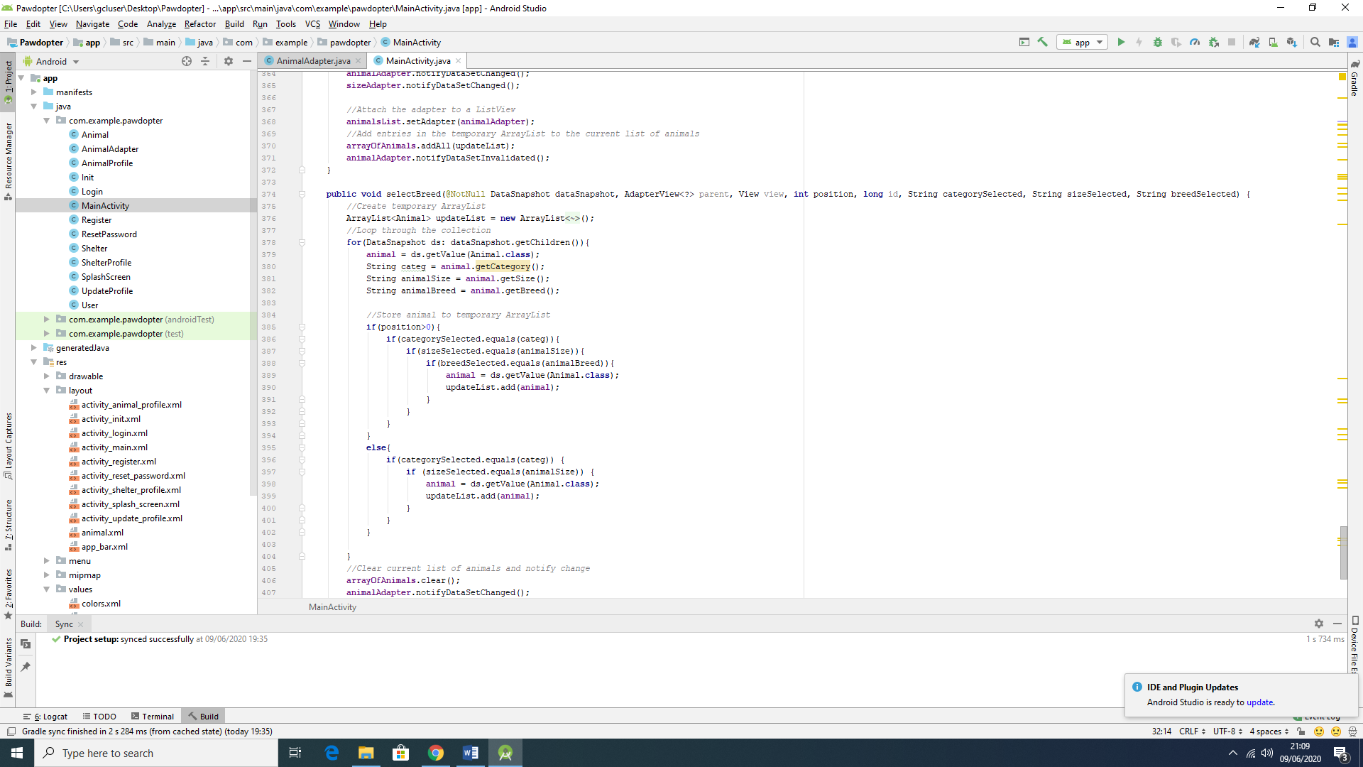

Figure 4.4d: Snippet of Code for the Filtering Process

The wireframe differs from the actual screen in many aspects. It starts by the exclusion of the *logo* on the top left corner and its replacement by presenting only the name of the application. This is followed by the menu mentioned, represented by the three bullet points in a vertical order. The Filters are kept in the same position as in the wireframe, meaning the top of the screen, right after the title of the app. However, the display of the animals is made more informative in the actual application screen, showing more information about each pet, and clear separation of the information for the different animals presented. In this case, the picture of the animal is positioned on the left side with three information sections, positioned on the right-hand side, for each animal: Name, Age, Personality.

**4.5 Screen 5: *Update User Profile* Screen**

This screen is similar with the *Registration* screen, except here the user can update its information in some of the entry fields. There are few entry fields, where information cannot be changed, such as *Name* and *E-mail*, since they are unique to each user. Thus, on this screen, the user can change their contact *mobile number* and the *password*, according to the specifications for each field, as previously discussed for the *Registration* screen. Once the *Save* button is clicked, all the information changed will be updated in the application’s *Firebase* real time database.

Figure 4.5a illustrates the wireframe for the *Update User Profile* Screen, Figure 4.5b shows snippets of code (Java code to the left, XML code to the right of the figure) for the screen, while Figure 4.5c displays snapshot of the actual application *Update User Profile* Screen. Figures 4.5d and 4.5e show *before* and *after* the information change has been reflected in database, respectively.

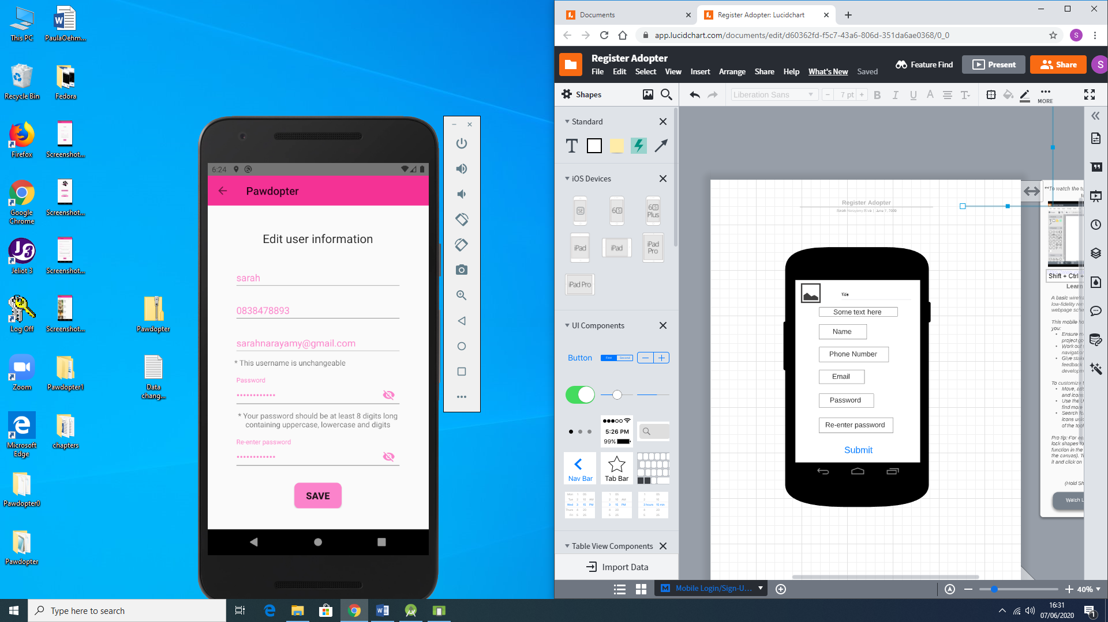

Figure 4.5a: Wireframe for Screen 5: Update User Profile Screen

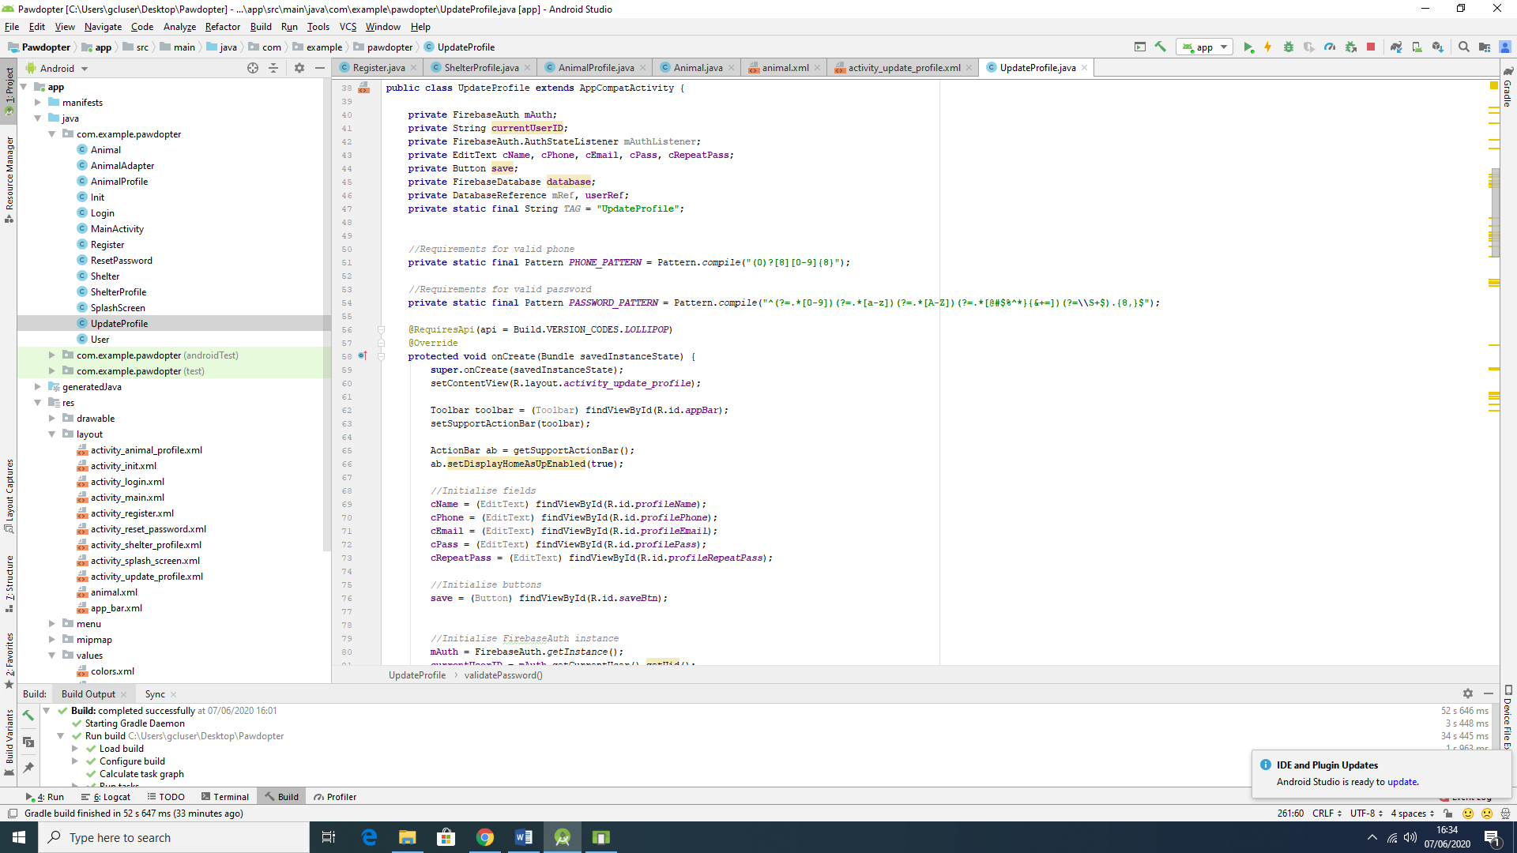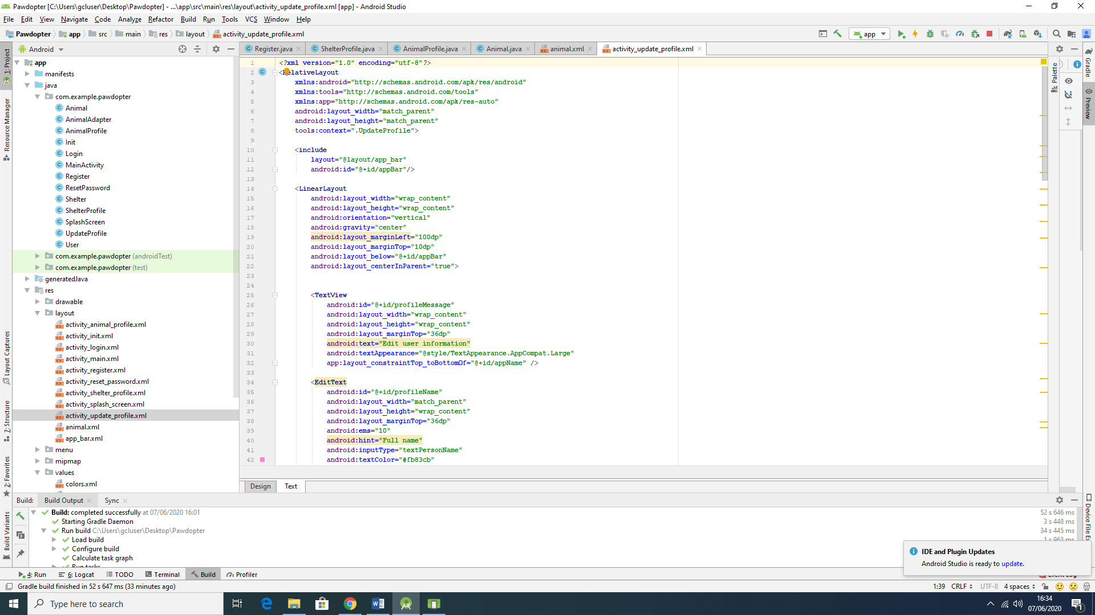

Figure 4.5b: Snippets of Code for Screen 5: Update User Profile Screen

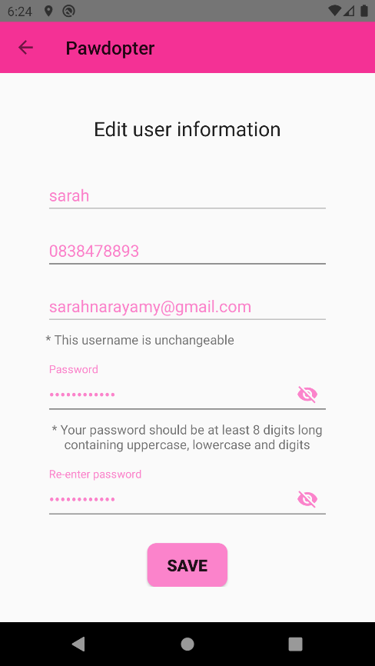

Figure 4.5c: Snapshot of the Actual Application Screen 5: Update User Profile Screen

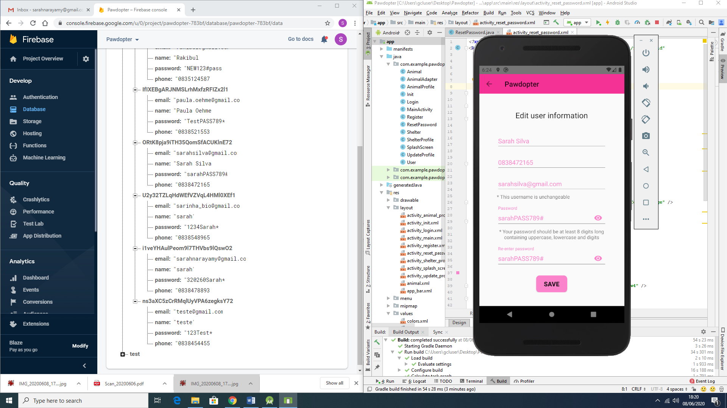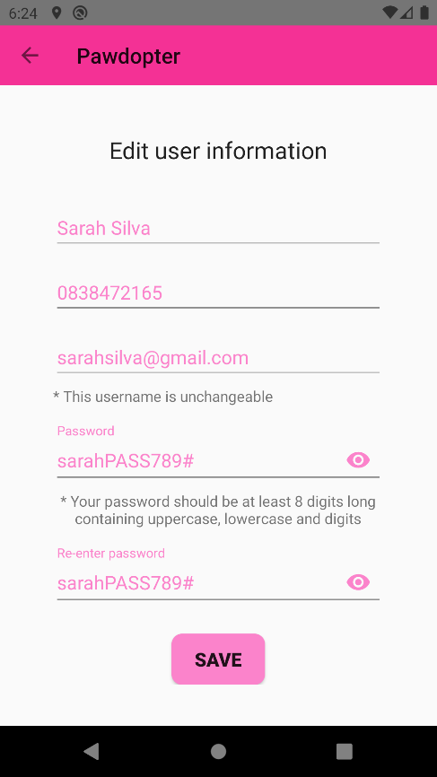

Figure 4.5d: Before the information is changed (Database on the left-hand side and snapshot of the actual screen on the right-hand side of the Figure)

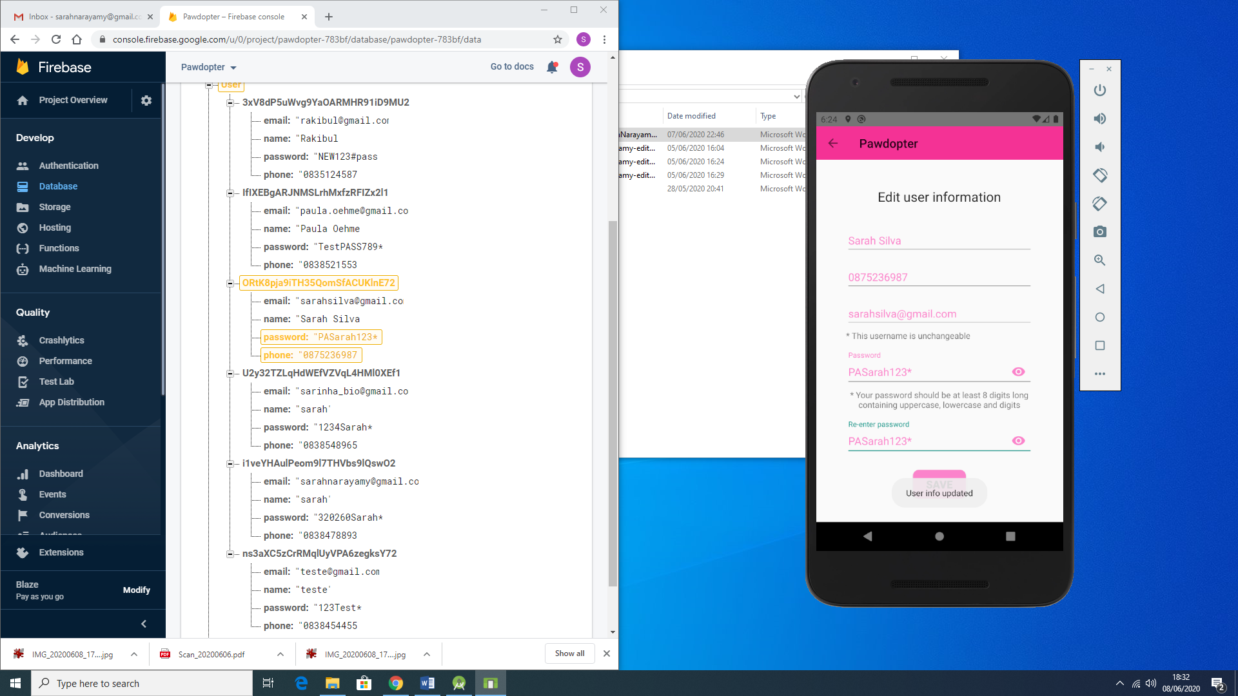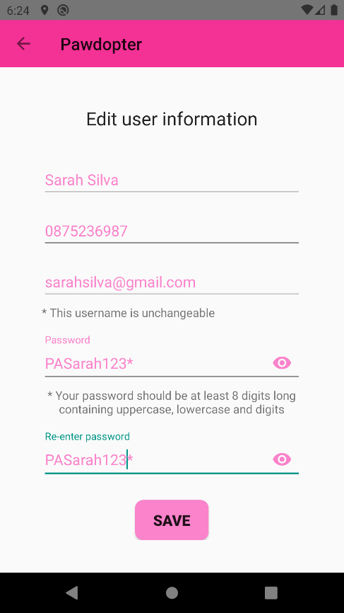

Figure 4.5e: After the information is being changed (Database on the left-hand side and snapshot of the actual screen on the right-hand side of the Figure)

**4.6 Screen 6: *Chosen Pet Visualization* Screen**

When the user clicks on a desired pet from the *Pet Browsing and Filtering* Screen (Screen 4), the user is redirect to a new screen – Chosen Pet Visualization Screen, which provides all detailed information about the chosen animal, such as: picture, name, breed, age, gender, personality, and the name of the shelter where this animal is kept.

Figure 4.6a illustrates the wireframe for the *Chosen Pet Visualization* Screen, Figure 4.6b shows snippets of code (Java code to the left, XML code to the right of the figure) for the screen, while Figure 4.6c displays snapshot of the actual application *Update User Profile* Screen.

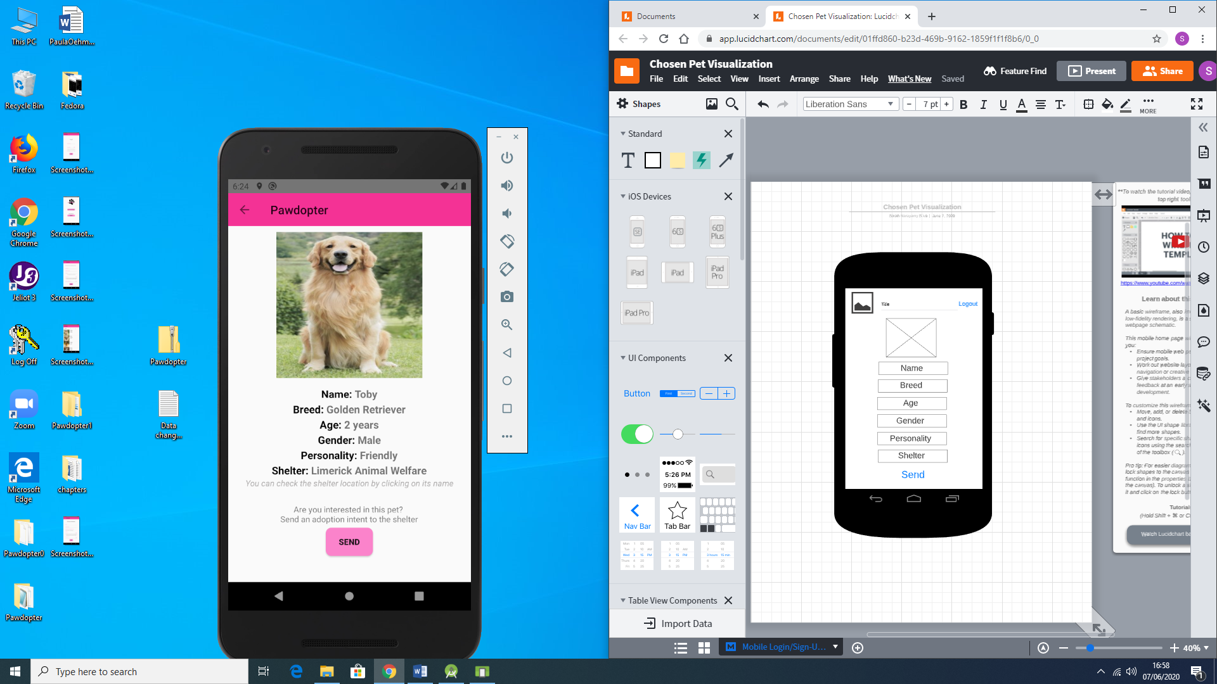

Figure 4.6a: Wireframe for Screen 6: Chosen Pet Visualization Screen

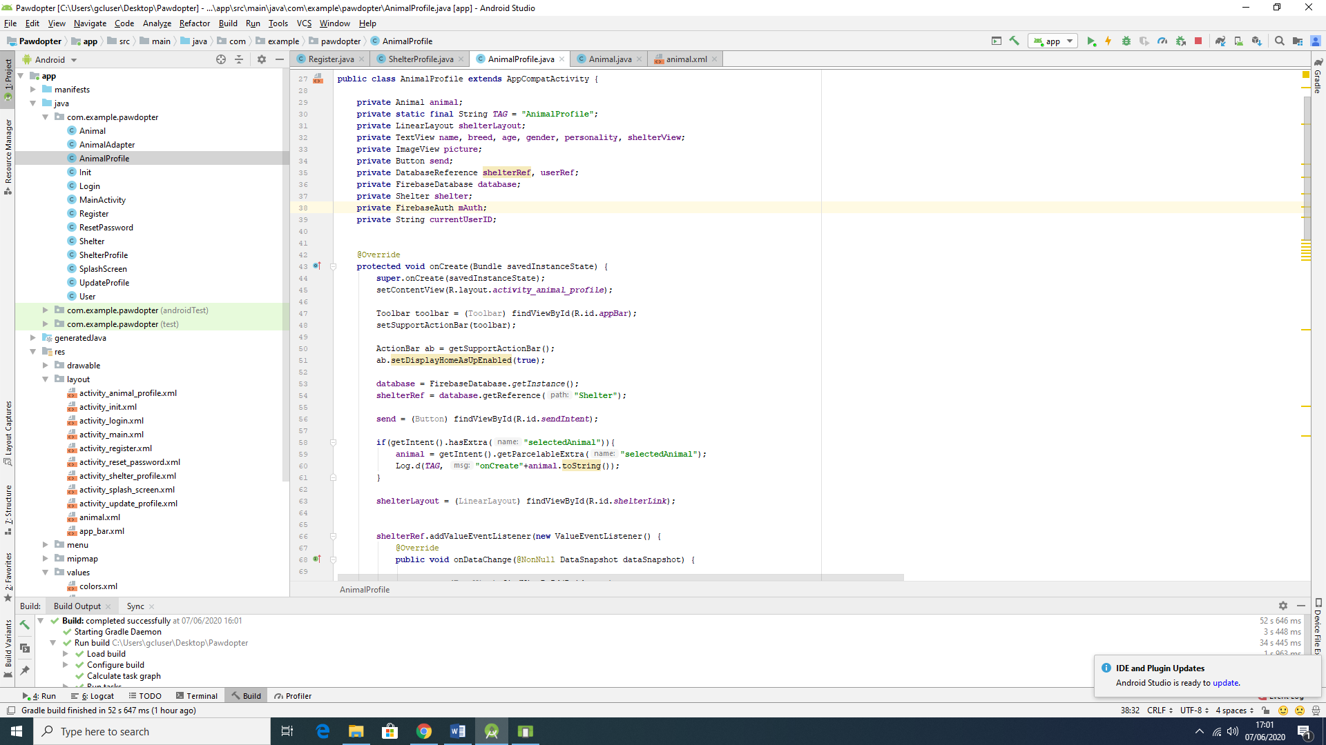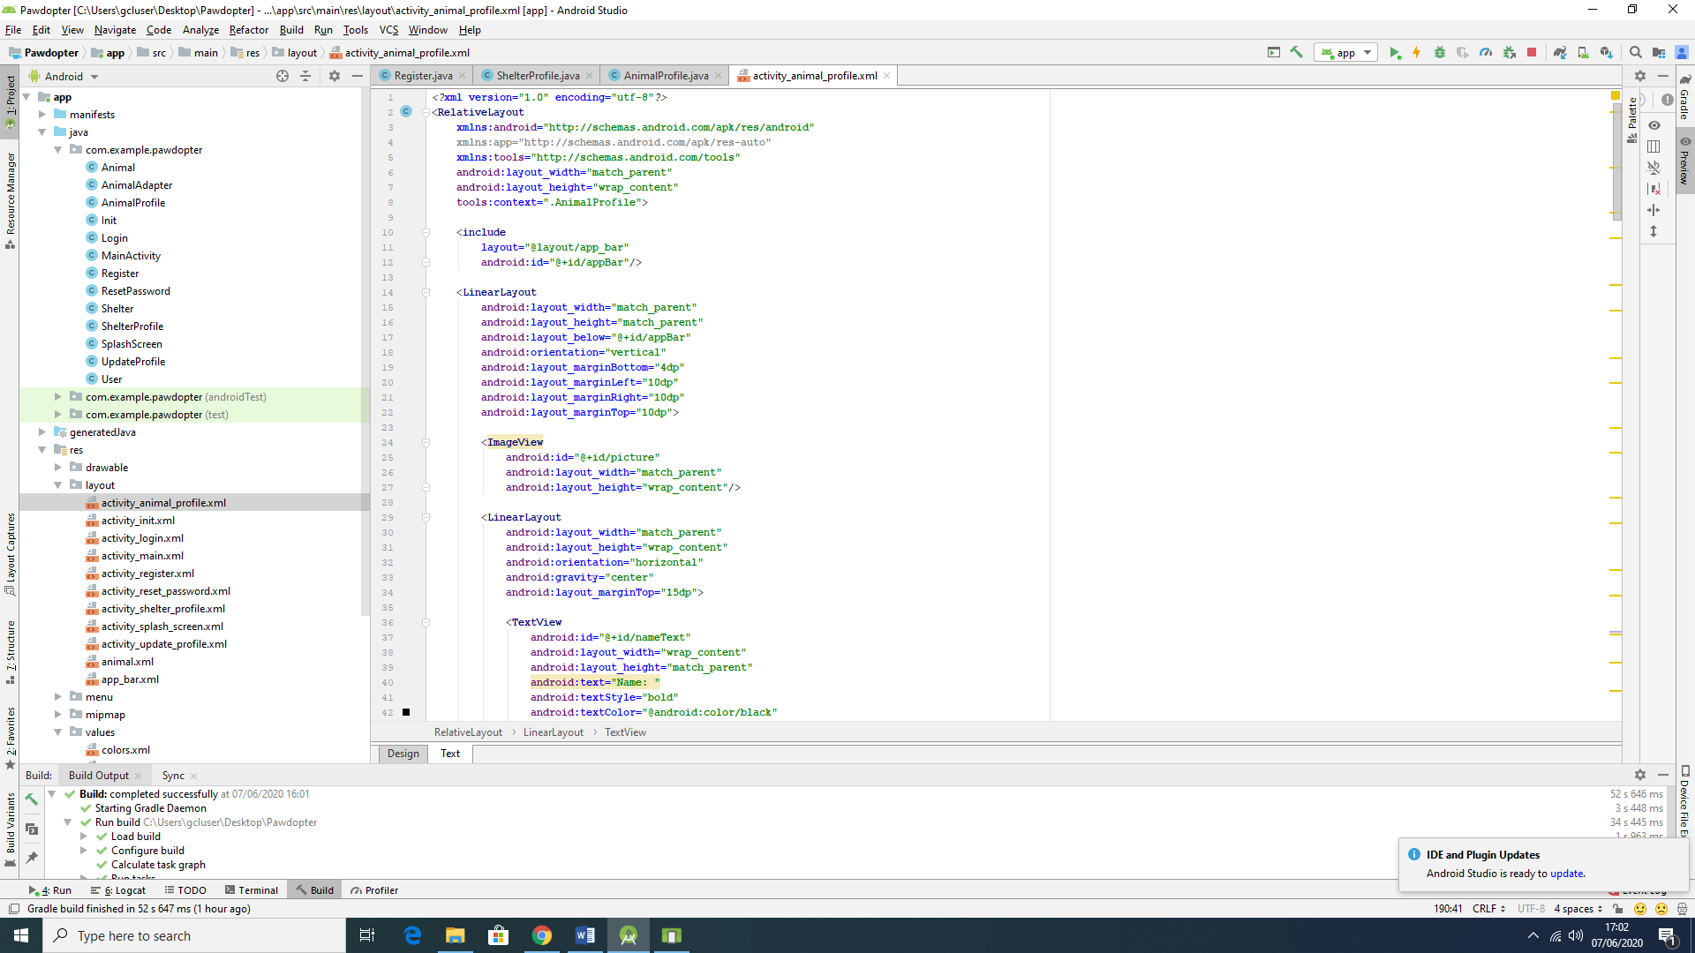

Figure 4.6b: Snippets of Code for Screen 6: Chosen Pet Visualization Screen

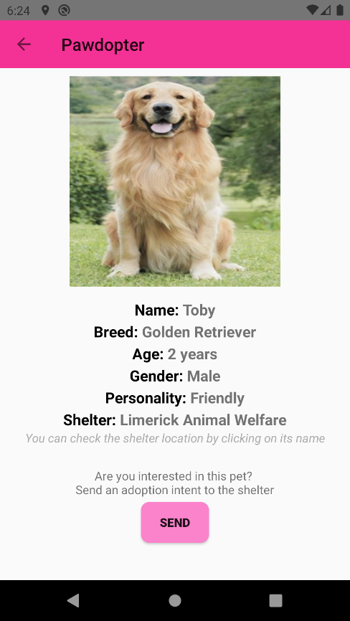

Figure 4.6c: Snapshot of the Actual Application Screen 6: Chosen Pet Visualization Screen

The actual *Chosen Pet Visualization* Screen differs from the wireframe of the screen as mentioned for the previously described screens. At the top of the screen the logo is not displayed – instead, a left arrow is used, indicating that the user can go back to the *Pet Browsing and Filtering* screen. The name of the application is displayed right beside the arrow, and at the bottom of the *Chosen Pet Visualization* Screen there is a *Send* button, which allows the user to send an *Adoption Intent* message, in an e-mail format, to the corresponding shelter where the animal is located. Also, on this screen, it was decided to make the name of the shelter clickable, so the user can see Google Maps location of the shelter with detailed contact information for the shelter. By clicking on the shelter’s name, the user will be redirected to another screen which will display the information of the shelter.

Clicking on the *Send* button, the user will be asked to select which e-mail platform will be used as an e-mail to be sent. Figure 4.6d shows the options (which should vary, according to the user’s usage (Gmail, Outlook, Yahoo mail, etc)).

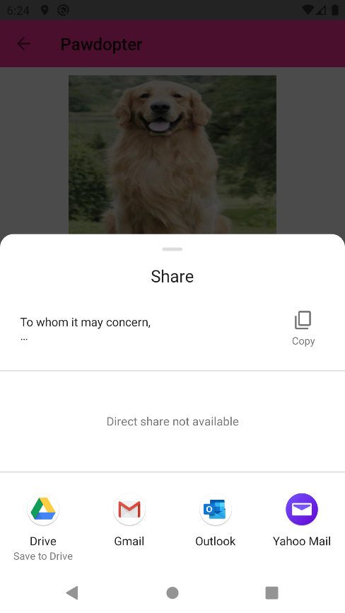

Figure 4.6d: Options to choose from to send the Intent of Adoption Form, according to the device being used

Once the option is chosen, a predefined standard e-mail template, which retrieves the information of the user and the chosen animal, is presented on screen. The user can add information on the e-mail as they are pleased, however if there is no intention on modifying it, the user should just click on the *Send* button from the e-mail. Figure 4.6e shows the pre-written e-mail. In this case, for security reasons, accordingly to the General Data Protection Act (GDPR), the application only retrieves the e-mail and the name of the user, in order to make a first contact with the shelter, however as mentioned before, the user is able of adding information, such as mobile number, or other information, as they are pleased. Figure 4.6f shows the e-mail sent to the shelter and followed by the e-mail received from the shelter in response, with a date and time for visiting the sanctuary.

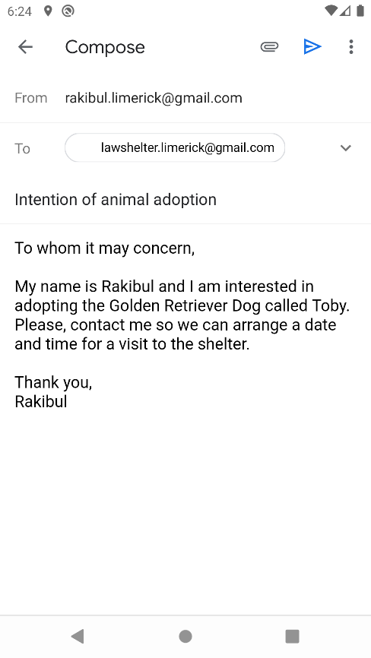 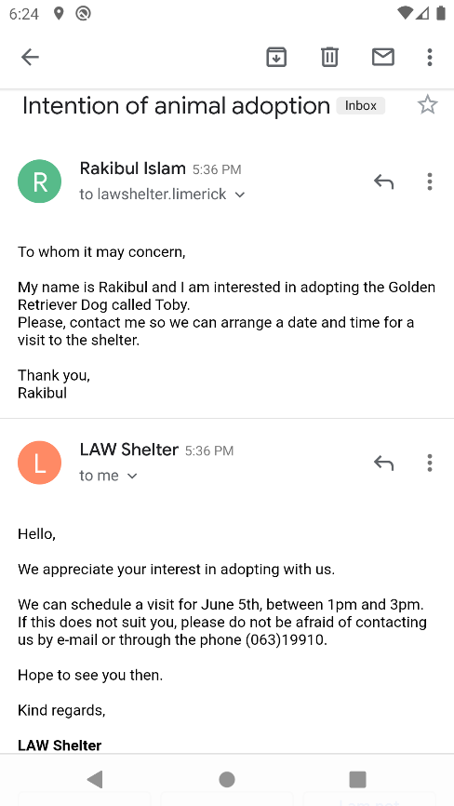

Figure 4.6e: Sample of pre-written e-mail sent by user on the left-hand side, and the e-mail response from the shelter on the right-hand side of the figure

**4.7 Screen 7: *Shelter Information* Screen**

The *Shelter Information* screen, as the name says, provides information as stored in the database about specific shelter, such as name, phone number, physical address, and e-mail address. There is also a back button, to allow user to go back to the previous screen, which is the *Chosen Pet Visualization* Screen, and view the pet information once again.

Figure 4.7a presents the wireframe for the *Shelter Information*Screen, Figure 4.7b shows snippets of code (Java code to the left-hand side, XML code to the right-hand side of the figure) for the screen, while Figure 4.7c displays snapshot of the actual application *Shelter Information* Screen.

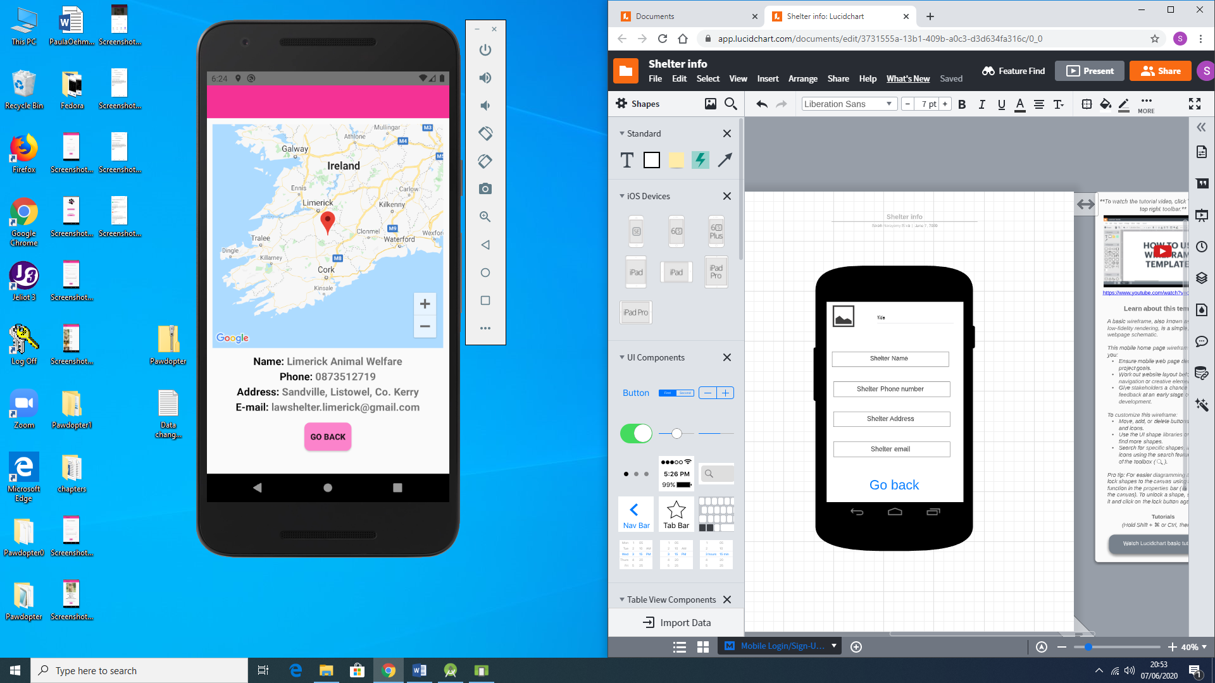

Figure 4.7a: Wireframe of Screen 7: Shelter Information Screen

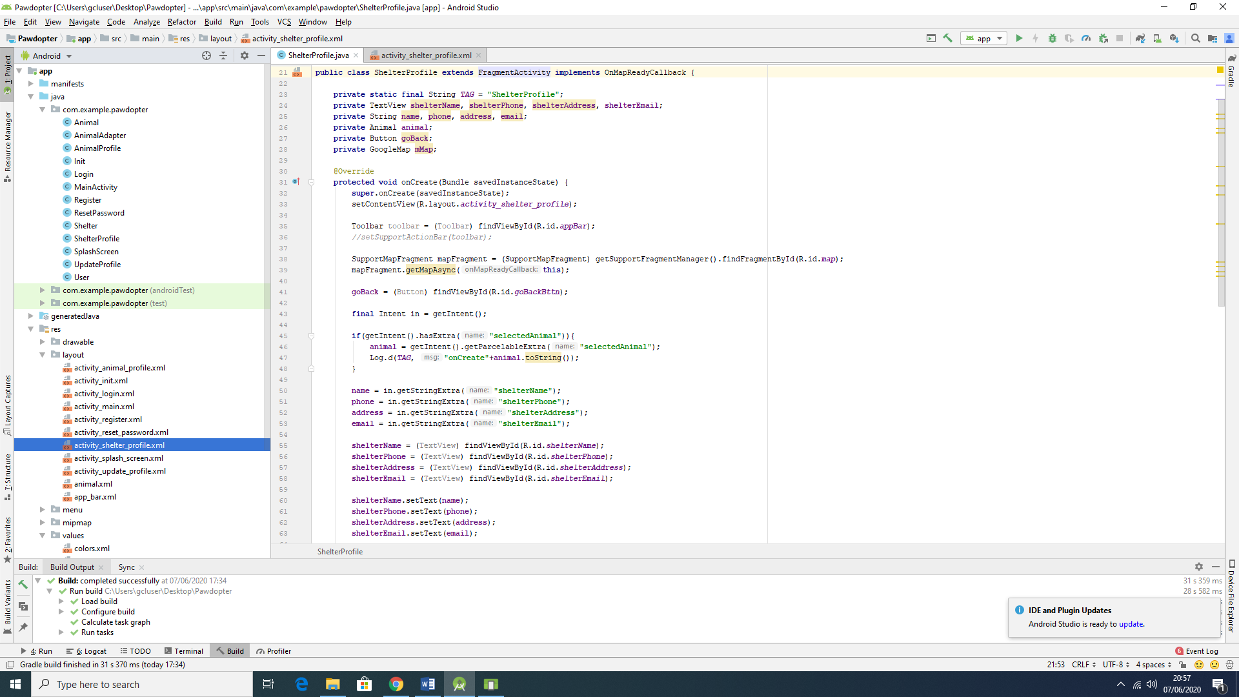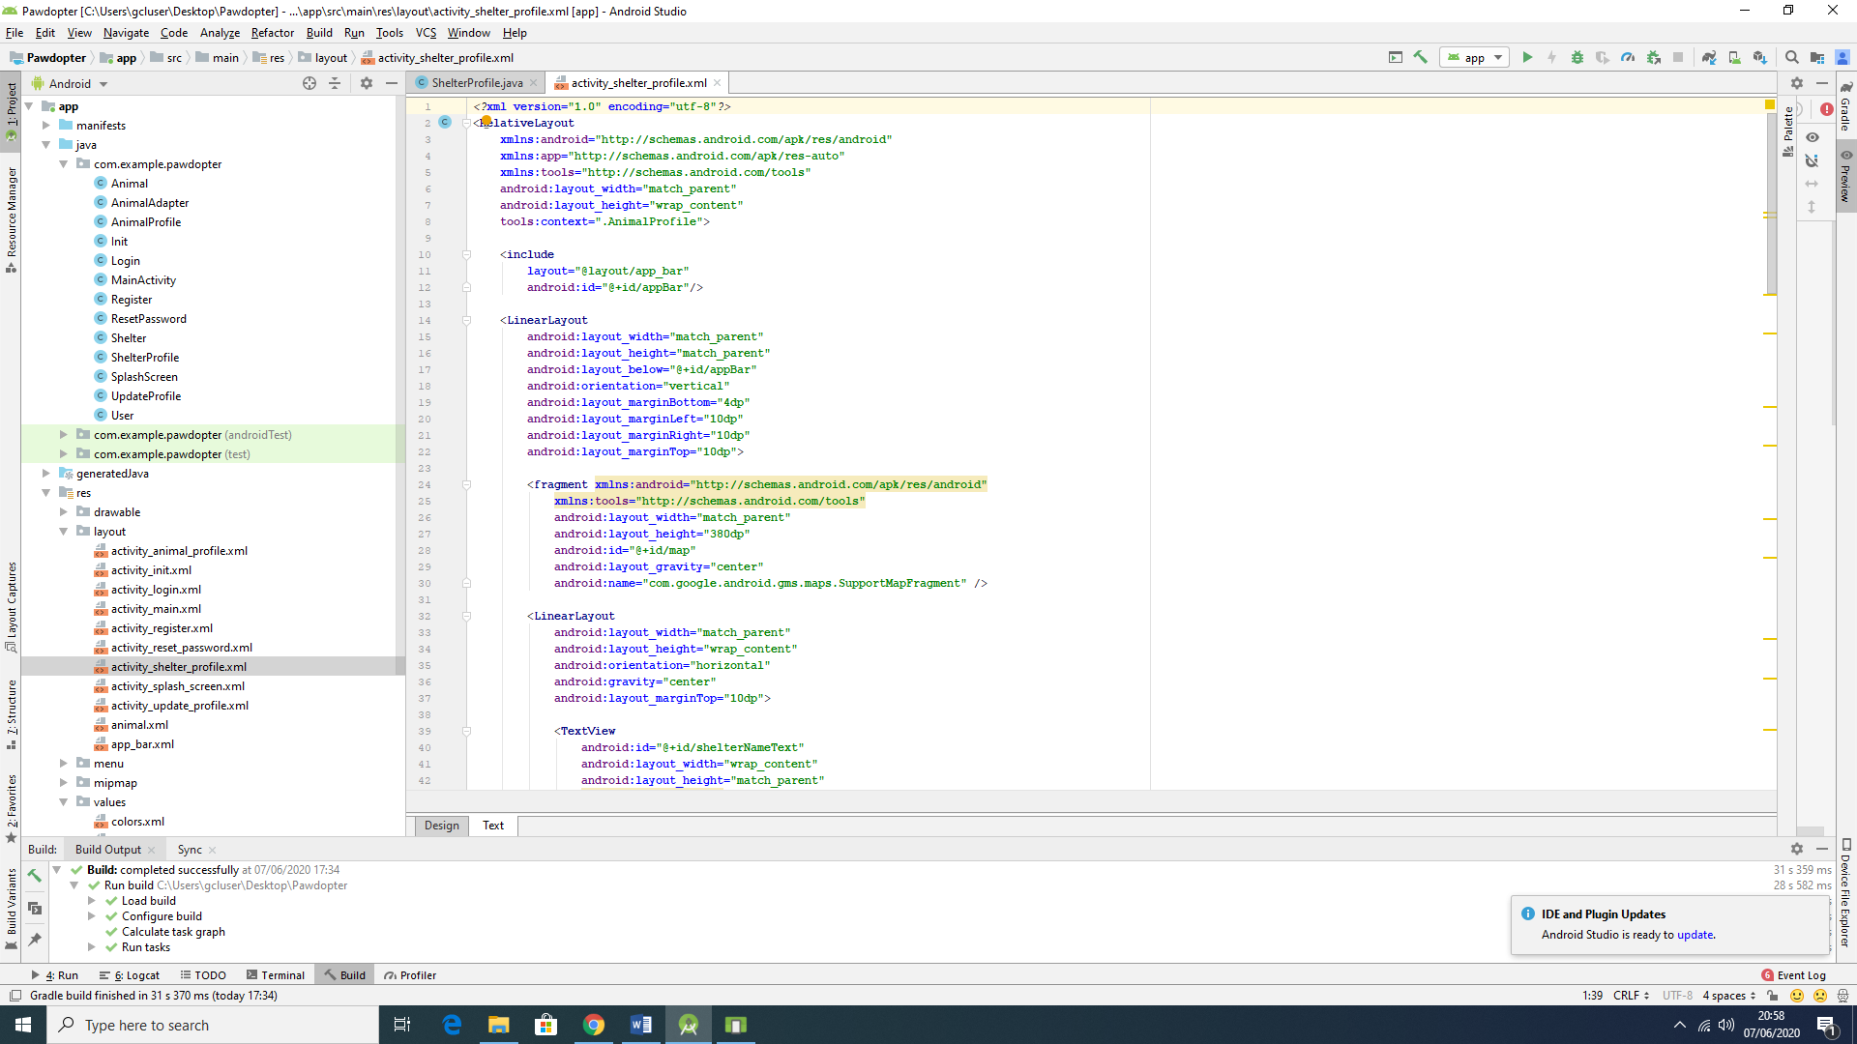

Figure 4.7b: Snippets of Code for Screen 7: Shelter Information Screen

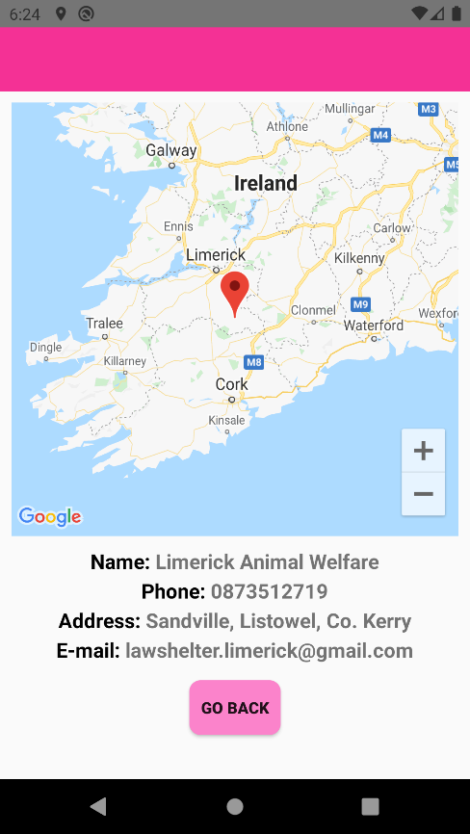

Figure 4.7c: Snapshot of the Actual Application Screen 7: Shelter Information Screen

The wireframe and the actual screen differ - a Google Maps image with the location of the shelter is presented on the actual screen, which means that the user can not only view textual information about the shelter, but can see the actual physical location of the shelter on the map, and calculate the distance to their location. This image is placed above all written information about the shelter.

**4.8 Screen 8: *Reset Password* Screen**

The *Reset Password* Screen presents the *Reset Password* process, which is as simple as it can be. It provides a field to type the user’s e-mail address, as provided during the registration process, and *Reset* button to activate the resetting password. Once the user clicks on the button, an automatic e-mail is generated by the app and sent to the user’s address.

Figure 4.8a illustrates the wireframe for the *Reset Password* Screen, Figure 4.8b shows snippets of code (Java code to the left, XML code to the right of the figure) for the screen, while Figure 4.8c displays snapshot of the actual application *Reset Password* Screen.

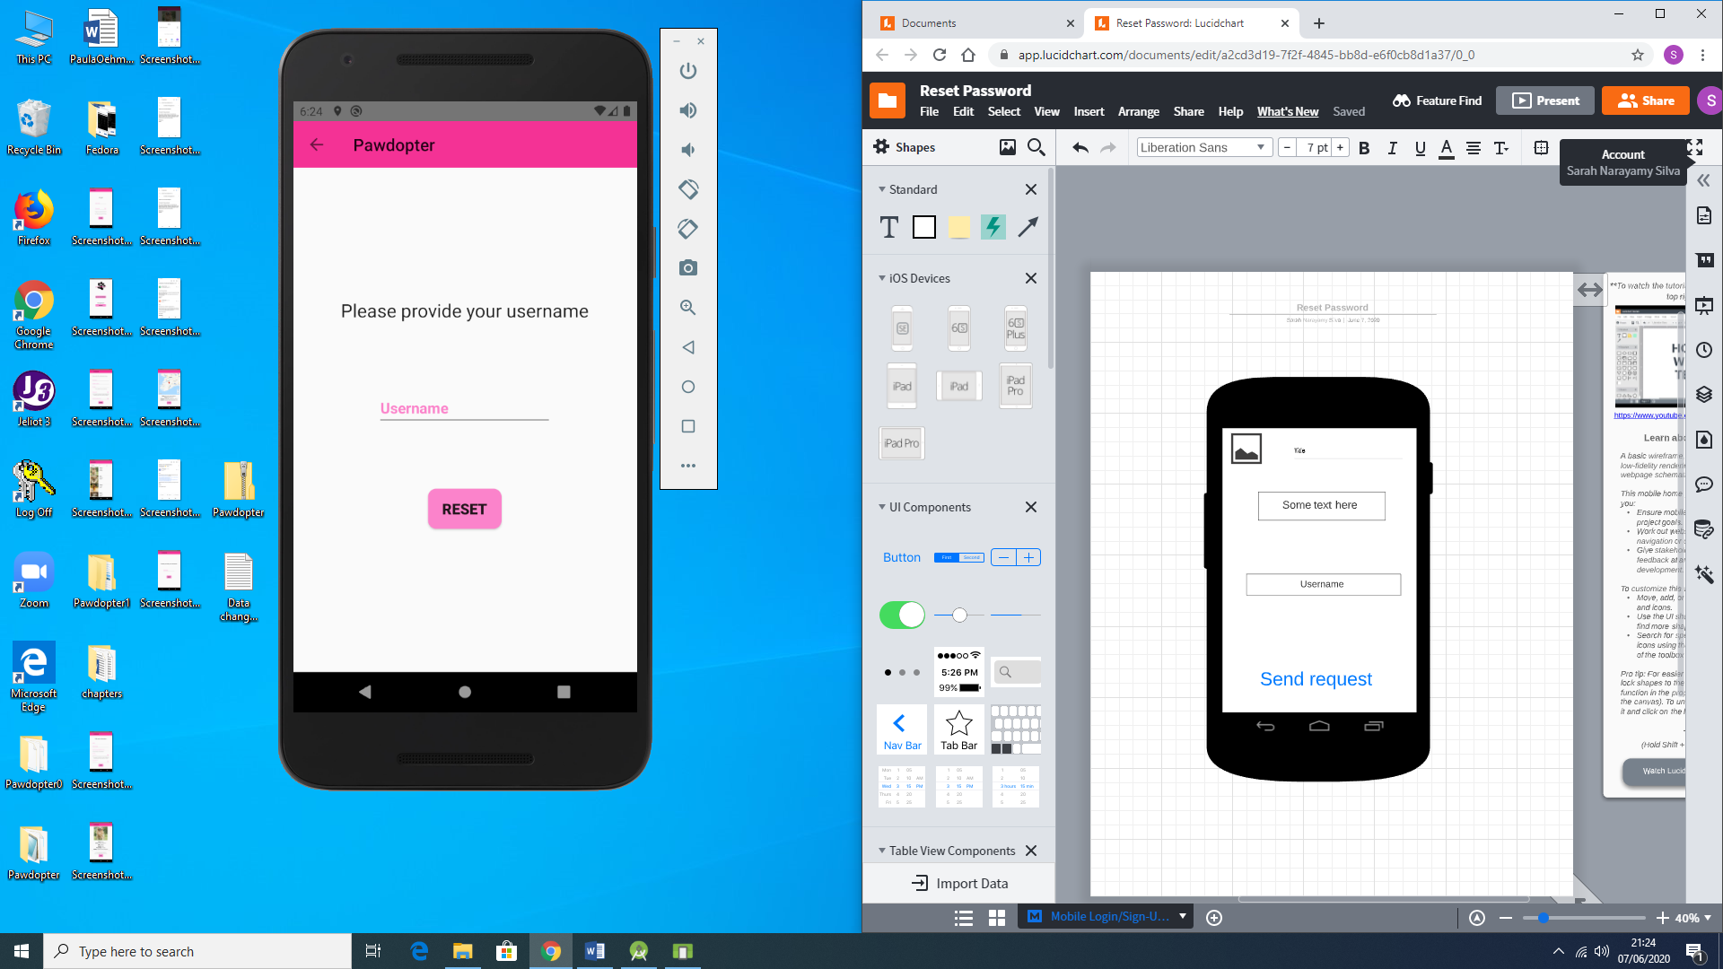

Figure 4.8a: Wireframe of Screen 8: Reset Password Screen

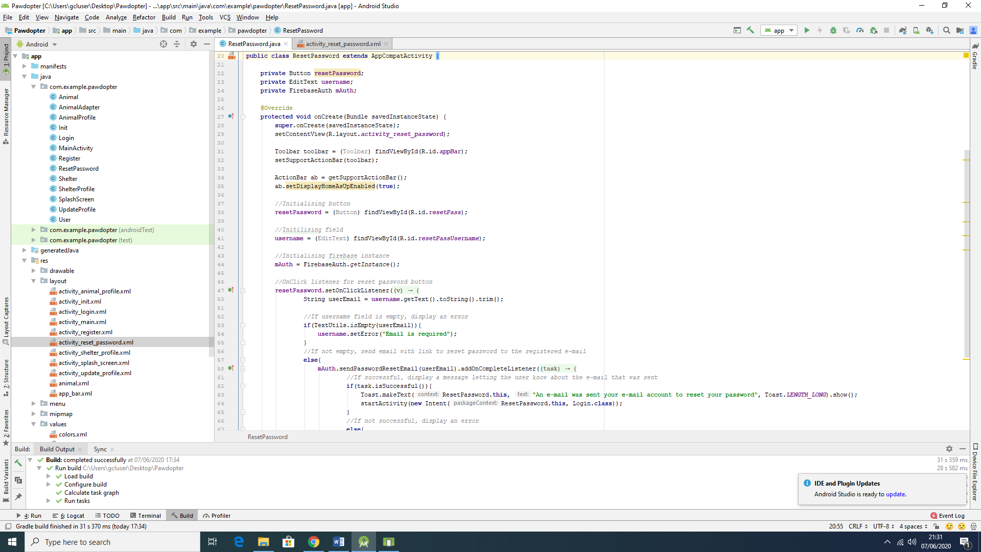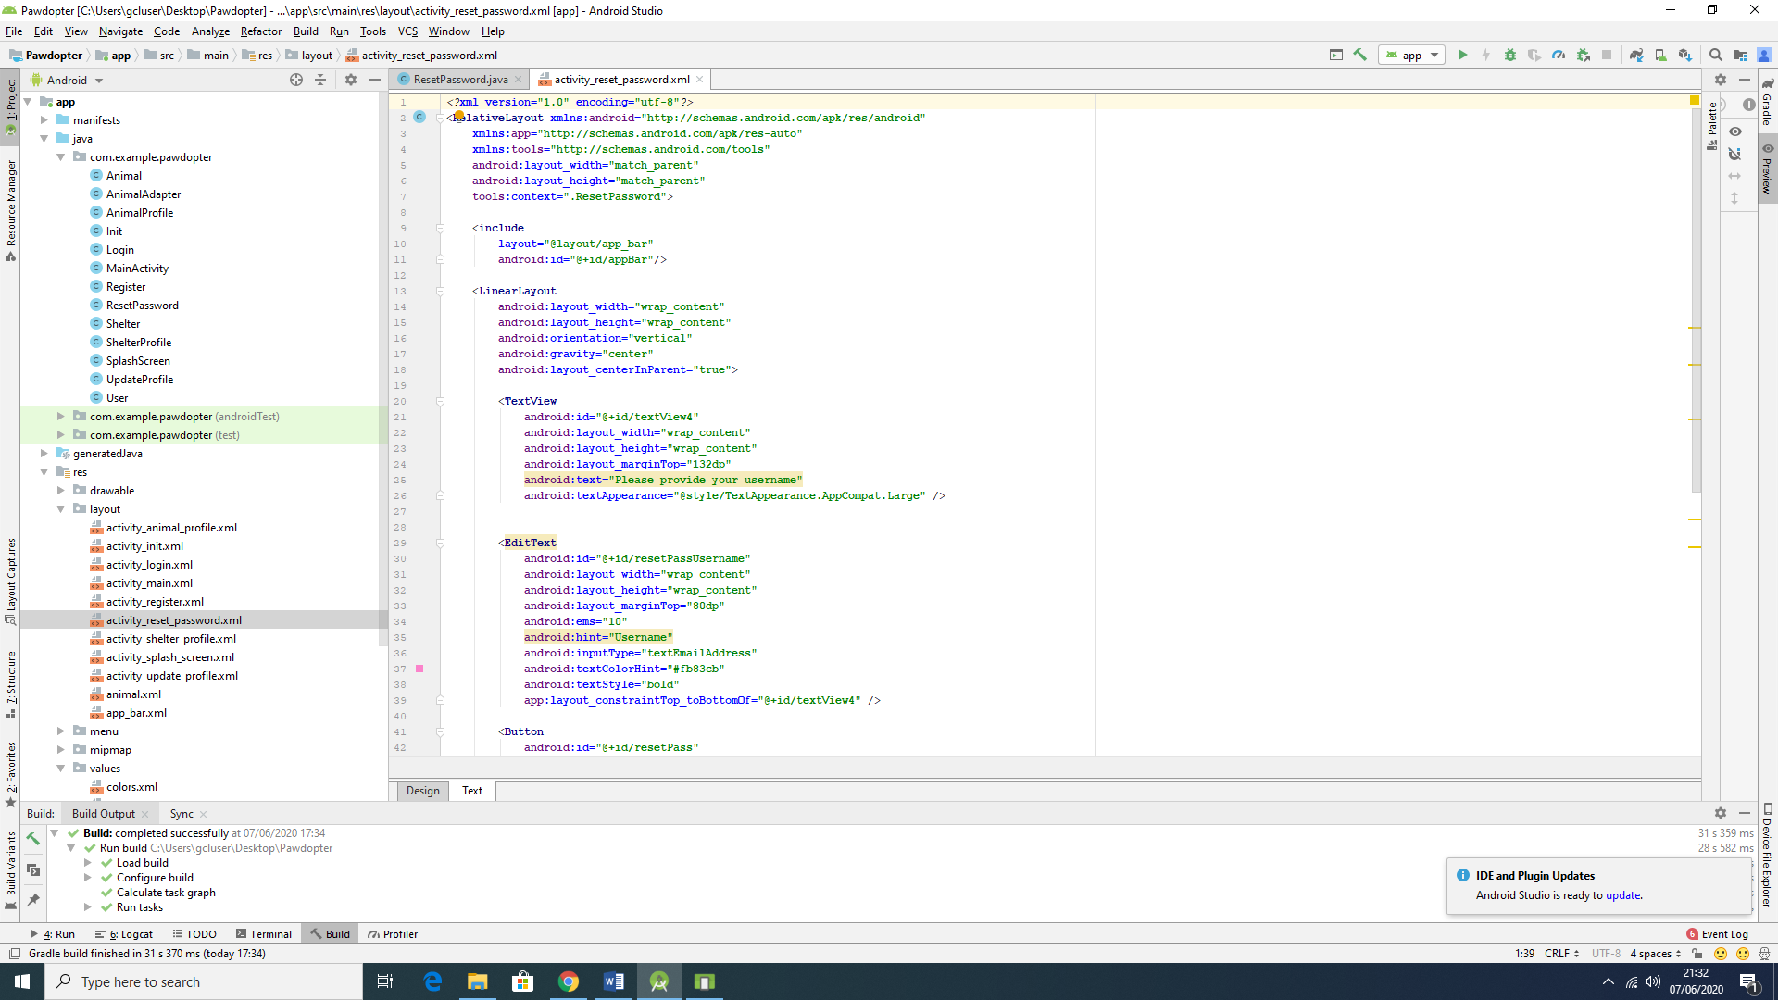

Figure 4.8b: Snippets of Code for Screen 8: Reset Password Screen

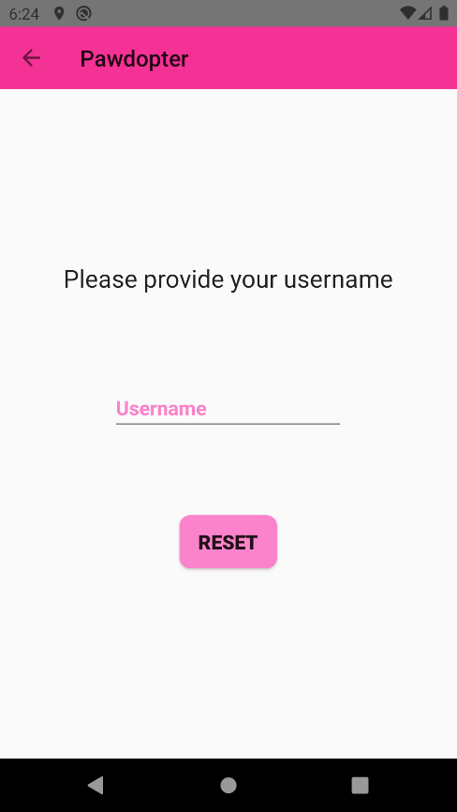

Figure 4.8c: Snapshot of the Actual Application Screen 8: Reset Password Screen

The wireframe and the actual screen differ on aspects mentioned before, such as logo and name of the application, which are replaced by a left arrow and followed by the name, respectively. Also, the name of the button was changed from *Send Request* to *Reset*, with the purpose of making it more user friendly. As mentioned before, the user will receive an automatically generated e-mail by the application, with a link to *reset* the password. Figure 4.8d shows the generated and sent e-mail.

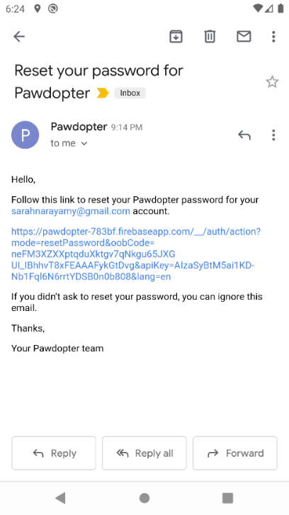

Figure 4.8d: Automatically generated and sent by the application e-mail to reset password

It is not possible to show the *before* and *after* images of the password being reset, because this functionality is made by the Firebase Authentication provider.

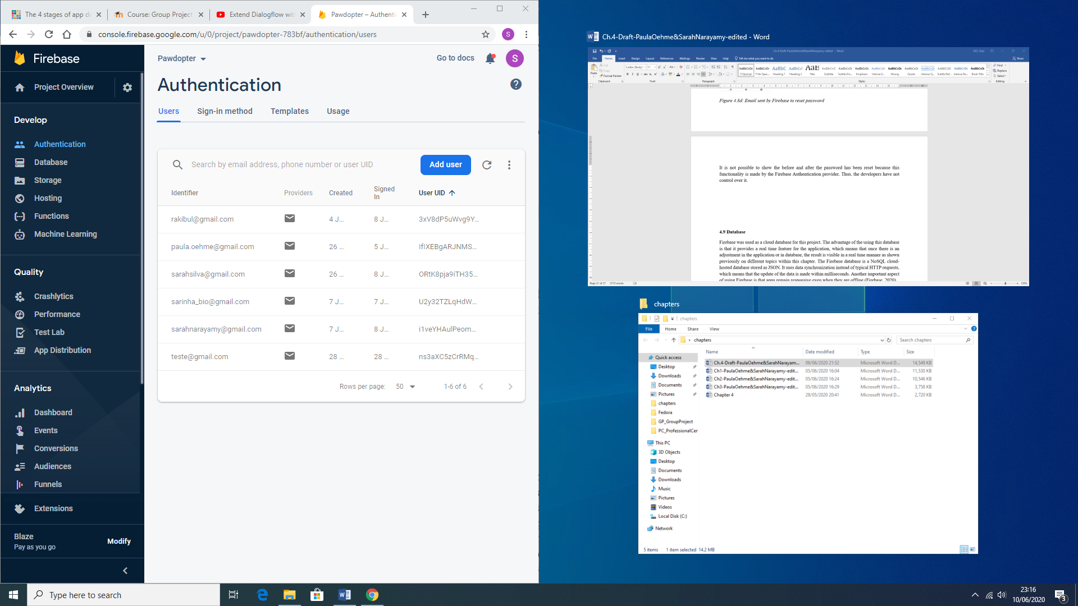

**4.9 Database**

*Google Firebase* was used as a *Cloud*-based *No SQL* database for this project. The advantage of using it is that it provides a *real time* updating features for the application, which means that once there is an adjustment in the application, or in database, the result is visible in a real time manner, as demonstrated previously in different sections of this chapter. The *Firebase* database is a *NoSQL* *cloud*-hosted database, stored as JSON. It uses data synchronization, instead of typical HTTP requests, which means that the update of the data is made within milliseconds. Another important aspect of using *Firebase* is that apps remain responsive, even when they are offline (Firebase, 2020).

Figure 4.9a shows the general representation of the application database with each collection (table), as an entity, as discussed in Chapter 3. It is important to mention that since a shelter’s interface was not created, due to time constraints, each animal and animal-related information was hard-coded into the database. All this information can be retrieved by the application in the code, using *Android Studio*, but the application does not make changes onto the database, except for the User collection (table).

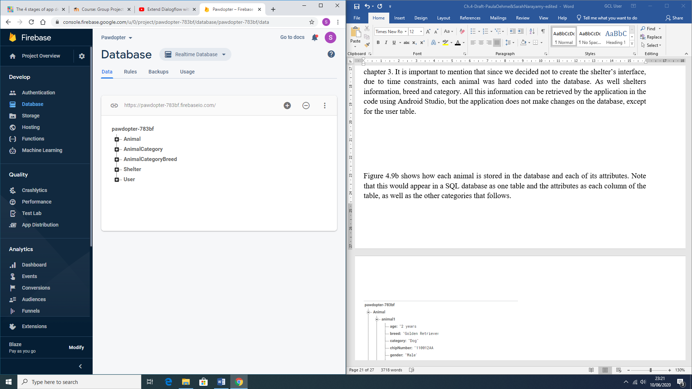

Figure 4.9a: Representation of the Application’s Database and its Collections (Tables)

Figure 4.9b shows how the Animal collection (table) and how each animal record is stored in it within the database, with each of its attributes. Note, that this would appear in a SQL database as a table, and the attributes as columns of the table (same is with the other collections that follows as description).

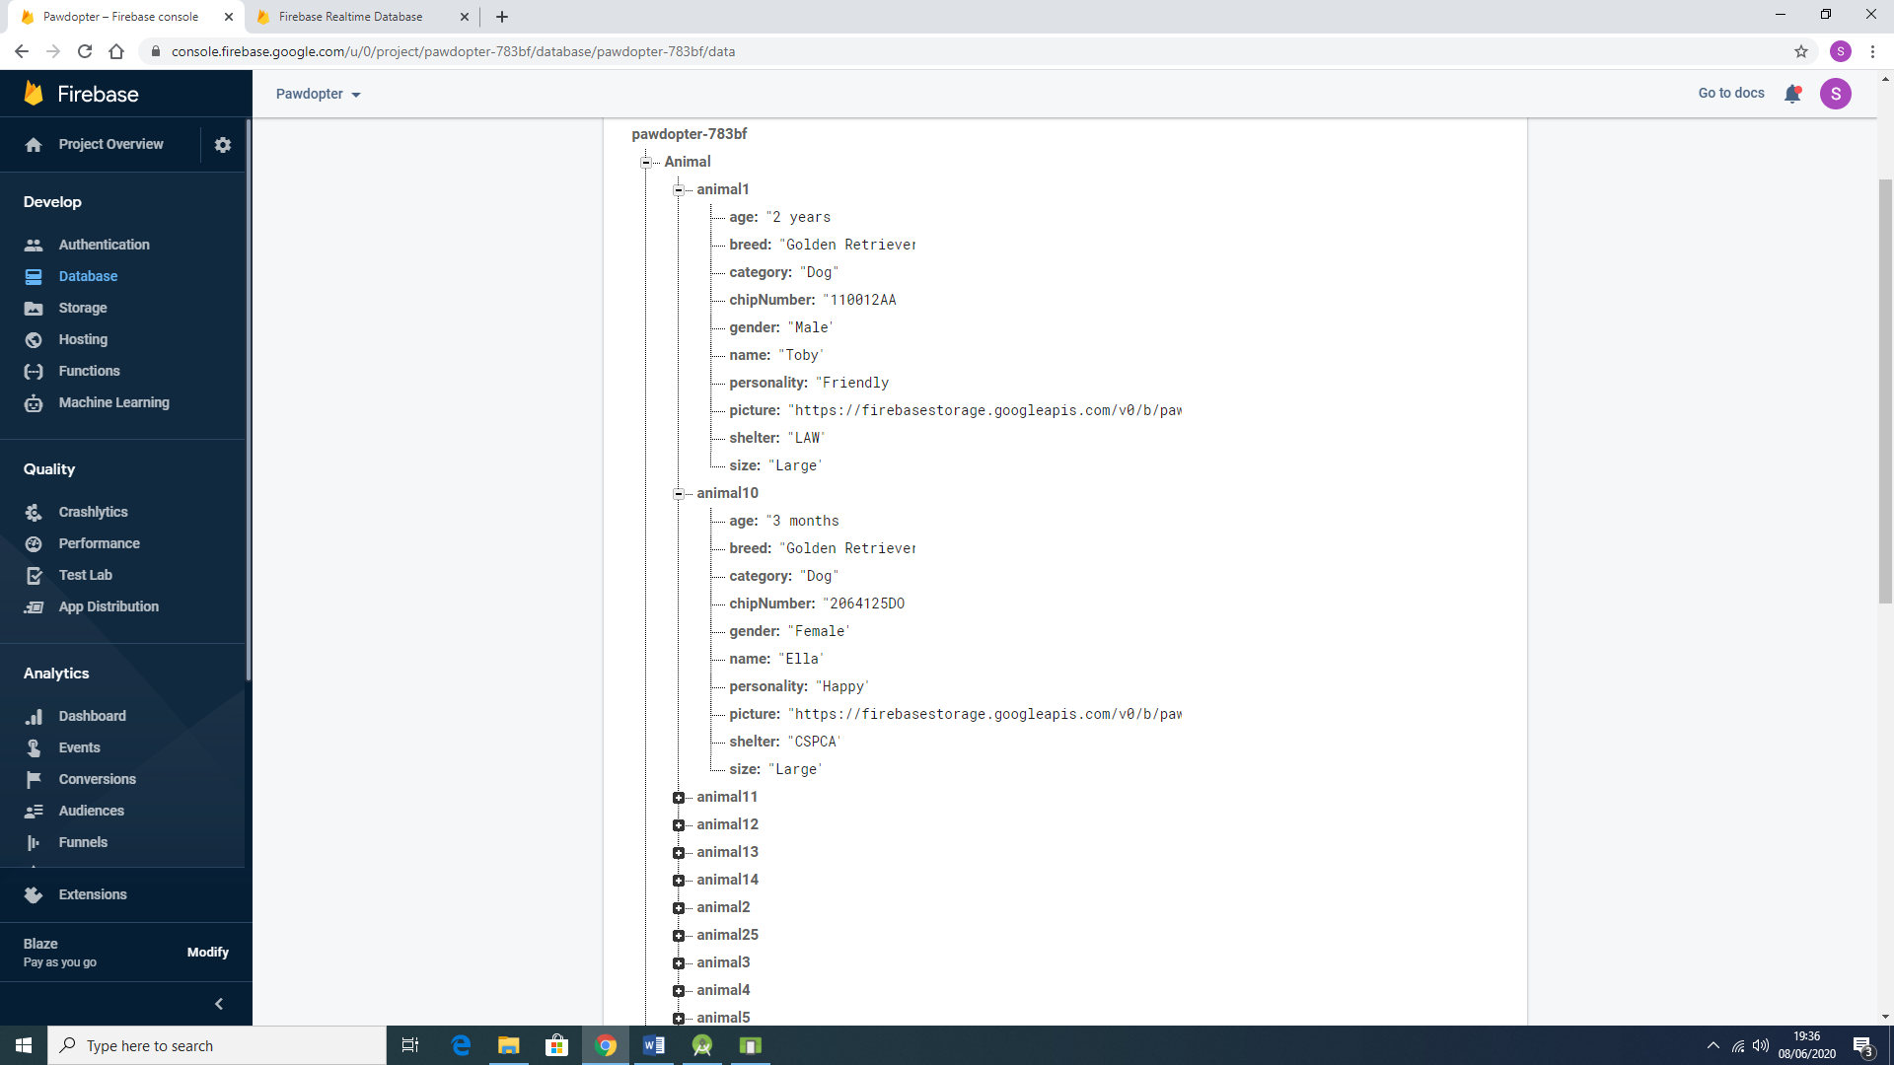

Figure 4.9b: Representation of the Animal Collection (Table) and its Attributes (and their Values), stored in the Database

Figure 4.9c shows how *Animal Category* collection is stored in the database. As mentioned before, this collection would be considered a Table, and the attribute is applied into the Animal collection as described and shown above.

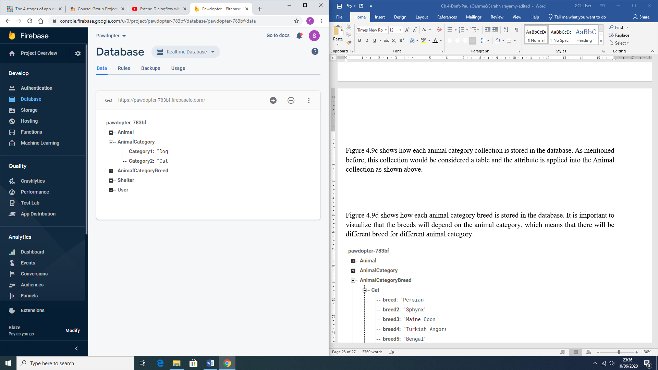

Figure 4.9c: Representation of the Animal Category Collection in the Application Database

Figure 4.9d shows how each Animal Category *Breed* is stored in the database. It is important to visualize that the *breeds* will depend on the *animal category*, which means that there will be different breeds for different animal categories.

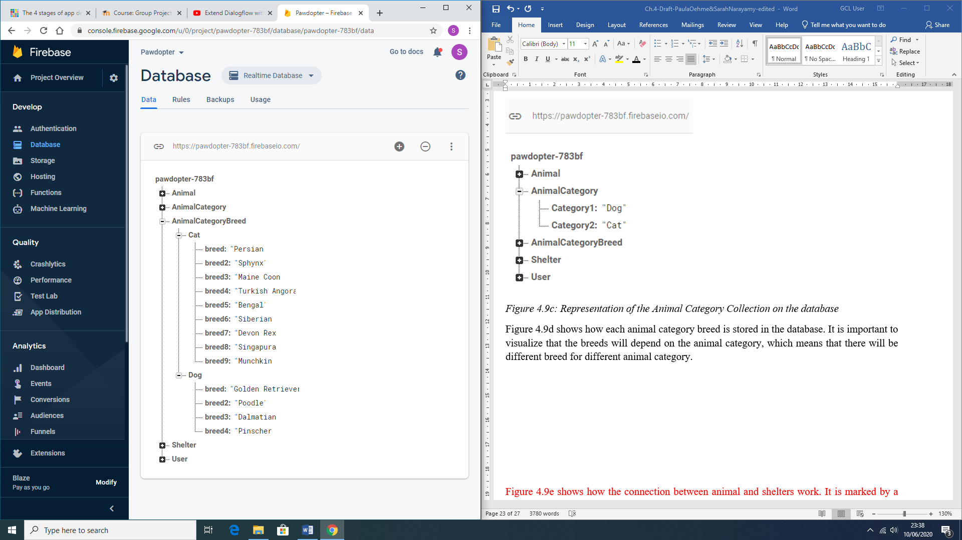

Figure 4.9d: Representation of the Animal Category Breed collection in the Application Database

Figure 4.9f shows how each shelter record is saved in the database. The *Shelter* collection (table) is also connected to the *Animal* collection (table), as shown on Figure 4.9b.

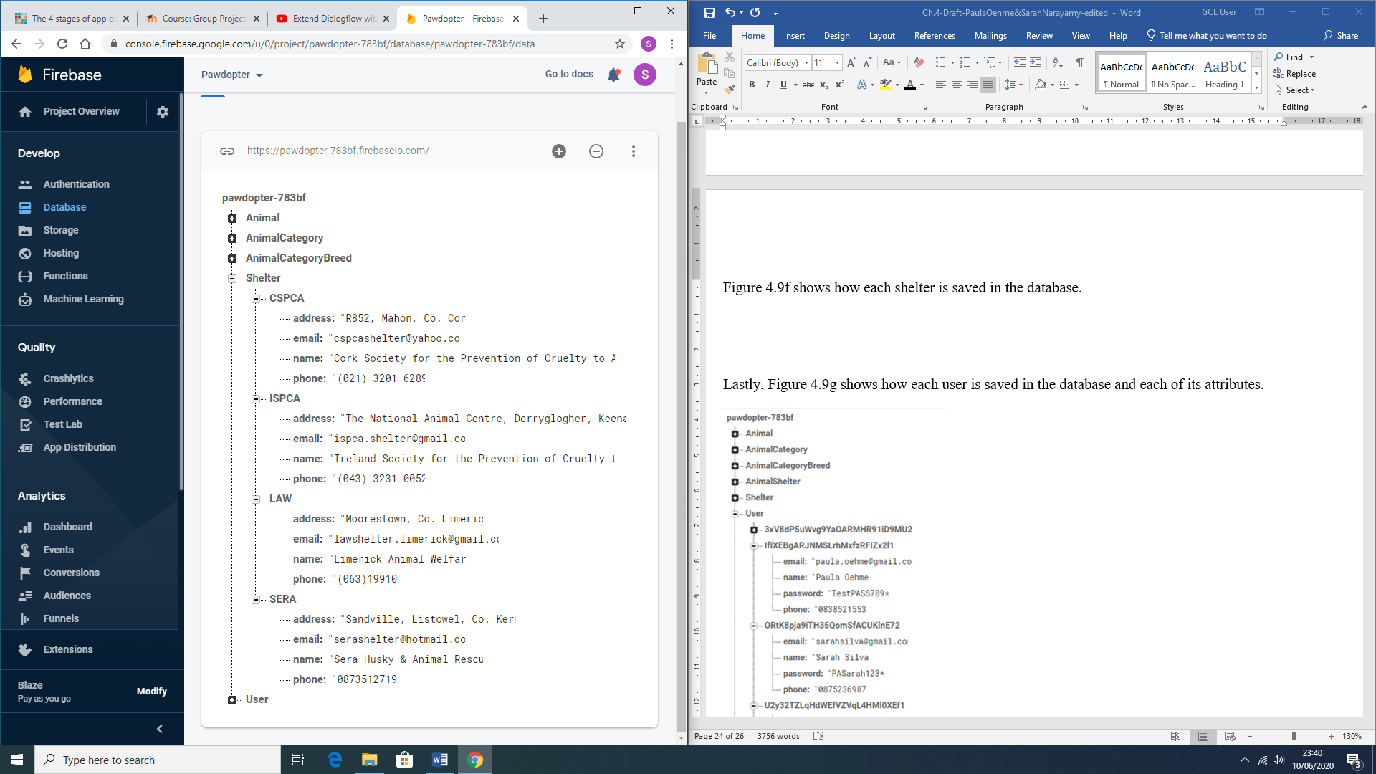

Figure 4.9f: Representation the Shelter collection in the Application Database

Lastly, Figure 4.9g shows how each User record is saved in the User collection of the application database with each of its attributes.

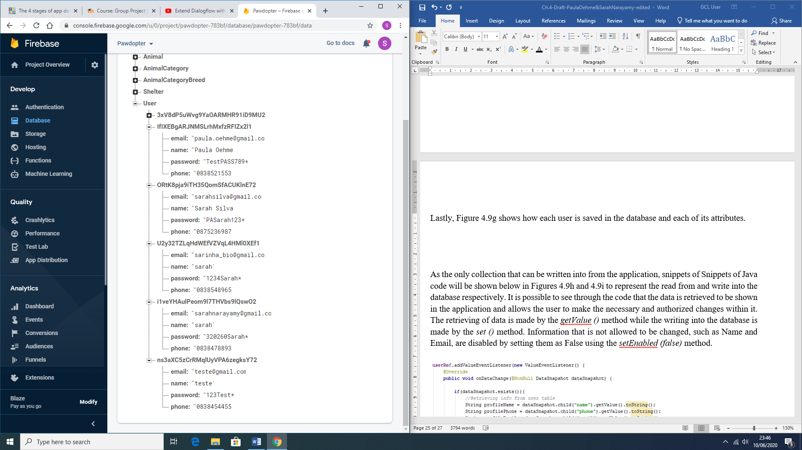

Figure 4.9g: Representation of the User collection in the database

As the only collection where records can be written into from the application, snippets of Java code are shown on Figures 4.9h and 4.9i to present the *read from* and *write into* the database processes, respectively. It is possible to see from the code, that the data is retrieved to be shown in the application and allows the user to make the necessary and authorized changes within it. The *retrieving* of data is made by the *getValue ()* method, while the *writing into* the database is made by the *set ()* method. Information that is not allowed to be changed, such as *Name* and *E-mail*, are disabled by setting them as False, using the *setEnabled (false)* method.

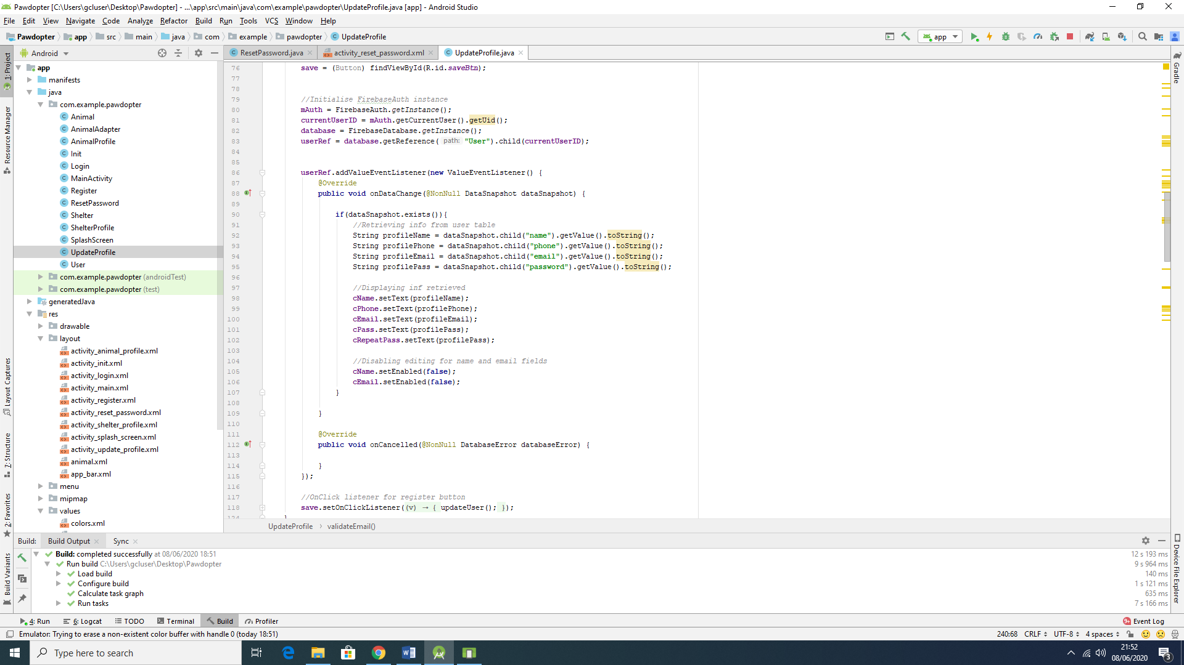

Figure 4.9h: Snippet of Code, showing read from and write into the User Collection of the Database

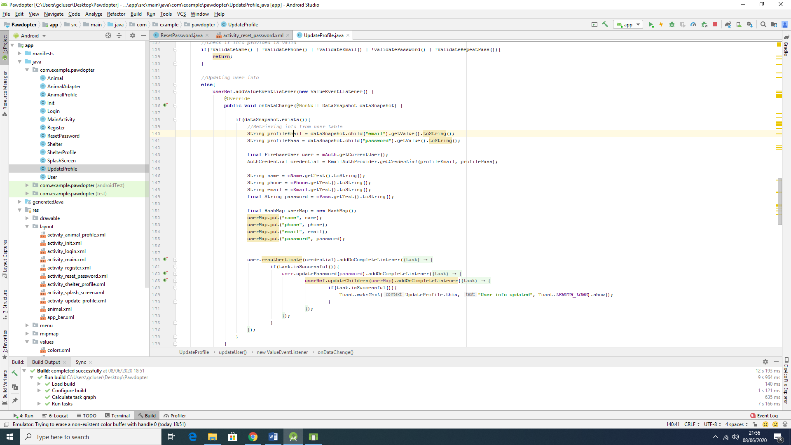

Figure 4.9i: Snippet of Code, showing read from and write into the User Collection of the Database

**4.10 DialogFlow**

*DialogFlow* is a platform that is powered by Google’s machine learning, which means that it incorporates this expertise, in order to develop products, such as Google Cloud Speech-to-Text (Dialogflow, 2020). This platform handles the interpreting and processing of natural language, so it can provide an end-user experience of high-quality conversation. It uses concepts, such as *Agents*, *Intents*, *Entities*, *Follow-up intents*, *Fulfilment for Integrations*, and so on. *Agents* are responsible for handling conversations with the end-user. By using *DialogFlow*, the end-user text or voice is translated into a structured data, that the application and services can understand. An *Intent* categorizes what is the user’s intention with the conversation. Several *intents* can be defined for one *agent*. An example of an *intent* is the *currency converter,* so if the user asks: “How much can I get in Brazilian Real?” then *DialogFlow* would match the expression to the *currency converter intent*. An *agent* is composed of training phrases, actions, parameters, and responses. Figure 4.10a show the connection between the user-*expressions*, the *agent*, and the *intents* (Google Cloud, 2020).

To active the *Google Assistant* within the *Google Home* IOT device, or through your smartphone, the user has to say an *activation phrase*, in this case “*Hey Google*”. The connection with the app is no different than that. In order for the *Google Assistant* to communicate with the application, the user must also say an *activation phrase*, in this case it is “*Talk to Pet Finder App”.* The reason why it uses this phrase, instead of “*Talk to Pawdopter*” (which is the actual name of the application), is because *Google Assistant* is not capable of recognizing the word *Pawdopter*. Also, Google has a rule about such activation phrase, which says that it has to have at least two words for *Google Assistant* to recognize it. Thus, in order to have the connection with the application, the activation phrase to be said to *Google Assistant* is: “Hey Google, Talk to *Pet Finder* App”.

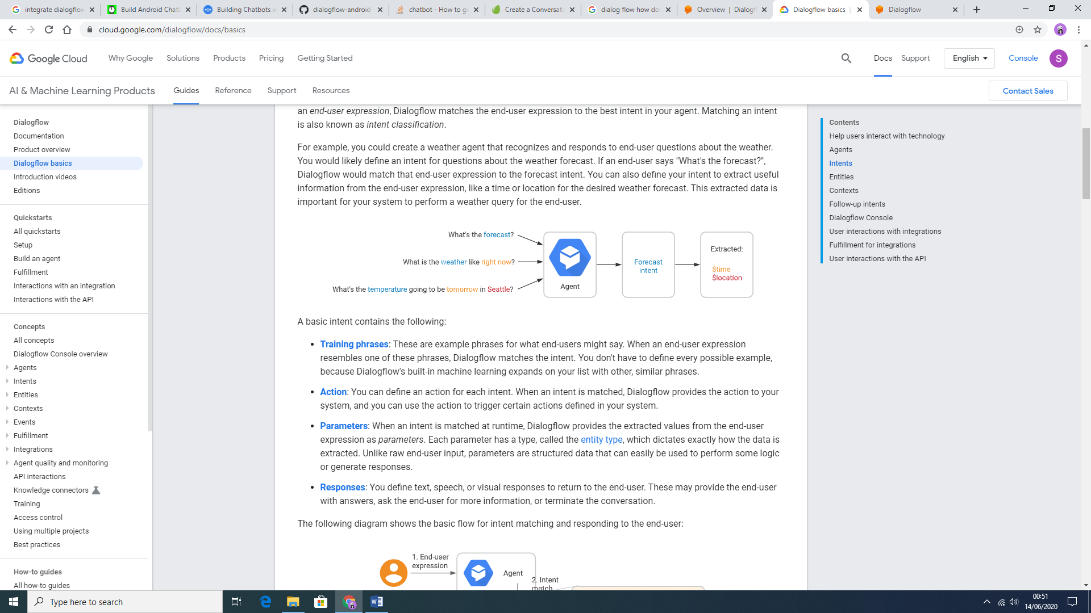

Figure 4.10a: DialogFlow Agent and Intent demo (Google Cloud, 2020)

Still, according to Google Cloud (2020), “each intent parameter has a *type*, called the *entity type*, which dictates exactly how *data* from an end-user *expression* is extracted”. Follow-up intents are used to set the context for pair of intents automatically, usually these follow-up intents are common user’s replies, such as “Yes”, “No”, or “Cancel”, but they can also be created according to the developers’ needs. Fulfilments are used in *DialogFlow* to provide a more dynamic response to the user. That means that when the fulfilment is enabled for an intent, the response that *DialogFlow* provides is based on calling a service defined by the developer, such as a database. Figure 4.10b shows the flow of the fulfilment process.

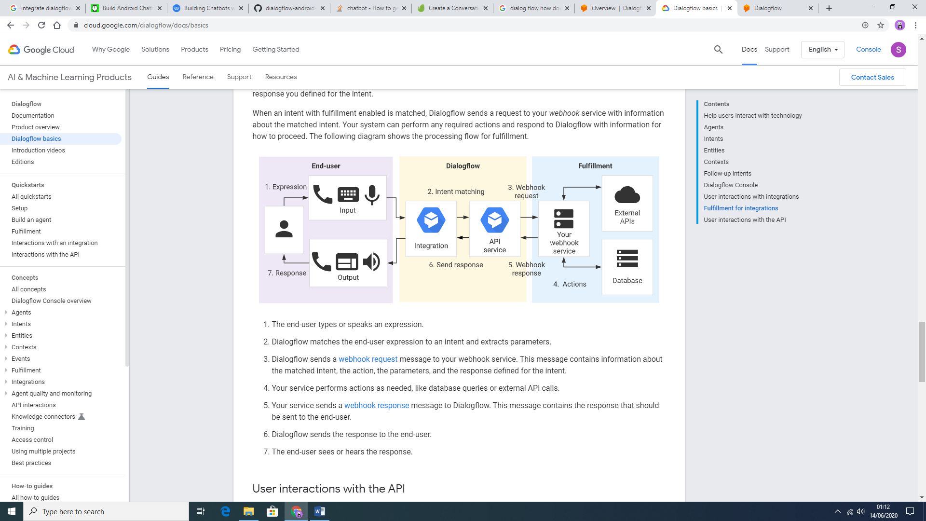

Figure 4.10b: Fulfilment Processing Flow (Google Cloud, 2020)

This process is developed with *JavaScript* as a language. Figure 4.10c: represents snippet of code for the fulfilment in this project, showing a function that creates a list of *breeds* from the database, according to what the user has asked for.

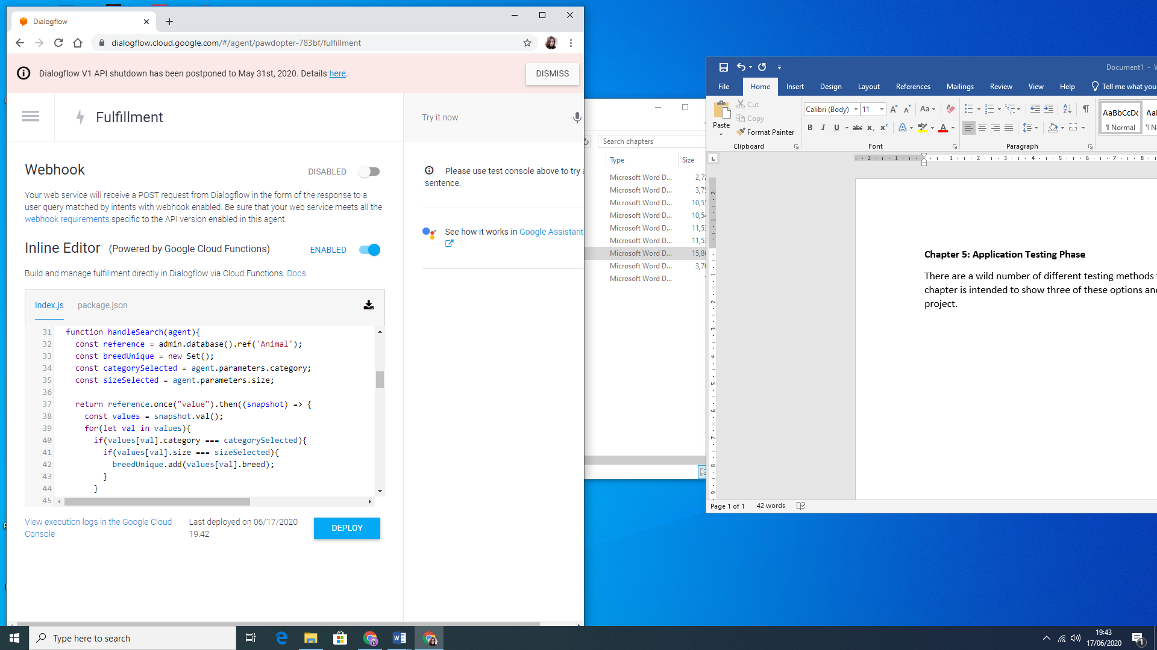

Figure 4.10c: Snippet of Code from the Fulfilment in DialogFlow

Figure 4.10d shows the structure of the Intent for the current application, called *LookingForPet*.

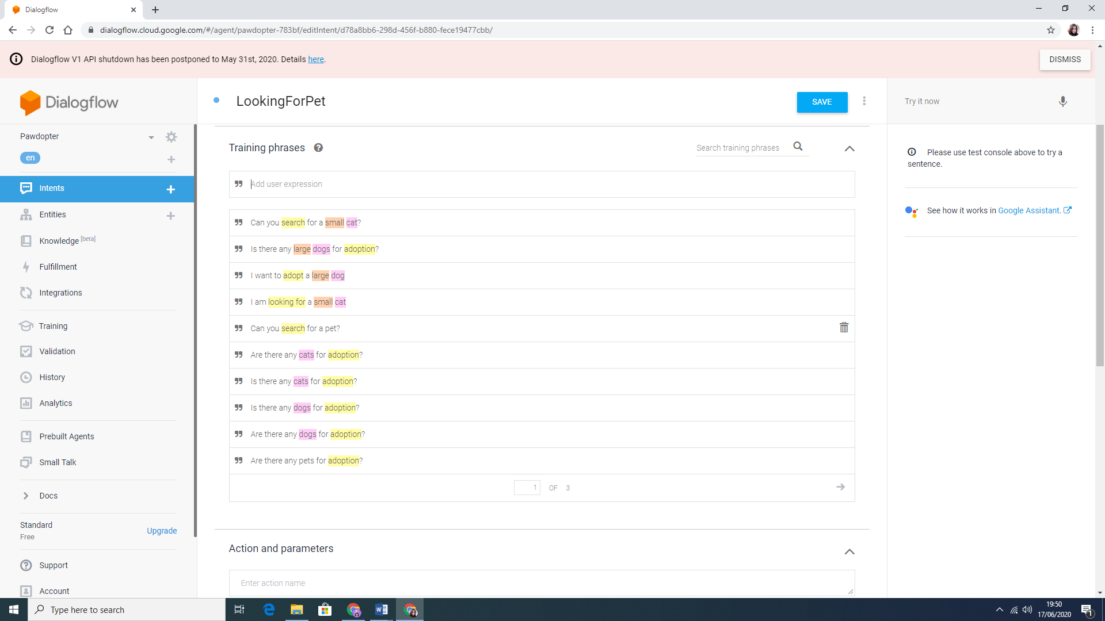 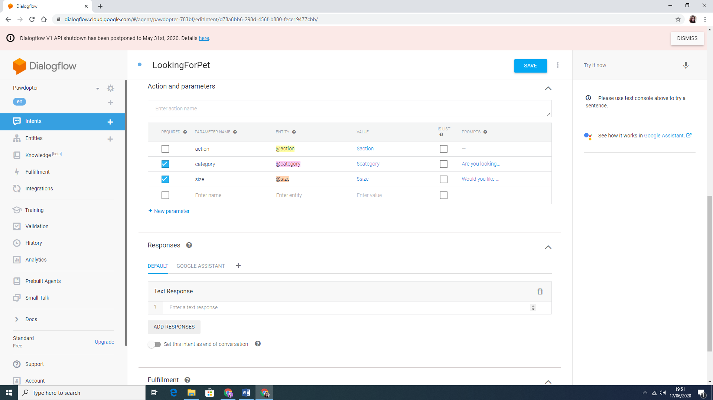

Figure 4.10d: LookingForPet Intent Structure

Figure 4.10e show a Follow-up intent structure, according to the chosen Breed, after selecting the category and size of the desired pet.

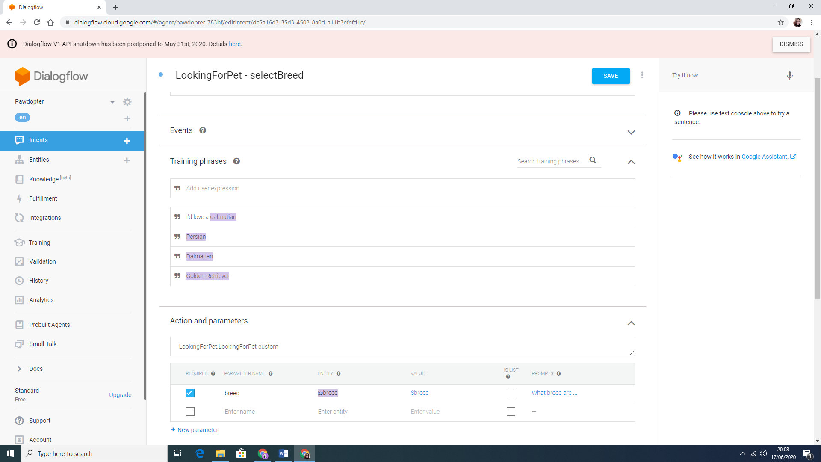

Figure 4.10e: Follow-up Intent Structure

Figure 4.10f shows the Entities created for the current application on the left, and the structure of one of these Entities on the right. Each entity, such as cat or dog, has its synonyms and the Fuzzy matching selection allows Google Assistant to match user’s input with the entities, even when the spelling or pronunciation are not correct.

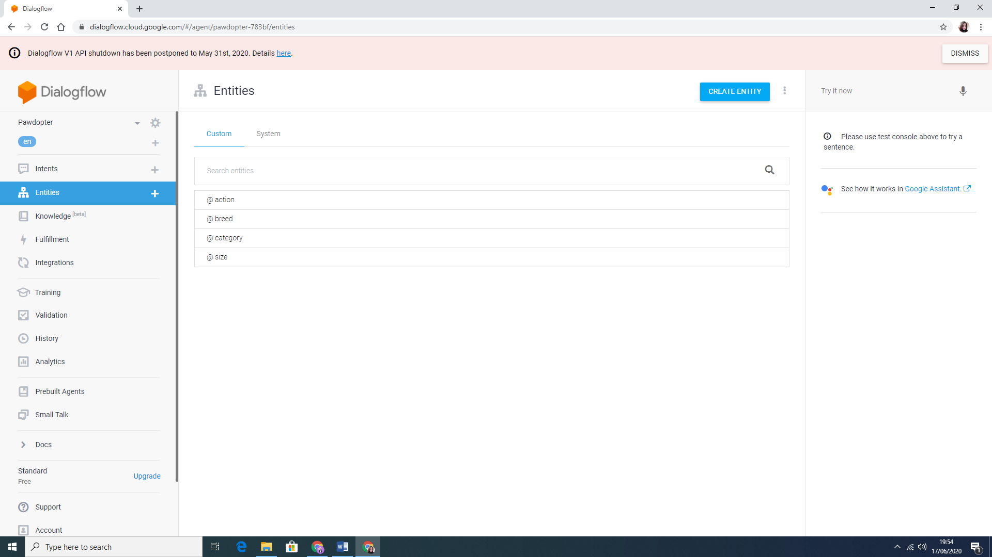 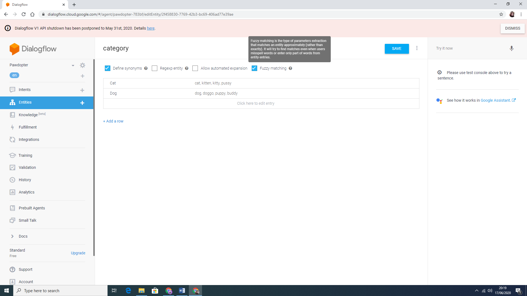

Figure 4.10f: Entities and Entity Structure

**4.11 Three-Tier Architecture**

This project is based on a Three-Tier Architecture for software development that consists of *Presentation* (*User) Tier, Application Tier, and Database Tier*. *The Presentation Tier, or User Tier*, allows the communication with the other two tiers. It represents the Graphical User Interface (GUI), and the communication with the other tiers is made through Application Program Interface (API) calls. In this project, *JavaScript* was used to create the *Presentation Tier*. The *Application Tier,* or *Logic Tier,* uses a programming language (Java) to provide the business logic and the processing of user input for obtaining data and making decision(s), to support the application’s functions. These functions include network management, security, datastore access, etc. In the current project, *Android Studio* with *Java*, as a language, were used. The last tier of this architecture is the *Data Tier,* or *Database Tier,* which is responsible for storing the information. Google’s *Firebase* was used for this project (Rouse, 2020). Figure 4.11a shows the Three-Tier architecture.

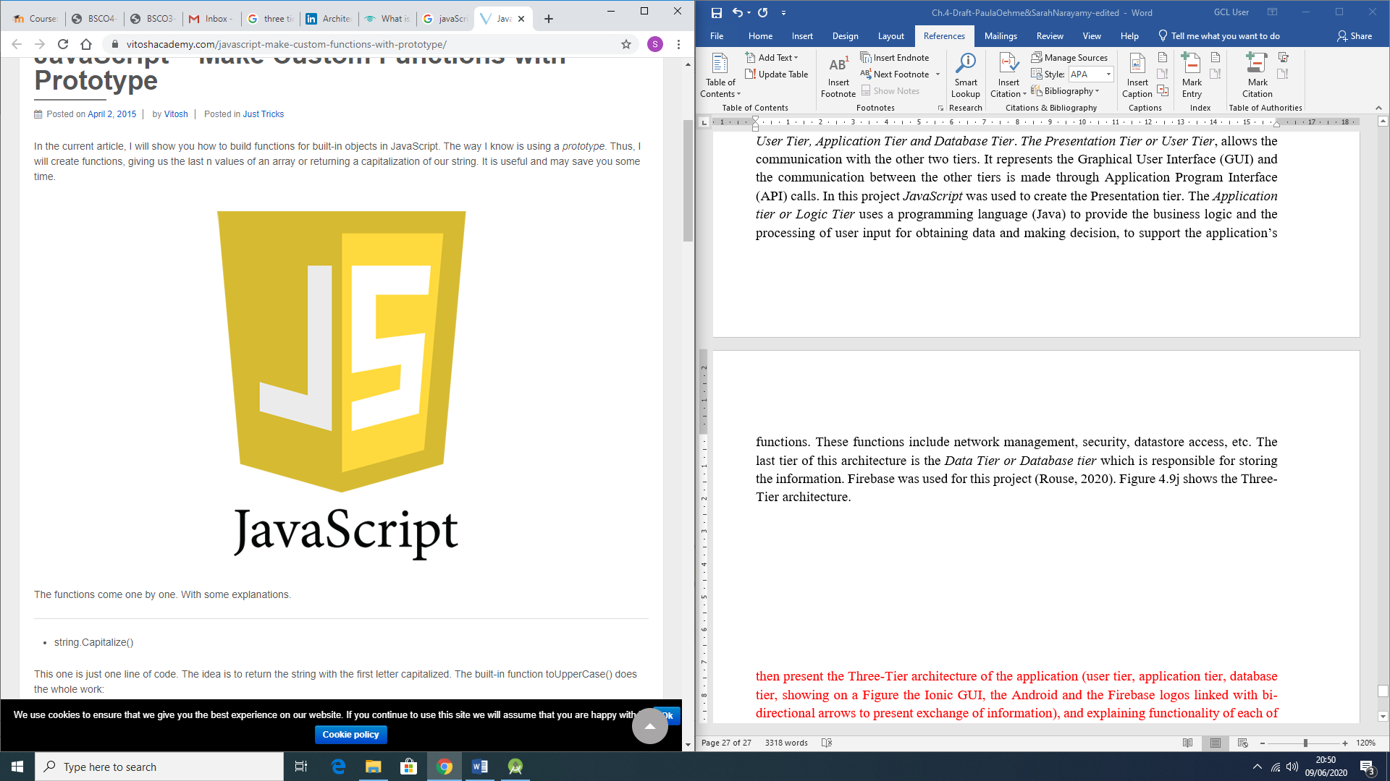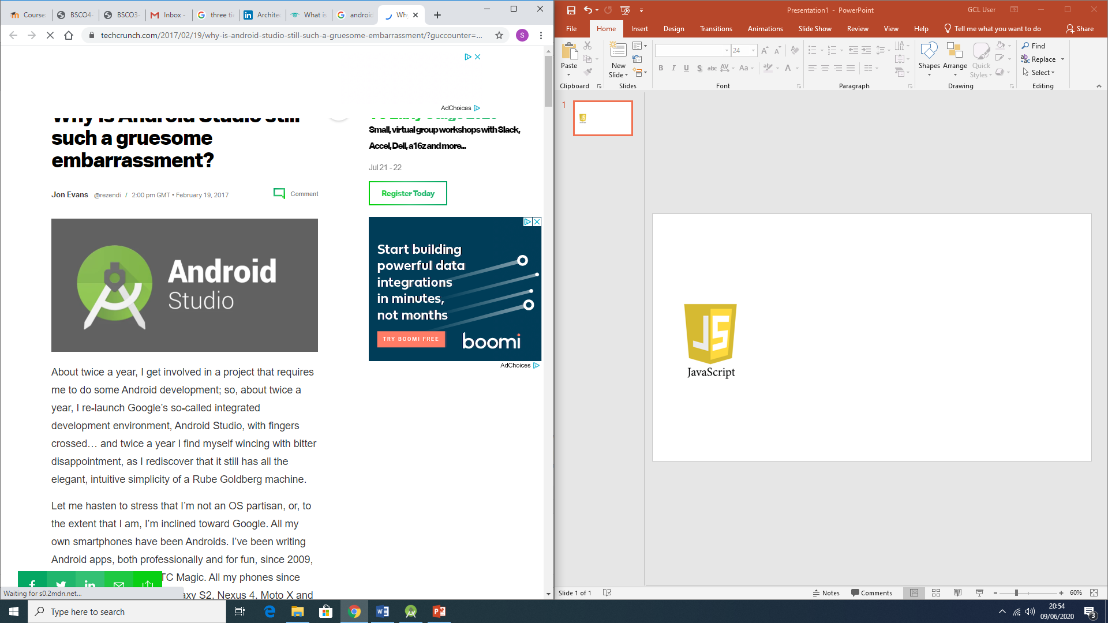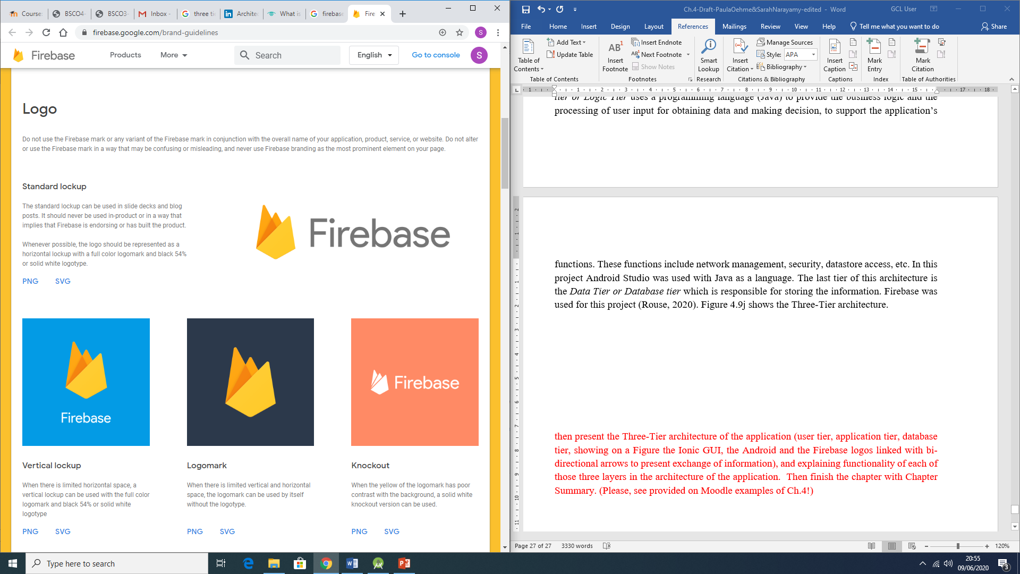

Figure 4.11a: Representation of the Three-Tier Architecture

**4.11 Chapter Summary**

This chapter was important to detail the Design and Coding processes of the current Project’s mobile application. Each section illustrates the importance of planning the design, and the necessary changes being made during the coding process, due to different reasons as explained. These changes were mostly done, in order to enhance either the appearance, or the functionality of the application, or both.

The next chapter will discuss the *Testing* Phase of the application development process.

**Chapter 5: Application Testing Phase**

The *Testing* phase is one the most important one, where the developed solution, in which a lot of time and efforts were invested in, get to be tested. The *Testing* phase usually runs smoothly when all other phases were completed adequately. The *Testing* process is used to ensure that the solution fits the Client’s needs. At organizational level, the product testing may be responsibility of different actors within the business, such as Project Sponsor, Project Manager, Testing Lead, Functional Analyst, Subject Matter Experts (SMEs), and the Technical Staff (Niesse, 2018).

When testing a software, developed with in Agile methods, it is important to follow few principles as follows:

* Testing is continuous;
* Continuous feedback;
* Tests performed by the whole team;
* Decrease time of feedback response;
* Simplified & clean code;
* Less documentation;
* Test driven.

There are a few advantages of Agile Testing, such as Saving time and money, Reduction of documentation, Flexible and highly adaptable to changes, provides a way for receiving regular feedback from the end-user, and Better determination of issues through daily meetings (reqtest, 2018).

There are several different types of Testing, and this chapter is focused on explaining a few of them, and determine an option chosen for the developed application.

**5.1 White-Box Testing**

*White-Box* Testing, also called *Clear-Box* Testing, *Open-Box* Testing, *Glass-Box* Testing, *Transparent-Box* Testing, *Code-Based* Testing, or *Structural* Testing, is a software testing method that tests the internal structure, the design and implementation of the solution to be implemented. Inputs are chosen by the tester to verify paths throughout the code and to determine the appropriate outputs (STFa, 2020).

In order for such testing to be completed, the tester must have a good knowledge and understanding of the internal structure, the code of the software. It tests the logic of the software and it is generally applicable to lower levels of software testing (Jain, 2020).

**Advantages**:

* It can start at an early stage, which means that there is no need to wait for the GUI to be available;
* This procedure is more thorough and has the possibility to cover most paths.

**Disadvantages**:

* High skilled personnel with thorough knowledge of programming and implementation is required, since this testing can be very complex;
* It can become a burden, if the changes are too frequent;
* It is an expensive method

(STFa, 2020)

**5.2 Black-Box Testing**

*Black-Box* Testing is also called *Behavioural* Testing, *Opaque-box*, *Closed-box*, *Specification-based*, or *eye-to-eye* Testing (Software Testing Help, 2020). With this method, the structure, the design, and the implementation of the software, being tested, are not known to the tester. It is usually functional but can also be non-functional. The errors found with this type of testing can be within a few categories, such as Incorrect of missing functions, Interface errors, Errors in data structures or external database access, Behaviour, or performance errors. The name of this testing technique is given because the software program acts like a *black-box* in the eyes of the tester. Figure 5.1a show the structure of the Black-Box Testing (STFb, 2020).

Unlike the *White-Box* testing, the *Black-Box* Testing analyses the functionality of an application, according to its specifications and tests the behaviour of the software. It is appropriate to the higher levels of testing of software and can be done by trial and errors (Jain, 2020).

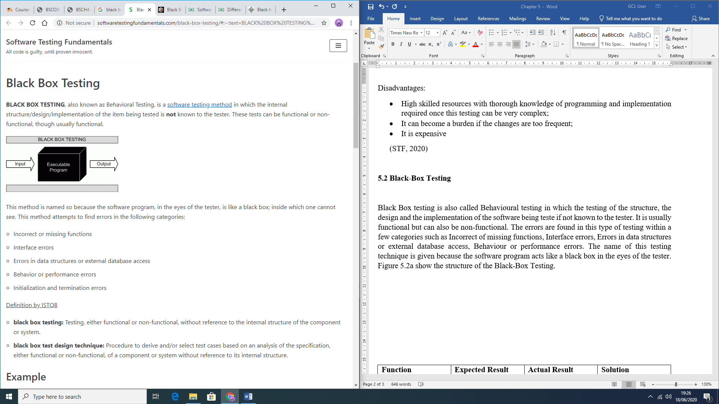  
**Advantages**:

Figure 5.1a: Black-Box representation (STFb, 2020)

* The test is done from the user point of view, helping to expose discrepancies in the specifications;
* There is no need for knowledge of the programming languages or knowledge of the software;
* It can avoid developer-bias, since the testing can be conducted by a body, independent from the developers;
* Allows for an objective perspective;
* Once the specifications are completed, the test can be designed.

**Disadvantages**:

* Possibility of leaving many program paths untested, since it allows for just a small number of possible inputs to be tested;
* It can be difficult to design Testing Cases, if there are no clear specifications;
* Redundancy, if the developer has already run a Testing Case;

(STFb, 2020)

**5.3 Grey-Box Testing**

*Grey-Box* Testing combines both, *Black-Box* and *White-Box* Testing methods features. Initially, the internal structure of the software is known, which means involving having access to internal data structures and algorithms in order to design the Test Cases, but testing is done from the user’s point of view (Black-Box level). The name is given because the program is like a grey or semi-transparent box in the eyes of the tester, which means that internally can be partially seen (STFc, 2020).

By being able to identify context-specific errors that belong to web systems, if the testers encounter any defect, they are able to make the changes in the code and test it again in real time. It provides opportunity to test either, the presentation layer, and/or the internal coding structure of the software (JavaTPoint, 2020).

**Advantages**:

* The goals are clear for the users and developers while testing;
* User focused, since the testing is mostly done from user perspective;
* No need for high programming knowledge for this testing;
* Non-intrusive;
* The overall quality of the software is improved;
* Combined benefits from Black-Box and White-box testing;
* Unbiased, avoiding conflicts between a tester and a developer;
* More effective in integration testing.

**Disadvantages**:

* If testing is performed for distributed systems, the defect association is difficult;
* Limited access for code path traversal lead by limited access to internal structure;
* Not possible to do a complete White-box testing, because the source code cannot be accessed
* Not suitable for algorithm testing;
* Difficulty to design most of the Testing Cases.

(GeeksforGeeks, 2020)

**5.4 Chosen Testing Method**

*Grey-Box* testing was chosen for this project due to its combined advantages and to the fact that allows testing from both, user and developer perspectives. Errors are meant to be encountered while developing the software, however, with *Grey-Box* testing these errors can be fixed along with the coding. Also, the testing coverage is increased within all areas of the application and suits the limited project time frame.

**5.5 Errors Encountered During Application Development**

A few errors were encountered during the development of the software. Table 5.5a presents these errors and how they were fixed.

|  |  |  |  |
| --- | --- | --- | --- |
| **Function** | **Expected Result** | **Actual Result** | **Solution** |
| Register | Error message displayed, when user presses the *Register* button, *without* complying with security requirements | User registered successfully *even* without complying with security requirements | Use of the appropriate patterns (phone, e-mail, and password) and use of appropriate *validation* methods |
| Use of the filters | Necessary to use one filter, to activate the next, and so forward | User was able to select different filters *without* dependency | Nest each one of the filters within the other |
| Shelter Profile display | Show the appropriate information for specific shelter | *Mismatched* information displayed on the screen | Passing the specific information about a shelter through use of (putExtra()) in an *intent* |
| Return to *Animal* Profile from a *Shelter* profile | Returning to the *Animal* profile | Error occurred, landing the user to the *Home* screen | Passing the *Animal* object through an *intent* when opening the *Shelter* profile screen |

*Table 5.1a: Initial Errors Encountered during the Development process*

**5.6 Application Testing Process with Testing Cases**

All functionalities were completely tested and Table 5.1b presents the checks done with Testing Cases and outcomes of these tests.

Table 5.1b: Application Testing process with Testing Cases

|  |  |  |  |  |
| --- | --- | --- | --- | --- |
| **Action** | **Expected result** | **Pass** | **Fail** | **Actual result** |
| Open  application | Initial screen opens if user has *not registered* and *logged in*, otherwise main screen opens | ✓ |  | Initial screen is displayed if user has *not registered* and *not logged in*. Main screen is displayed otherwise |
| Select *Register* option | *Registration* screen opens | ✓ |  | *Registration* screen is displayed |
| *Register* button pressed *without* any data entered | Display *error message* to enter data for each field | ✓ |  | Error message *is displayed* in each field, asking user to enter data |
| *Register* button pressed when *invalid* data is entered | Display *specific error* message to each field where data is *invalid*, guiding the user on how to fix it | ✓ |  | *Specific error message* is displayed to each field where data is *invalid*, guiding the user on how to fix it |
| *Register* button pressed with *valid* data entered in all fields | Create *new user* and open *main* screen | ✓ |  | New user is created, and main screen is displayed |
| Select *Login* option | *Login* screen opens | ✓ |  | *Login* screen is displayed |
| *Login* button pressed *without* any data entered | Display *error message* to enter data | ✓ |  | *Error message* is displayed in each field, asking user to *enter* data |
| *Login* button pressed when *invalid* data is entered | Display *specific Toast message,* regarding the error | ✓ |  | Specific Toast message regarding the error is displayed |
| *Login* button pressed with *correct* username and password | User is logged in successfully, while a Toast messaged is displayed and *main* screen opens | ✓ |  | Login is *successful* while a Toast message is displayed, and *main* screen is displayed |
| *“Not registered yet?”* TextView is clicked | *Registration* screen opens | ✓ |  | *Registration* screen is displayed |
| *“Forgot your password?”* TextView is clicked | *Reset password* screen opens | ✓ |  | *Reset password* screen is displayed |
| *Reset password* button is clicked *without* any e-mail entered | Display *error message* to enter username | ✓ |  | *Error message* is displayed, asking user to *enter* their username |
| *Reset password* button is clicked with *invalid* e-mail entered | Display *specific error* message, guiding user on how to fix it | ✓ |  | *Specific error* message is displayed, guiding user on how to fix it |
| *Reset password* button is clicked with *correct* e-mail entered | An e-mail with a *link for resetting the password* is sent to the user’s registered e-mail | ✓ |  | Send a *resetting password link* to the user’s registered e-mail address |
| *Update Profile* menu item is clicked | *Update Profile* screen opens | ✓ |  | *Update Profile* screen is displayed |
| *Update Profile* button clicked with *empty* fields | Display *error message* to enter data for each field | ✓ |  | *Error message* is displayed in each field, asking user to enter data |
| *Update Profile* button clicked when *invalid* data is entered | Display *specific* error message to each field, where data is *invalid*, guiding the user on how to fix it | ✓ |  | *Specific error message* is displayed to each field where data is *invalid*, guiding the user on how to fix it |
| *Update Profile* button clicked when *valid* data is entered | Display Toast message, notifying the user that the *changes were saved* | ✓ |  | Toast message notifying the user that the *changes were saved* is displayed |
| *Logout* menu item is clicked | User is *logged out* while a Toast message is being displayed on the screen, and *initial* screen opens | ✓ |  | *Logout successful* Toast message is displayed, and *initial* screen is displayed |
| *Category* filter is selected | Options of *Animal category* are displayed in a *dropdown menu* | ✓ |  | Displays the *Animal category options* available in a *dropdown menu* format |
| *Category option* item is clicked | *List of* *animals* displayed on the screen to match the *selected category*. *Size filter* selection is enabled | ✓ |  | Displays the *list of animals* that matches the *selected category* and enables the *size filter* selection |
| *Size filter* is clicked | Options of *size* are displayed in a *dropdown menu* | ✓ |  | Displays the *size options* in a *dropdown menu* format |
| *Size option* item is clicked | *List of animals* displayed on the screen to match the *selected size*, while also matching the *pre-selected category* filter. *Breed filter* selection is enabled | ✓ |  | Displays the *list of animals* that match the *selected size* while also matching the *pre-selected category* filter. Enables the *breed filter* selection |
| *Breed filter* is clicked | *Options of breeds* that match both the *pre-selected category* and *size filters* are displayed in a *dropdown menu* | ✓ |  | Displays the *animal breed options* that match both the *pre-selected category* and *size filters* in a *dropdown menu* format |
| *Breed option* item is clicked | *List of animals* displayed on the screen to match *all filters applied* (category, size, and breed) | ✓ |  | Displays the *list of animals* that match *all filters selected* (category, size, and breed) |
| *Chosen Animal* item from the list is clicked | *Animal profile* screen opens | ✓ |  | *Animal profile* screen is displayed |
| Click on *Send Intent for Adoption* | Prompts the user to *select* from e-mail providers, available on the user’s phone, that may be used to send the Intent form | ✓ |  | A selection of *e-mail providers*, available on the user’s phone is prompted, so the user can *choose* one to *send* the Adoption Intent form |
| E-mail provider is *selected* | Opens the external *e-mail application* with automatically generated template with *recipient’s address*, *subject* and *pre-defined e-mail body* with selected *animal name* information | ✓ |  | External *e-mail application* is opened, with automatically generated template with *recipient’s address*, *subject* and *pre-defined e-mail body* with selected *animal name* information |
| *Shelter name* TextView is clicked | *Shelter profile* screen opens | ✓ |  | *Shelter profile* screen is displayed |
| *Zoom in* button on the integrated *Google Map* is clicked | Map is *zoomed in* one level, being able to zoom in *up to level 20* | ✓ |  | *Zoom in* one level is applied on map, being able to zoom in *up to level 20* |
| *Zoom out* button on the integrated Google Map is clicked | Map is *zoomed out* one level, being able to zoom out up to the *level 7* (starting on the minimum zoom level) | ✓ |  | *Zoom out* one level is applied on map, being able to zoom out *up to the level 7* (starting on the minimum zoom level) |
| *Go back* to *Animal profile* button is clicked | Returns user back to the *Animal profile* screen | ✓ |  | Goes *back* to the *Animal profile* screen, the user was navigated from |
| *Back* button is clicked | Return to the *previous* screen | ✓ |  | Goes *back* to the *previous* screen |

**5.7 Chapter Summary**

Three major Testing methodologies were presented in this chapter (*White-Box* testing, *Black-Box* Testing and *Grey-Box* Testing) with their advantages and disadvantages, in order to decide on which one to be used within the current project. After analysing thoroughly each option, decided was that the *Grey-Box* Testing would be the most appropriate option, since it combines both the *Black-* and *White*-Box advantages and favours the short time frame of the Project.

Also presented in this chapter was the Testing process with Testing Cases, developed for the completed application, all of which were *successfully* passed.

The next chapter will present the end-user Testing results of the software (User Evaluation Results Analysis), as well as Project’s Conclusion, Achievements and Scope for Future work.

# REFERENCES:

Abellán, E. (2020). *WAM.* [Online]   
Available at: https://www.wearemarketing.com/blog/what-is-the-agile-methodology-and-what-benefits-does-it-have-for-your-company.html  
[Accessed 11 April 2020].

Agile Modeling (2020). *UML 2 - Use Case Diagramming Guidelines.* [Online]   
Available at: http://www.agilemodeling.com/style/useCaseDiagram.htm  
[Accessed 09 April 2020].

Amazon, 2020. *Amazon.* [Online]   
Available at: https://us.amazon.com/Raspberry-Pi-Zero-W-Kit/dp/B07RXHJW9W  
[Accessed 28 March 2020].

Anderson, N., McGowan, A., Hanna, P. & Busch, J. (2015). Strange, but true? Object-Oriented programming is best taught, and learnt, while sitting on the floor. *Australian Association for Research in Education*, 29 November, p. 15. [Online]

Available at: https://files.eric.ed.gov/fulltext/ED593835.pdf

[Accessed 07 April 2020].

Animal Health and Welfare Act, 2013. *Eletronic Irish Statute Book.* [Online]   
Available at: http://www.irishstatutebook.ie/eli/2013/act/15/enacted/en/pdf  
[Accessed 25 March 2020].

Appelo, J. (2008). *The Definitive List of Software Development Methodologies.* [Online]   
Available at: https://noop.nl/2008/07/the-definitive-list-of-software-development-methodologies.html  
[Accessed 11 April 2020].

Athuraliya, A. (2017). *Sequence Diagram Tutorial: Complete Guide with Examples.* [Online]   
Available at: https://creately.com/blog/diagrams/sequence-diagram-tutorial/  
[Accessed 10 April 2020].

Bravo, E., 2019. *Smart.city_lab.* [Online]   
Available at: https://www.smartcitylab.com/blog/urban-environment/amsterdam-launches-a-modular-urban-lighting-system/  
[Accessed 26 March 2020].

Callaham, J., 2017. *Android Authority.* [Online]   
Available at: https://www.androidauthority.com/android-market-google-play-history-754989/  
[Accessed 22 March 2020].

Callaham, J. (2019). *The history of Android OS: its name, origin and more.* [Online]   
Available at: https://www.androidauthority.com/history-android-os-name-789433/  
[Accessed 07 April 2020].

Canney, S., 2019. *Houses of the Oireachtas.* [Online]   
Available at: https://www.oireachtas.ie/en/debates/question/2019-01-22/604/#pq-answers-604  
[Accessed 24 March 2020].

Cherednichenko, S., 2018. *Mobindustry.* [Online]   
Available at: https://www.mobindustry.net/how-to-develop-an-app-for-the-internet-of-things-iot/  
[Accessed 27 March 2020].

Citizens Information, 2019. *Data Protection Act.* [Online]   
Available at: https://www.citizensinformation.ie/en/government_in_ireland/national_government/standards_and_accountability/data_protection.html  
[Accessed 26 March 2020].

Citizens Information, 2020. *Control of Dogs.* [Online]   
Available at: https://www.citizensinformation.ie/en/environment/animal_welfare_and_control/control_of_dogs.html  
[Accessed 26 March 2020].

Control of Dogs Act, 1986. *Eletronic Irish Statute Book.* [Online]   
Available at: http://www.irishstatutebook.ie/eli/1986/act/32/enacted/en/print.html  
[Accessed 24 March 2020].

Council of Europe, 1981. *Conventions.* [Online]   
Available at: https://www.coe.int/en/web/conventions/full-list/-/conventions/treaty/108  
[Accessed 26 March 2020].

Cyrenne, S., 2019. *Homeo Animal.* [Online]   
Available at: https://www.homeoanimal.com/blogs/blog-pet-health/81114180-animal-rescue-and-animal-shelter-what-is-the-difference  
[Accessed 23 March 2020].

Data Protection Act, 1988. *Eletronic Irish Statute Book.* [Online]   
Available at: http://www.irishstatutebook.ie/eli/1988/act/25/enacted/en/print.html  
[Accessed 26 March 2020].

Dataplicity, 2019. *Get Pi connected to the Internet.* [Online]   
Available at: https://docs.dataplicity.com/docs/get-pi-connected-to-the-internet  
[Accessed 24 April 2020].

Department of Rural and Community Development, Ireland (2018). *Gov.* [Online]   
Available at: https://www.gov.ie/en/collection/879d4c-dog-control-statistics/  
[Accessed 01 March 2020].

DialogFlow, 2020. *DialogFlow.* [Online]   
Available at: https://dialogflow.com/  
[Accessed 13 June 2020].

Dundalk Dog Rescue, 2020. *Dundalk Dog Rescue.* [Online]   
Available at: http://www.dundalkdogrescue.ie/about/  
[Accessed 21 March 2020].

Evans, D., 2011. *Cisco.* [Online]   
Available at: https://www.cisco.com/c/dam/en_us/about/ac79/docs/innov/IoT_IBSG_0411FINAL.pdf  
[Accessed 27 March 2020].

Firebase, 2020. *Firebase.* [Online]   
Available at: https://firebase.google.com/docs/database

Fromaget, P. (2020). *Raspberry Tips.* [Online]   
Available at: https://raspberrytips.com/raspberry-pi-history/  
[Accessed 27 February 2020].

Gebhart, A., 2019. *Cnet.* [Online]   
Available at: https://www.cnet.com/how-to/everything-you-need-to-know-about-google-home/  
[Accessed 28 March 2020].

GeeksforGeeks (2020). *Kotlin Programming Language.* [Online]   
Available at: https://www.geeksforgeeks.org/kotlin-programming-language/  
[Accessed 08 April 2020].

GeeksforGeeks, 2020. *GeeksforGeeks.* [Online]   
Available at: https://www.geeksforgeeks.org/gray-box-testing-software-testing/  
[Accessed 18 June 2020].

Google Cloud, 2020. *Google Cloud.* [Online]   
Available at: https://cloud.google.com/dialogflow/docs/basics  
[Accessed 13 June 2020].

Google Play, 2020a. *Nest.* [Online]   
Available at: https://play.google.com/store/apps/details?id=com.nest.android  
[Accessed 27 March 2020].

Google Play, 2020b. *Wistle.* [Online]   
Available at: https://play.google.com/store/apps/details?id=com.whistle.bolt  
[Accessed 27 March 2020].

Google Play, 2020c. *Smart Life.* [Online]   
Available at: https://play.google.com/store/apps/details?id=com.tuya.smartlife&gl=IE  
[Accessed 27 March 2020].

Google Play, 2020d. *Appets.* [Online]   
Available at: https://play.google.com/store/apps/details?id=co.applist.appets&gl=IE  
[Accessed 2 March 2020].

Google Play, 2020e. *Pets Adoption.* [Online]

Available at: https://play.google.com/store/apps/details?id=com.SelfappDeveloper.AdoptDog&gl=IE  
[Accessed 3 March 2020].

Gubbi, J., Buyya, R., Marusic, S. & Palaniswami, M. (2013). Internet of Things (IoT): A vision, architectural elements, and future directions. *Future Generation Computer Systems,* 29(7), pp. 1645-16660.

Guru99 (2020). *Dynamic Software Development Method.* [Online]   
Available at: https://www.guru99.com/agile-scrum-extreme-testing.html#10  
[Accessed 11 April 2020].

Hammarberg, k., Kirkman, M. & de Lacey, S. (2016). Qualitative research methods: when to use them and how to judge them. *Human Reproduction,* 31(3), pp. 498-501.

Hardwood, T., 2019. *Postscapes.* [Online]   
Available at: https://www.postscapes.com/iot-history/  
[Accessed 26 March 2020].

Horwitz, L., 2017. *Cisco.* [Online]   
Available at: https://www.cisco.com/c/en/us/solutions/internet-of-things/smart-city-infrastructure.html  
[Accessed 27 March 2020].

Houpt, K. A.; Goodwin, D.; Uchida, Y.; Baranyiová, E.; Fatjó, J.; Kakuma, Y. (2007). Proceedings of a workshop to identify dog welfare issues in the US, Japan, Czech Republic, Spain and the UK. *In:* Fatjó, J.; Bowen, J.; Garcia, E.; Calvo, P.; Rueda, S.; Amblas, S.; Lalanza, J. F. (2015). Epidemiology of dog and cat abandonment in Spain (2008–2013). *Animals,* 5(2), pp. 426-441.

Independent (2016). *Ireland's largest pet ownership study: here's all the facts you need to know.* Eds. [Online]   
Available at: https://www.independent.ie/life/family/irelands-largest-pet-ownership-study-heres-all-the-facts-you-need-to-know-34505427.html  
[Accessed 01 March 2020].

IntellectSoft (2019). *Top 12 Software Development Methodologies You Should Know.* [Online] Available at: https://www.intellectsoft.net/blog/top-12-software-development-methodologies-you-should-know/  
[Accessed 08 April 2020].

Islam, M. (2017). *RAD.* [Online]   
Available at: http://sddmohammedislam.weebly.com/rad.html  
[Accessed 11 April 2020].

Jain, A. (2019). *Unified Modeling Language (UML) - Sequence Diagrams.* [Online]   
Available at: https://www.geeksforgeeks.org/unified-modeling-language-uml-sequence-diagrams/  
[Accessed 10 April 2020].

Jain, A. (2020). *Unified Modeling Language (UML) - Object Diagrams.* [Online]   
Available at: https://www.geeksforgeeks.org/unified-modeling-language-uml-object-diagrams/  
[Accessed 10 April 2020].

Jain, M., 2020. *GeeksforGeeks.* [Online]   
Available at: https://www.geeksforgeeks.org/differences-between-black-box-testing-vs-white-box-testing/  
[Accessed 18 June 2020].

JavaTPoint (2018). *Waterfall Model.* [Online]   
Available at: https://www.javatpoint.com/jira-waterfall-model  
[Accessed 10 April 2020].

JavaTPoint, 2020. *JavaTPoint.* [Online]   
Available at: https://www.javatpoint.com/grey-box-testing  
[Accessed 18 June 2020].

JetRuby, 2017. *Medium.* [Online]   
Available at: https://expertise.jetruby.com/brief-history-of-mobile-apps-286fbbf766a9  
[Accessed 21 March 2020].

Johnson, B., 2020. *Howstuffworks.* [Online]   
Available at: https://computer.howstuffworks.com/raspberry-pi2.htm  
[Accessed 24 April 2020].

Lee, W.-M. & Chng, C., 2018. *Code magazine.* [Online]   
Available at: https://www.codemag.com/Article/1607071/Introduction-to-IoT-Using-the-Raspberry-Pi  
[Accessed 27 March 2020].

Lee, I. & Lee, K. (2015). The Internet of Things (IoT): Applications, investments, and challenges for enterprises. *Elsevier,* 4(58), pp. 431-440.

Lucid Chart (2020a). *UML Use Case Diagram Tutorial.* [Online]   
Available at: https://www.lucidchart.com/pages/uml-use-case-diagram  
[Accessed 09 April 2020].

Lucid Chart (2020b). *UML Class Diagram Tutorial.* [Online]   
Available at: https://www.lucidchart.com/pages/uml-class-diagram  
[Accessed 10 April 2020].

LucidChart Content Team (2019). *4 Phases of Rapid Application DevelopmentMethodoly.* [Online]   
Available at: https://www.lucidchart.com/blog/rapid-application-development-methodology  
[Accessed 11 April 2020].

LucidChart Content Team (2020). *LucidChart.* [Online]   
Available at: https://www.lucidchart.com/blog/rapid-application-development-methodology  
[Accessed 03 March 2020].

Lueth, K. L., 2018. *Iot analytics.* [Online]   
Available at: https://iot-analytics.com/state-of-the-iot-update-q1-q2-2018-number-of-iot-devices-now-7b/  
[Accessed 28 March 2020].

Mitchel, S., Villa, N., Stewart-weeks, M. & Lange, A., 2013. *Cisco.* [Online]   
Available at: https://www.cisco.com/c/dam/en_us/solutions/industries/docs/gov/everything-for-cities.pdf  
[Accessed 28 March 2020].

Monus, A. (2020). *6 OOP Concepts in Java with examples.* [Online]   
Available at: https://raygun.com/blog/oop-concepts-java/#association  
[Accessed 08 April 2020].

Muslihat, D. (2018). *Agile Methodology: An Overview.* [Online]   
Available at: https://zenkit.com/en/blog/agile-methodology-an-overview/  
[Accessed 11 April 2020].

Nakov, S., Dimitrov, D., Germanov, H., Murdanliev, I., Stoynov, M., Bivas, M., Kostov, N., Nedyalkov, N., Vasilev, N., Donchev, P., Hadjieva, P., Ivanov, R., Kirilov, R., Todorov, R., Zlatinov, S., Staev, S., Nakov, S., Bozhikov, T., Stoev, T., Konov, T., Georgiev, V., Kolev, V., Pavlov, V., Yosifov, Y. (2013). *Fundamentals of computer programming with C#. The Bulgarian C# book.* 1 ed. Bulgary: Faber Publishing.

Available at: https://introprogramming.info/wp-content/uploads/2013/07/Books/CSharpEn/Fundamentals-of-Computer-Programming-with-CSharp-Nakov-eBook-v2013.pdf

[Accessed 08 April 2020].

Niesse, E., 2018. *HRchitect.* [Online]   
Available at: https://hrchitect.com/testing-phase-clients-role-implementation/  
[Accessed 16 June 2020].

Nuttal, B. (2017). *Opensource.* [Online]   
Available at: https://opensource.com/article/17/3/physical-computing-raspberry-pi  
[Accessed 01 March 2020].

Open Source (2019). *Open Source.* [Online]   
Available at: https://opensource.com/resources/raspberry-pi  
[Accessed 01 March 2020].

Oracle (2020). *Oracle.* [Online]   
Available at: https://www.oracle.com/ie/internet-of-things/what-is-iot.html  
[Accessed 29 February 2020].

Pal, S. K. (2019). *Software Engineering - Spiral Model.* [Online]   
Available at: https://www.geeksforgeeks.org/software-engineering-spiral-model/  
[Accessed 11 April 2020].

Pet Rescue, 2019. *Pet Rescue.* [Online]   
Available at: https://www.petrescue.com.au/library/articles/the-difference-between-a-pound-shelter-and-rescue  
[Accessed 23 March 2020].

PETA - People for Ethical Treatment of Animals, n.d. *PETA - People for Ethical Treatment of Animals.* [Online]   
Available at: https://www.peta.org/issues/animal-companion-issues/animal-shelters/  
[Accessed 23 March 2020].

Pounds Provision and Maintenance Act, 1935. *Eletronic Irish Statute Book.* [Online]   
Available at: http://www.irishstatutebook.ie/eli/1935/act/17/enacted/en/print.html  
[Accessed 22 March 2020].

Project Manager (2020). *Waterfall Methodology in Project Management.* [Online]   
Available at: https://www.projectmanager.com/software/use-cases/waterfall-methodology  
[Accessed 09 April 2020].

Protection of Animals Amendment Act, 1965. *Eletronic Irish Statute Book.* [Online]   
Available at: http://www.irishstatutebook.ie/eli/1965/act/10/enacted/en/print  
[Accessed 23 March 2020].

Ranger, S. (2020). *ZDNet.* [Online]   
Available at: https://www.zdnet.com/article/what-is-the-internet-of-things-everything-you-need-to-know-about-the-iot-right-now/  
[Accessed 28 February 2020].

Raphael, J. (2020). *Android versions: A living history from 1.0 to 10.* [Online]   
Available at: https://www.computerworld.com/article/3235946/android-versions-a-living-history-from-1-0-to-today.html  
[Accessed 05 April 2020].

Raspberry Pi Foundation, 2020. *Raspberrypi.* [Online]   
Available at: https://www.raspberrypi.org/documentation/usage/gpio/  
[Accessed 24 April 2020].

Reisinger, D. (2020). *Google Home Vs Amazon Echo: A Comparison.* [Online]   
Available at: https://www.forbes.com/sites/forbes-personal-shopper/2020/02/06/google-home-vs-amazon-echo-a-comparison/  
[Accessed 11 April 2020].

Reqtest, 2018. *Reqtest.* [Online]   
Available at: https://reqtest.com/testing-blog/agile-testing-principles-methods-advantages/  
[Accessed 17 June 2020].

Rescue Animals Ireland, 2020a. *Rescue Animals Ireland.* [Online]   
Available at: http://rescueanimalsireland.ie/all-rescues  
[Accessed 23 March 2020].

Rescue Animals Ireland, 2020b. *Rescue Animals Ireland.* [Online]   
Available at: http://rescueanimalsireland.ie/useful-information/adopting-a-dog  
[Accessed 26 March 2020].

Romkey, J., Hackett, S., Stanford-Clark, A. & Nipper, A., 2014. A Brief History of the Internet of Things.. *Baseline*, 9 September, p. 1. Available at: http://web.b.ebscohost.com/ehost/detail/detail?vid=0&sid=6626a862-e4f9-44ec-bbef-55b1c08d6ade%40pdc-v-sessmgr04&bdata=JnNpdGU9ZWhvc3QtbGl2ZQ%3d%3d#AN=98969708&db=buh

[Accessed 27 March 2020].

Rouse, M., 2020. *Techtarget.* [Online]   
Available at: https://searchsoftwarequality.techtarget.com/definition/3-tier-application  
[Accessed 15 June 2020].

Sacolick, I. (2020). *What is Agile methodology? Modern software development explained.* [Online]   
Available at: https://www.infoworld.com/article/3237508/what-is-agile-methodology-modern-software-development-explained.html  
[Accessed 11 April 2020].

Sharma, R. (2019). *Developing for Android - An Introduction.* [Online]   
Available at: https://www.cprogramming.com/android/android_getting_started.html  
[Accessed 08 April 2020].

Silva, N. (2019). *Use Case Diagram Relationships Explained with Examples.* [Online]   
Available at: https://creately.com/blog/diagrams/use-case-diagram-relationships/  
[Accessed 09 April 2020].

Smart Draw (2020). *Sequence Diagram.* [Online]   
Available at: https://www.smartdraw.com/sequence-diagram/  
[Accessed 10 April 2020].

Software Testing Help, 2020. *Software Testing Help.* [Online]   
Available at: https://www.softwaretestinghelp.com/black-box-testing/  
[Accessed 18 June 2020].

StatCounter (2020a). *Mobile Operating System Market Share Ireland.* [Online]   
Available at: https://gs.statcounter.com/os-market-share/mobile/ireland  
[Accessed 7 April 2020]

StatCounter (2020b). *Mobile Operating System Market Share Worldwide.* [Online]   
Available at: https://gs.statcounter.com/os-market-share/mobile/worldwide  
[Accessed 8 April 2020].

STFa, 2020. *Software Testing Fundamentals.* [Online]   
Available at: http://softwaretestingfundamentals.com/white-box-testing/#:~:text=WHITE%20BOX%20TESTING%20(also%20known,is%20known%20to%20the%20tester.  
[Accessed 17 June 2020].

STFb, 2020. *Software Testing Fundamentals.* [Online]   
Available at: http://softwaretestingfundamentals.com/black-box-testing/#:~:text=BLACK%20BOX%20TESTING%2C%20also%20known,%2Dfunctional%2C%20though%20usually%20functional.  
[Accessed 18 June 2020].

STFc, 2020. *Software Testing Fundamentals.* [Online]   
Available at: http://softwaretestingfundamentals.com/gray-box-testing/  
[Accessed 18 June 2020].

TatvaSoft (2015). *Top12 Software Development Methodologies & its Advantages/Disadvantages.* [Online]   
Available at: https://www.tatvasoft.com/blog/top-12-software-development-methodologies-and-its-advantages-disadvantages/  
[Accessed 11 April 2020].

Techopedia, 2016. *Techopedia.* [Online]   
Available at: https://www.techopedia.com/definition/9505/splash-screen  
[Accessed 19 June 2020].

The Dublin Society for Prevention of Cruelty ti Animals - DSPCA, 2020. *The Dublin Society for Prevention of Cruelty ti Animals - DSPCA.* [Online]   
Available at: https://www.dspca.ie/dogadoptionprocess/  
[Accessed 25 March 2020].

The Irish Society for the Prevention of Cruelty to Animals (2019). *ISPCA - Caring for all animals.* [Online]   
Available at: https://www.ispca.ie/images/pages/Annual_Report.pdf  
[Accessed 02 March 2020].

The Tool (2018). *Differences Between Android and iOS in Mobile App Developmentl.* [Online]   
Available at: https://thetool.io/2018/mobile-app-development-ios-vs-android  
[Accessed 07 April 2020].

Tryqa (2017). *What is RAD model - advantages, disadvantages and when to use it?.* [Online]   
Available at: http://tryqa.com/what-is-rad-model-advantages-disadvantages-and-when-to-use-it/  
[Accessed 11 April 2020].

Tutorials Point (2020). *UML - Use Case Diagrams.* [Online]   
Available at: https://www.tutorialspoint.com/uml/uml_use_case_diagram.htm  
[Accessed 09 April 2020].

Upton, L., 2013. *Raspberry Pi Blog.* [Online]   
Available at: https://www.raspberrypi.org/blog/zoological-society-of-london-saving-rhinos-with-the-pi/  
[Accessed 28 March 2020].

Visual Paradigm (2020). *What is Unified Modeling Language (UML)?.* [Online]   
Available at: https://www.visual-paradigm.com/guide/uml-unified-modeling-language/what-is-uml/  
[Accessed 09 April 2020].

Viswanathan, P., 2019. *Lifewire.* [Online]   
Available at: https://www.lifewire.com/what-is-a-mobile-application-2373354  
[Accessed 23 March 2020].

Viva Differences (2019). *Difference Between Spiral Model and Prototype Model In Software Engineering.* [Online]   
Available at: https://vivadifferences.com/difference-between-spiral-model-and-prototype-model-in-software-engineering/  
[Accessed 11 April 2020].

Westernberg, J., 2019. *Android authority.* [Online]   
Available at: https://www.androidauthority.com/google-home-services-749968/  
[Accessed 28 March 2020].

# APPENDIX A1: Gantt Chart of the Project

# 

# APPENDIX A2: Graphical Representation of the Potential Adopters Survey Results

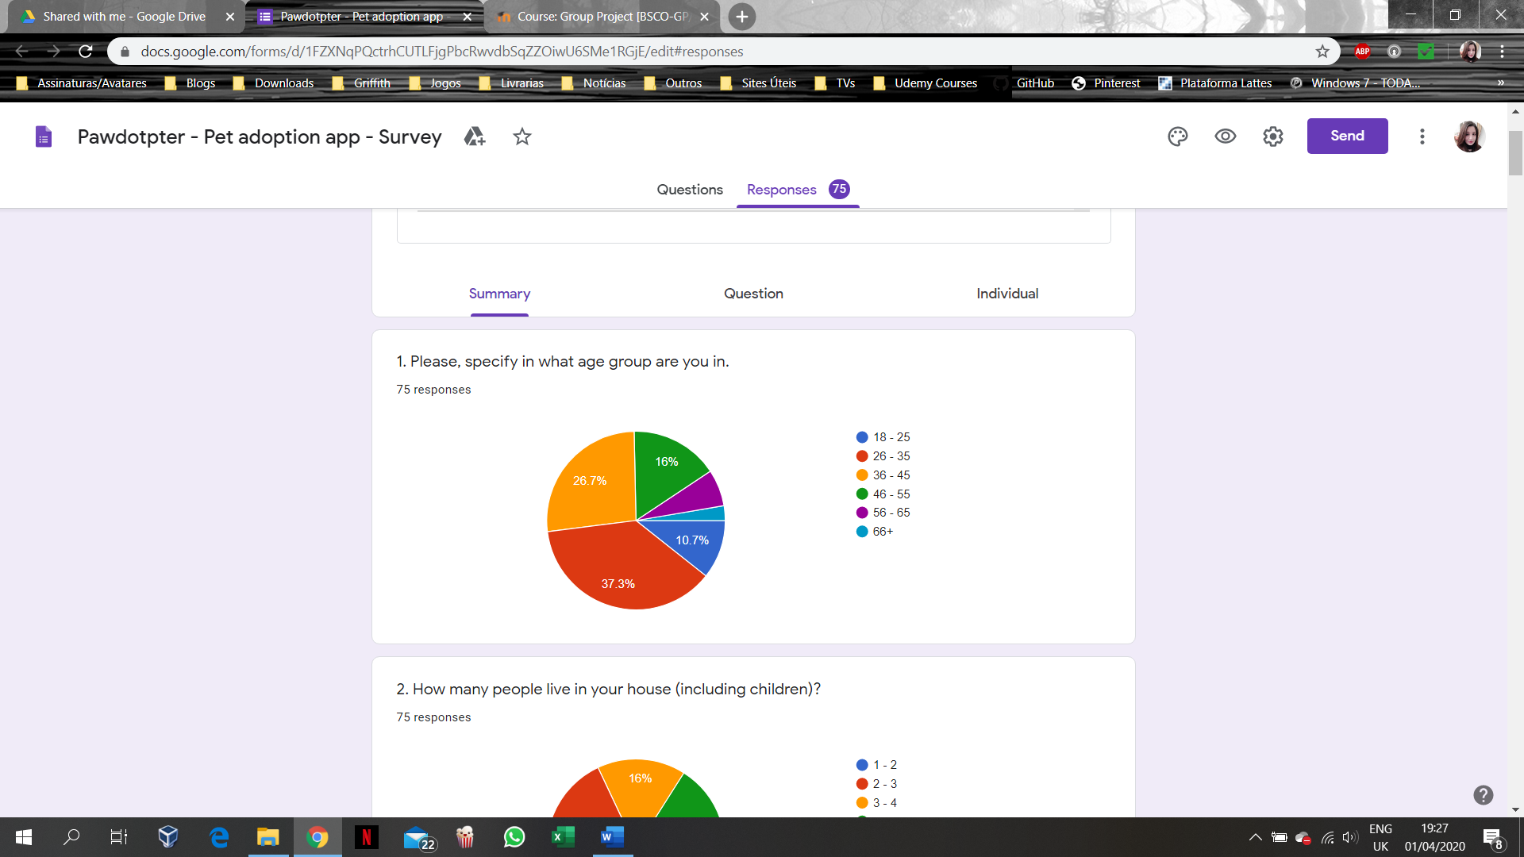

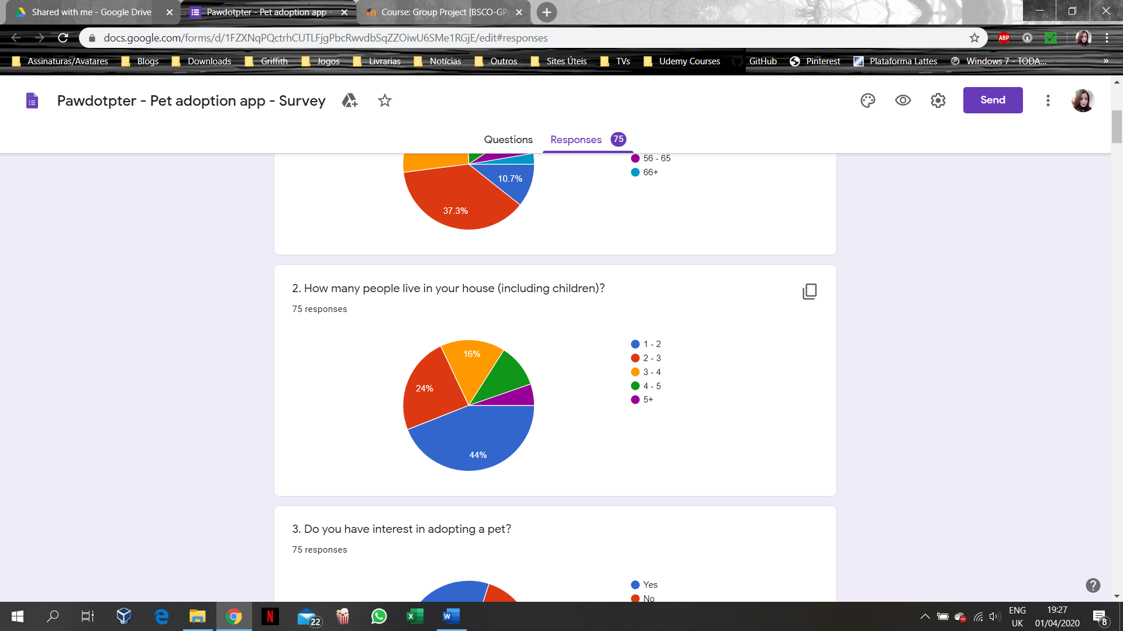

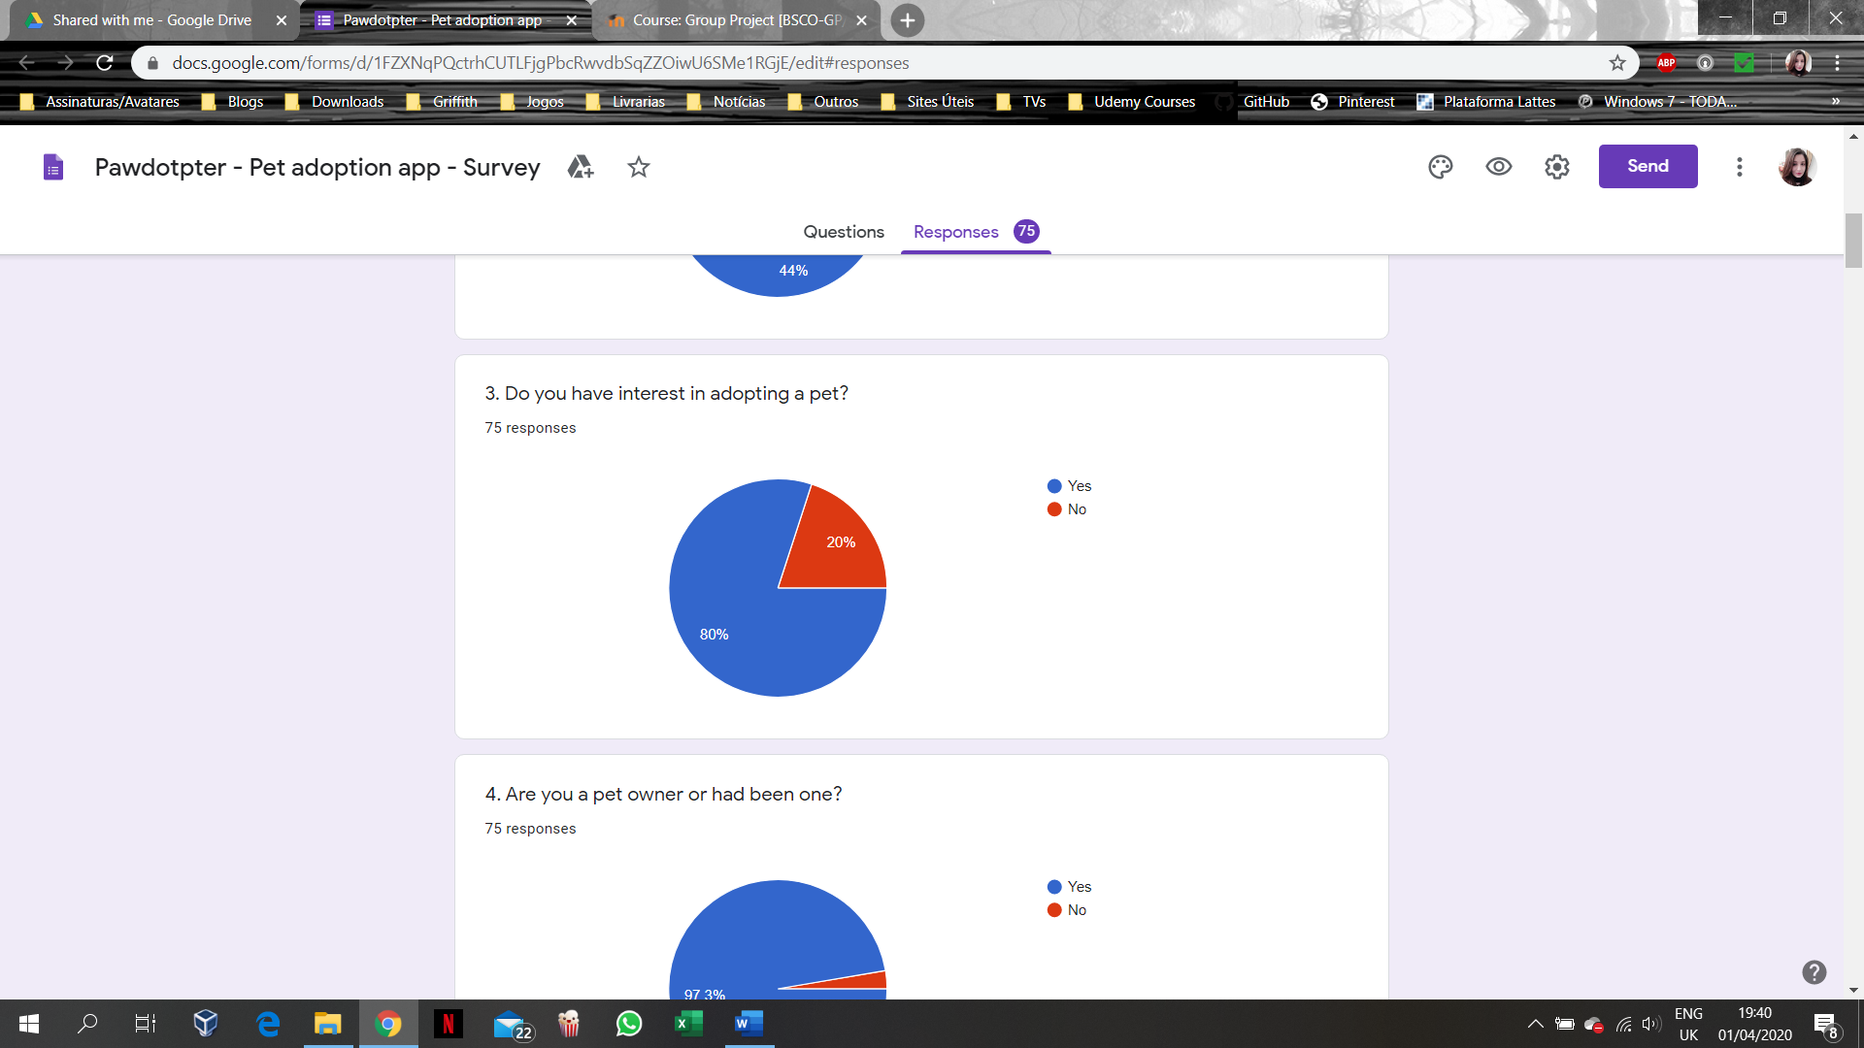

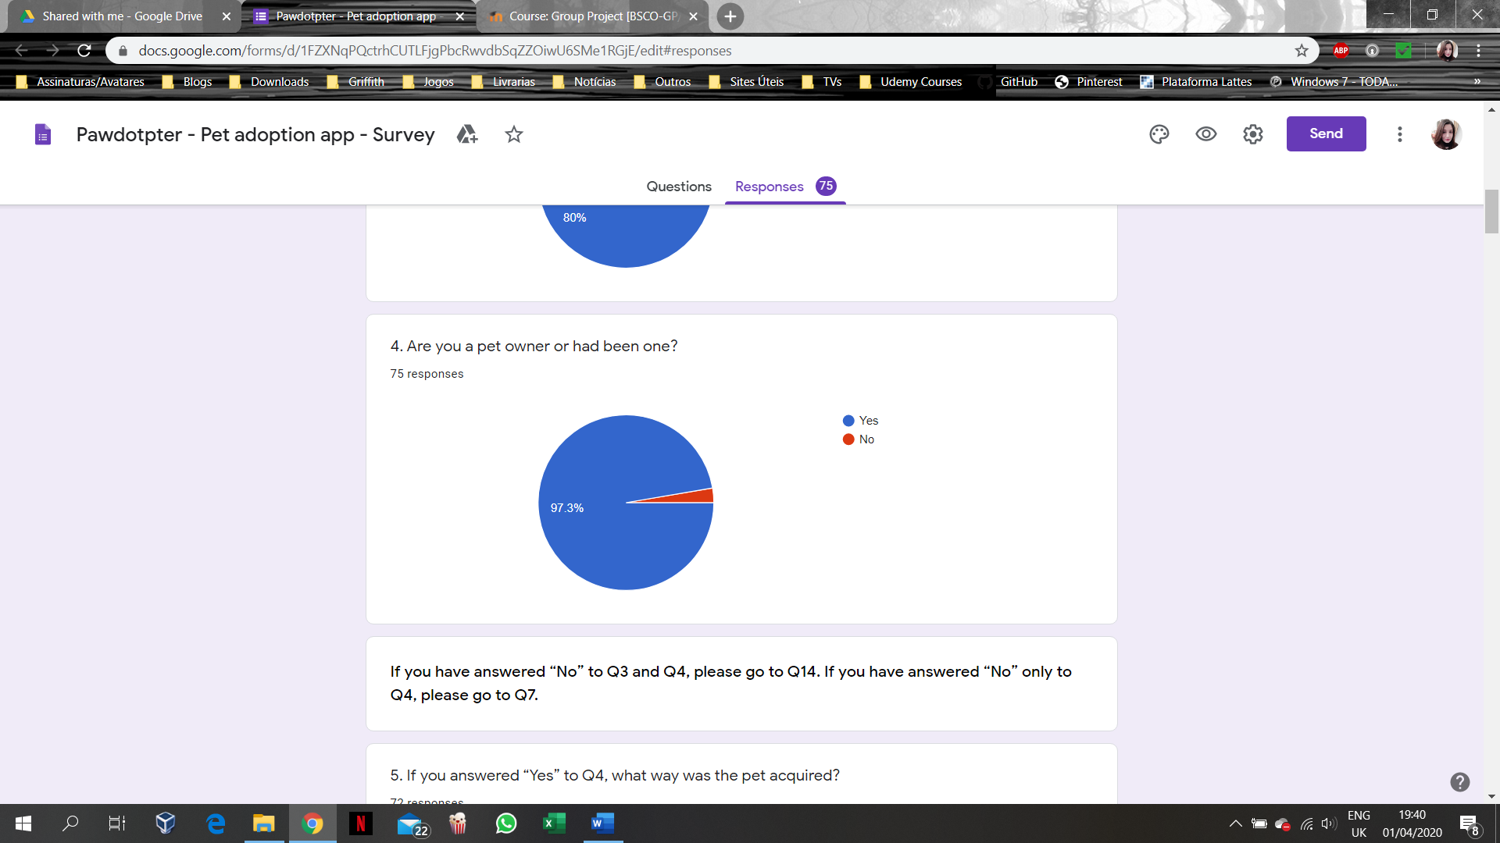

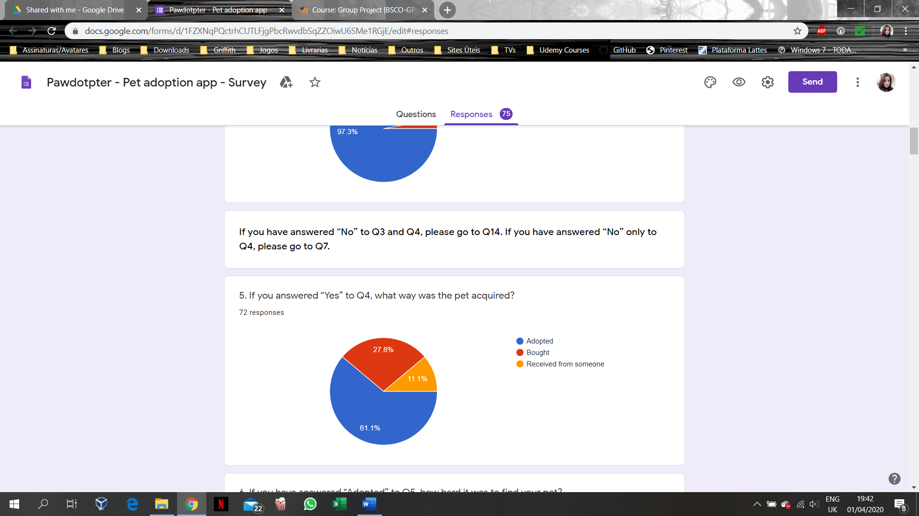



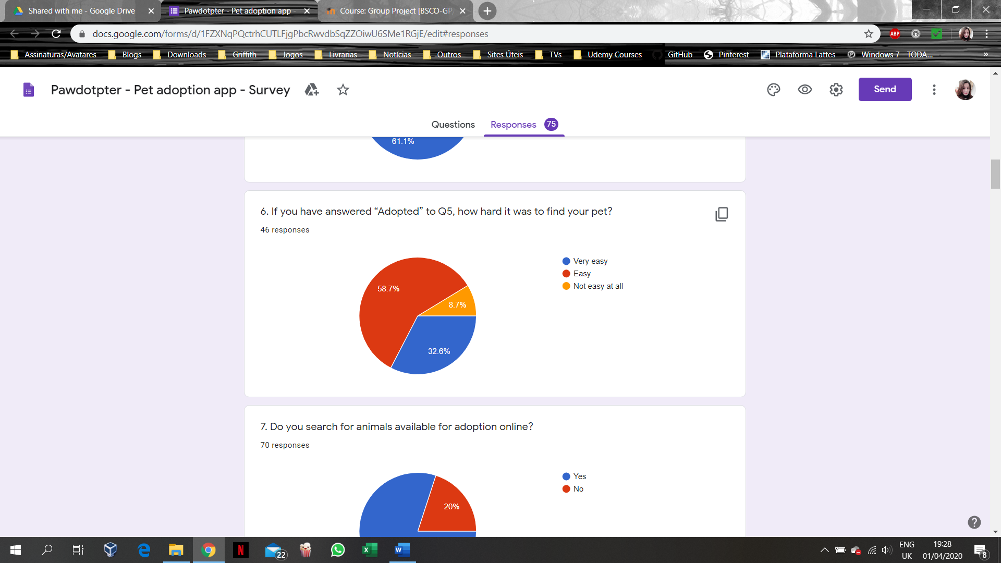

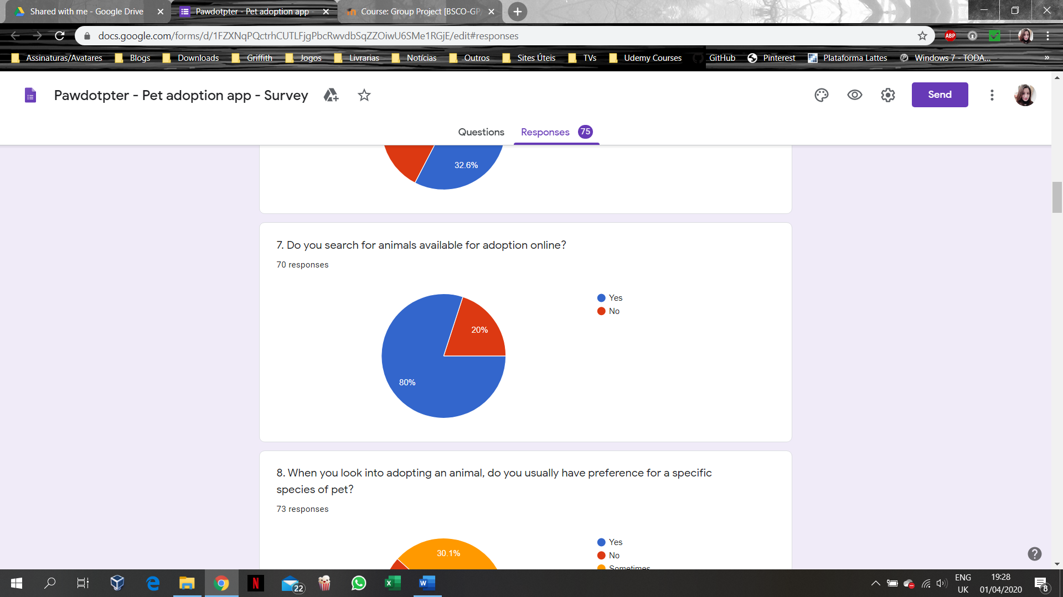

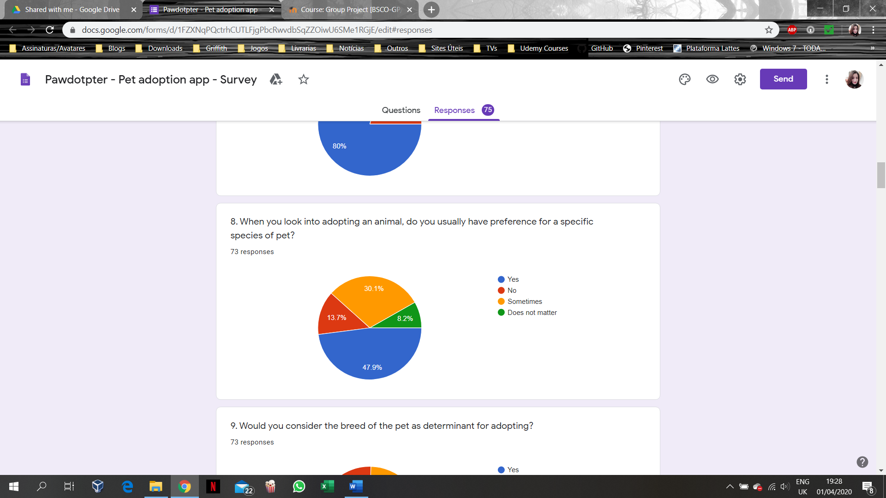

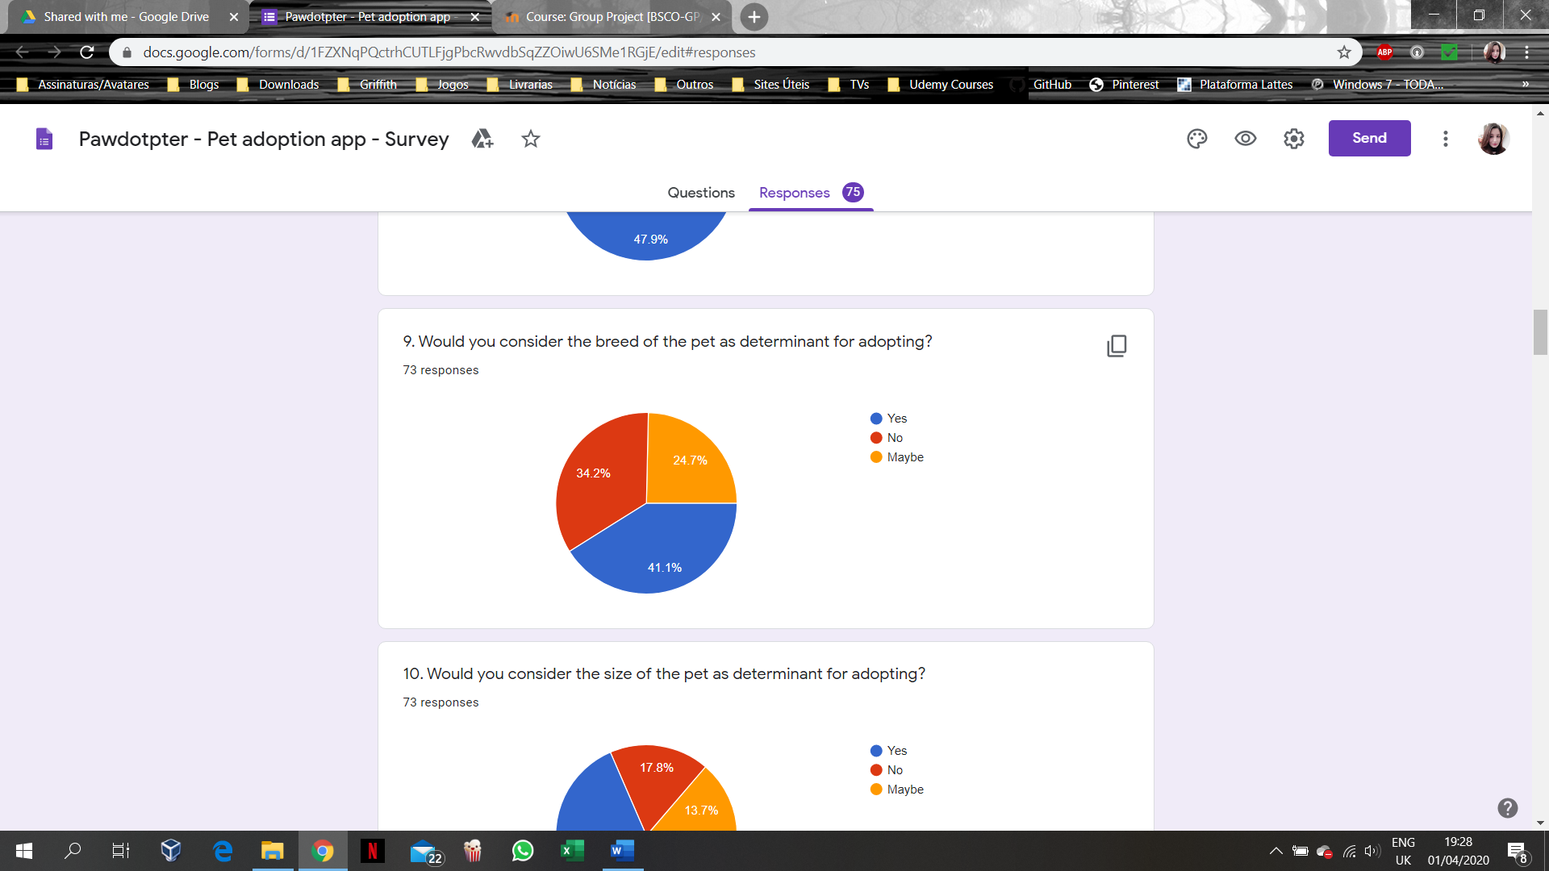

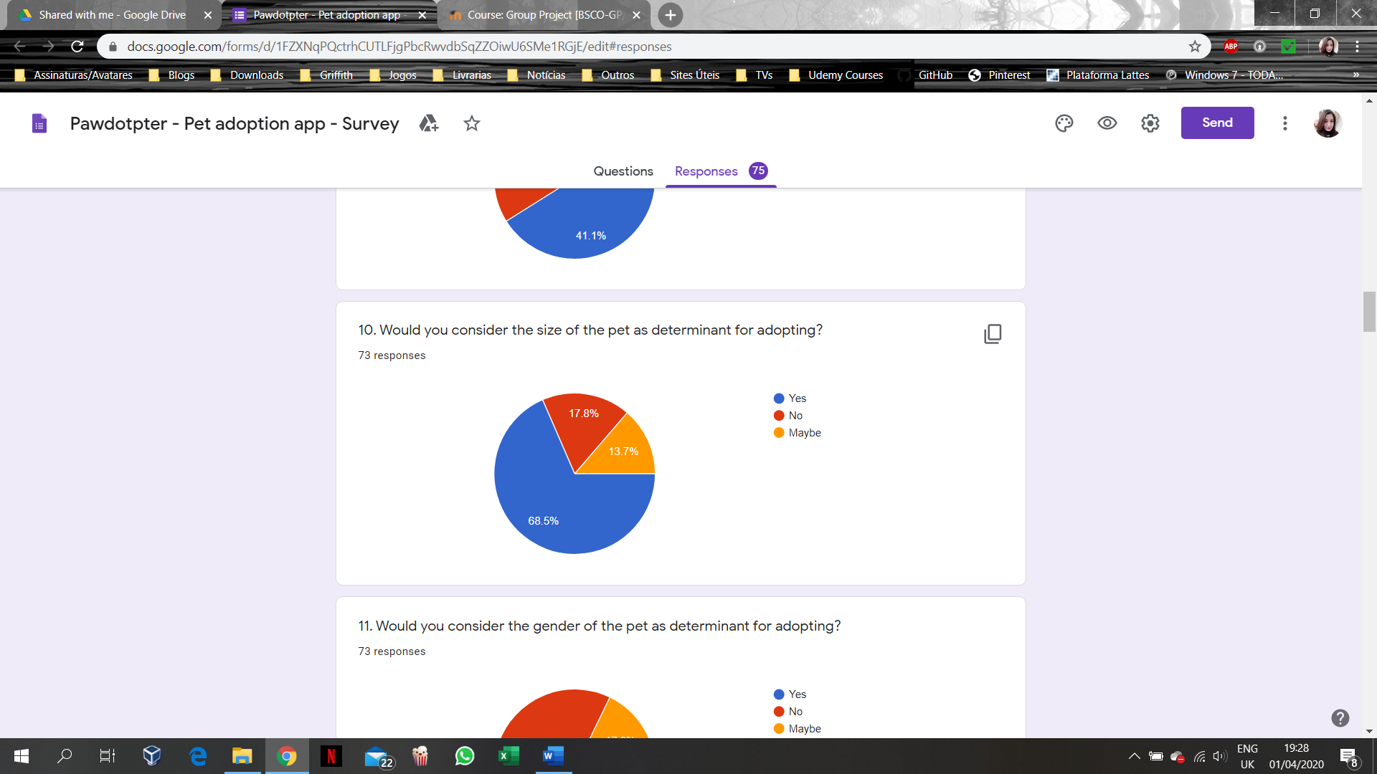

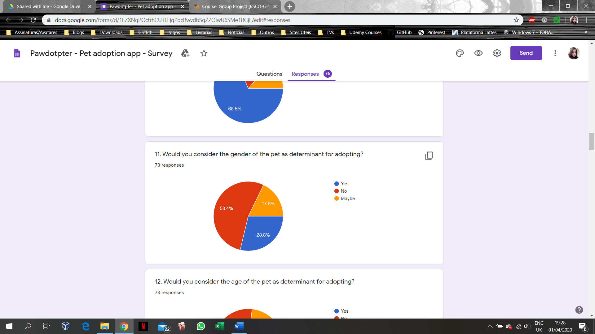

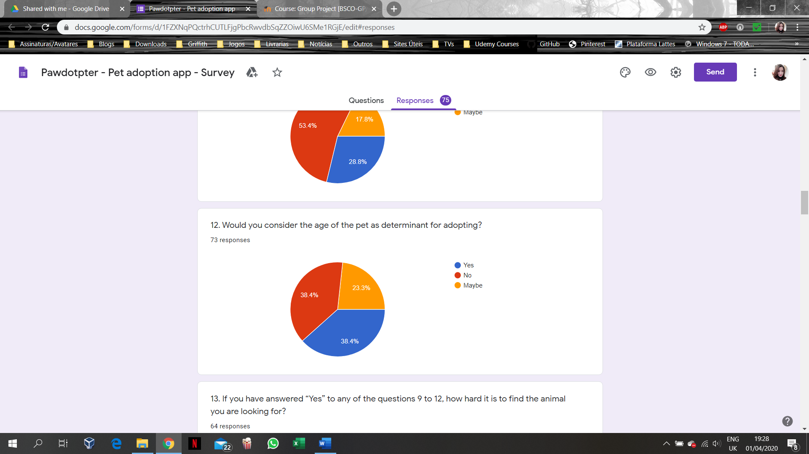

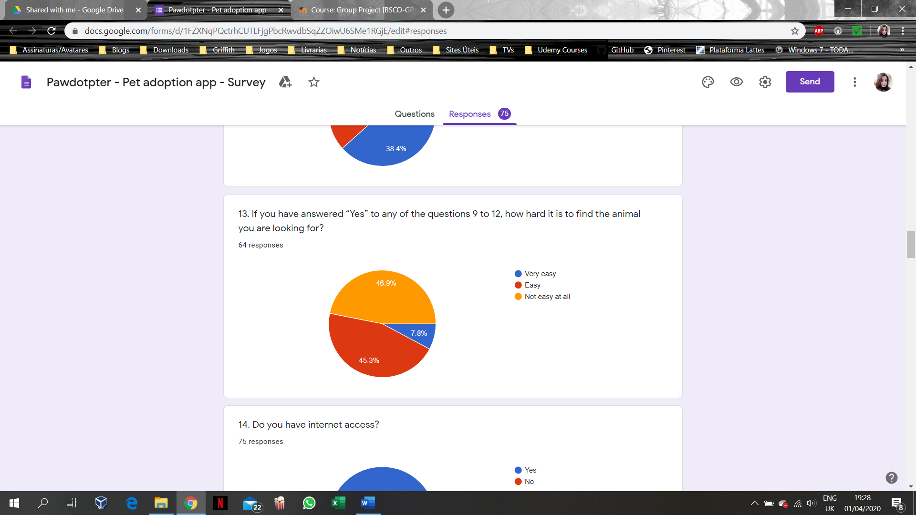

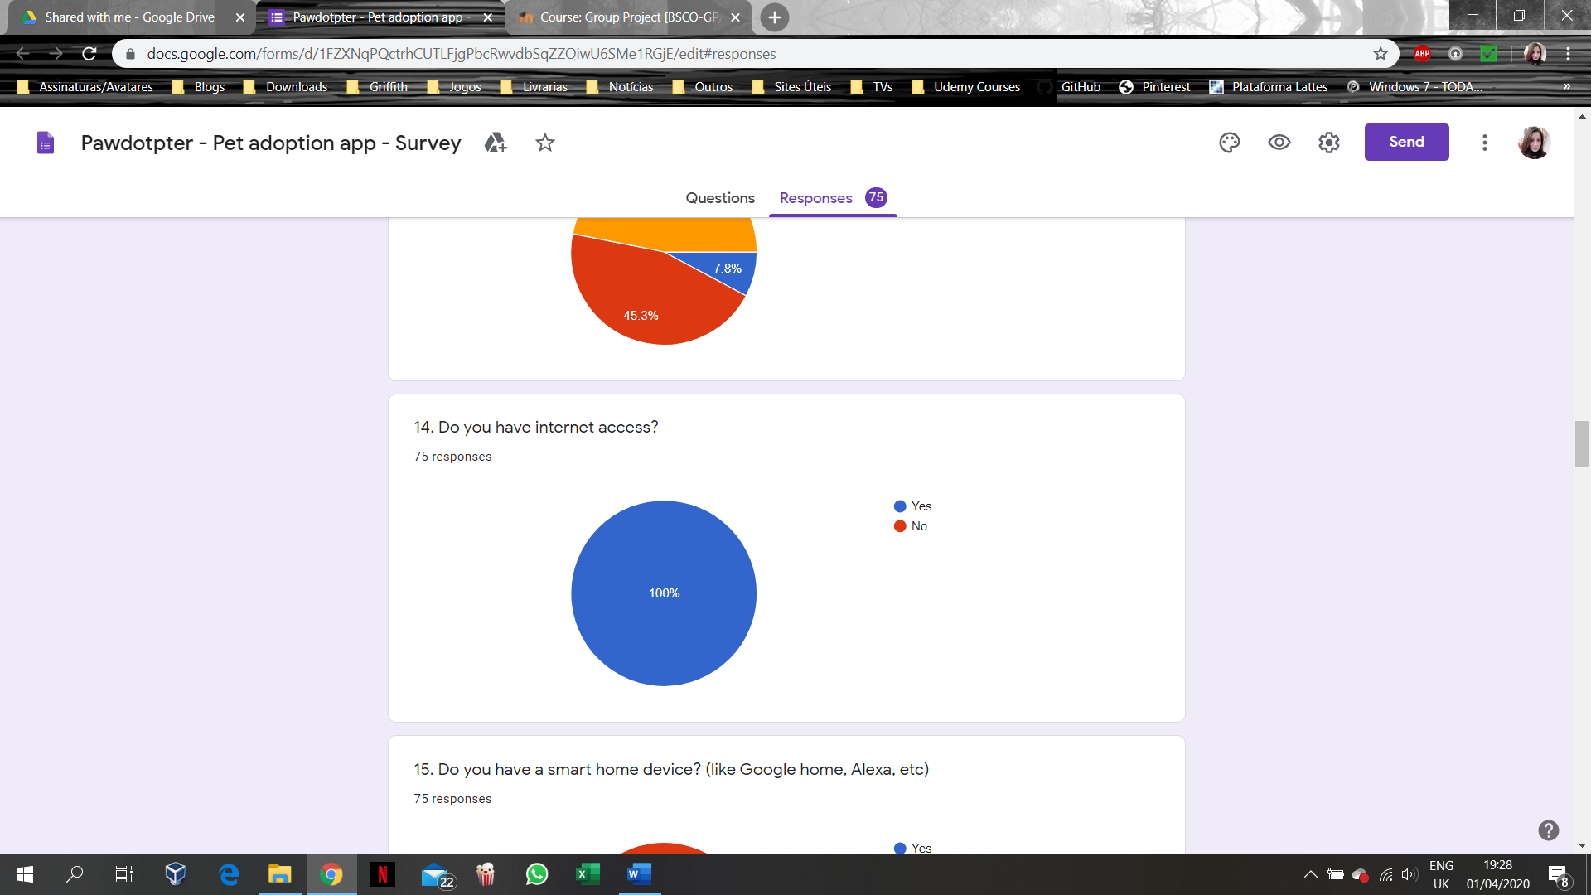

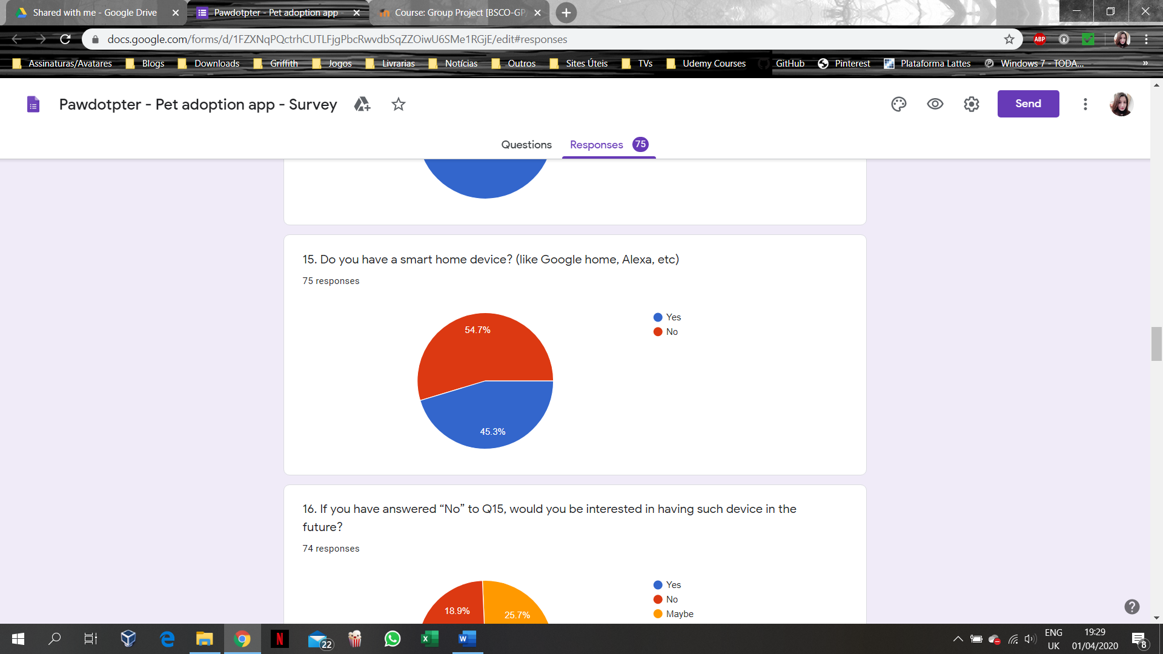

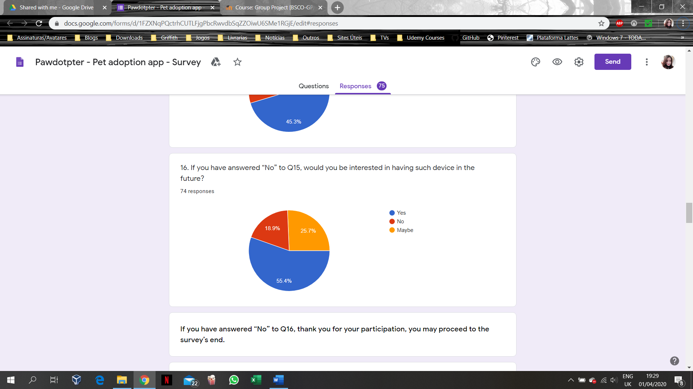

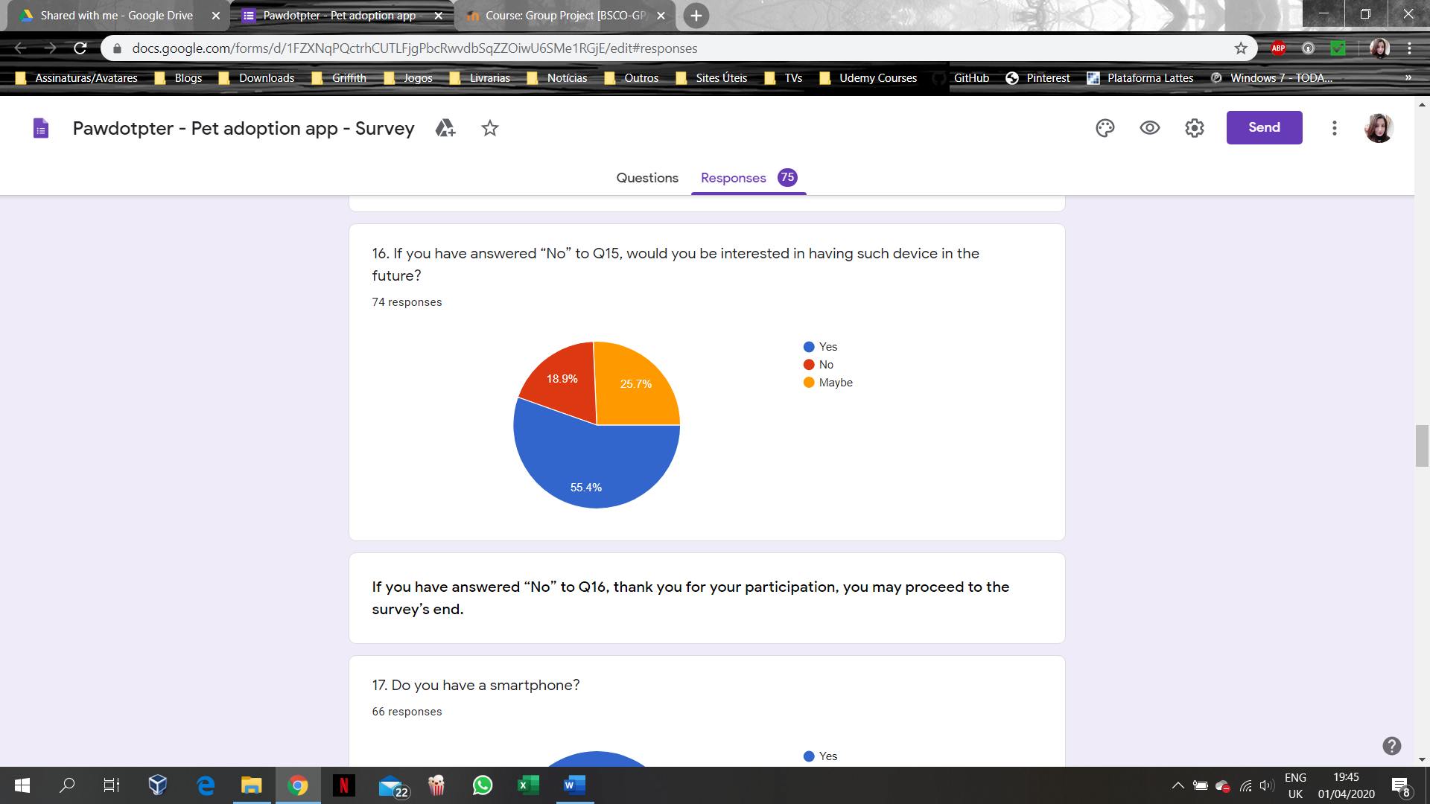

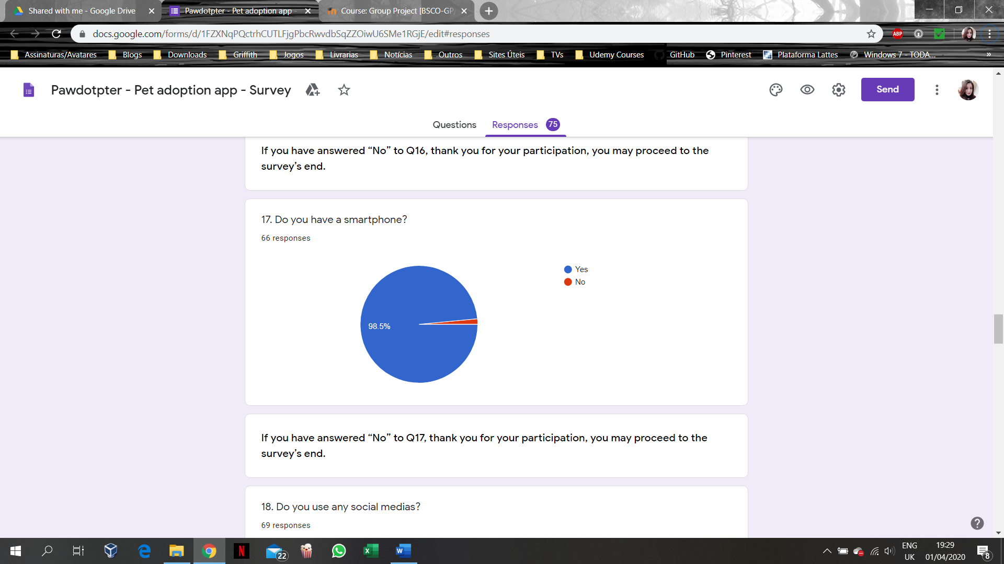

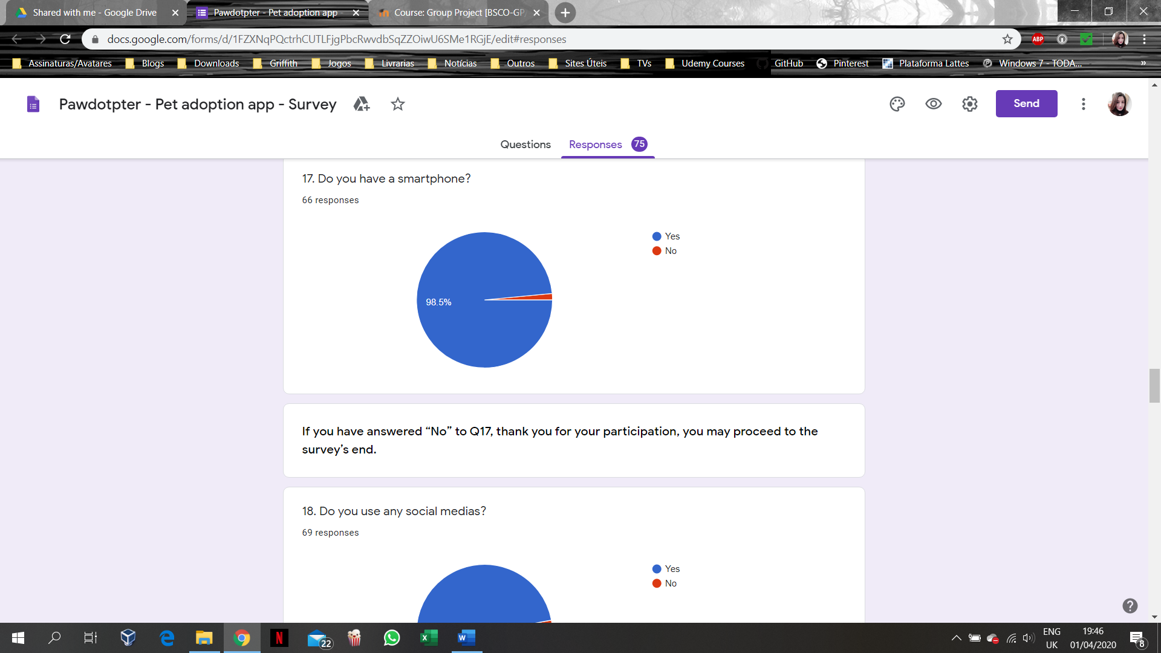

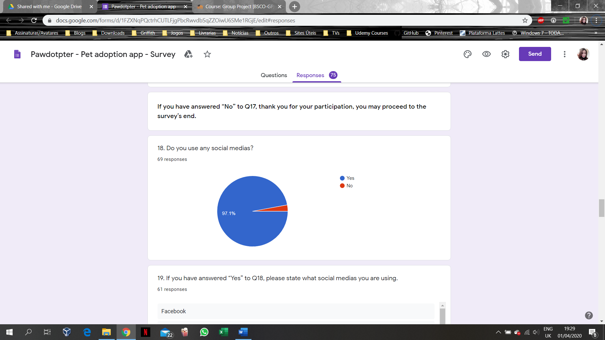

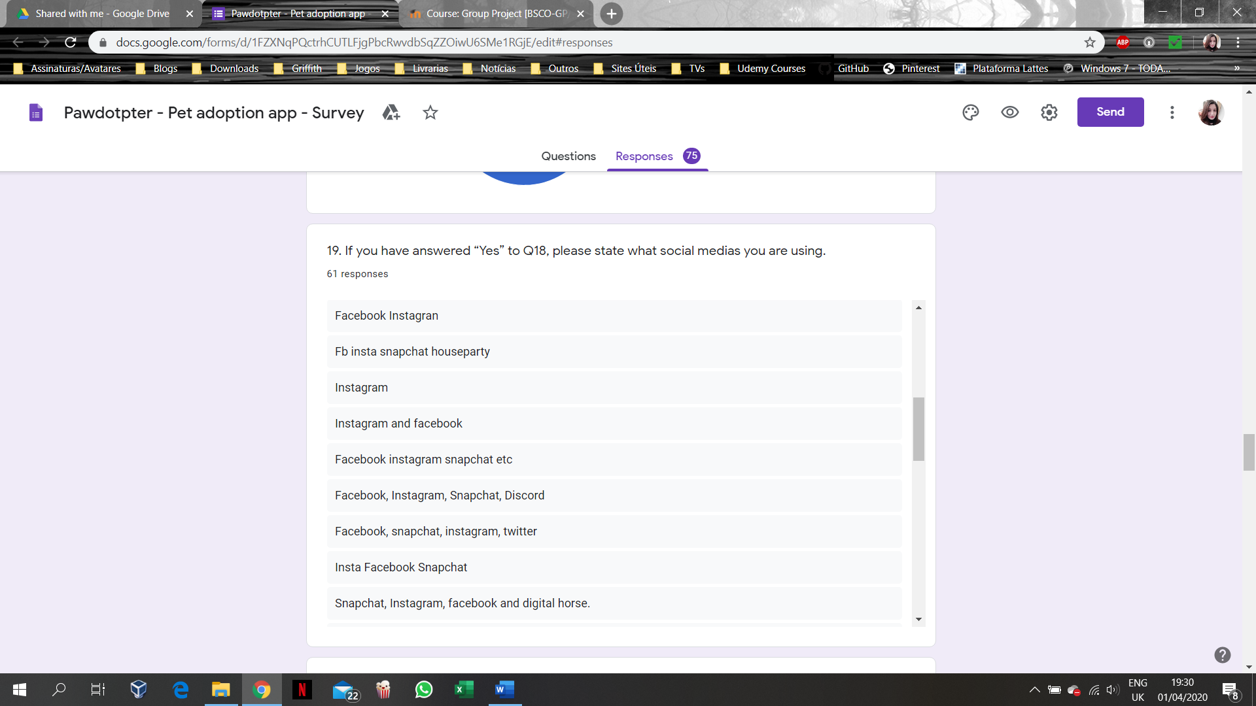

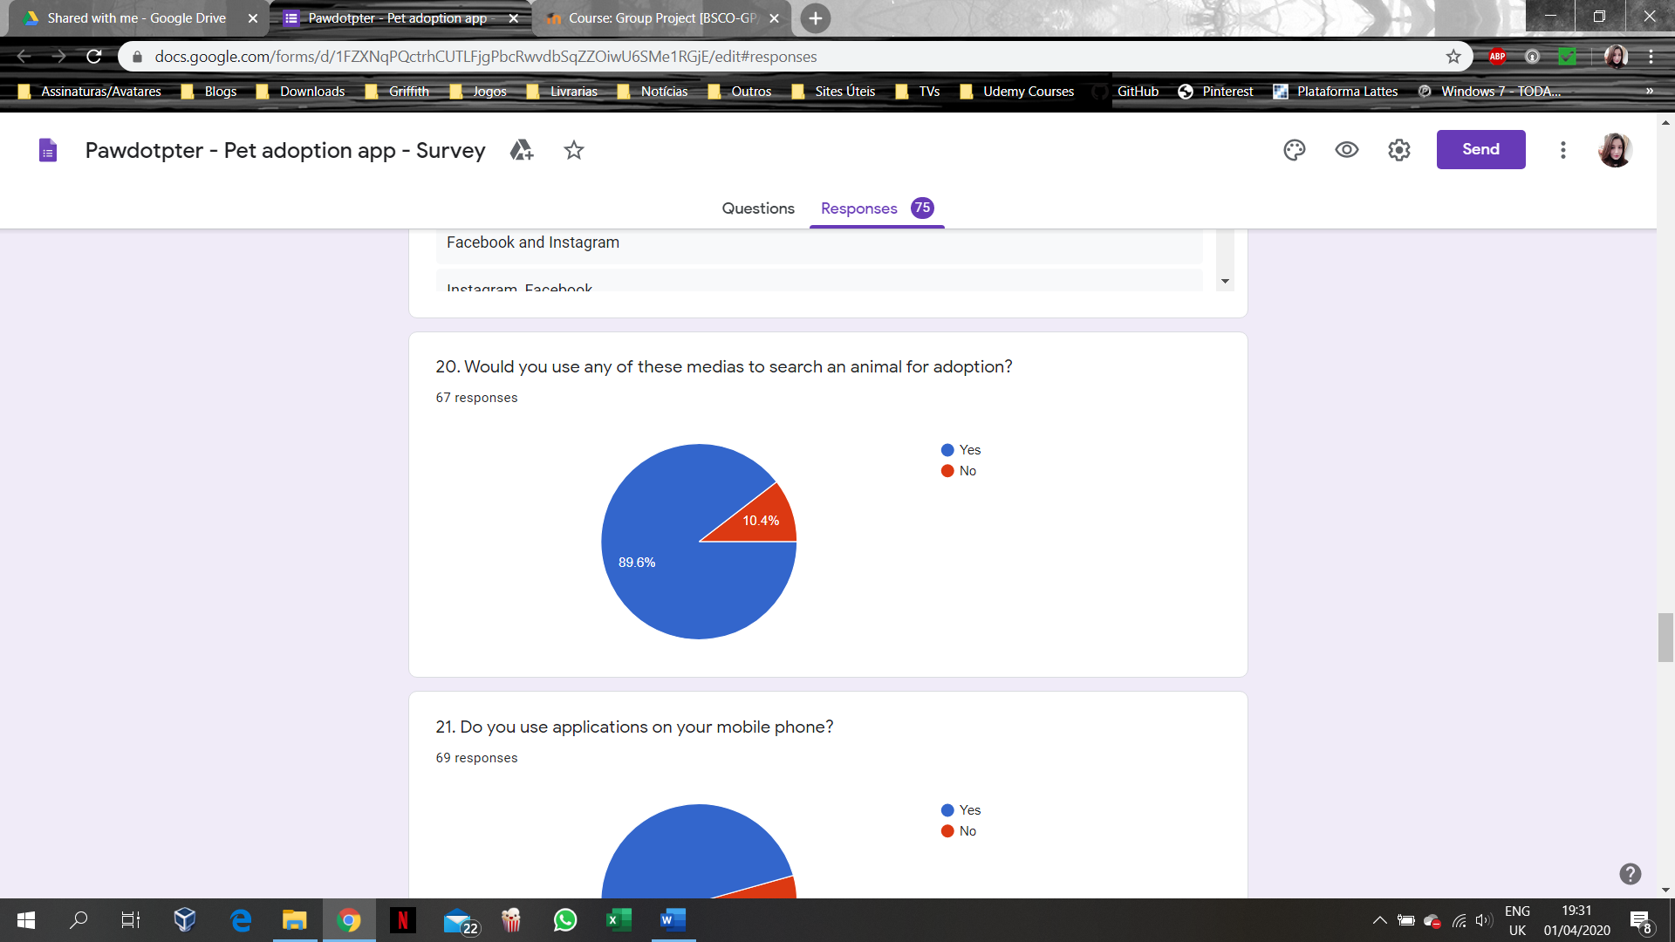

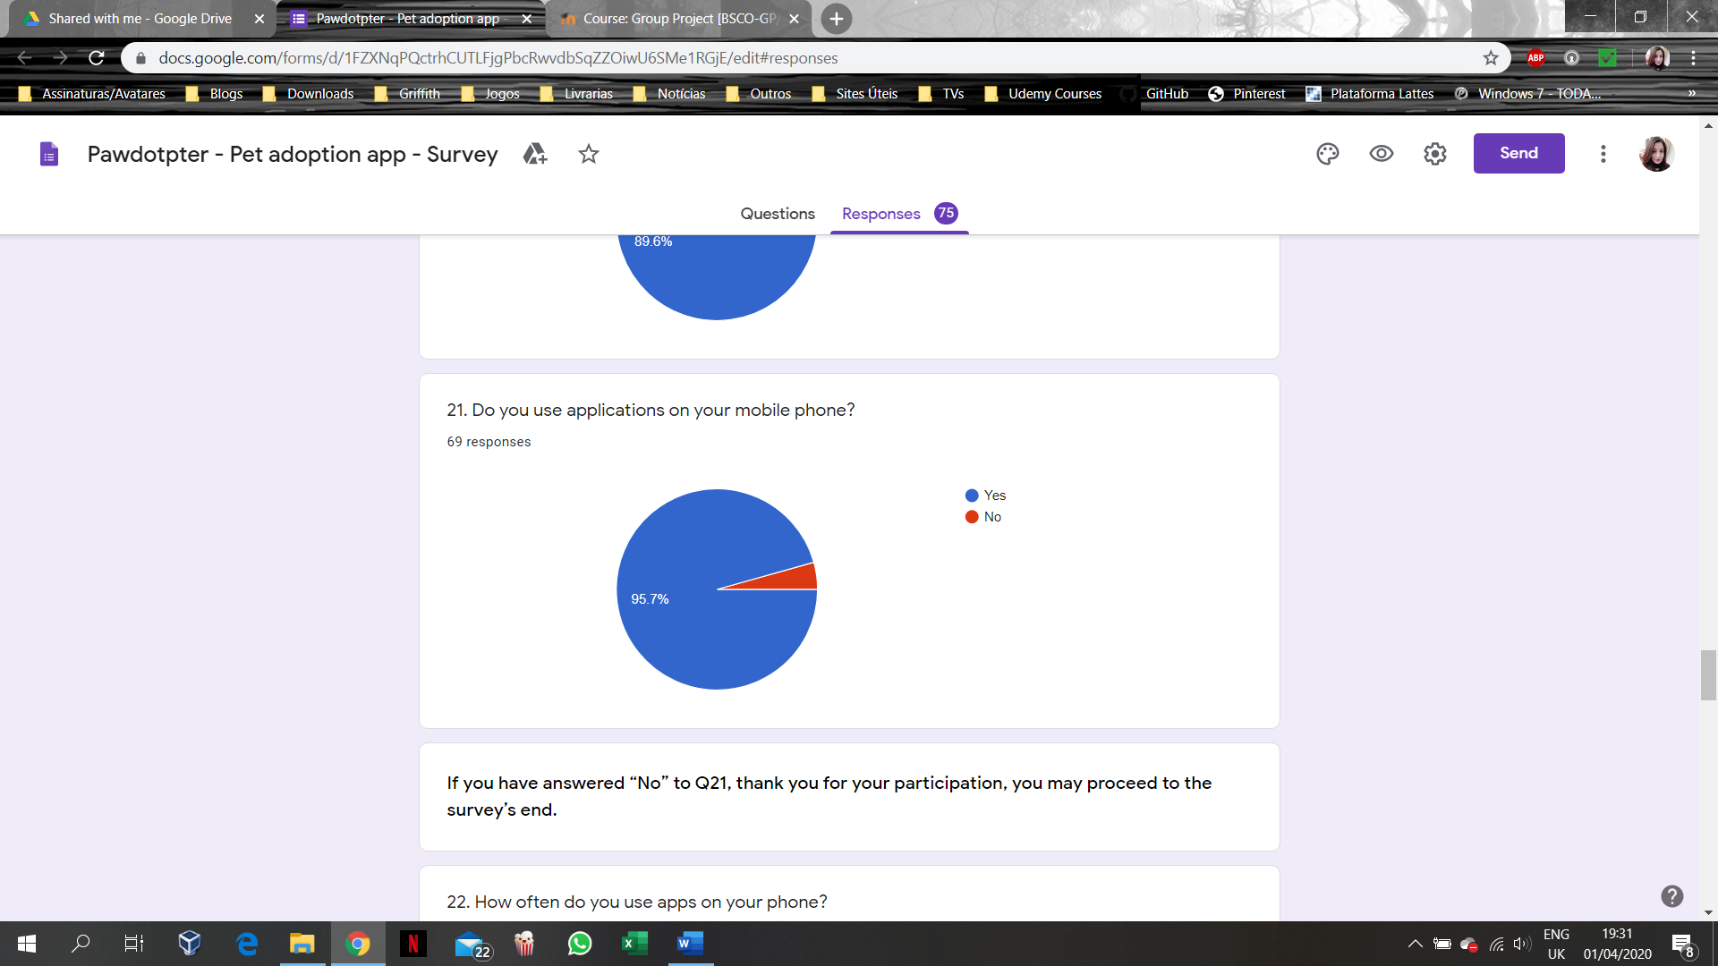

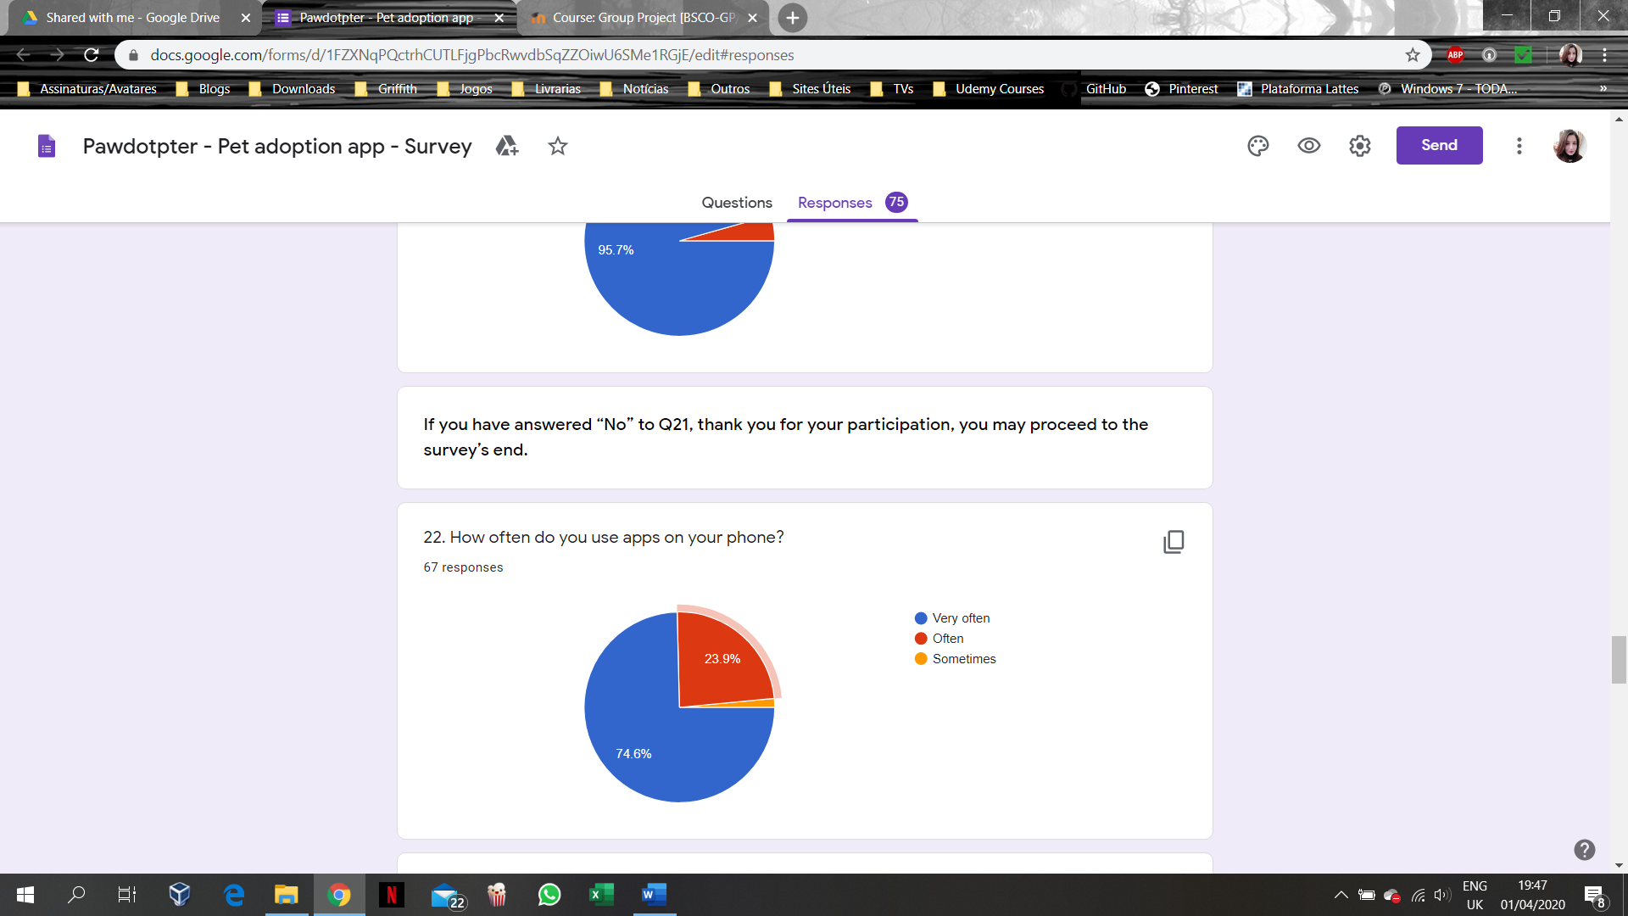

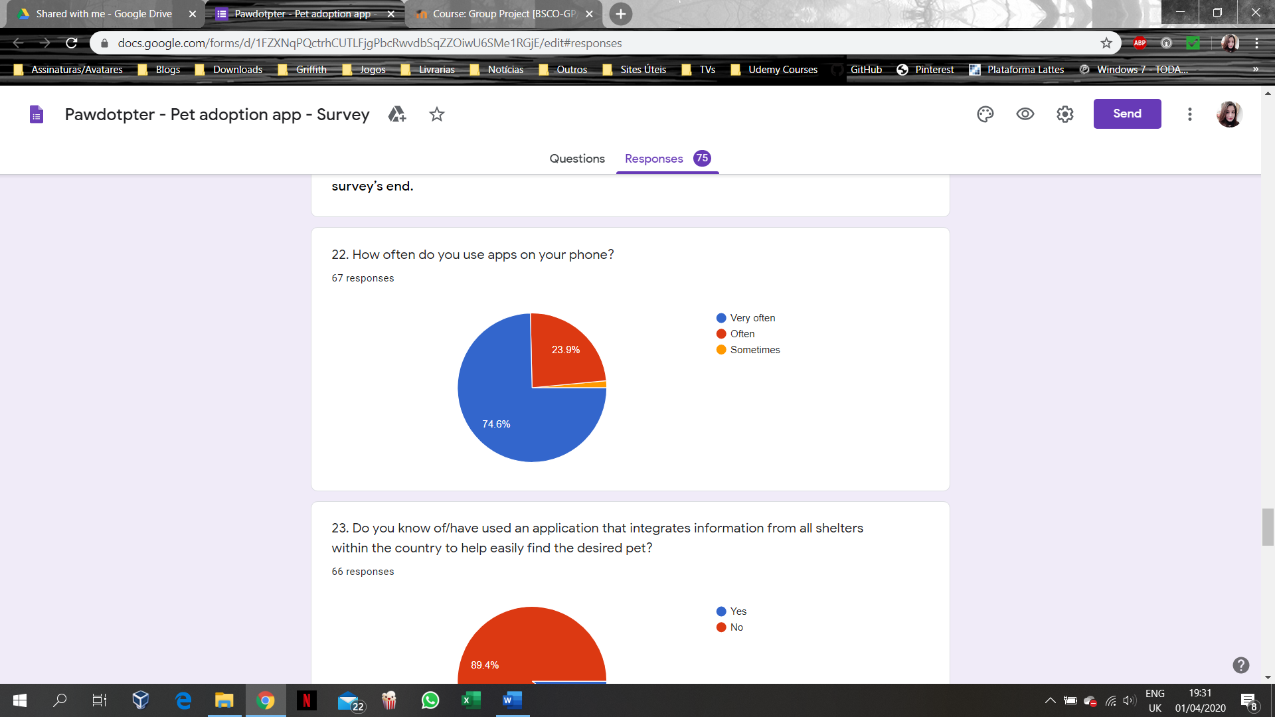

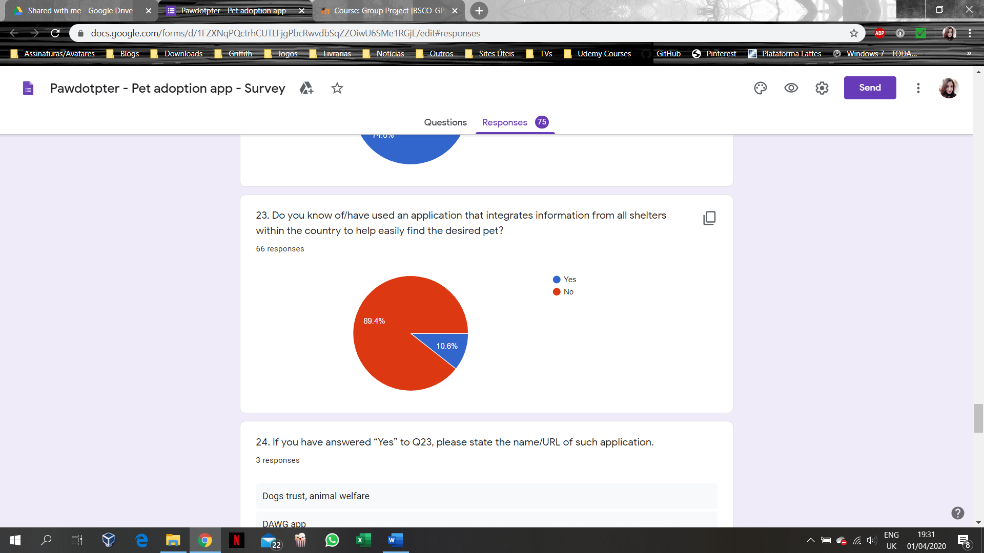

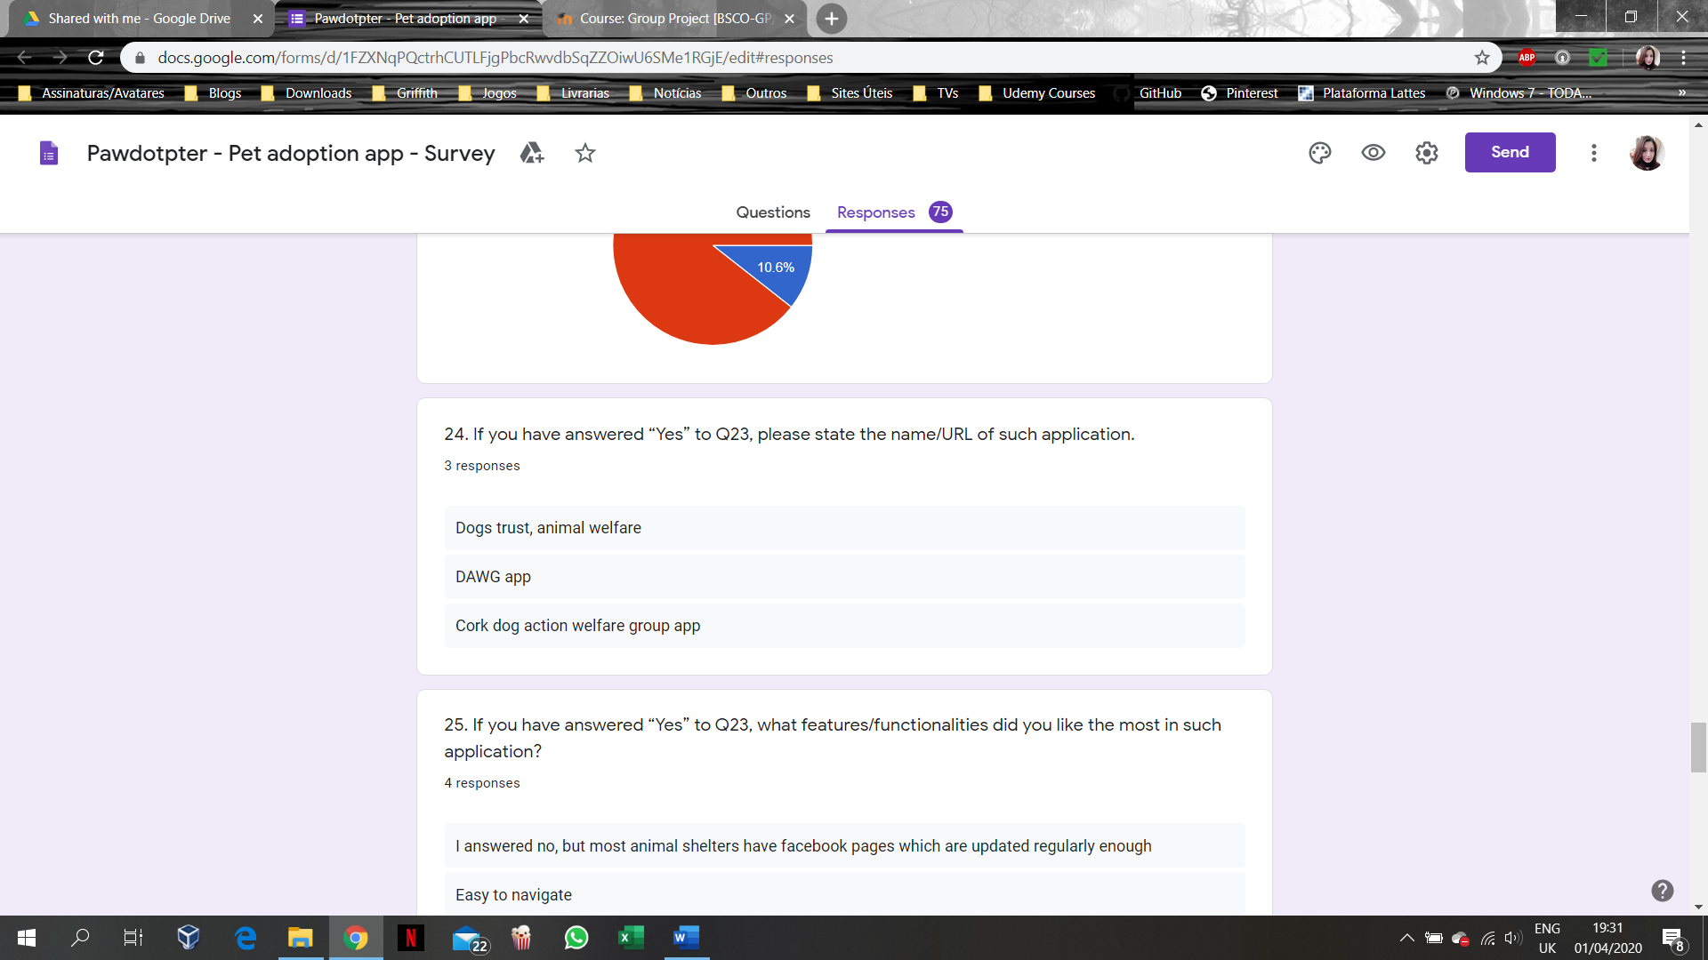

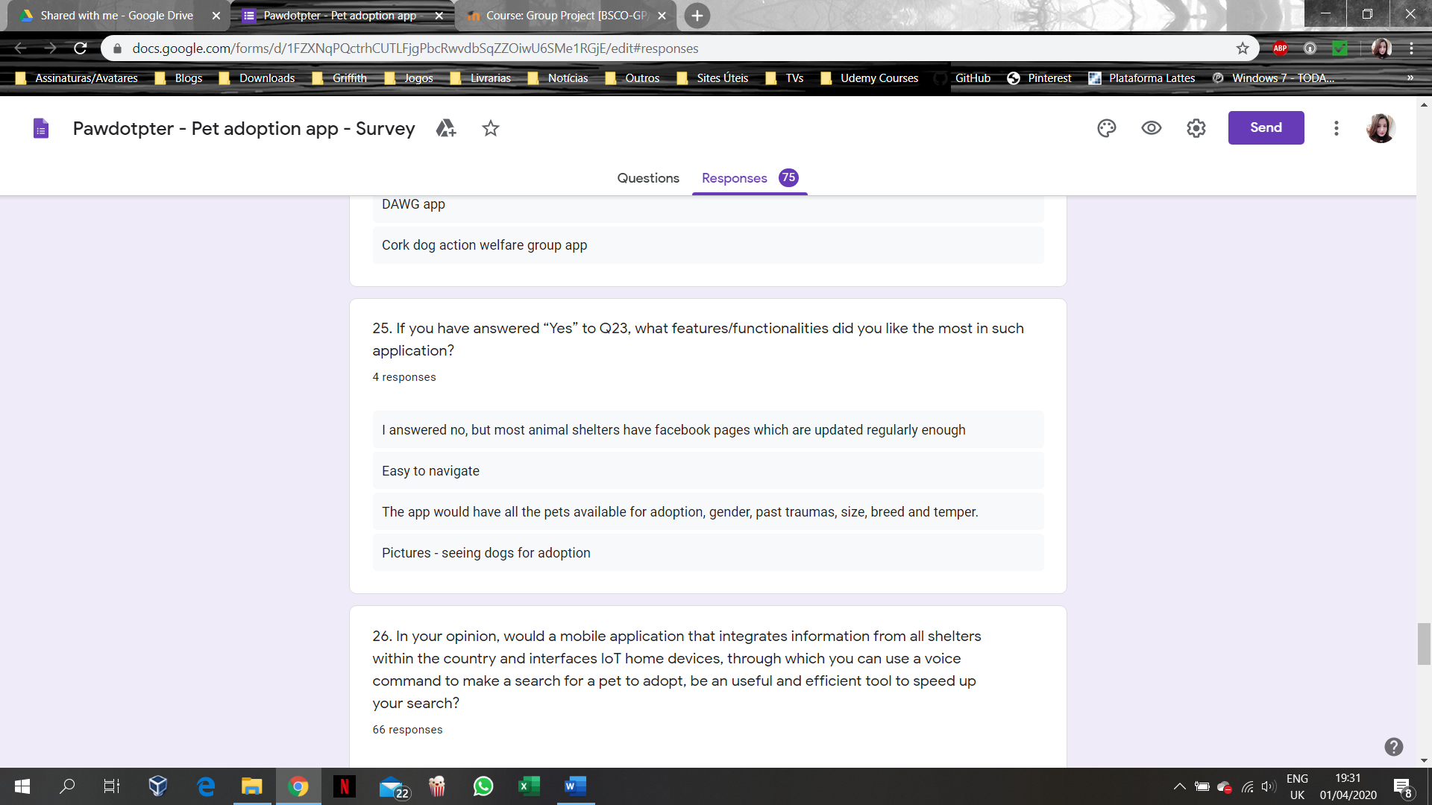

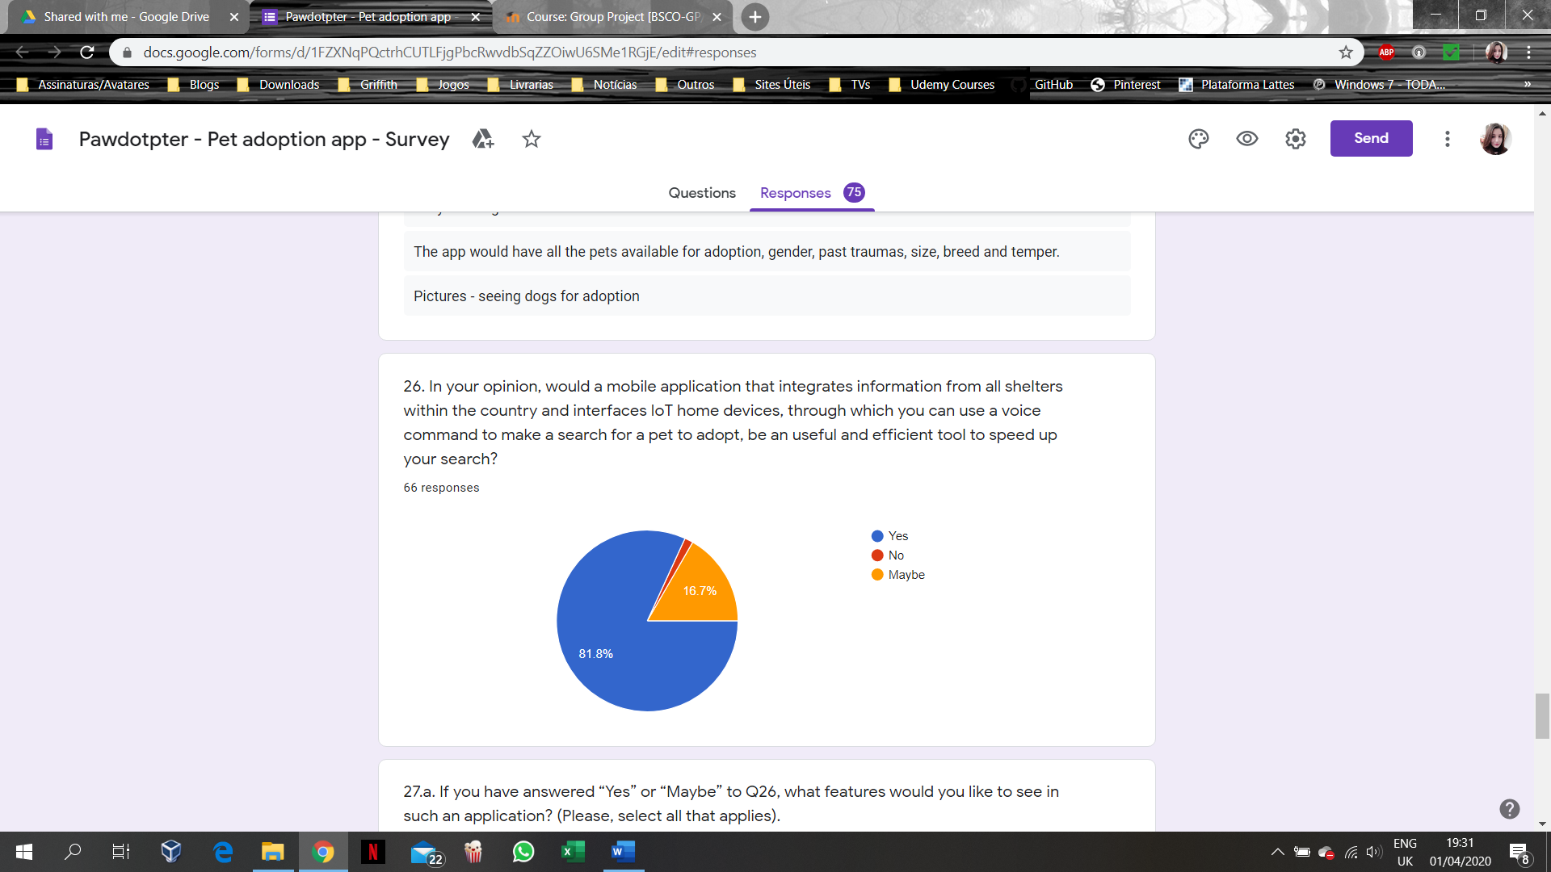

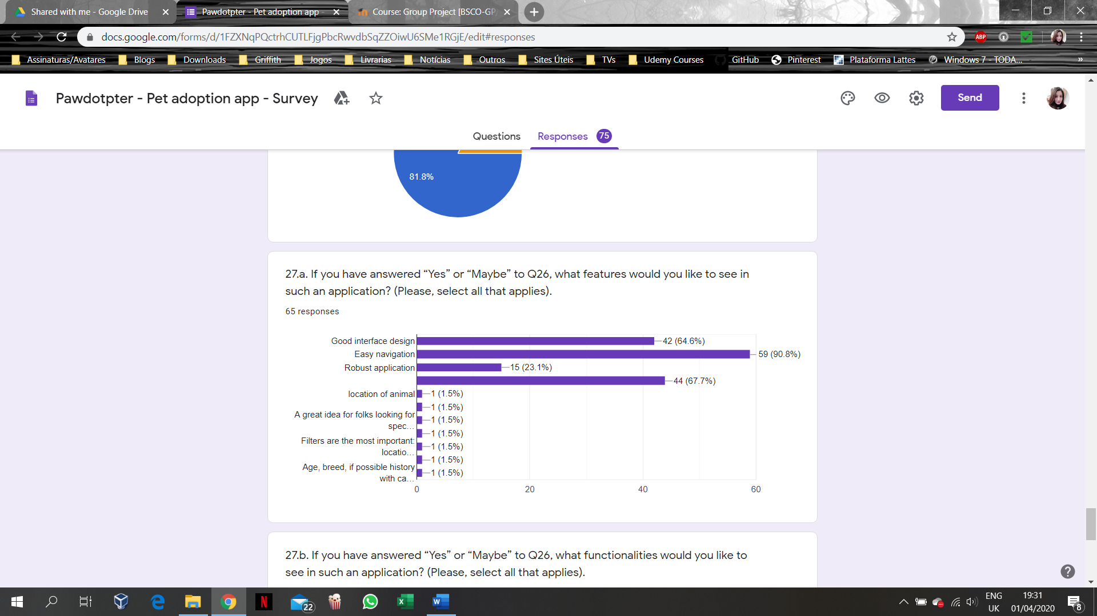

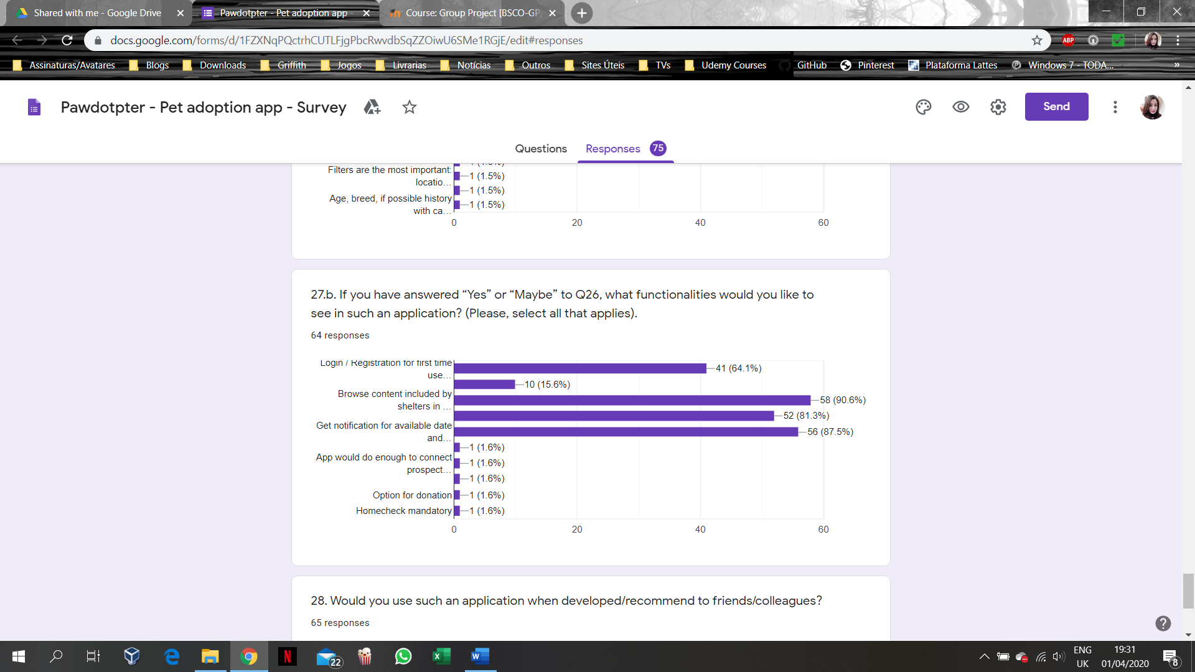

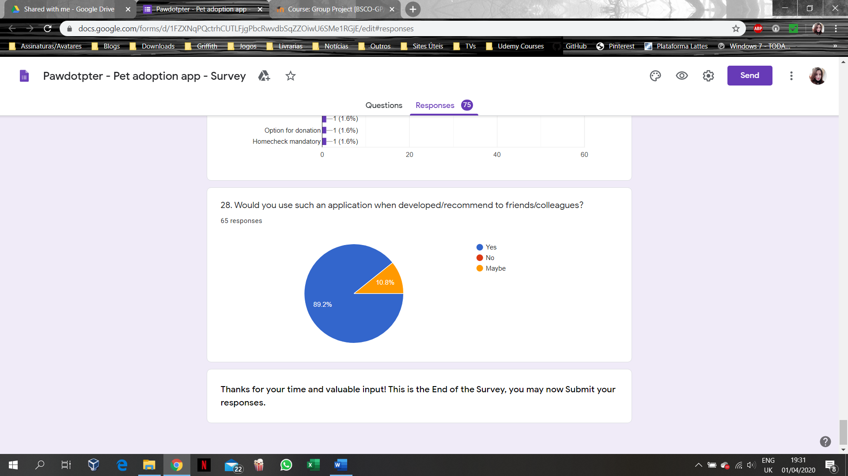

# APPENDIX A3: Structured Interview Questions for Shelter’s Management

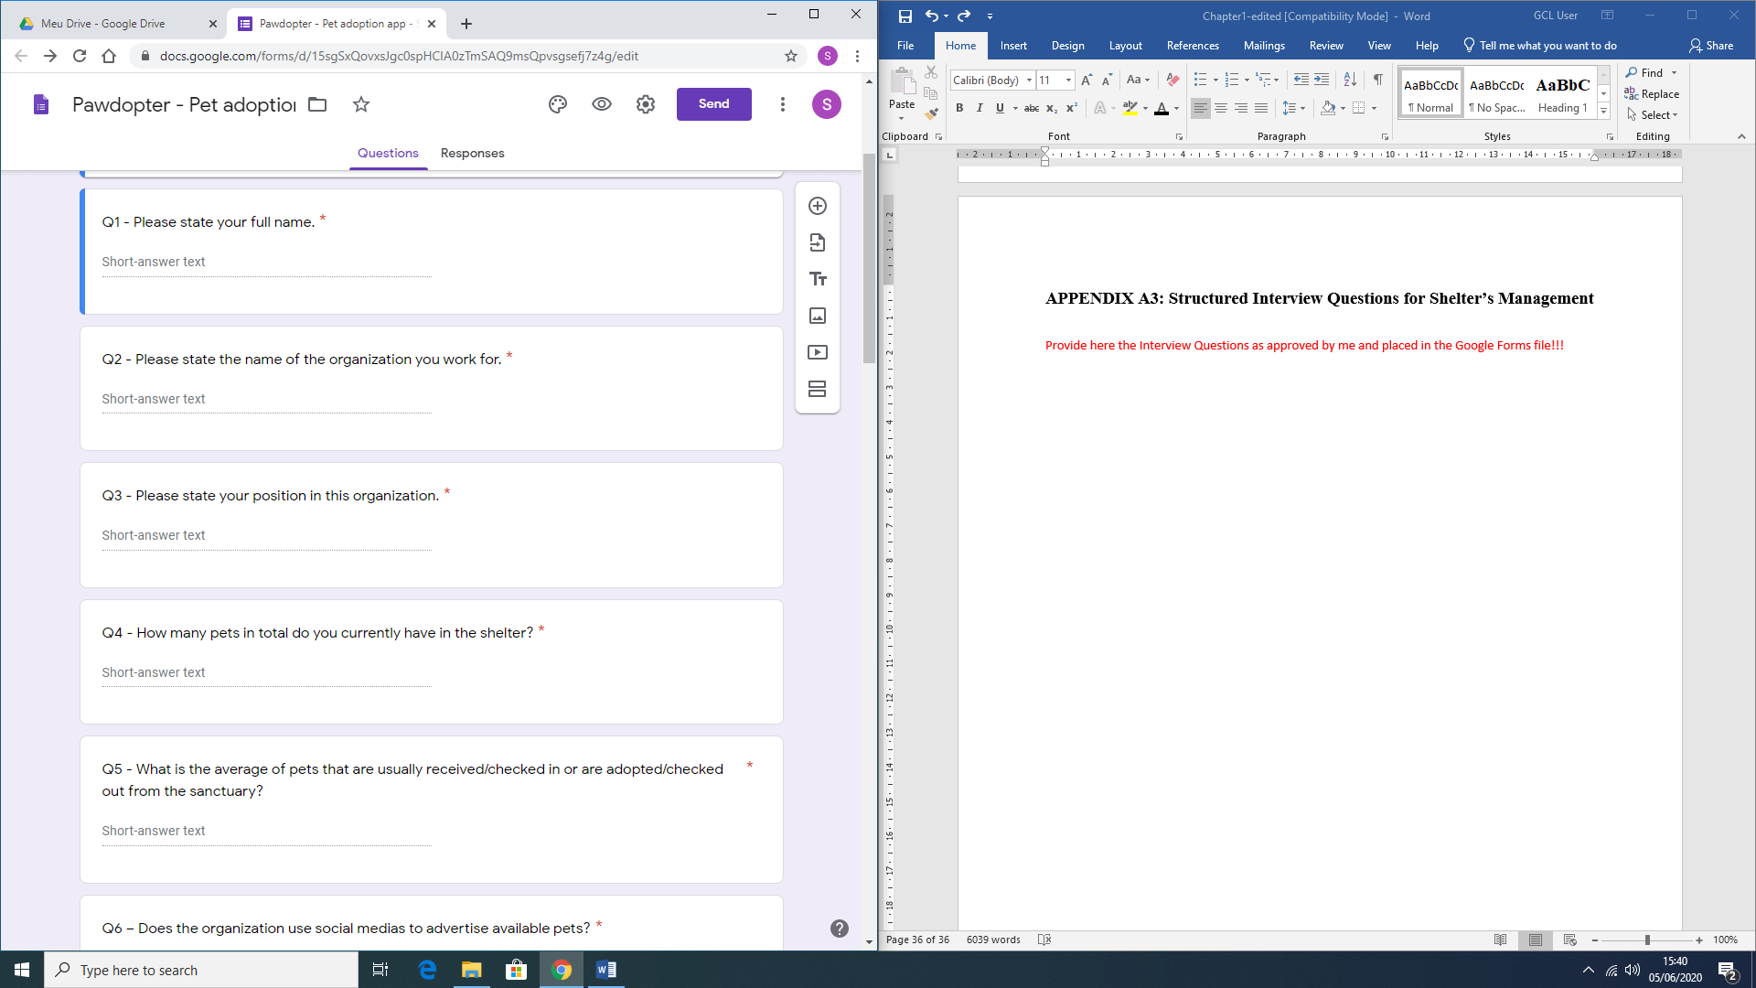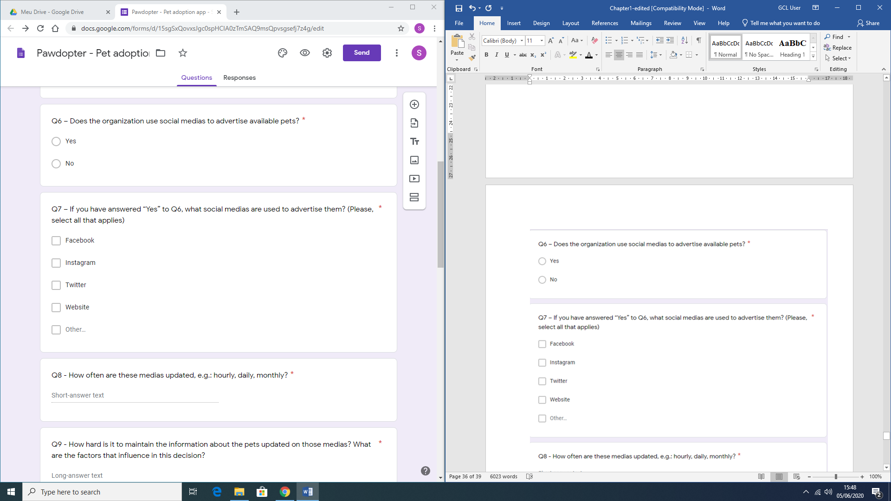

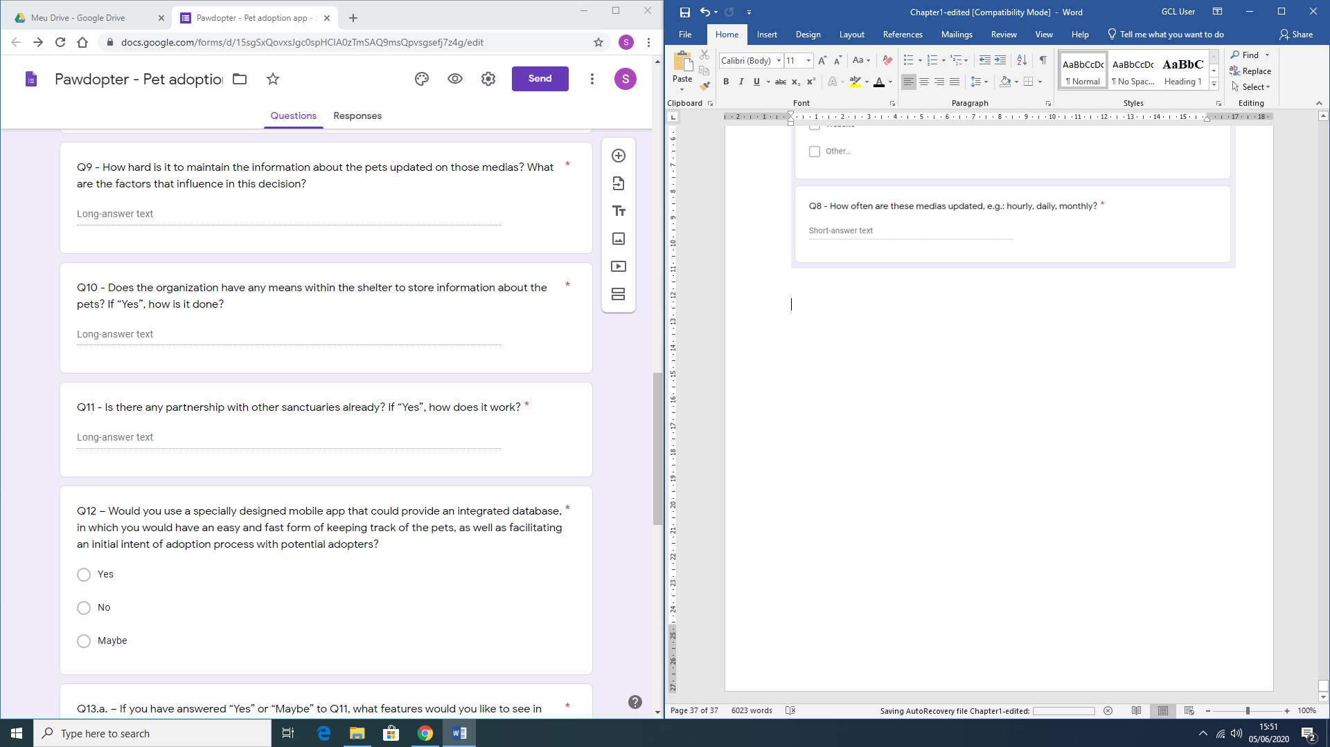

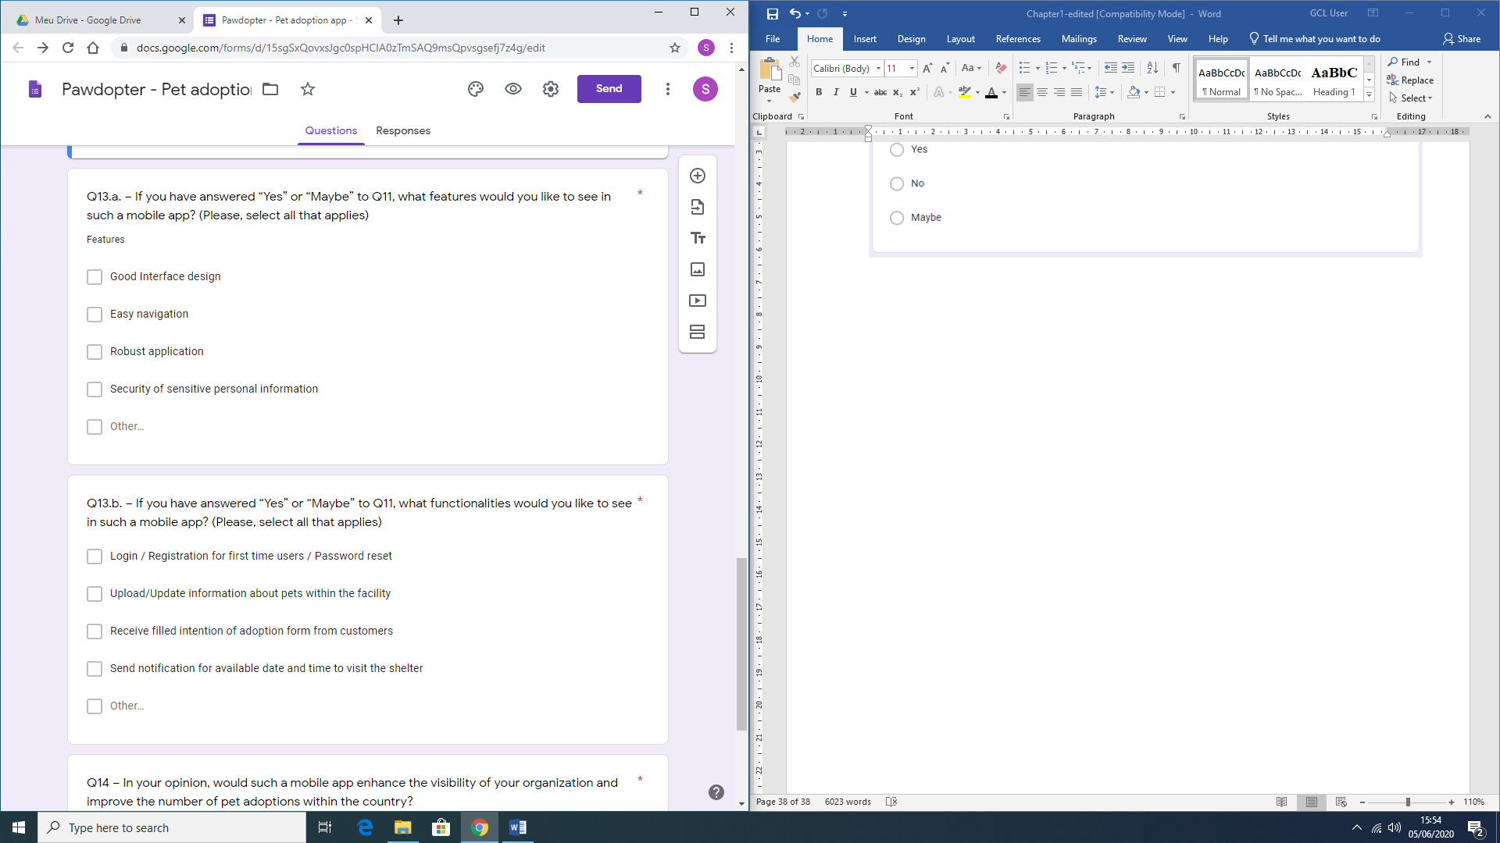

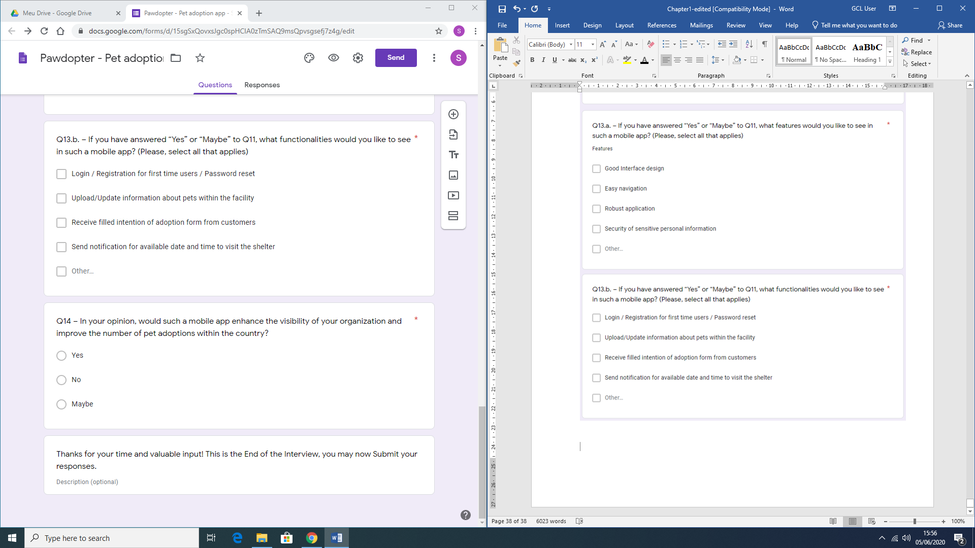

APPENDIX B: User Manual

This document has the goal of providing guidance to the user on how to navigate and use the proposed application.

There are two options for using this application: firstly, the user can use the app itself to perform a pet search; secondly, the user can use Voice commands through the Voice User Interface (VUI) of the IoT Home device (e.g. *Google Home*) to do the search. This document starts with explaining first the use of the application itself, and then the use of the VUI is explained.

**On lunch**

When the app is first loaded, users have two options. If have already been registered with the application and consequently logged in, the app will automatically redirect you to the *search screen* in which you can use filters to find suitable pet. However, if the user is not recognized as a registered user, a screen will be presented with options to *login* (in case you have logged out), where you will need to provide valid e-mail address and password, or to *register* (if a first-time user of the app), in which case you need to go through a *Registration* process, as a starting point.

**Login (Sign in)**

The *Login process* requires the typing of the *Username* and the *Password* as provided at the *Registration* process. There is also an option to *Reset your password*, in case it has been forgotten, or to *Register* if you are a first-time user of the application.

**Registration**

The *Registration process* is simple and straightforward. You need to fill out your Name, Mobile number, e-mail address and Password in specified fields on a form, to be registered with the application and have created a profile. Each field has specifications and limits, as well as being mandatory.

* As a mobile number, you should provide a valid Irish number, which means starting with 08.
* As an email, you should also provide a valid email, which means having the user, the @ symbol and the domain name of the email.
* As for the Password, the selected password should be at least 8 characters long, have a mixture of lower- and upper-case letters, digit(s) and at least one special character.

**Updating profile**

With this functionality, you may change specific information within your profile, such as your mobile number, and password. This functionality, when selected, redirects you to a screen, similar with the Registration screen, where the fields for name and e-mail address are locked as unchangeable, since they are considered unique for each person. Thus, only mobile number and password can be modified. This option, as well as *Logout*, only appears when you are already *Logged in*.

**Search Screen**

Within the *Search* screen, you will be able to browse available animals for adoption of specified shelters (which use the application), however, you can use filters to search through the database for a specific type and breed of pet you want to adopt. The filters are nested, which means they are dependent on each other.

* Selecting the first filter, you can choose the *Animal Category*, which could be a *cat,* or a *dog*, depending on the existing animal categories in the app’s database.
* By selecting the second filter, you can choose the S*ize* of the animal, which could be *small*, *medium,* or *large*.
* By selecting the third filter, you can choose the *Breed* of the animal, which is dependent on the filters, previously selected.

After information is being filtered, according to your preferences, you will be able to view in a list all available animals within your selection.

**Pet selected**

When a desired animal is selected from the list, you are redirected to a screen designed to show detailed information for the selected animal. This contains information about:

* Animal’s Name;
* Breed;
* Age;
* Gender;
* Personality;
* Shelter.

**Shelter information**

Still on the *Pet selected* screen, the *Shelter* field, where the animal is located, is clickable and brings the user to a screen with more detailed information for the shelter. This includes:

* Shelter’s Name;
* Phone number;
* Address;
* Email.

It also provides a Google Maps view on the shelter’s location.

**Intent of Adoption**

When you click on the *Send* button next to the selected pet within the *Pet Selected* screen, you will be redirected to the *Intent of Adoption* screen where an email to the Shelter having the pet you want to adopt will be generated, retrieving your user’s name and email, writing an automated email, and sending it to the shelter’s address. After the email is sent, it is up to the shelter to set up an appointment for visiting the shelter to see the pet of your choice.

**Navigation**

The navigation within the entire application is simple and intuitive, proving a menu option button on the top right-hand side corner of the screen for either *updating your profile* or *logging out*, as well as the *filters* for the *search* functionality.

**Voice User Interface (VUI)**

In order for you to use this functionality, you still have to follow the previous steps within the application itself, and you also must be in possession of a Smart Home device, such as *Google Home*.

To activate the application and the database within it, you must say “*Hey Google, talk to Pet Finder App*”.

After activating the application, you will be welcomed, and able to express your desire. For example:

* “I would like to adopt a pet.”
* “I would like to adopt a dog”
* “I would like to adopt a cat”
* “I would like to adopt a small dog”
* “I would like to adopt a medium cat”
* “I would like to adopt a large dog”

After saying what you want, you will be prompted to answer a few follow-up questions, such as:

* “Would you like to adopt a cat, or a dog?”
* “What animal size are you looking for: small, medium or large?”
* “Here are the breeds we found: *Labrador*, *Dalmatian*. What Breed would you like to see?”

After answering all prompting questions, you will be provided with the results of the search on a spoken manner and also, the Smart Home device will direct you to the app again, so you can view all the information from the search.